Ask and answer the questions.
A
1  Central  Chai Wan  Tuen Mun  Mong Kok  Tai Po | 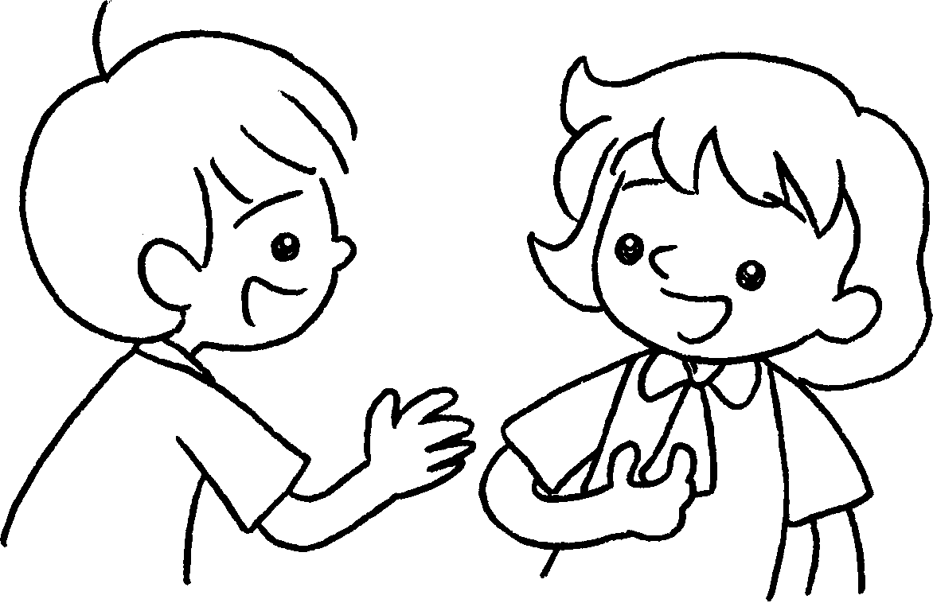  A  B  B |  | A : Where do you live?  A  B : I live Central.
2 | 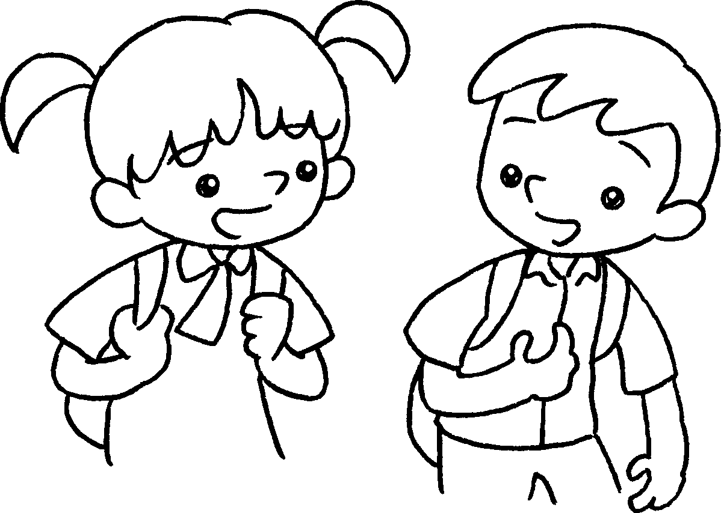  B |  | A : do you live?  B : I live Chai Wan.
3 | 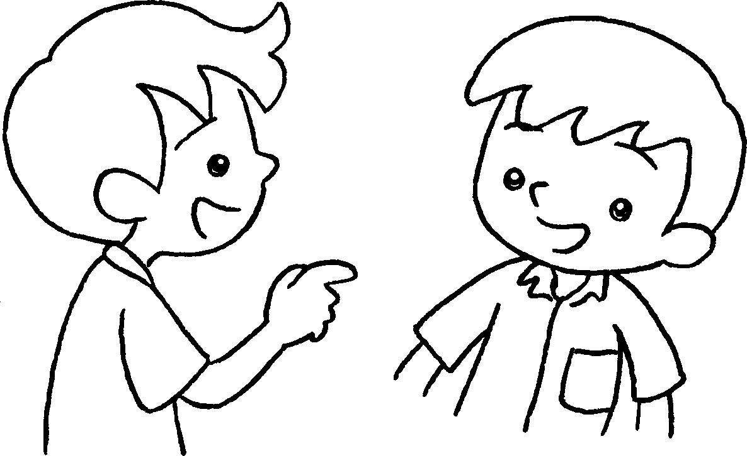  B |  | A : do you live?  B :  Tuen Mun.
4 | 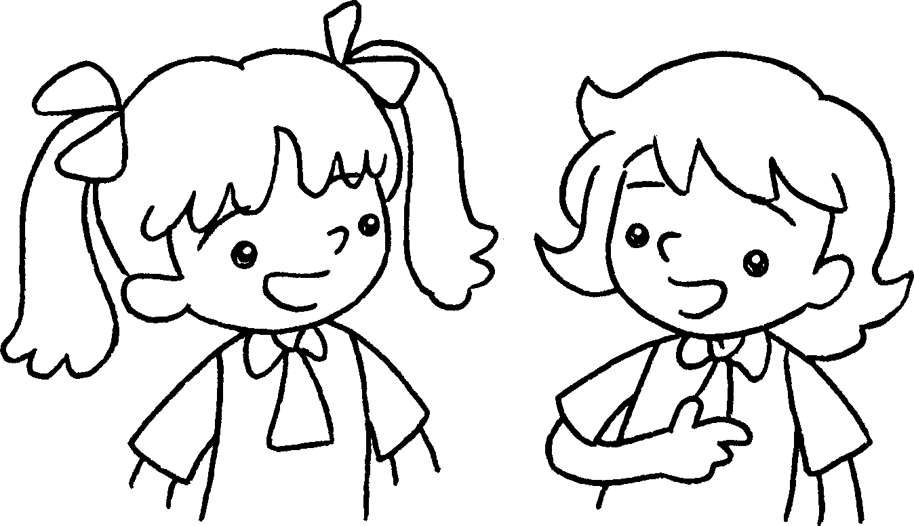 |  | A : I live Tai Po.  A  Where ?  B :  Mong Kok.


Book 2A Chapter 5 Graded Worksheets
Worksheet 2⬇⬇
- in
- Where
in
- Where
I live in
4 in
do you live
I live in

