Ask and answer the questions.
A
A
A
1  Central  Chai Wan  Tuen Mun  Mong Kok  Tai Po | 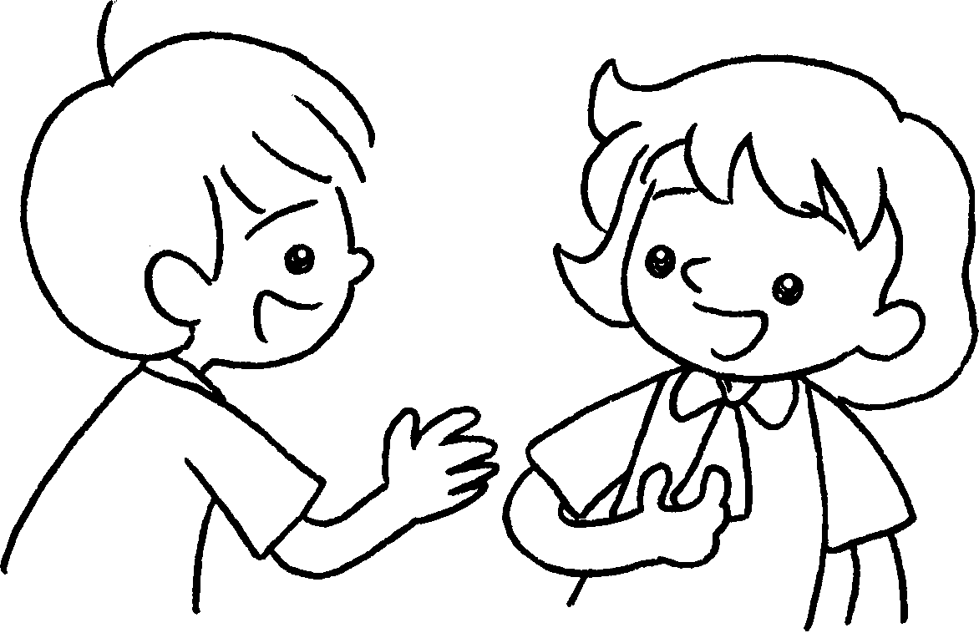  B  A |  | A : Where do you live?  B : I live _______ Central.
2 | 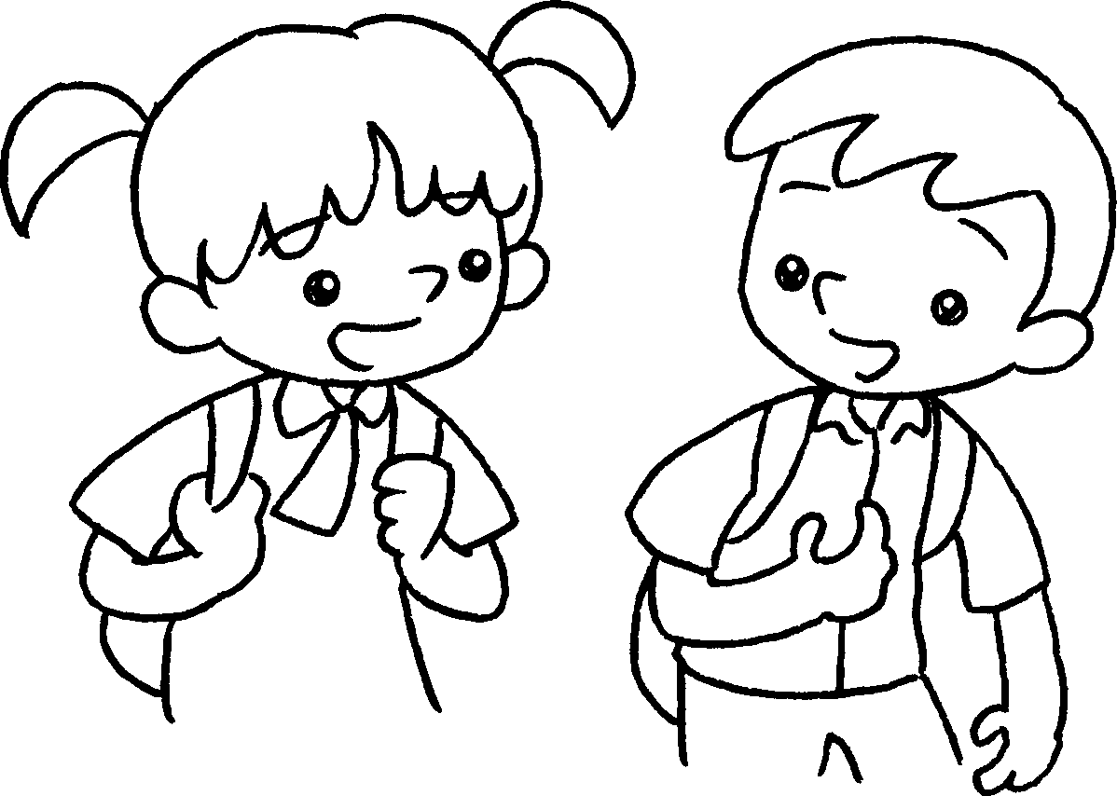  B |  | A : ___________ do you live?  B : I live ______________________  _________________________ .
3 | 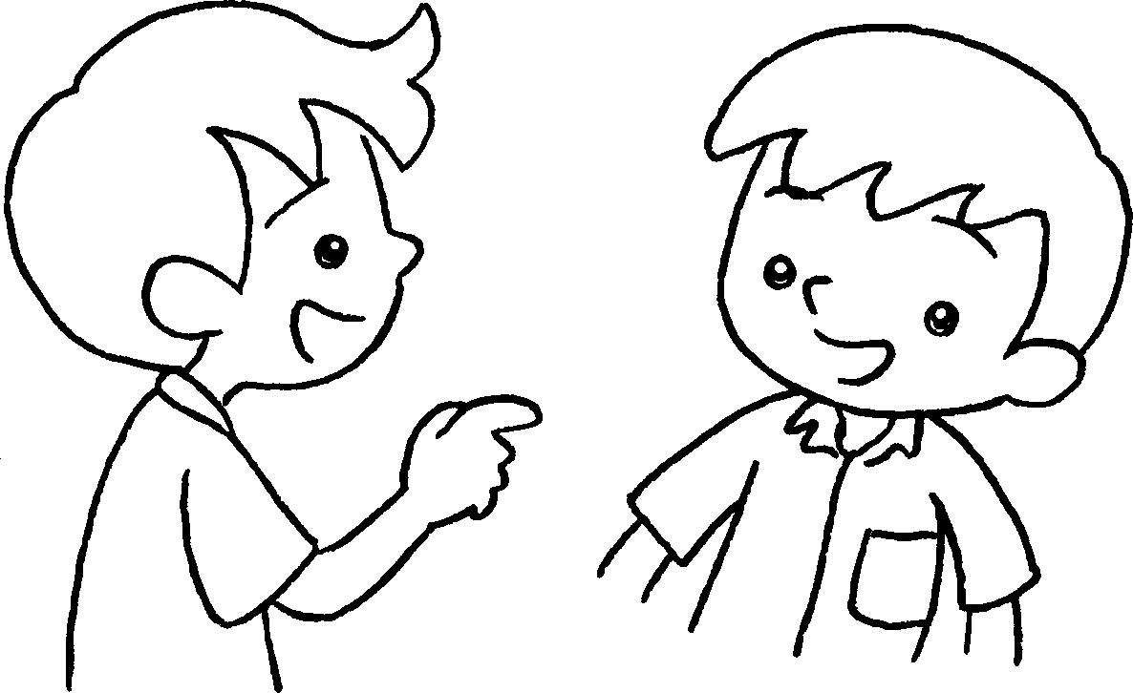  B |  | A : ______________________ live?  B : ___________________________  ___________________________
4 | 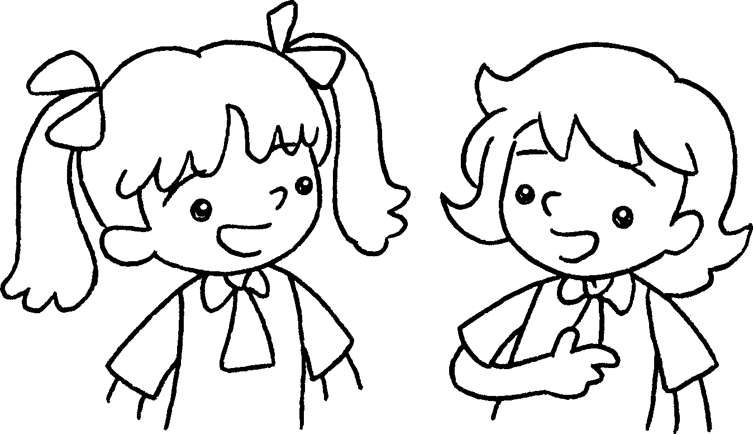  B |  | A : I live ____________________ .  Where __________________ ?  B : ___________________________  ___________________________


Book 2A Chapter 5 Graded Worksheets
Worksheet 2⬇⬇⬇
- in
- Where
in Chai Wan
- Where do you
I live in Tuen Mun.
4 in Tai Po
do you live
I live in Mong Kok.

