Choose and write.
 | How |  | by | on
A
B
A
B
A
B
A
B
1 |  | 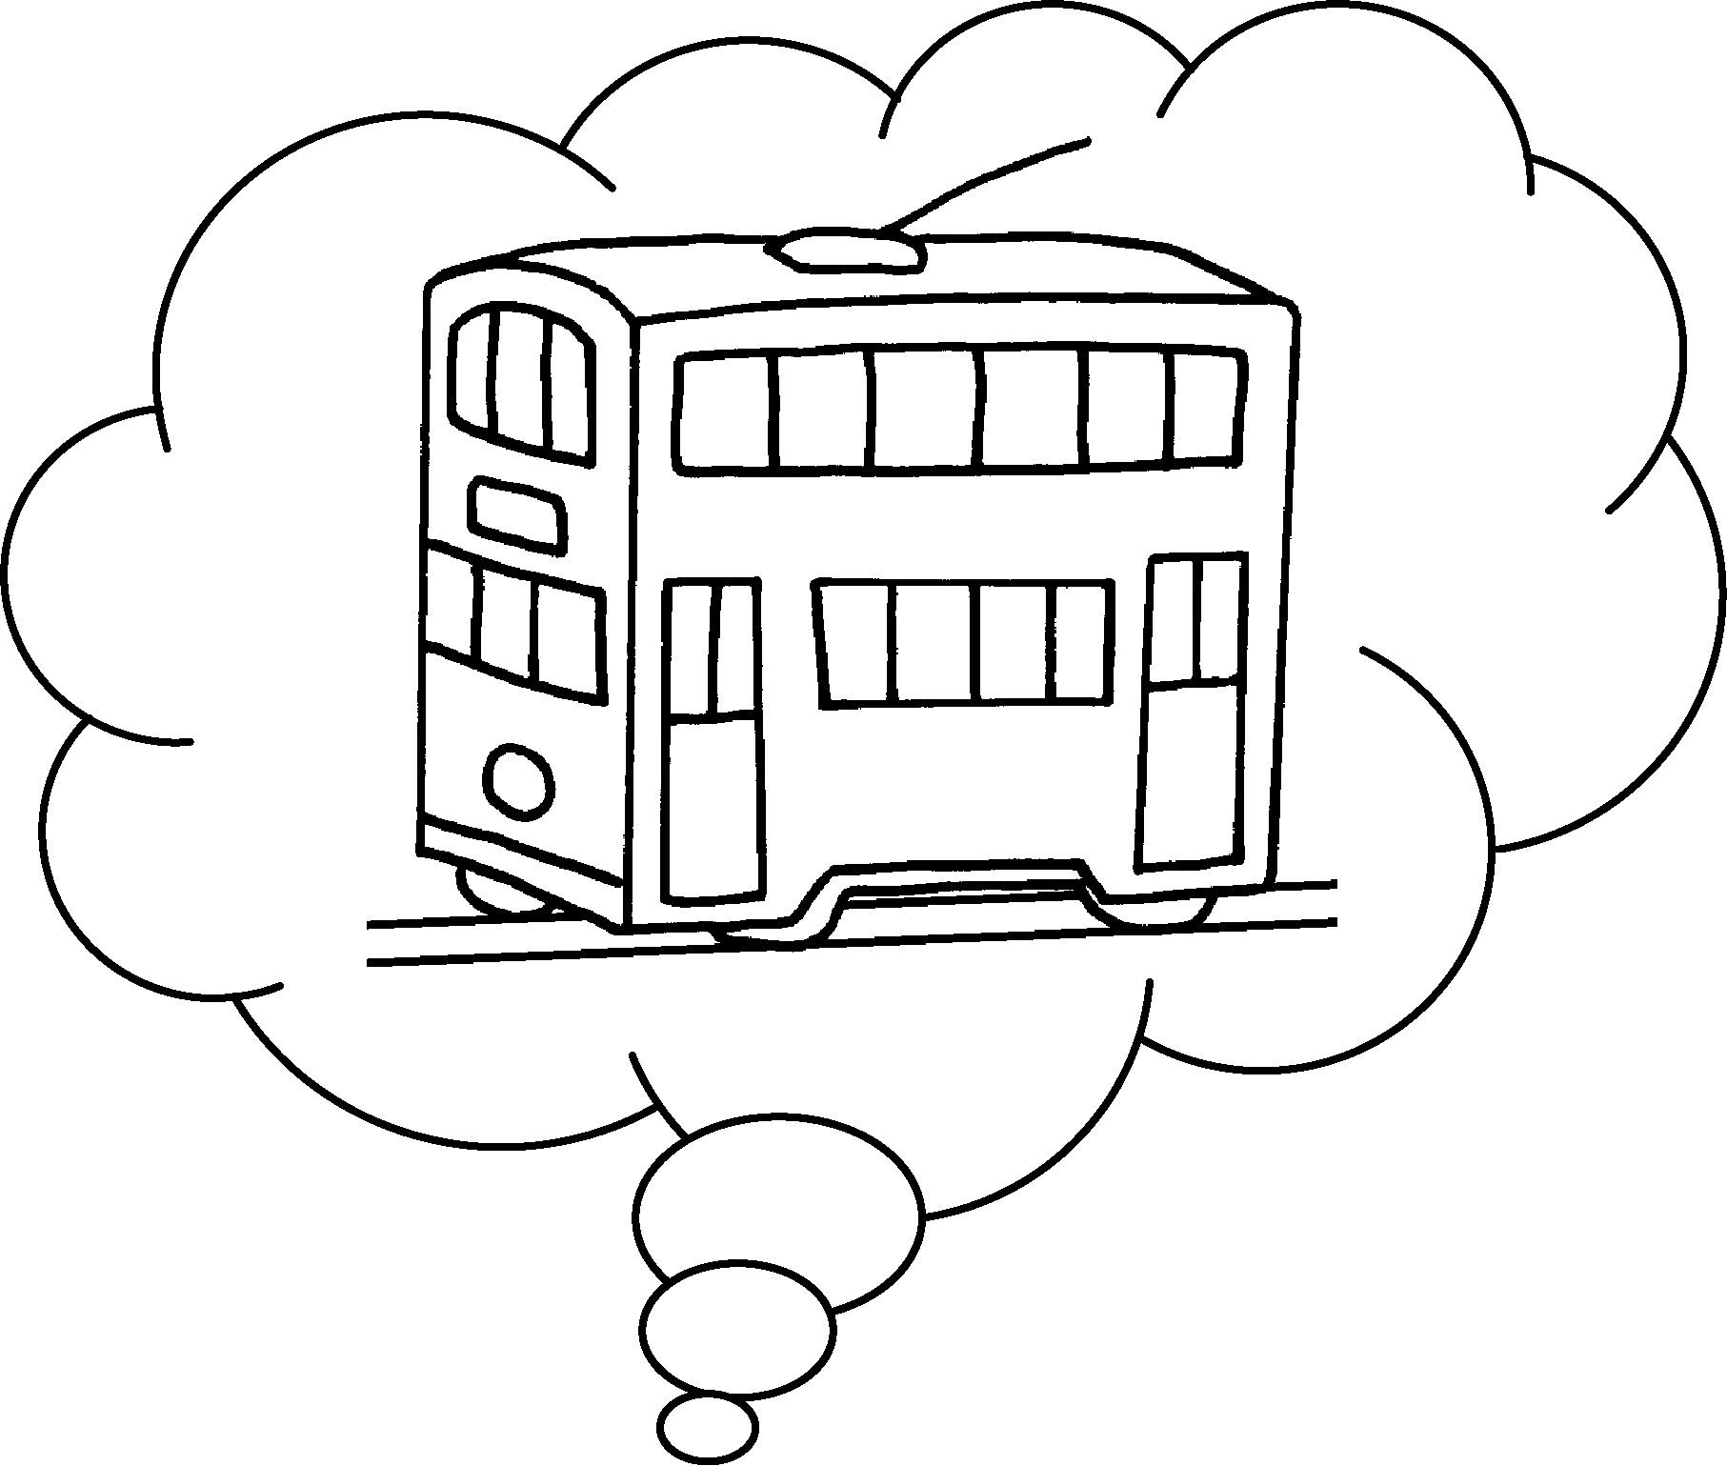 | A : do you come  to school?  B : I come to school by tram.
2 | 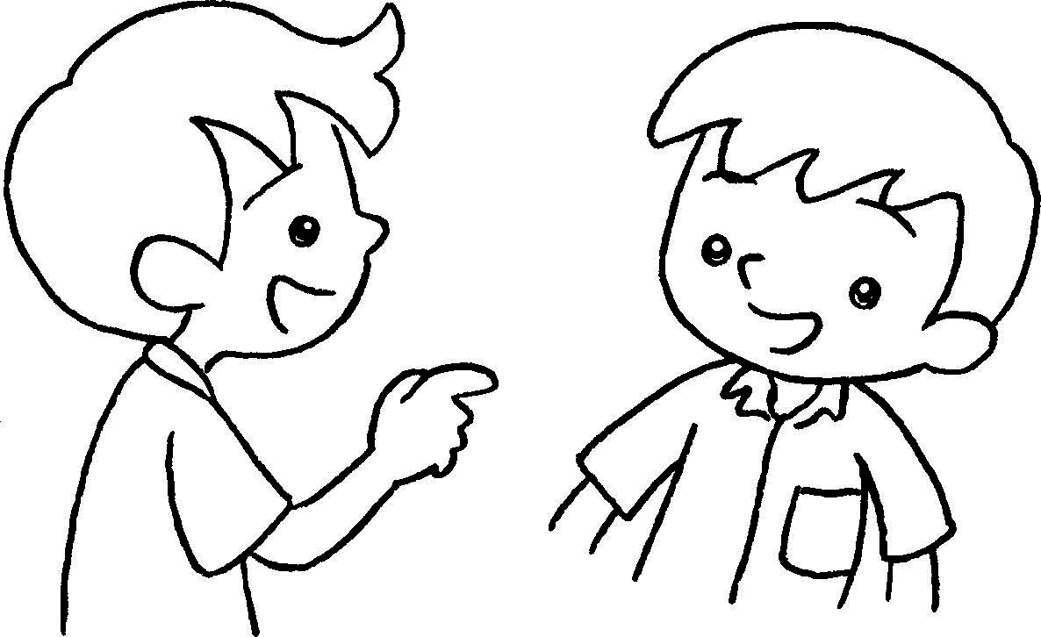 | 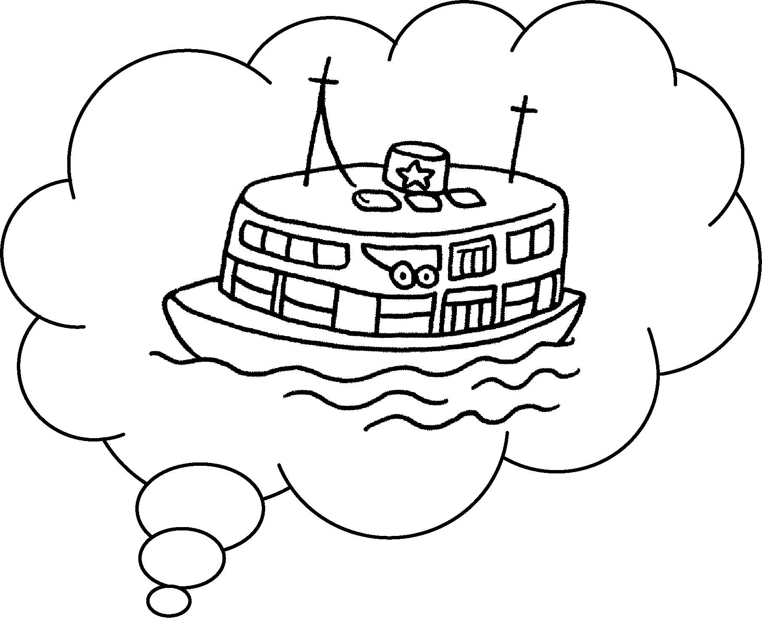 | A : How do you come to  school?  B : I come to school  ferry.
3 | 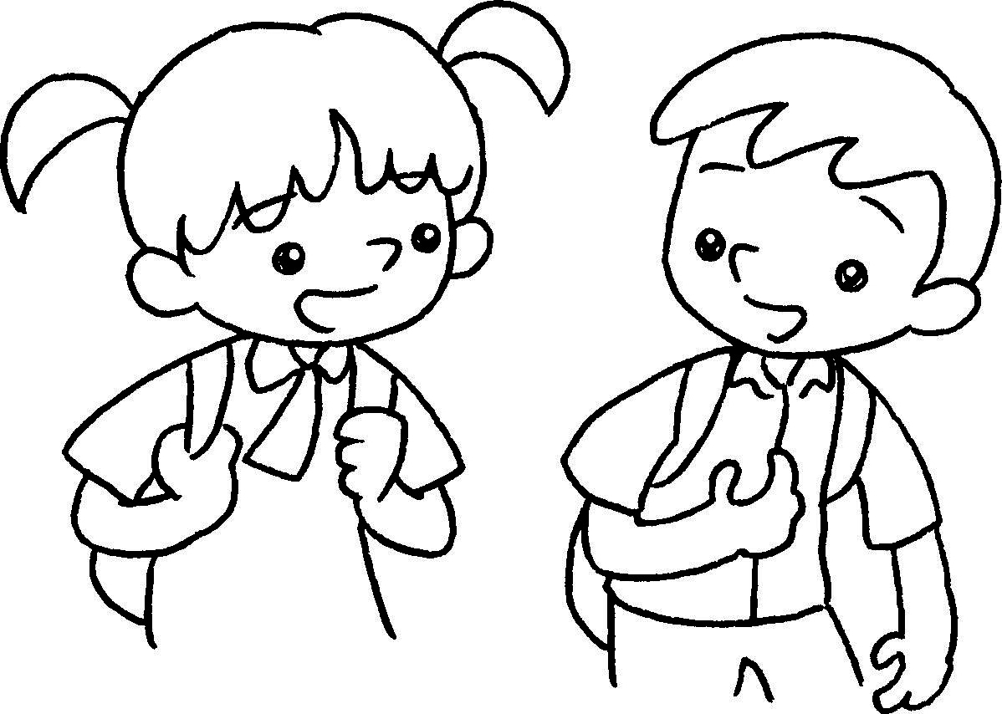 | 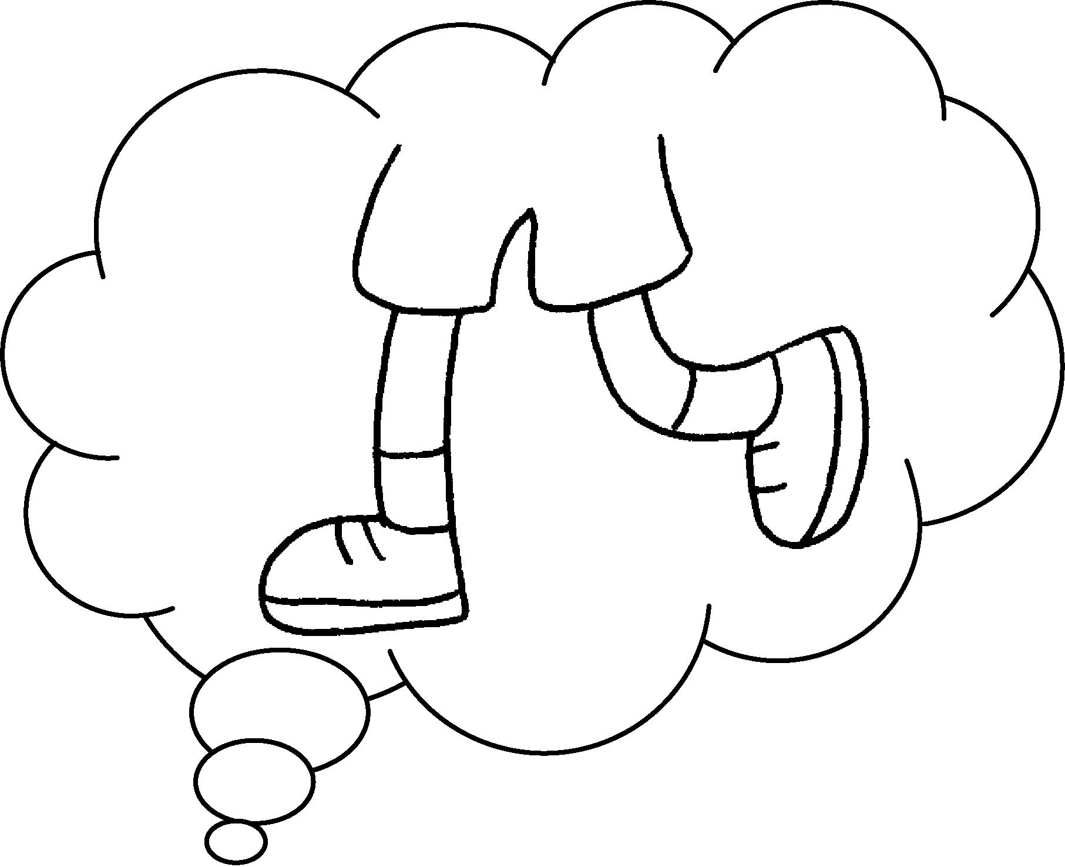 | A : do you come  to school?  B : I come to school  foot.
4 | 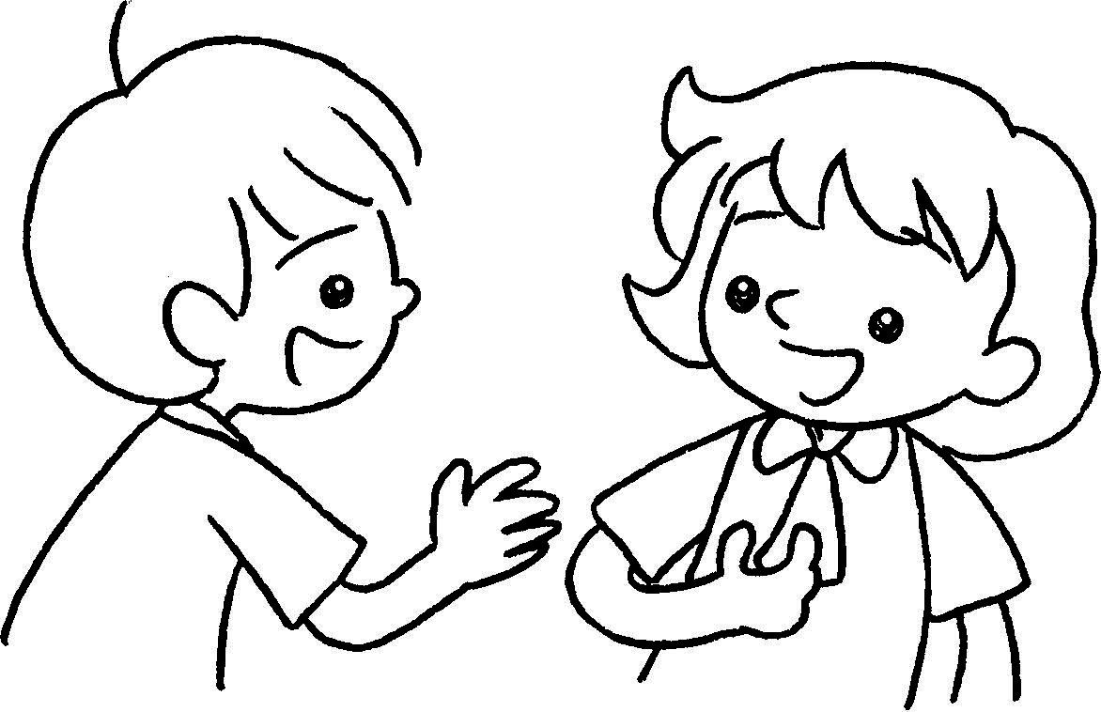 | 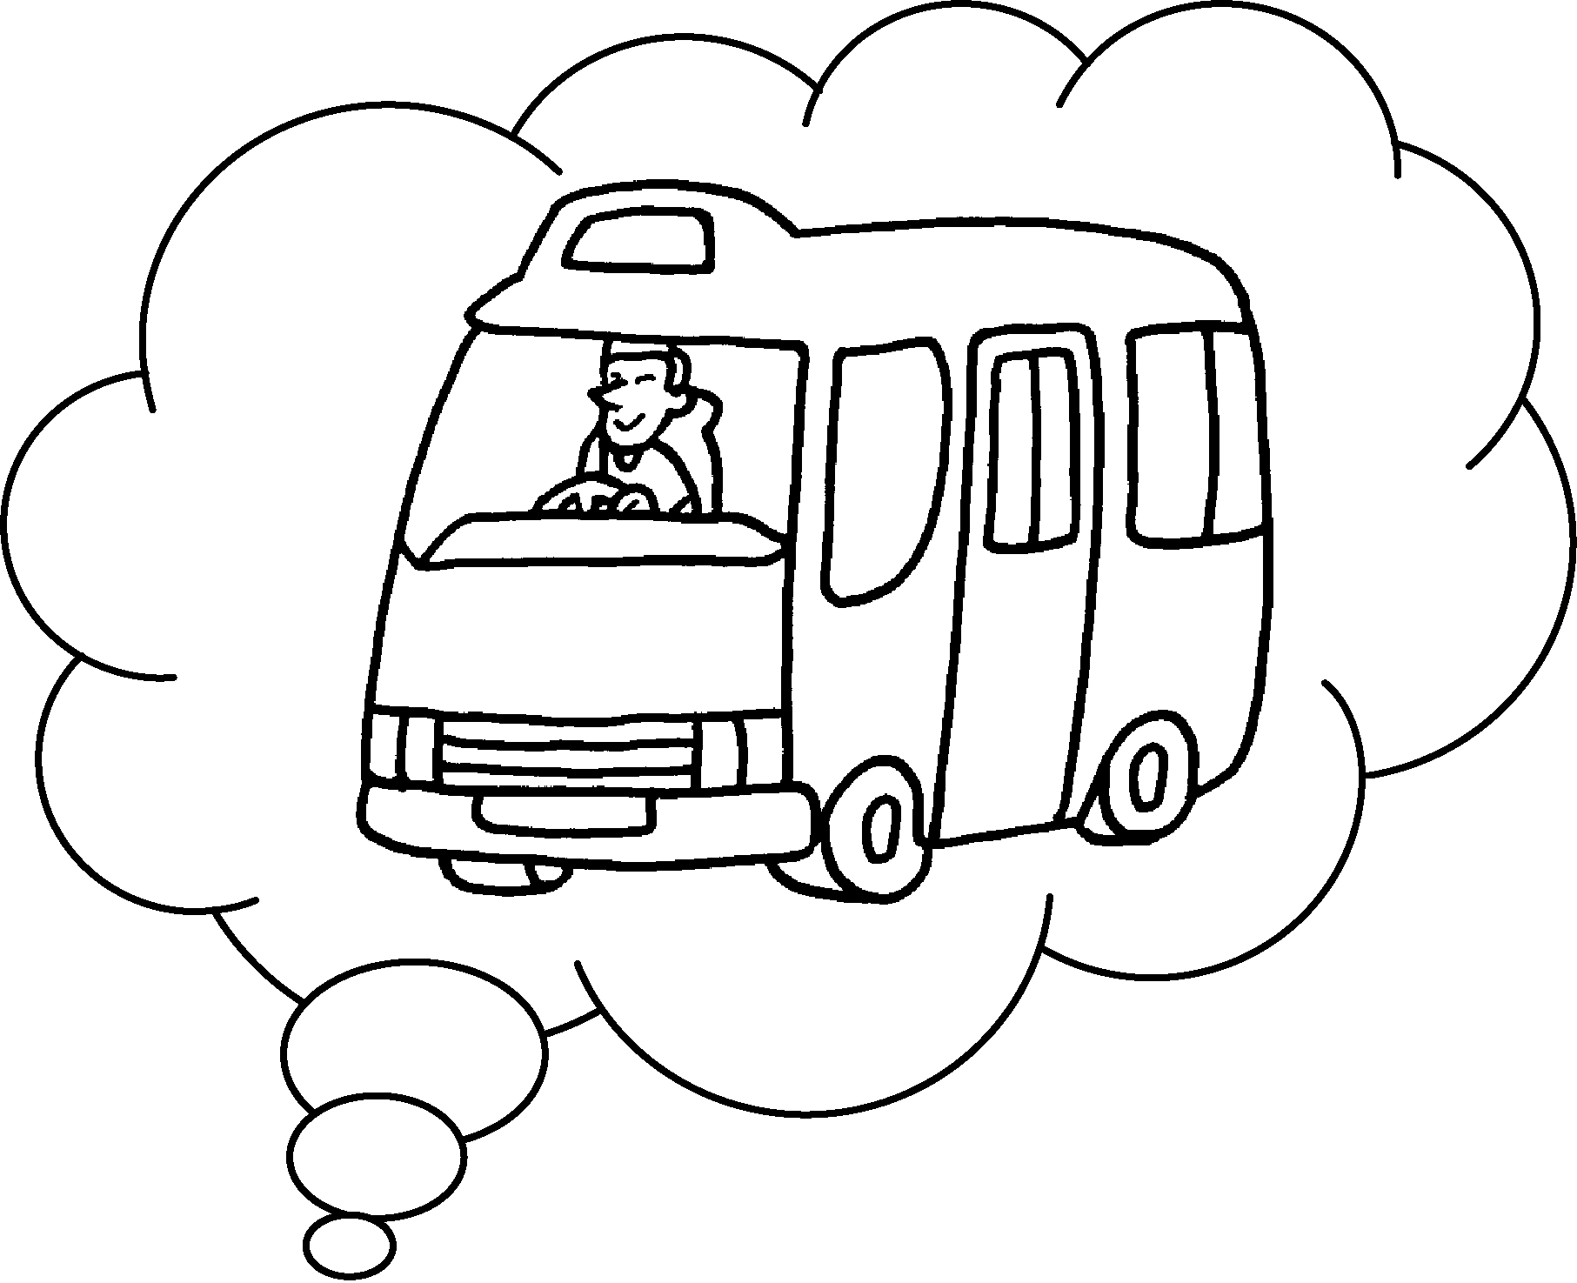 | A : do you come  to school?  B : I come to school  minibus.

Book 2A Chapter 5 Graded Worksheets

Worksheet 3⬇
- How
- by
- How
on
- How
by

