Ask and answer the questions.
A
B
A
B
A
B
A
B
1 | 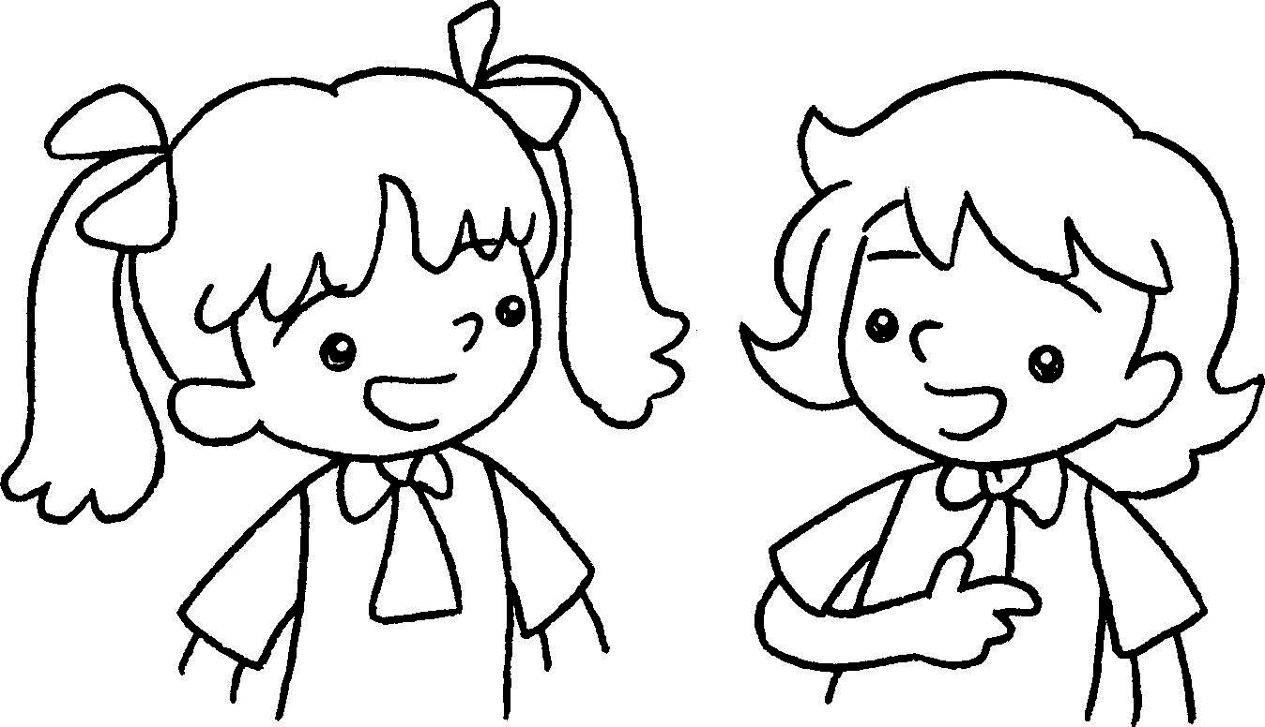 | 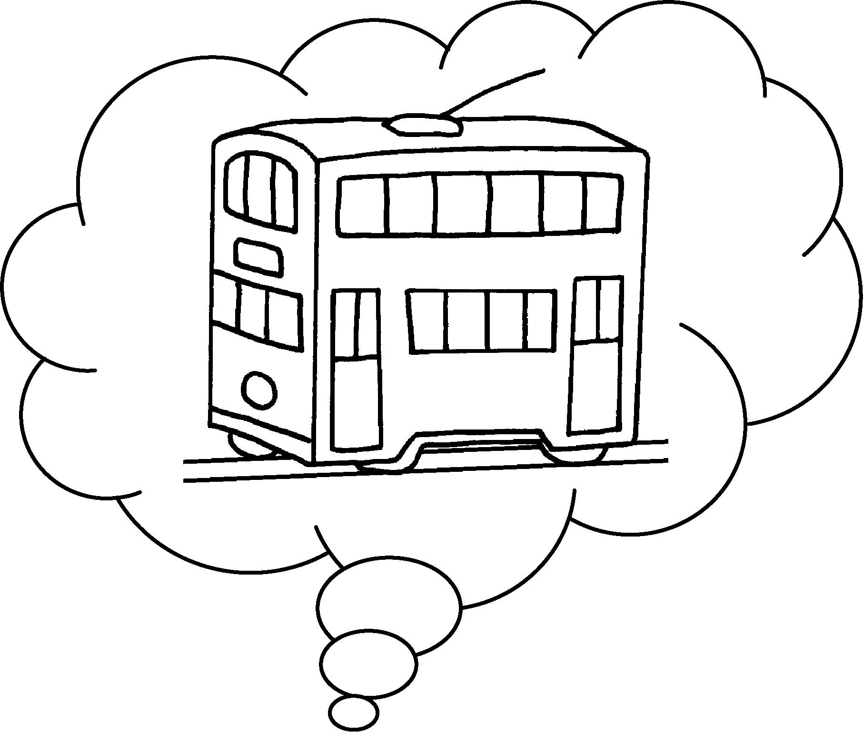 | A : How do you come to  school?  B : I come to school by  .
2 | 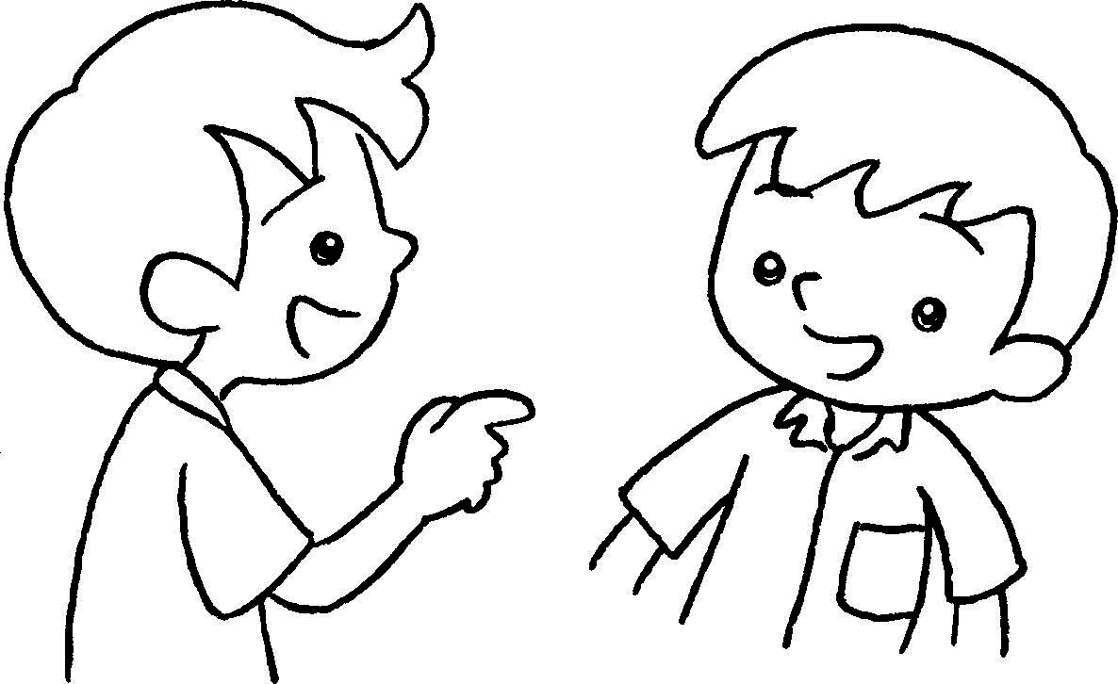 | 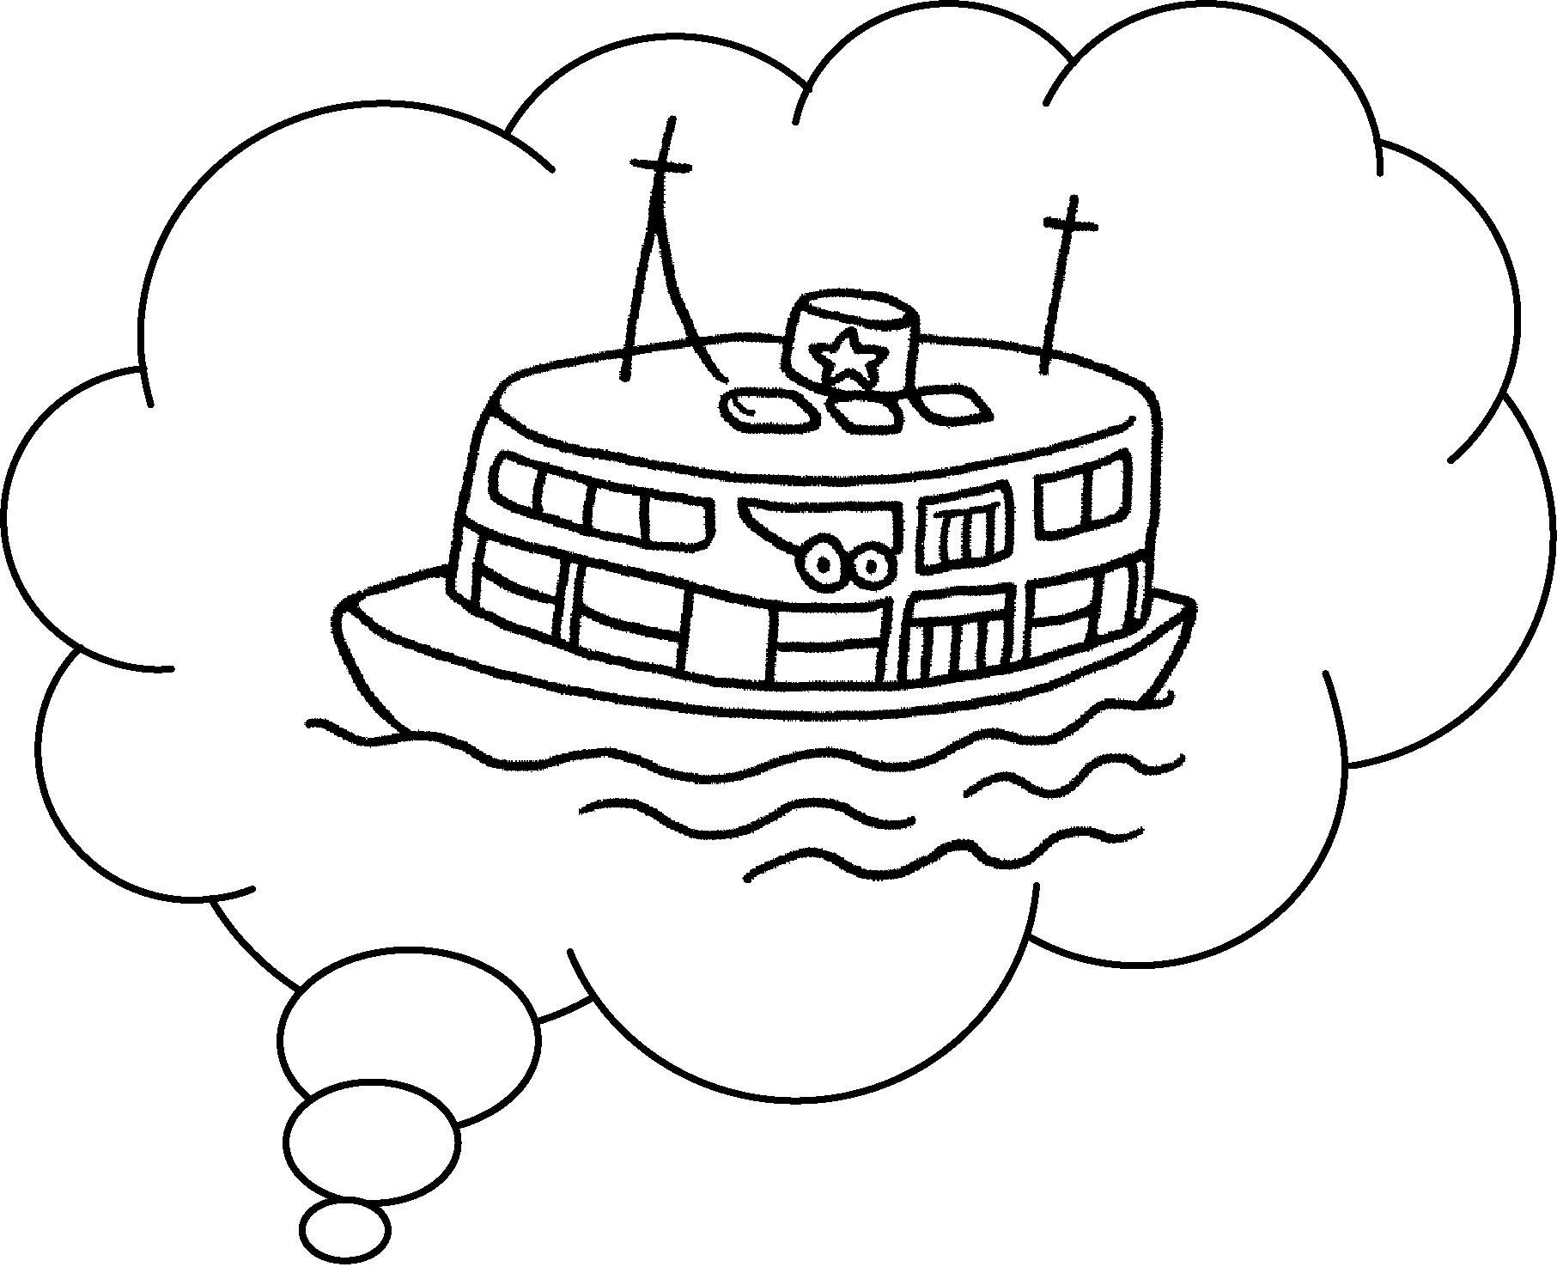 | A :  come to school?  B : I come to school  .
3 | 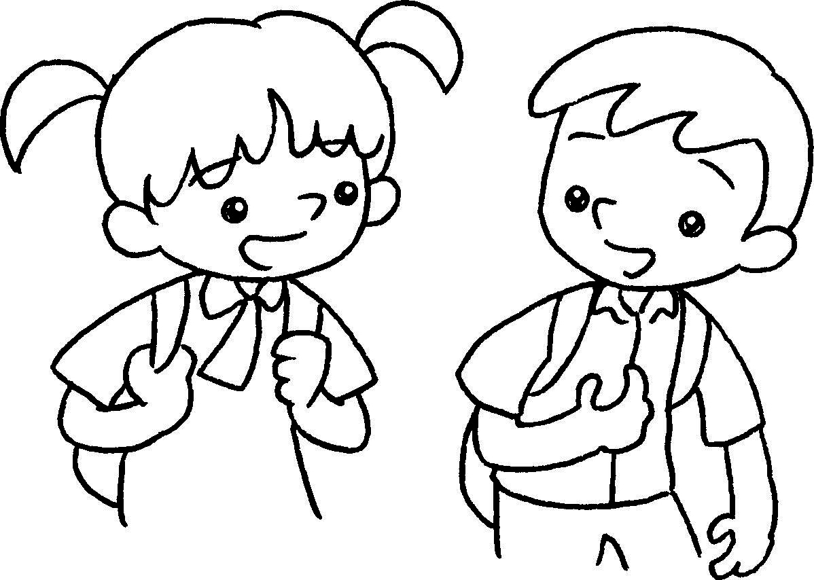 | 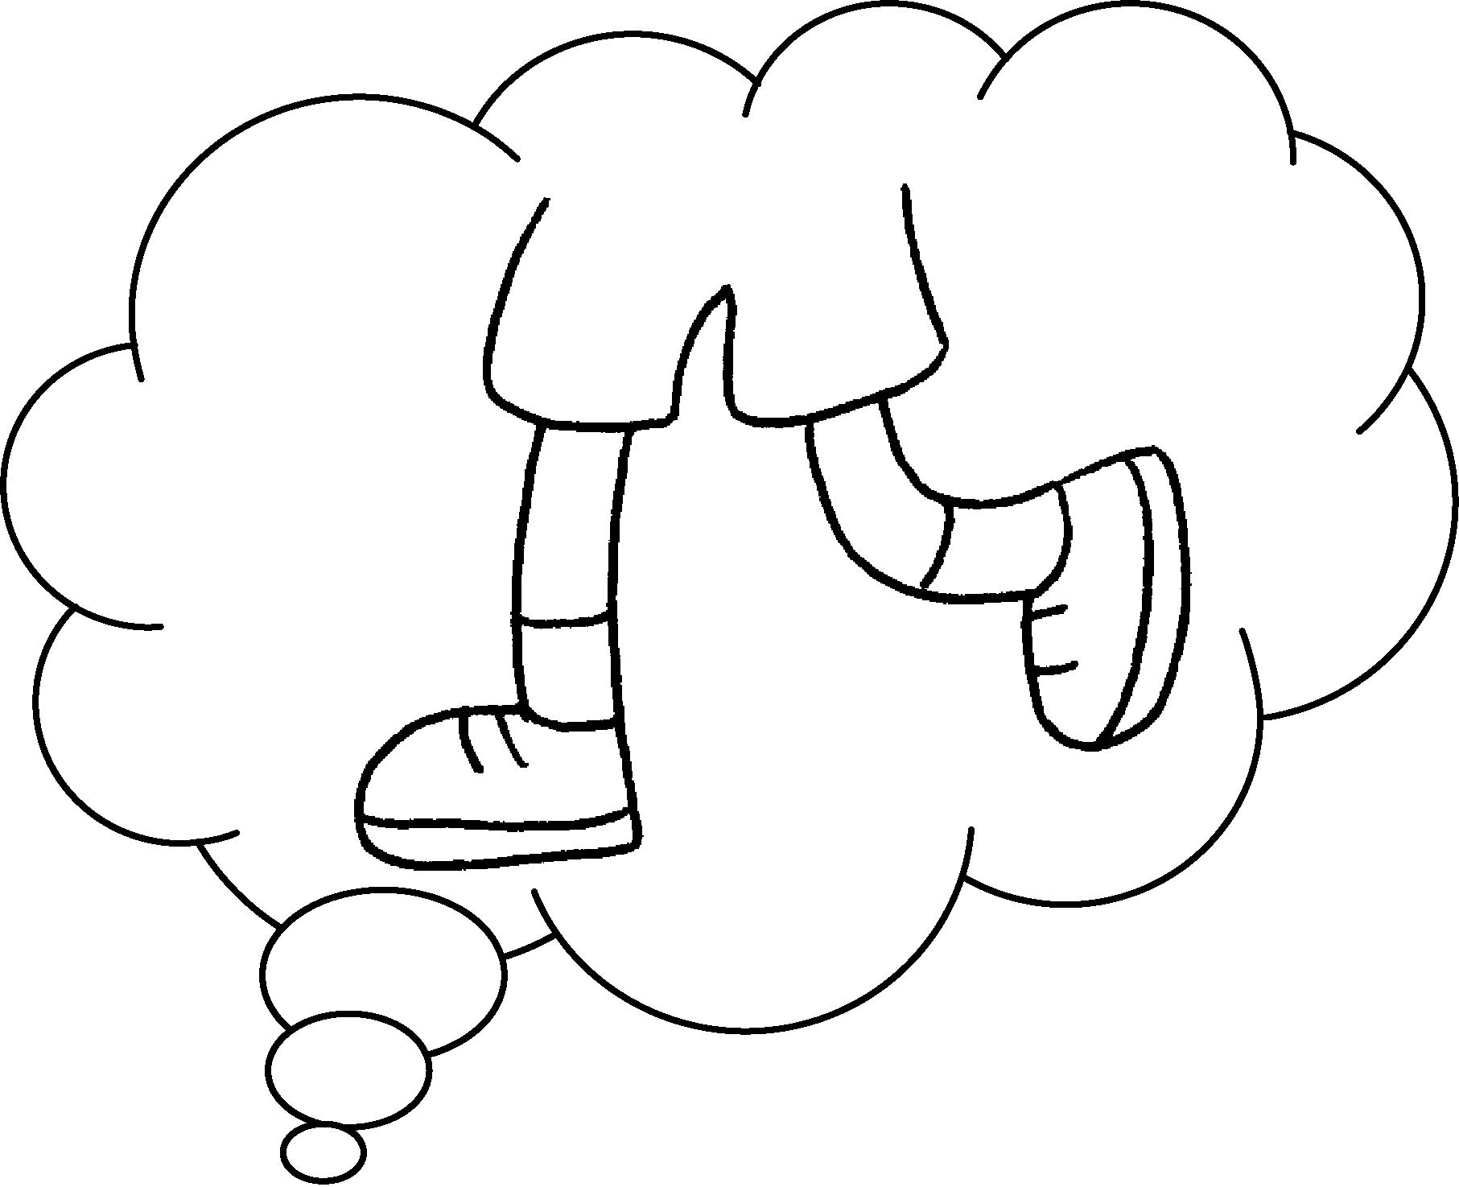 | A :  school?  B :
4 | 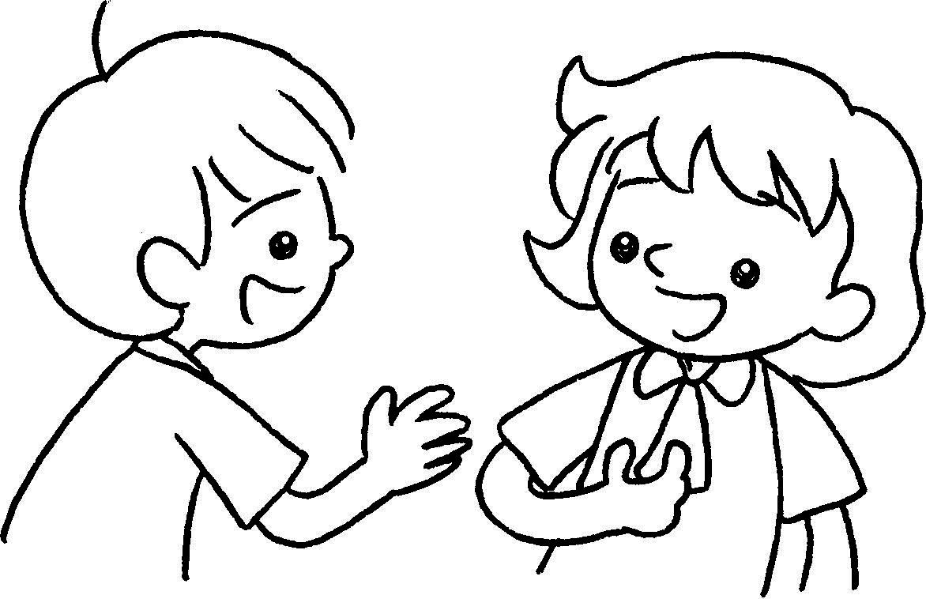 | 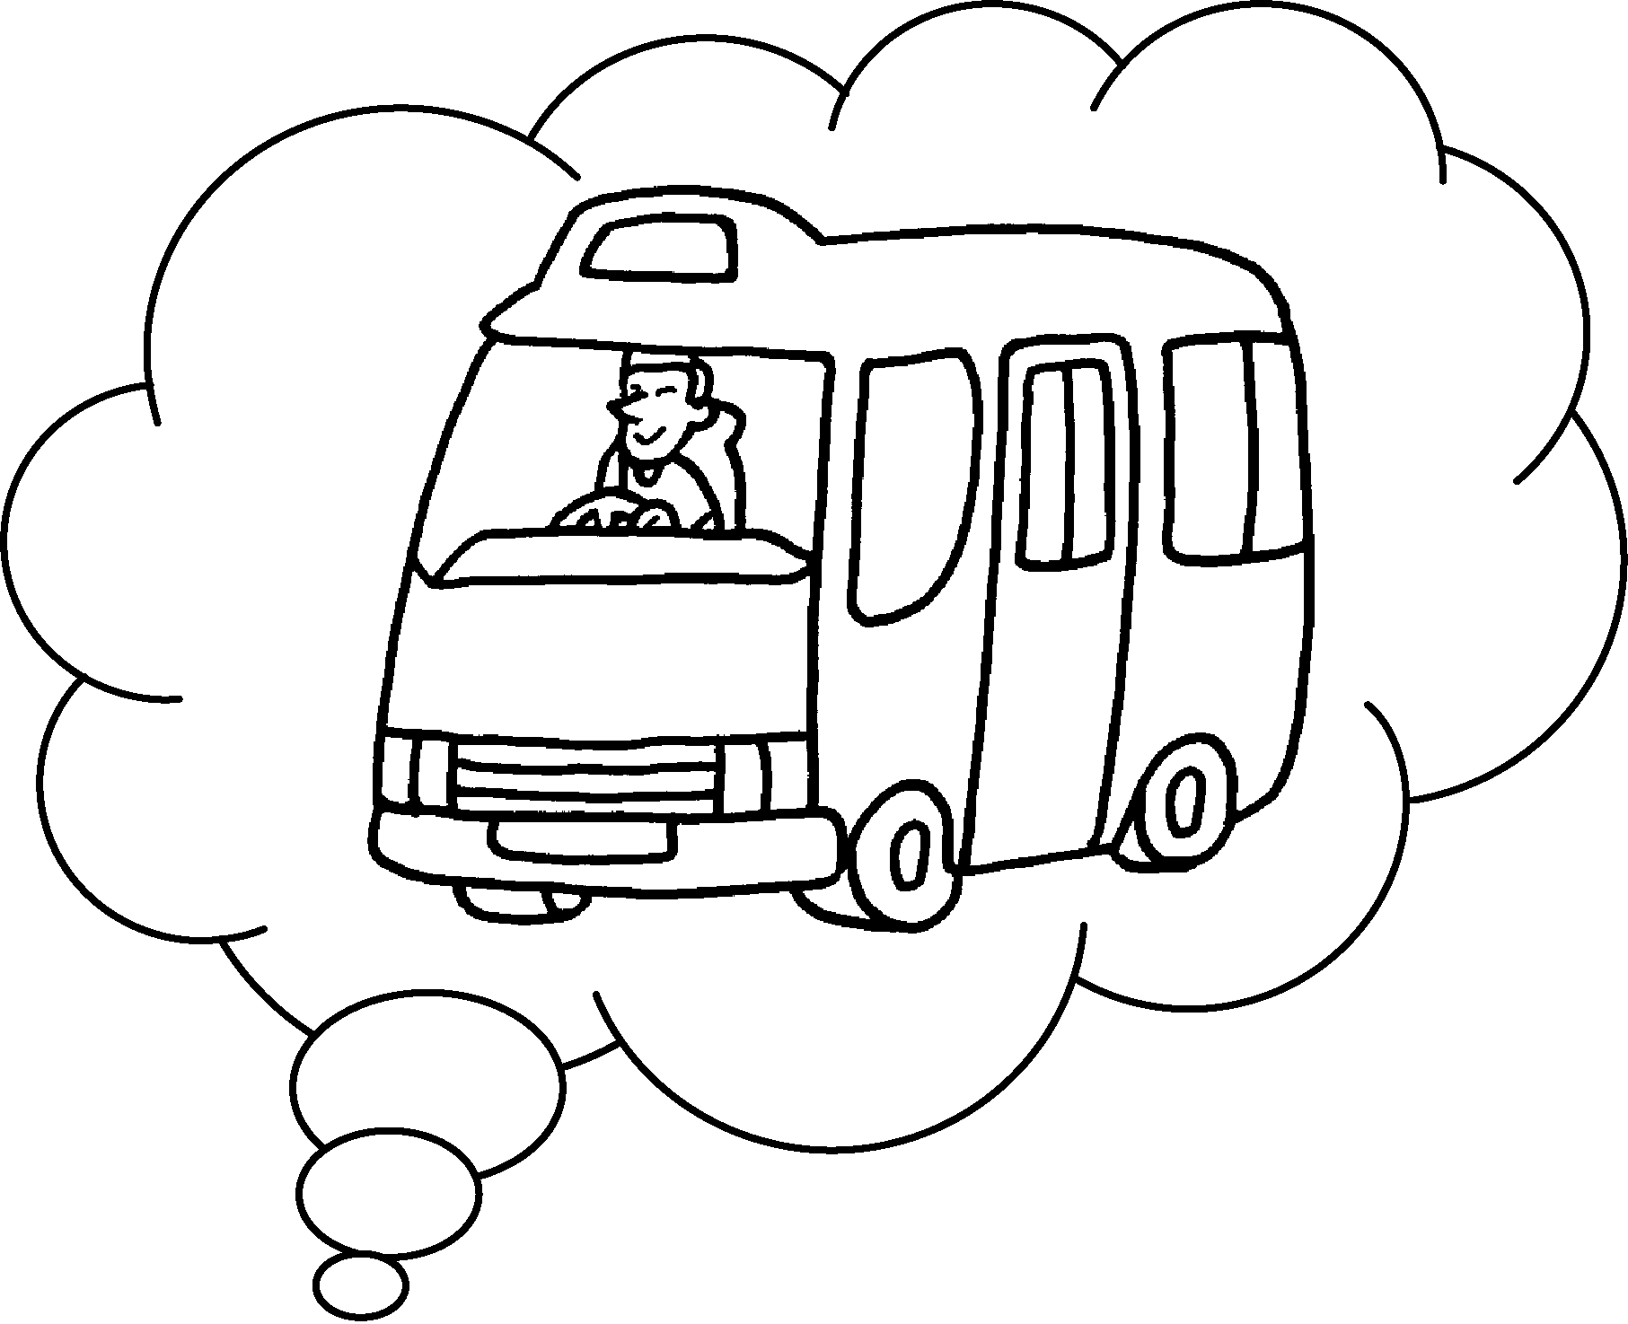 | A :  B :

Book 2A Chapter 5
Remedial Worksheets
Worksheet 3
1 How
2 by
3 How
on
4 How
by
Book 2A Chapter 5
Remedial Worksheets
Worksheet 2
1 Where
2 in
3 Where
in
4 in Where
in

Book 2A Chapter 5 Graded Worksheets

Worksheet 3⬇⬇⬇
- tram
- How do you
by ferry
- How do you come to
I come to school on foot.
4 How do you come to school?
I come to school by minibus.

