Choose and write.

fireman | policeman | policewoman | postman

1 | 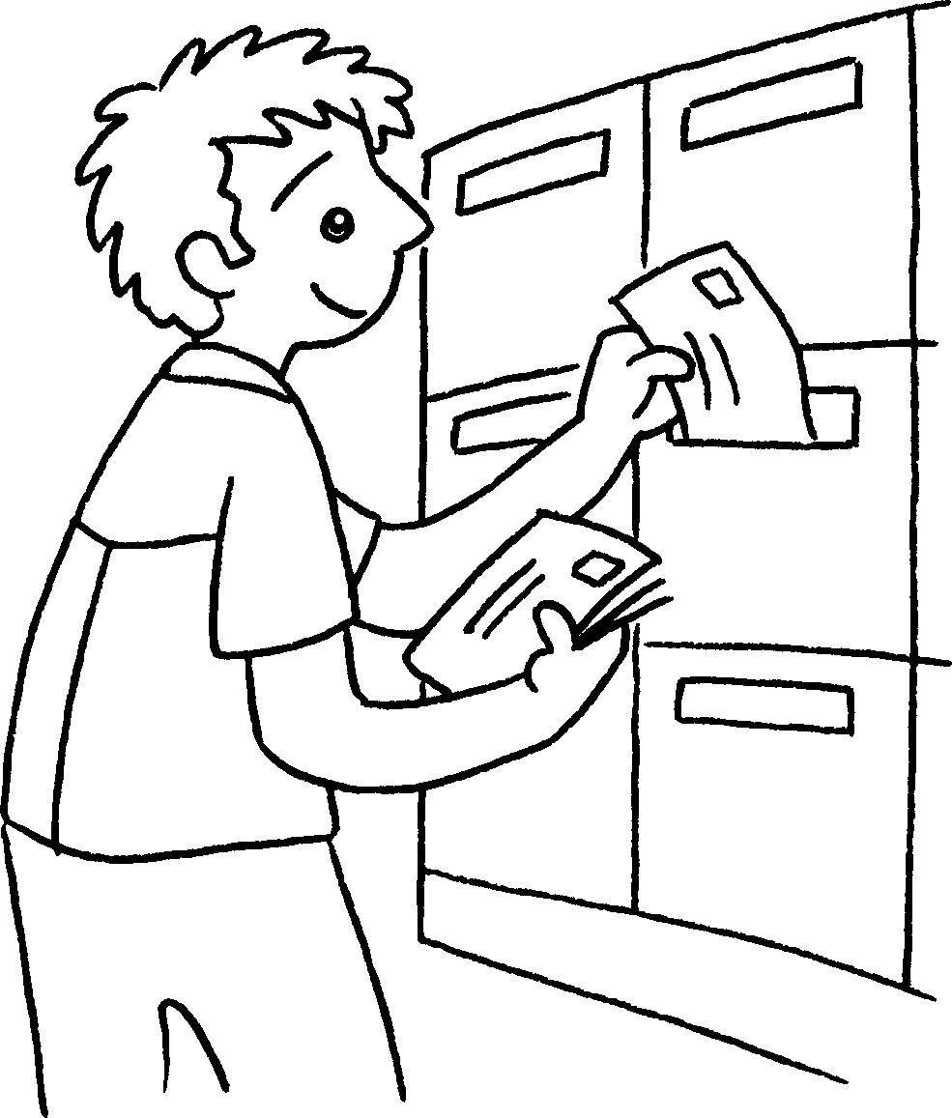 | 2 | 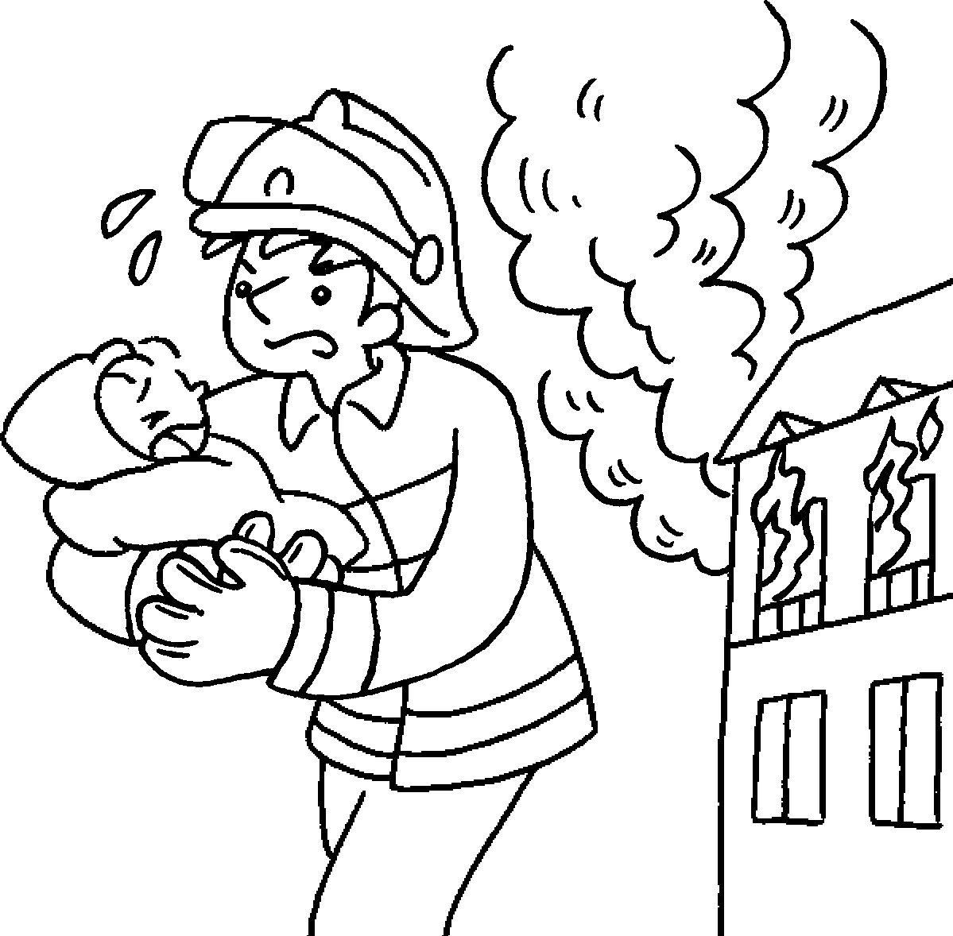 | 3 | 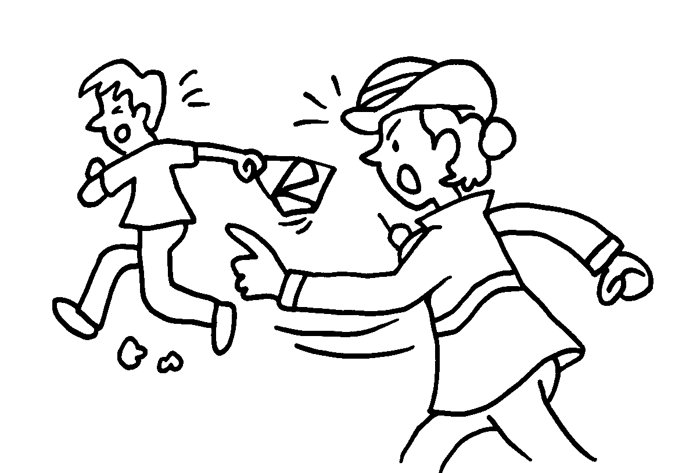 | 4 | 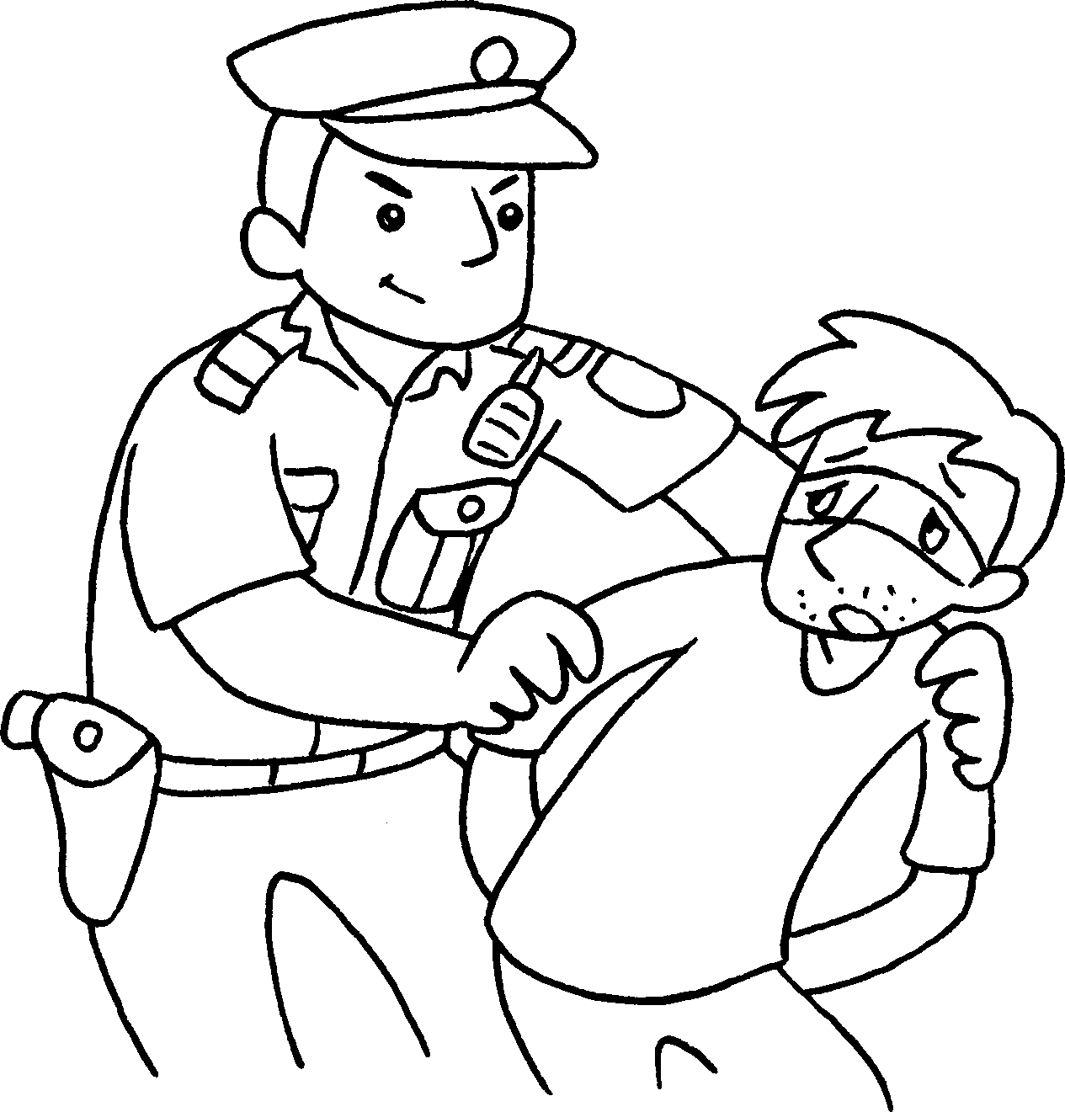

1 | a |  | 2 | a
3 | a |  | 4 | a

bus driver | doctor | housewife | nurse
taxi driver | teacher | waiter | waitress
9
5 |  | 6 | 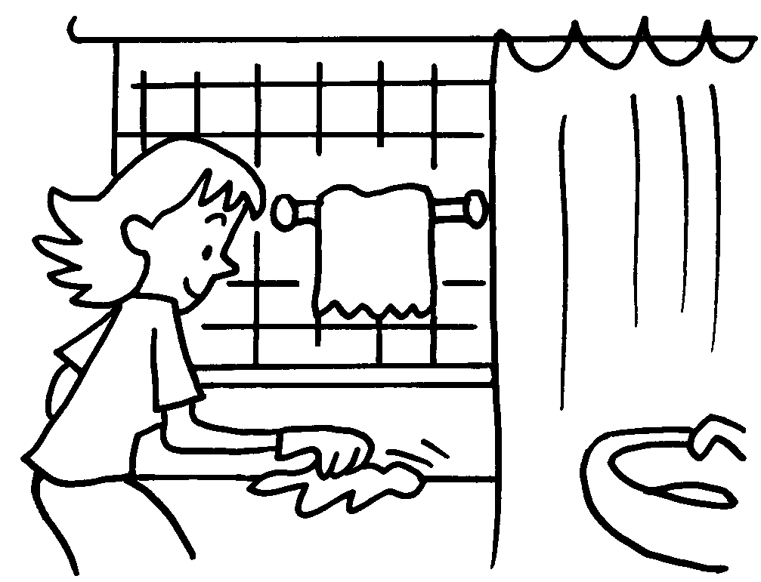 | 7 | 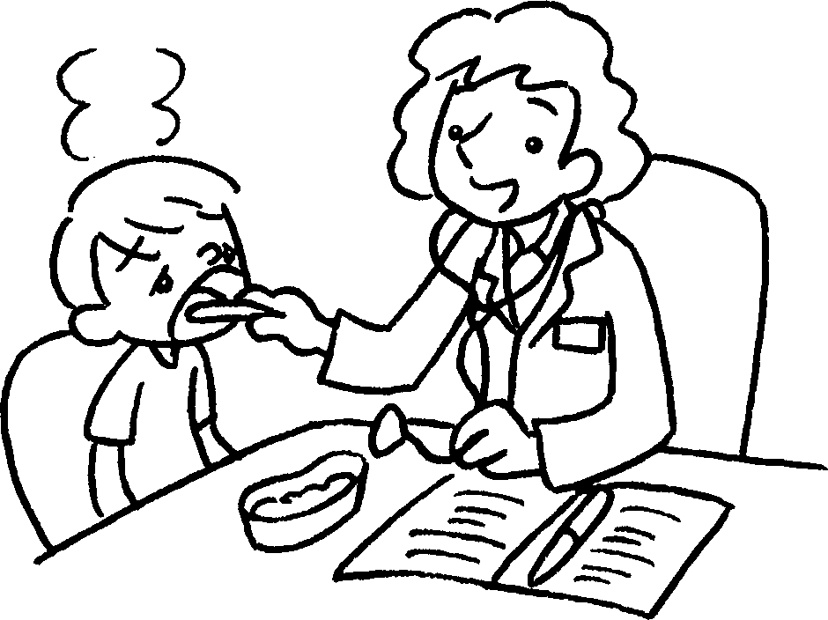 | 8 | 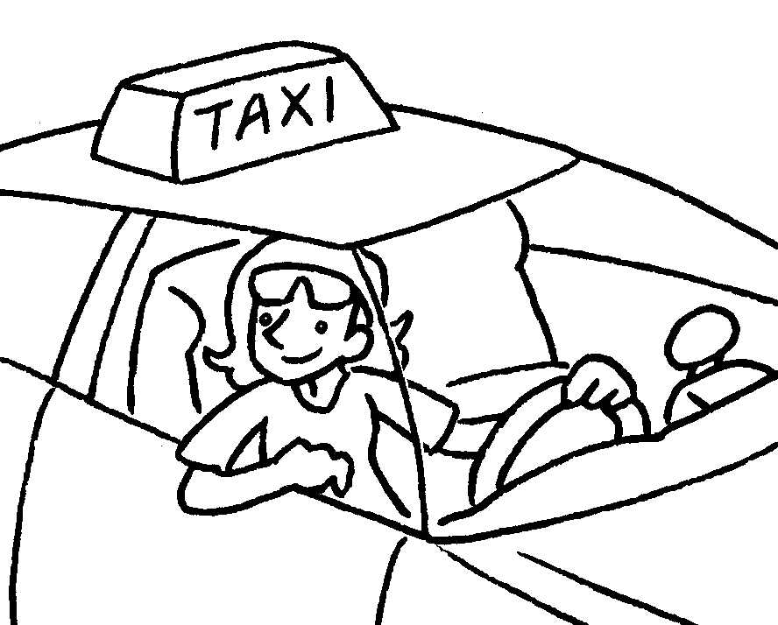
 |  | 10 | 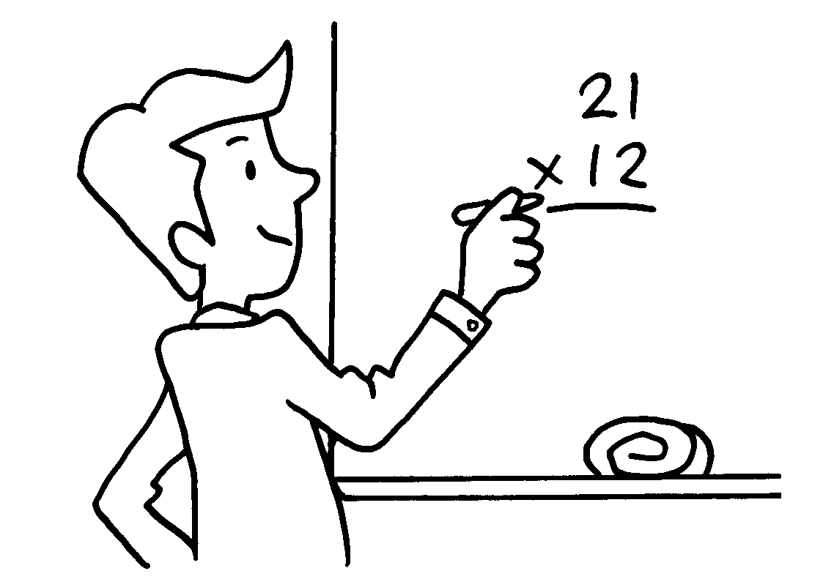 | 11 | 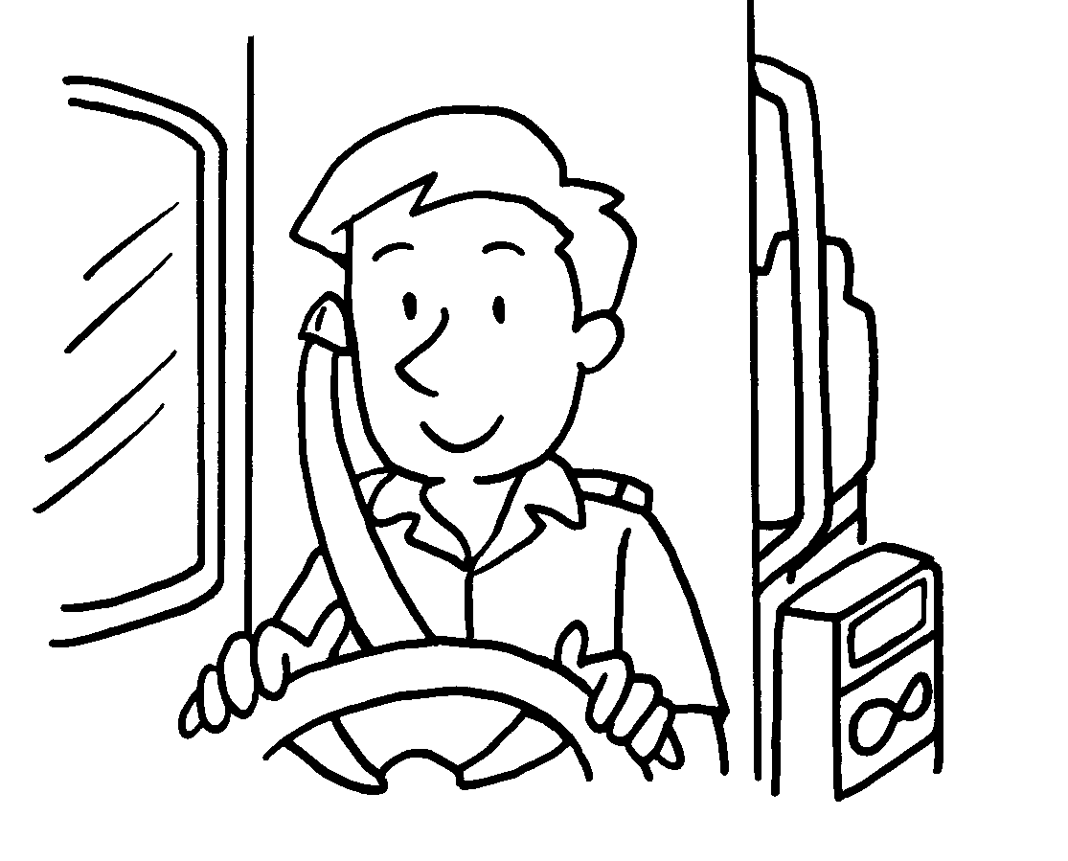 | 12 | 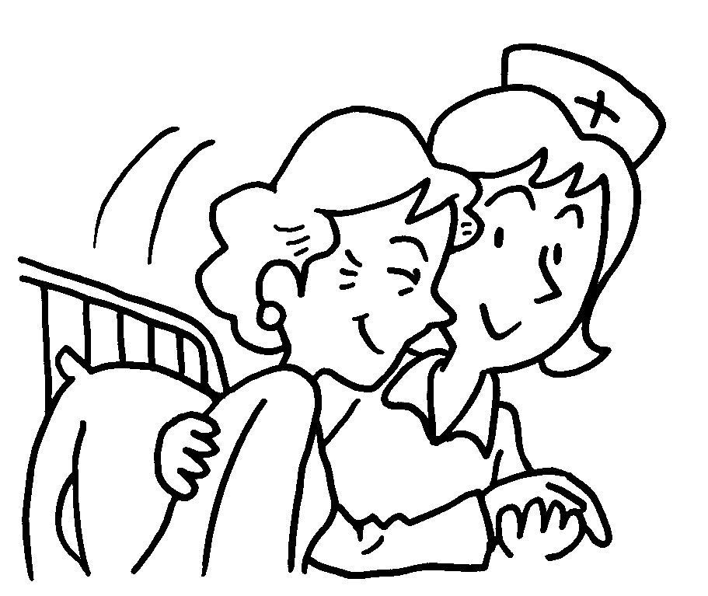

5 | a |  | 6 | a
7 | a |  | 8 | a
9 | a |  | 10 | a
11 | a |  | 12 | a


Book 2A Chapter 6 Graded Worksheets
Worksheet 1⬇
1 postman 2 fireman
3 policewoman 4 policeman
5 waiter 6 housewife
7 doctor 8 taxi driver
9 waitress 10 teacher
11 bus driver 12 nurse

