What are their jobs? Write.

1 | 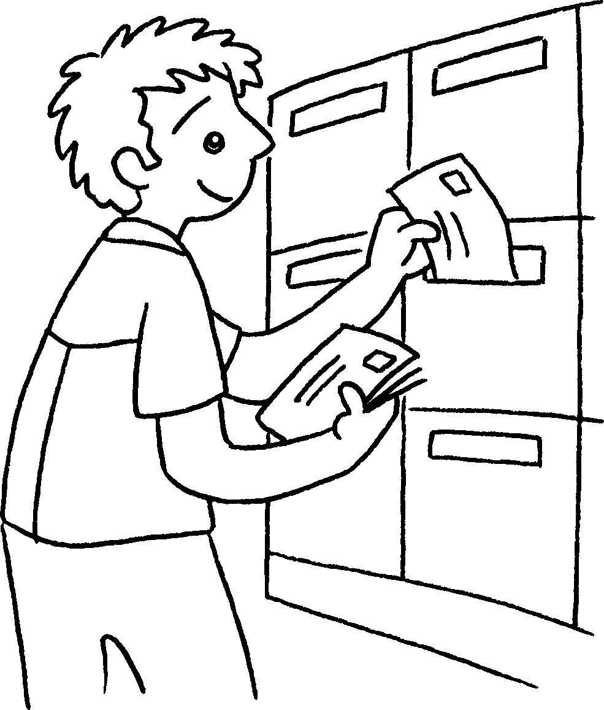 | 2 | 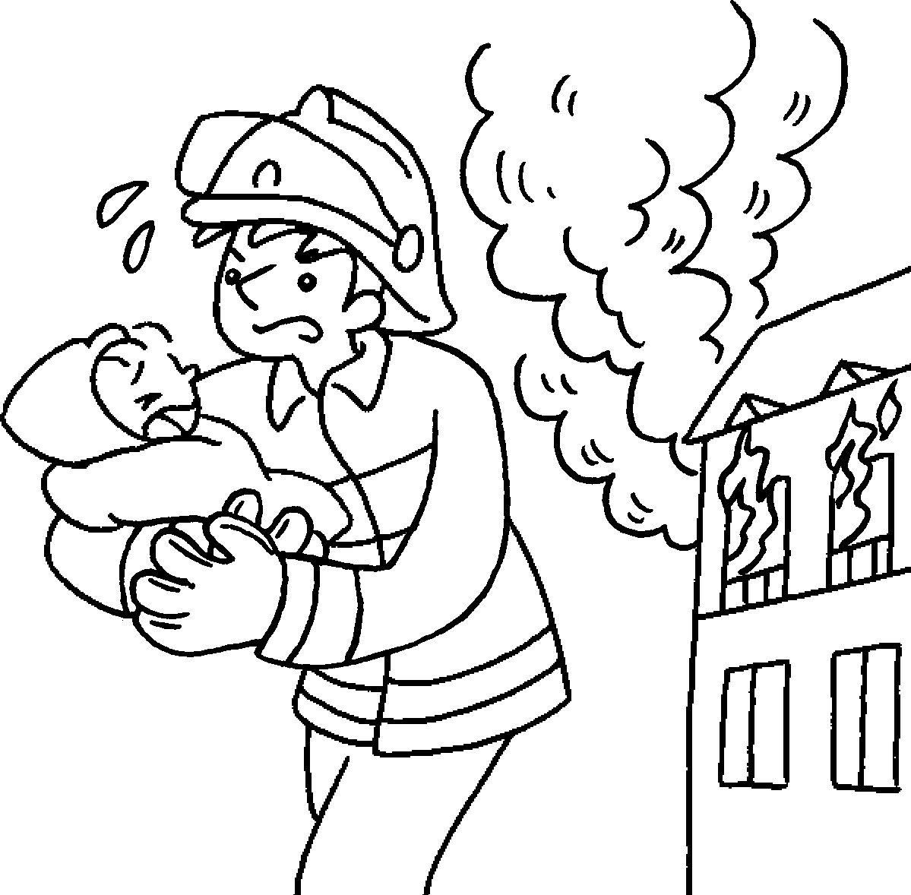 | 3 | 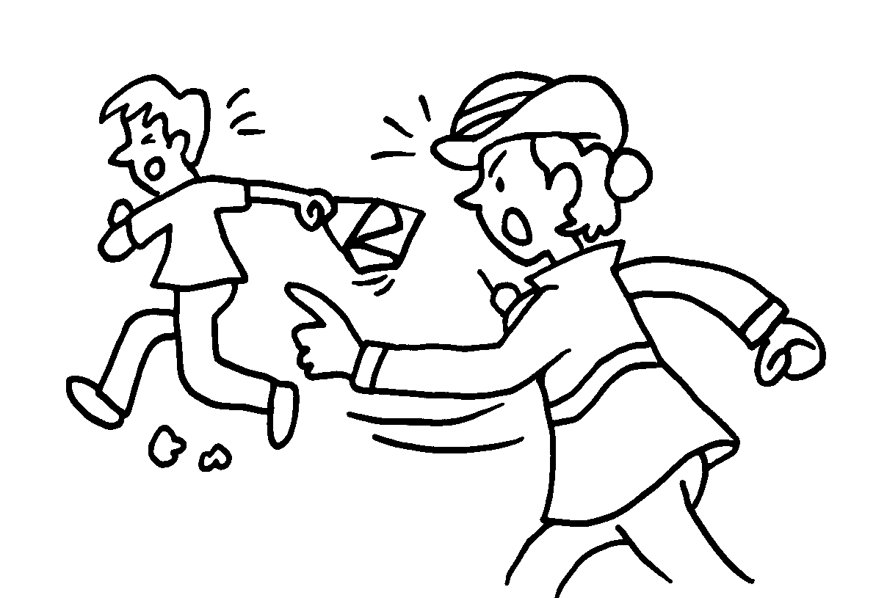 | 4 | 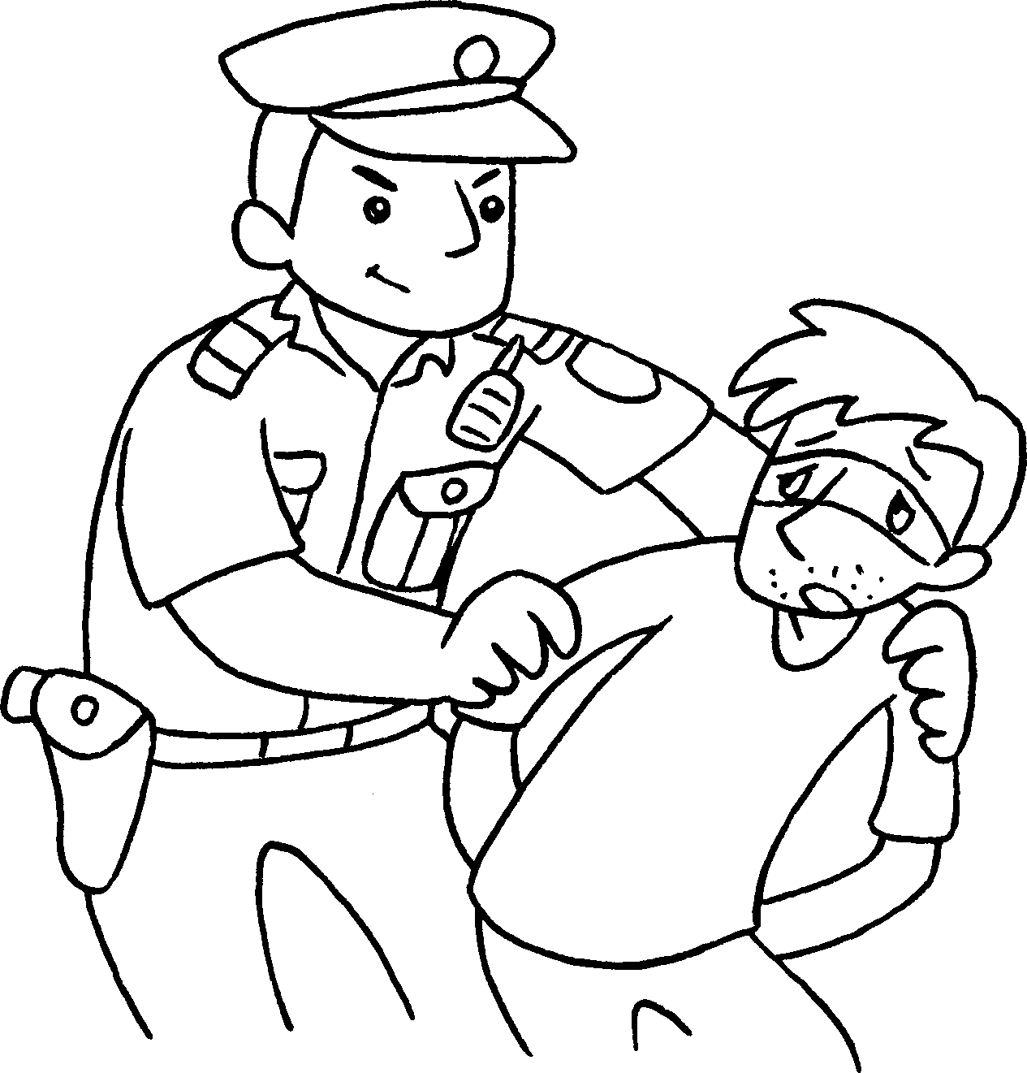

1 | a  (msnapot) |  | 2 | a  (femiarn)
3 | a  (liewcopanmo) |  | 4 | a  (namecilop)
9
5 |  | 6 | 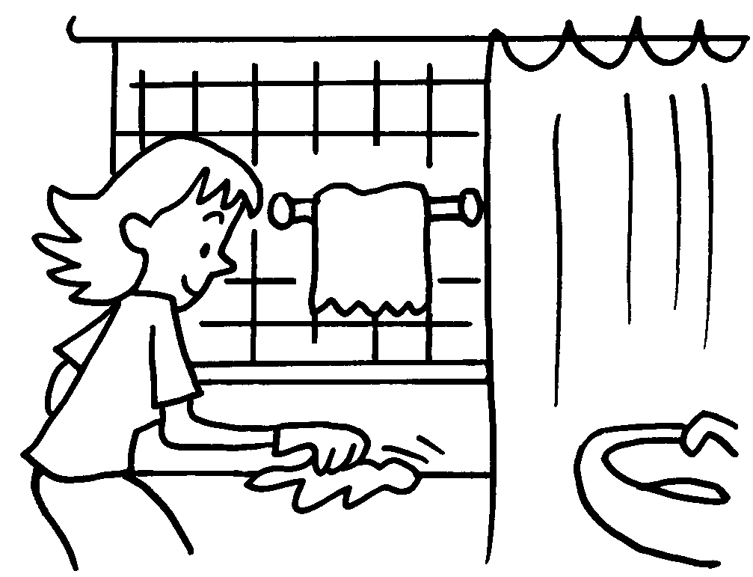 | 7 |  | 8 | 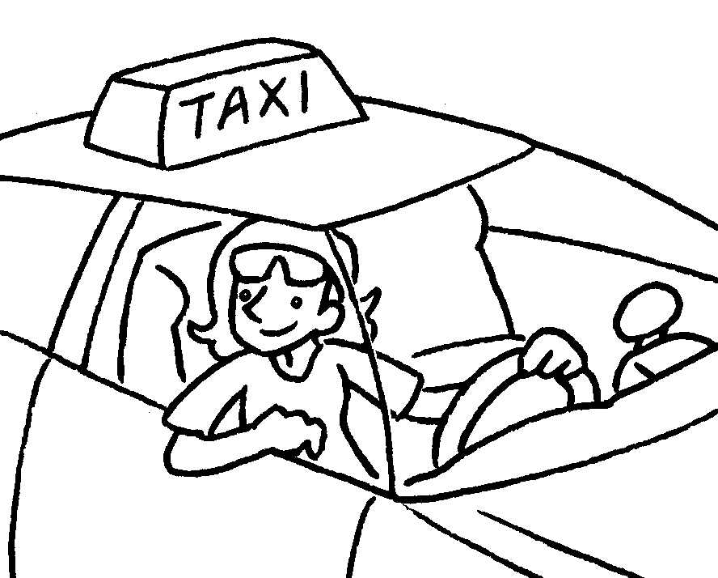
 |  | 10 | 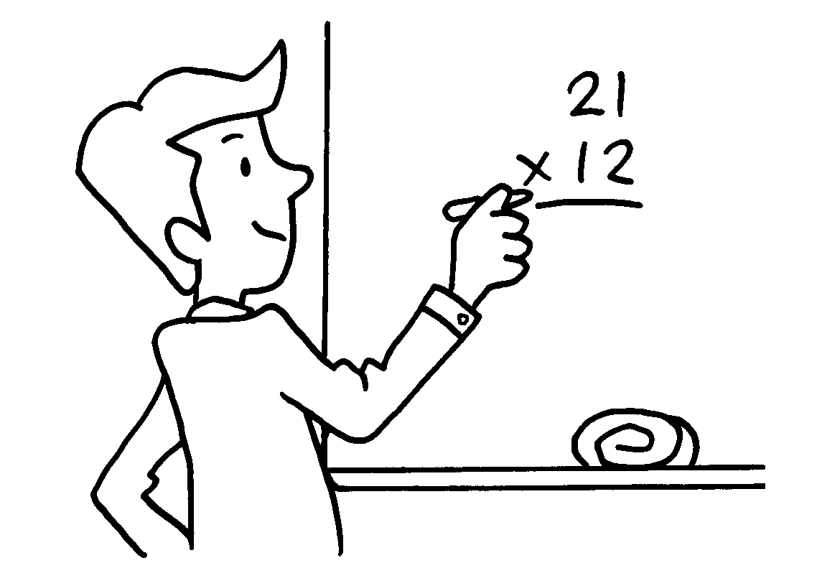 | 11 | 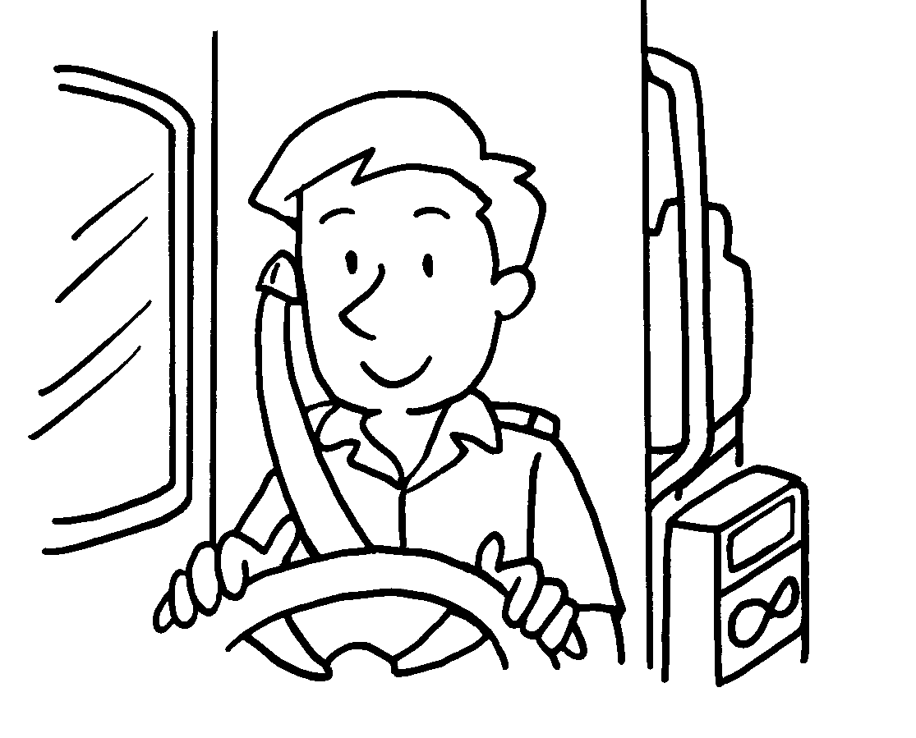 | 12 | 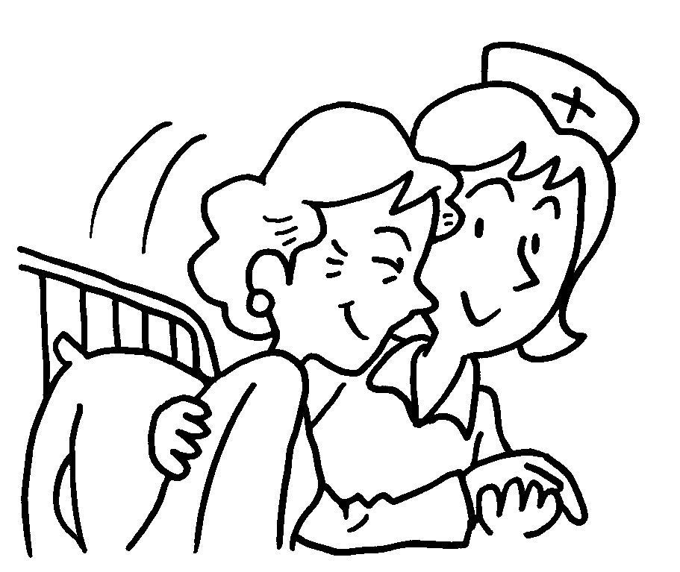

5 | a  (treiaw) |  | 6 | a  (wouseefih)
7 | a  (cordot) |  | 8 | a  (tiax) (rivder)
9 | a  (sitseraw) |  | 10 | a  (chreeat)
11 | a  (sub) (divrre) |  | 12 | a  (rusen)


Book 2A Chapter 6 Graded Worksheets
Worksheet 1⬇⬇
1 postman 2 fireman
3 policewoman 4 policeman
5 waiter 6 housewife
7 doctor 8 taxi driver
9 waitress 10 teacher
11 bus driver 12 nurse

