What are their jobs? Write.

1 | 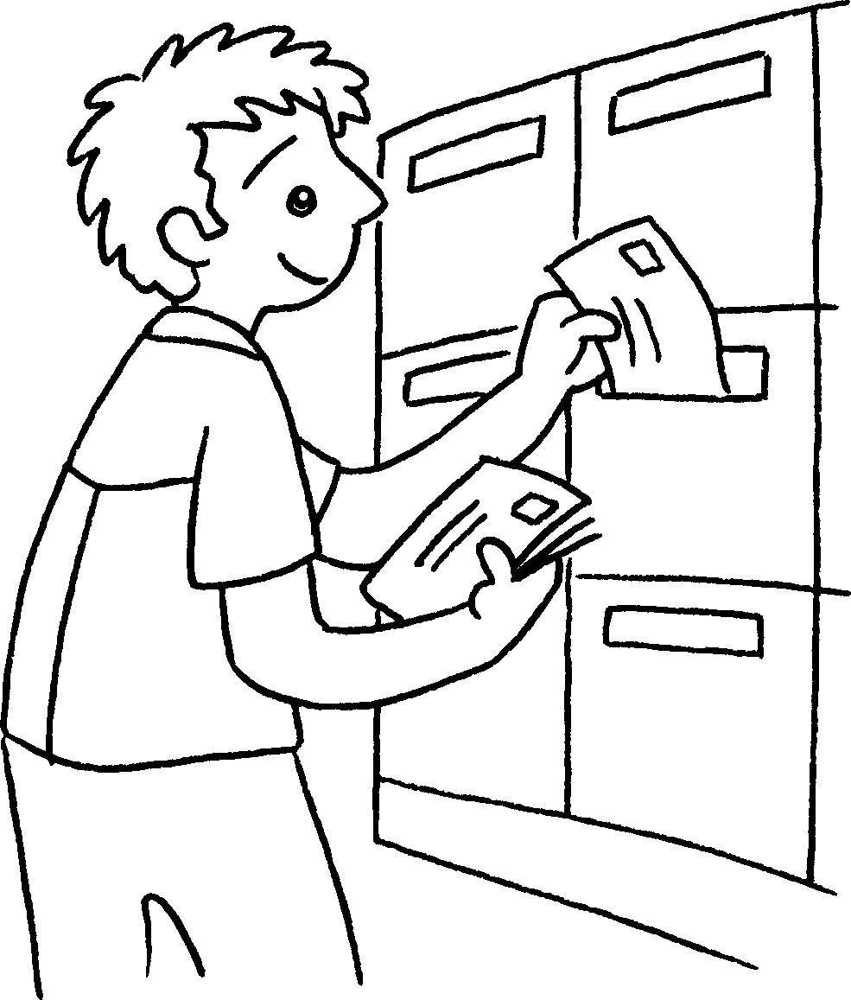 | 2 | 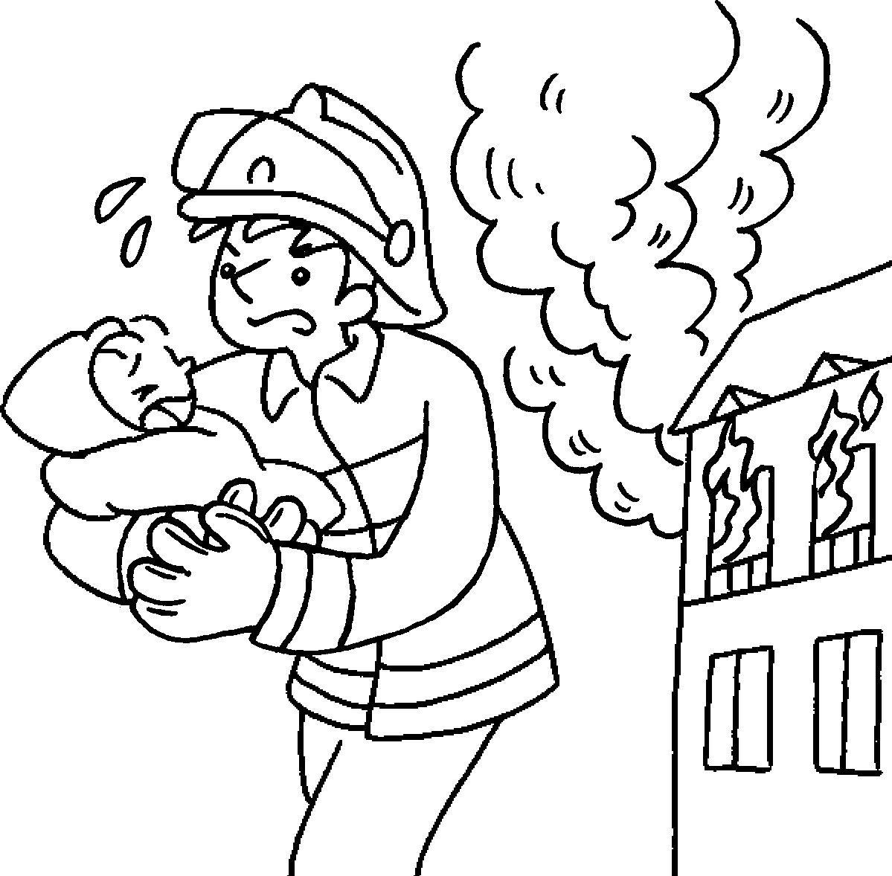 | 3 | 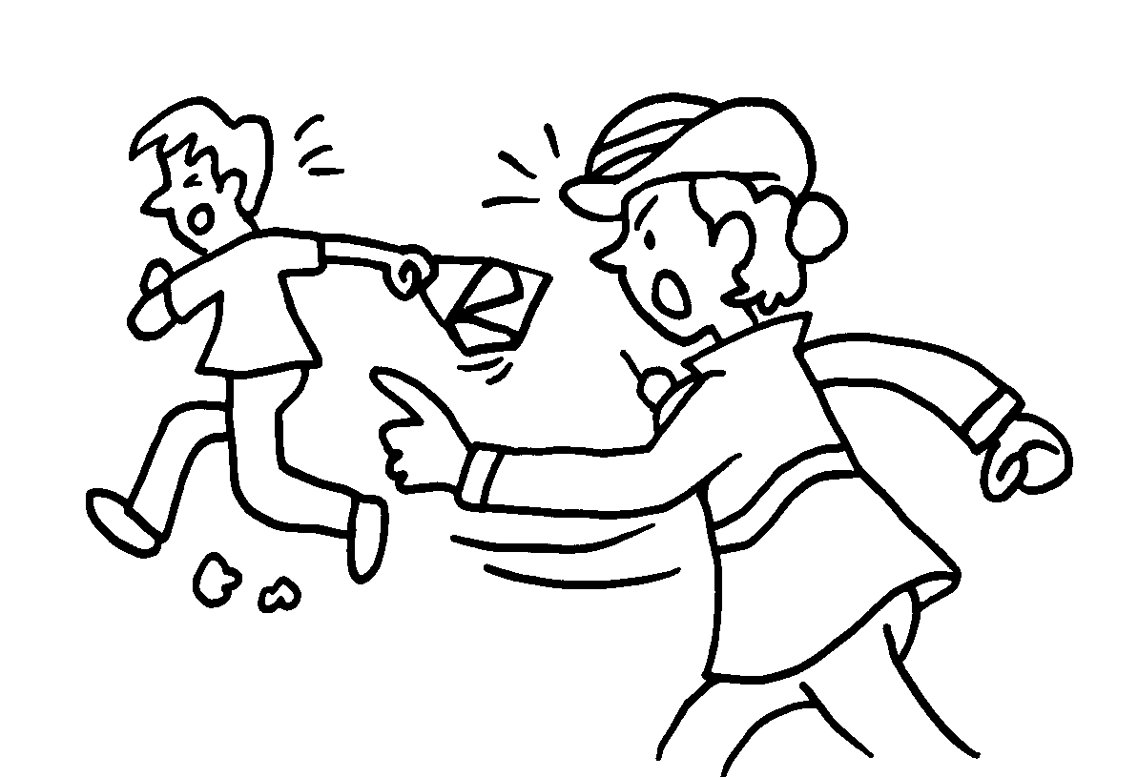 | 4 | 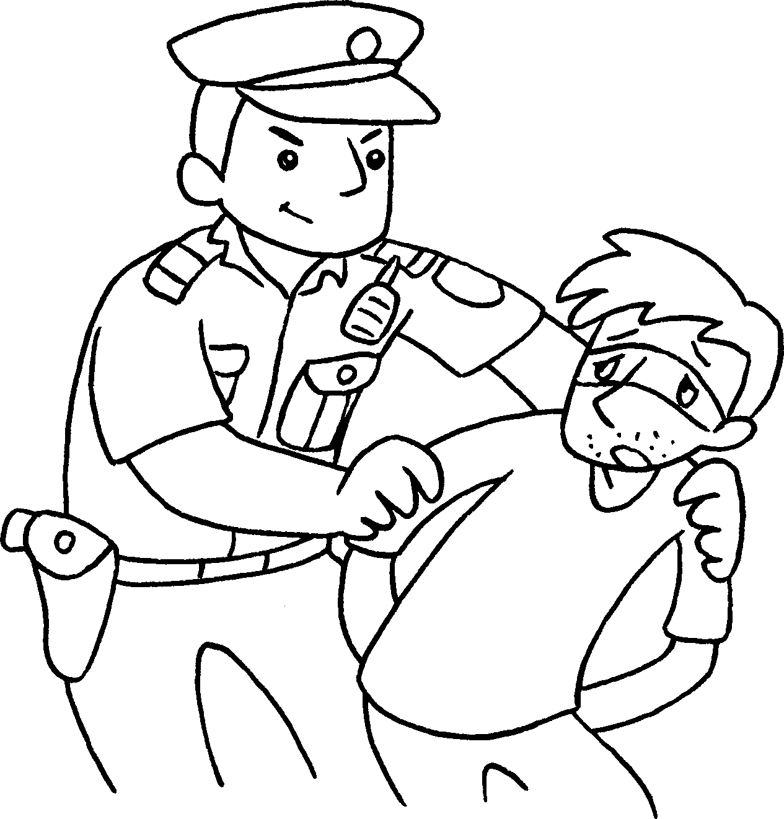

1 | a |  | 2 | a
3 |  |  | 4

9
5 |  | 6 | 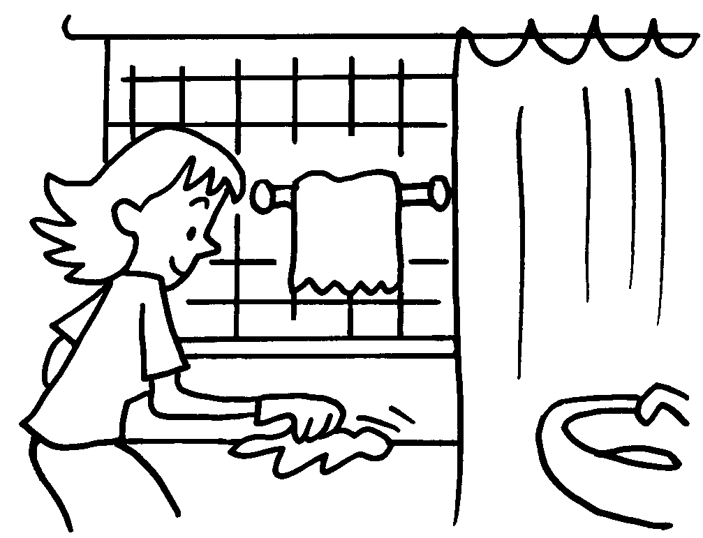 | 7 |  | 8 | 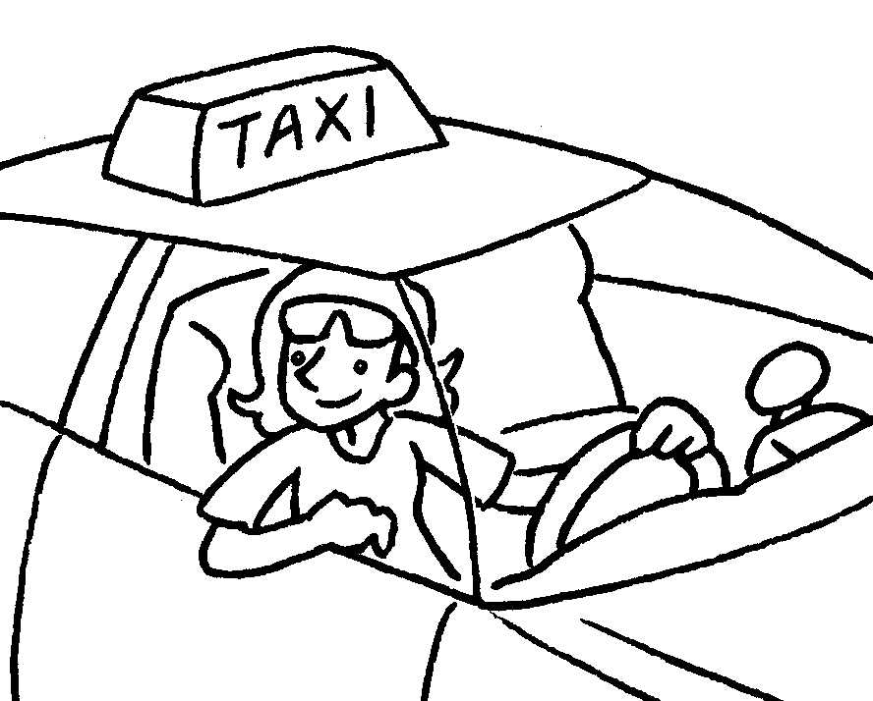
 |  | 10 | 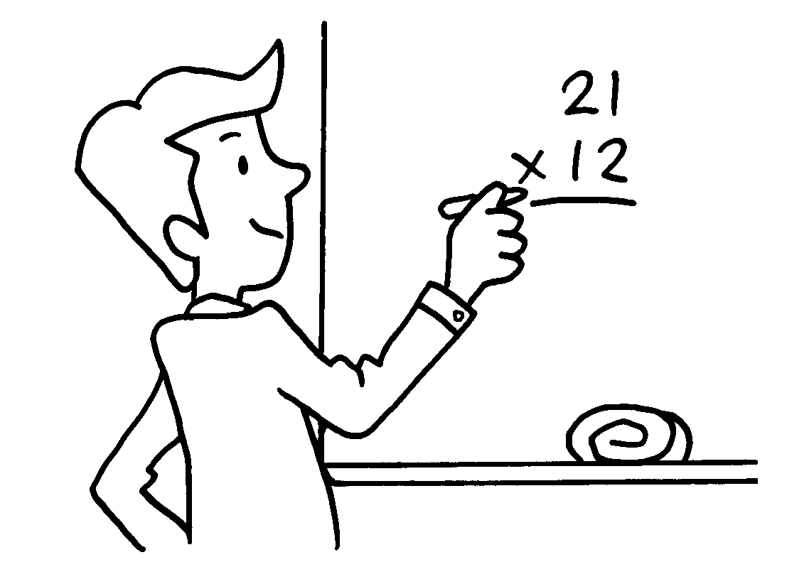 | 11 | 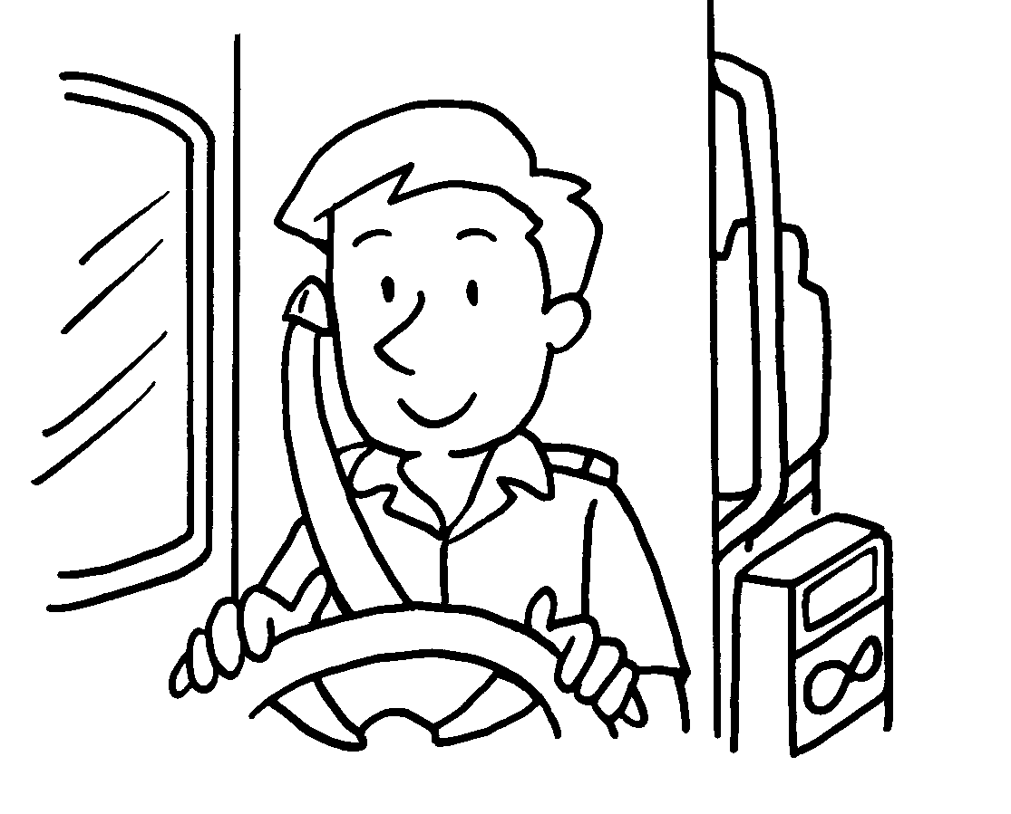 | 12 | 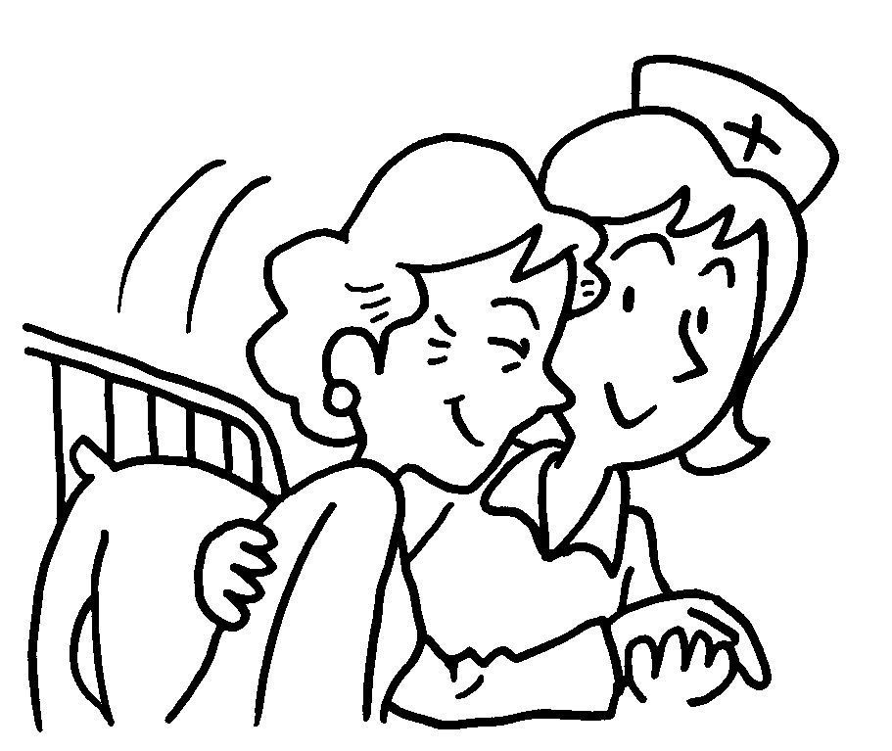

5 |  |  | 6
7 |  |  | 8
9 |  |  | 10
11 |  |  | 12


Book 2A Chapter 6 Graded Worksheets
Worksheet 1⬇⬇⬇
1 postman 2 fireman
3 a policewoman 4 a policeman
5 a waiter 6 a housewife
7 a doctor 8 a taxi driver
9 a waitress 10 a teacher
11 a bus driver 12 a nurse

