A
B
Circle the correct answers.
B
B
A

1 | 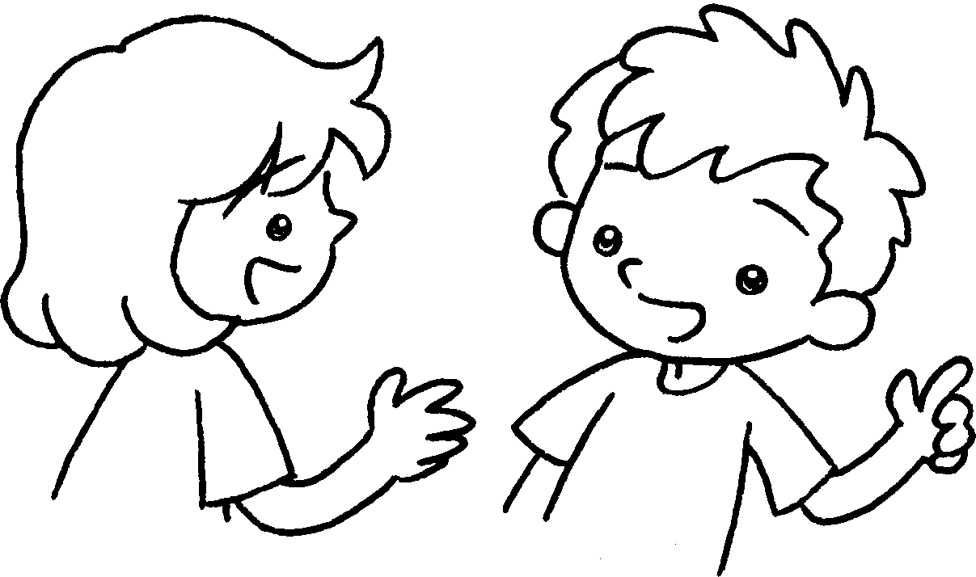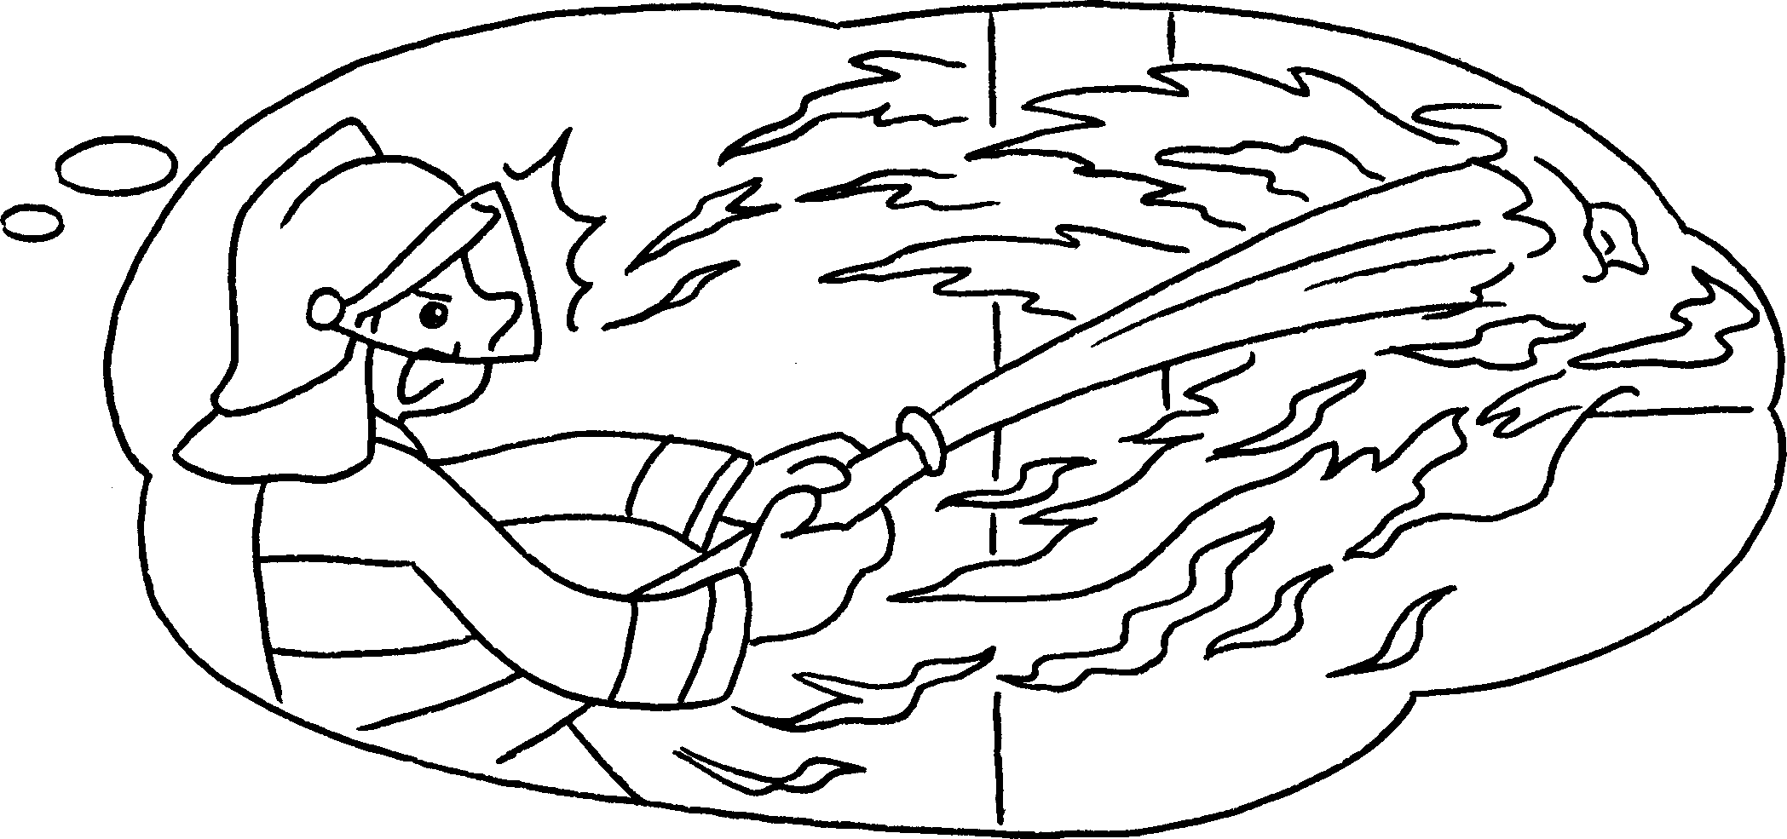
A : What is your ( fathers / father’s ) job?
B : He’s a fireman. He ( puts / put ) out fires.
2 | 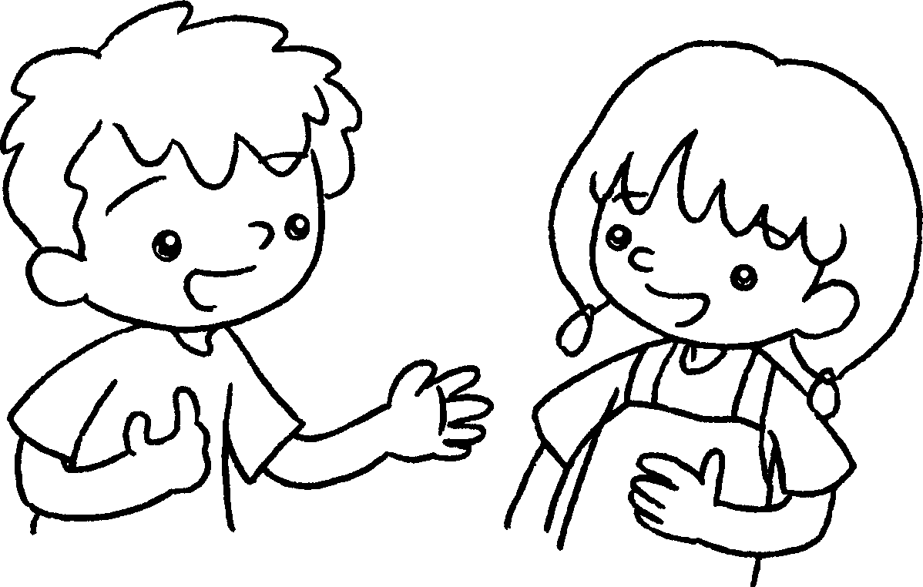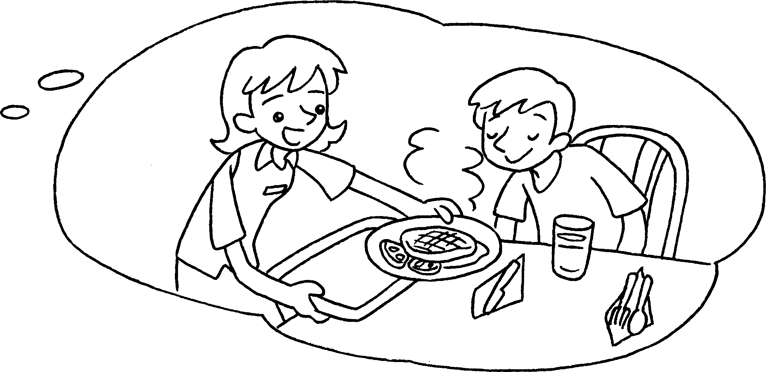
A : What is your ( mother’s / mothers ) job?
B : She’s a waitress. She ( serves / serve ) food to people.
3 | 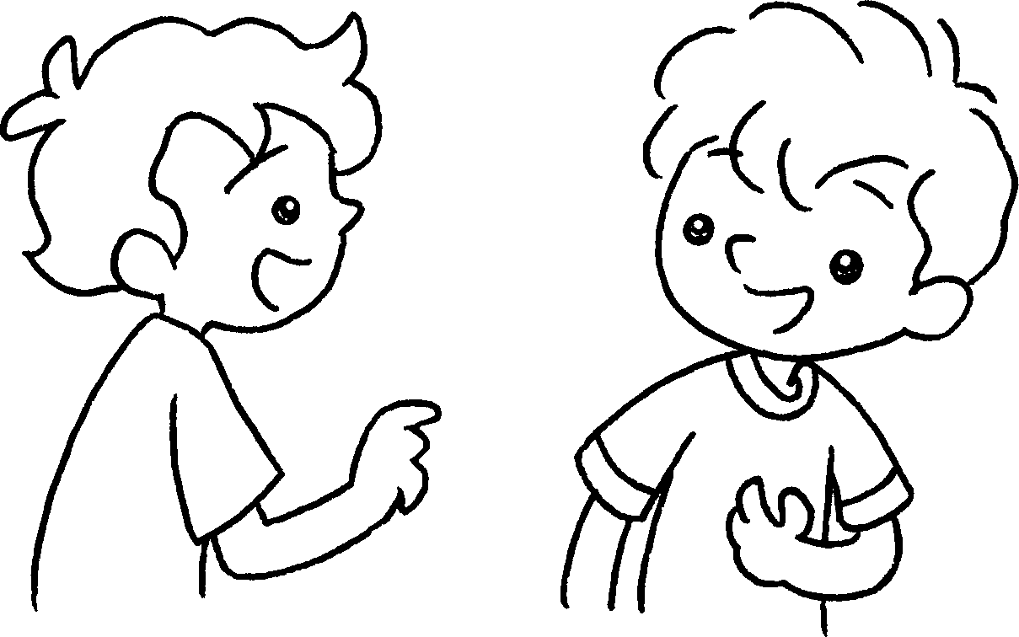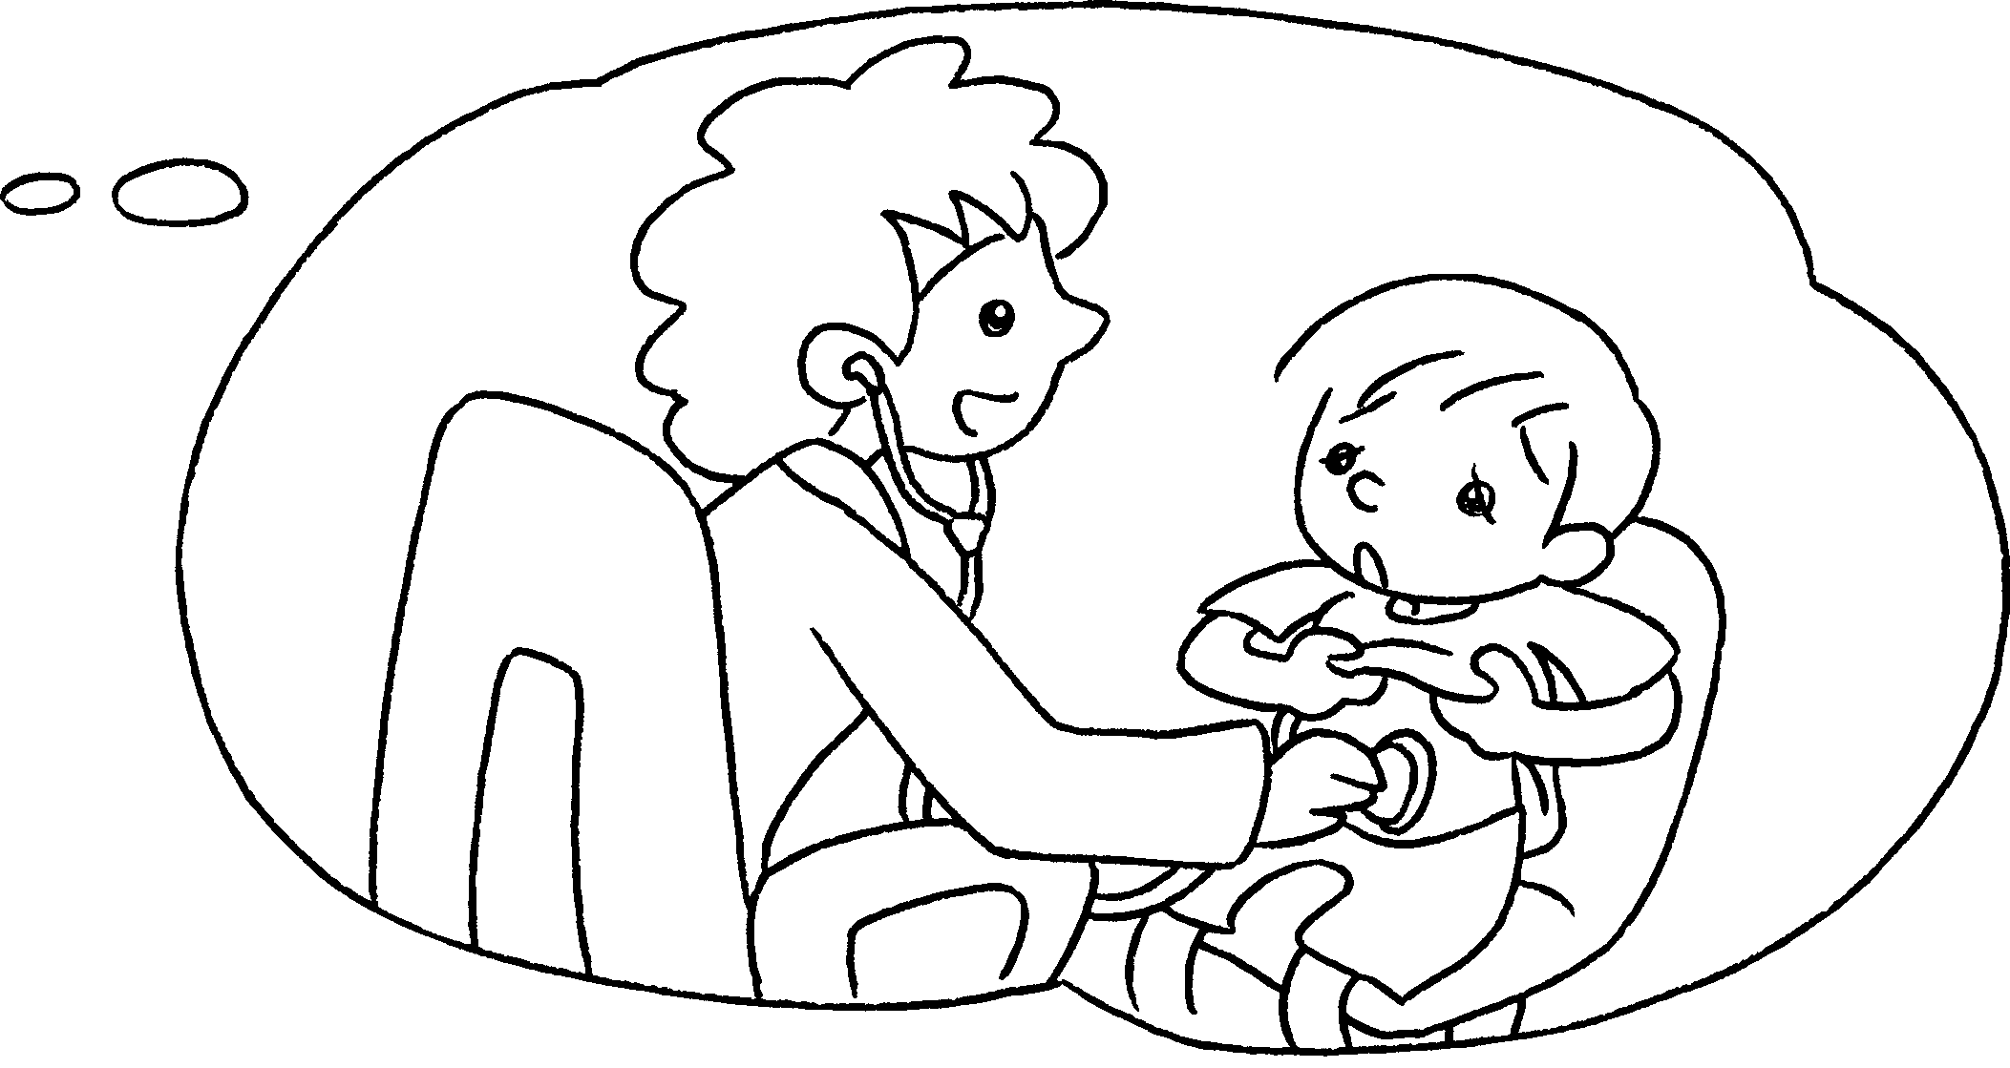  A
A : What is your ( mother’s / mothers ) job?
B : She’s a doctor. She ( help / helps ) sick people.
4 | 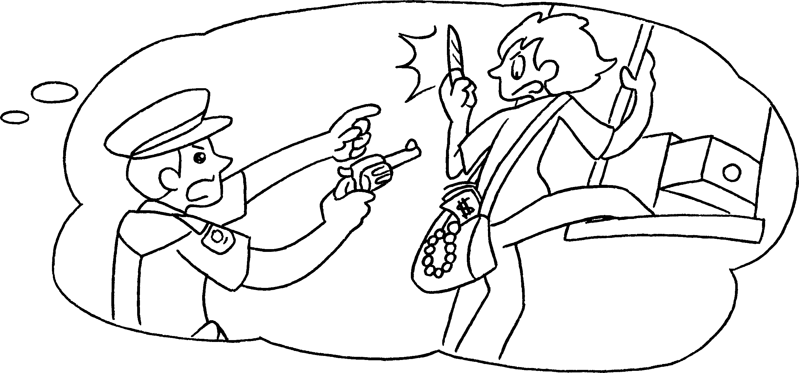  B  A
A : What is your ( father’s / fathers ) job?
B : He’s a policeman. He ( catches / catch ) bad
people.


Book 2A Chapter 6 Graded Worksheets
Worksheet 2⬇
- ( fathers / father’s )
( puts / put )
- ( mother’s / mothers )
( serves / serve )
- ( mother’s / mothers )
( help / helps )
- ( father’s / fathers )
( catches / catch )

