Circle and write.
A
B
A
A
1 | 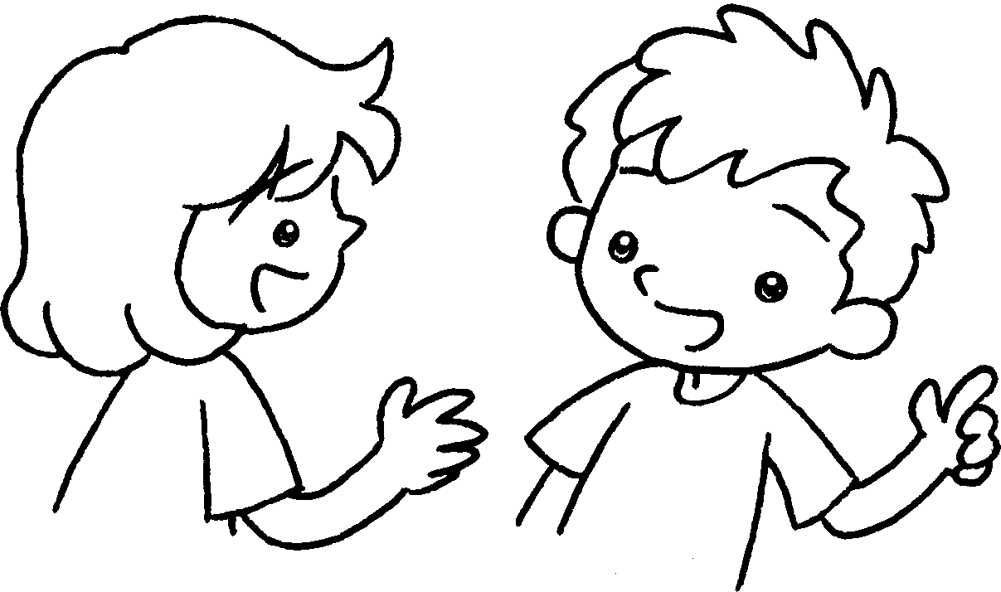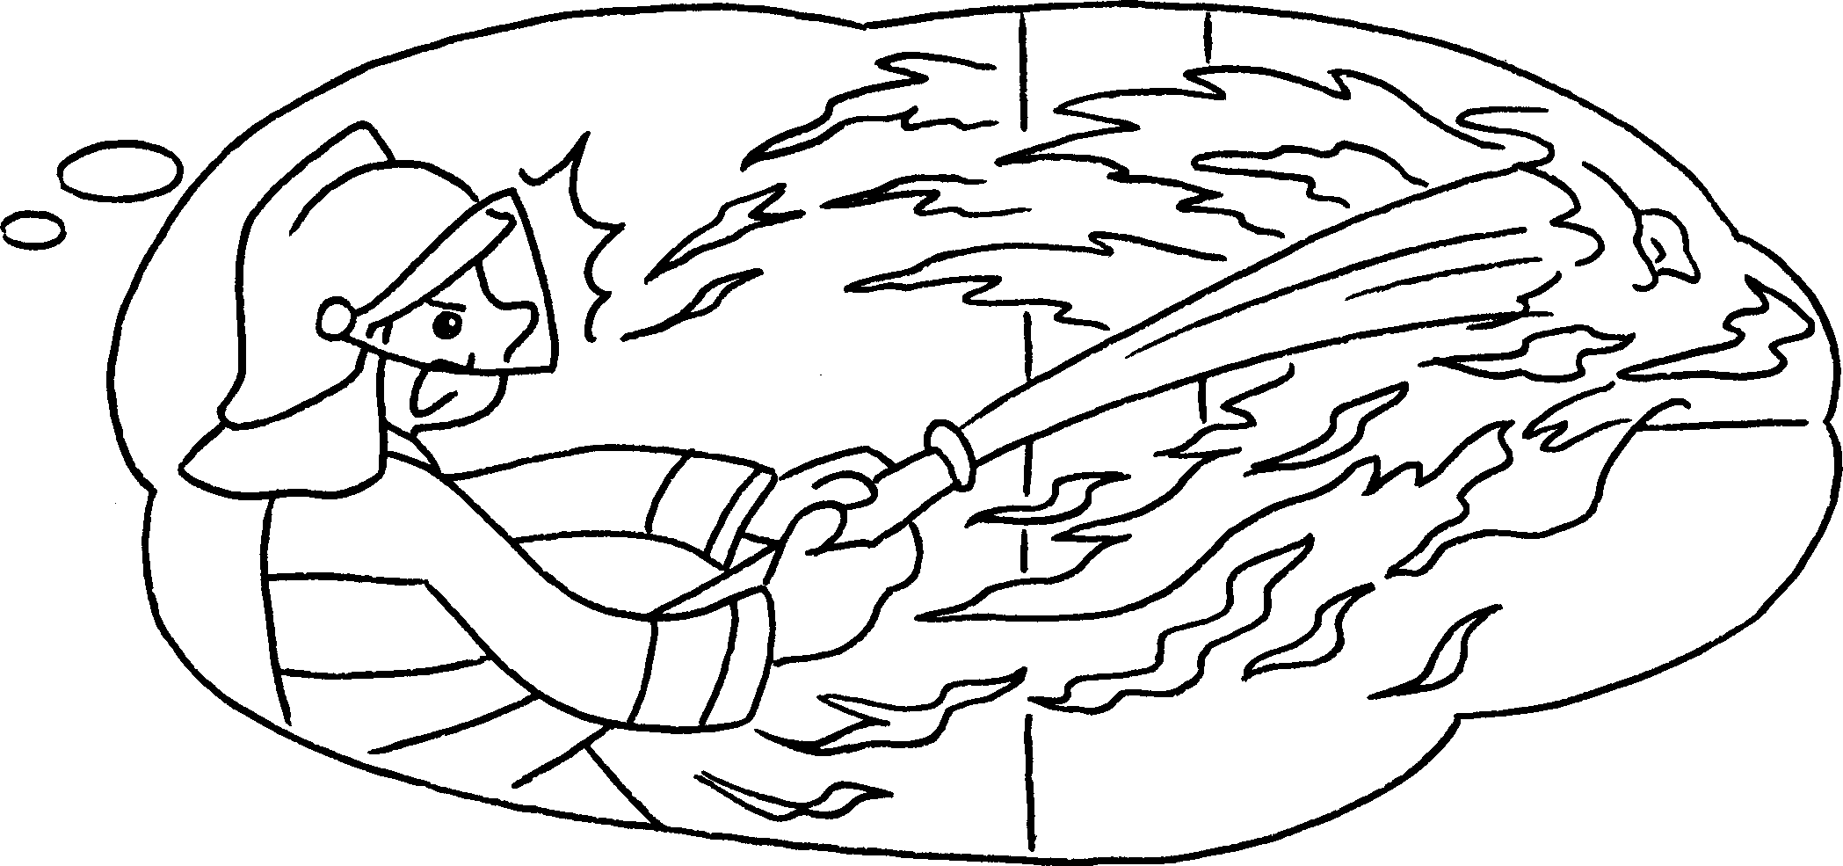  B  B
A : What is your ( fathers / father’s ) job?
A
B : He’s a fireman. He ________________ ( put ) out fires.
2 | 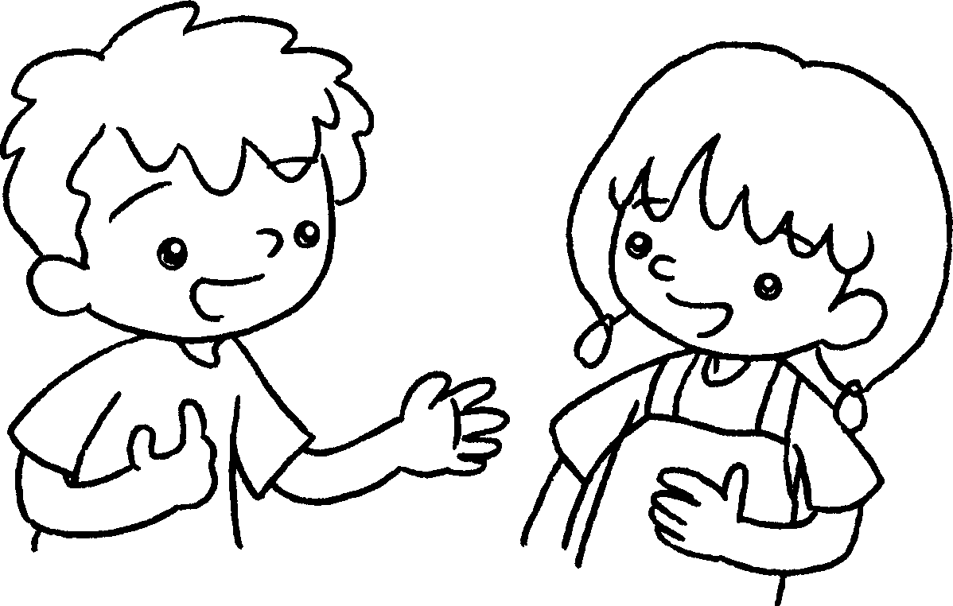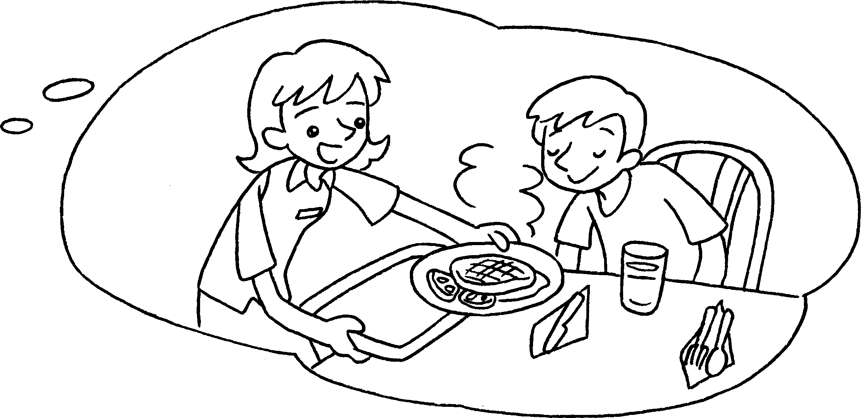  A  B
A : What is your ( mother’s / mothers ) job?
B : She’s a waitress. She ________________ ( serve ) food to people.
3 | 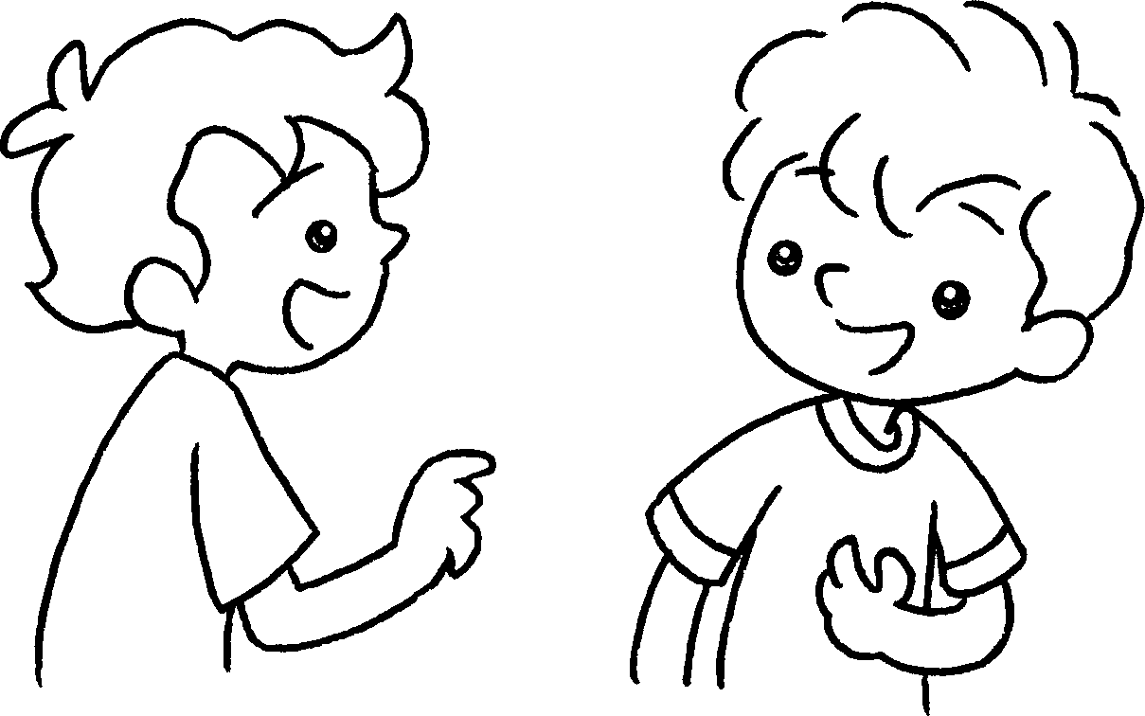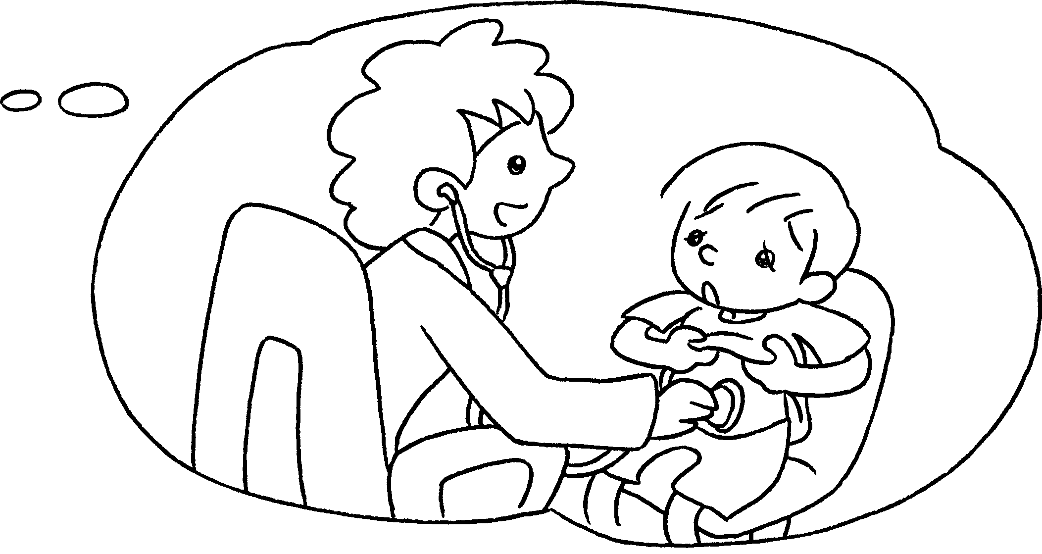  B
A : What is your ( mother’s / mothers ) job?
B : She’s a doctor. She ________________ ( help )
sick people.
4 | 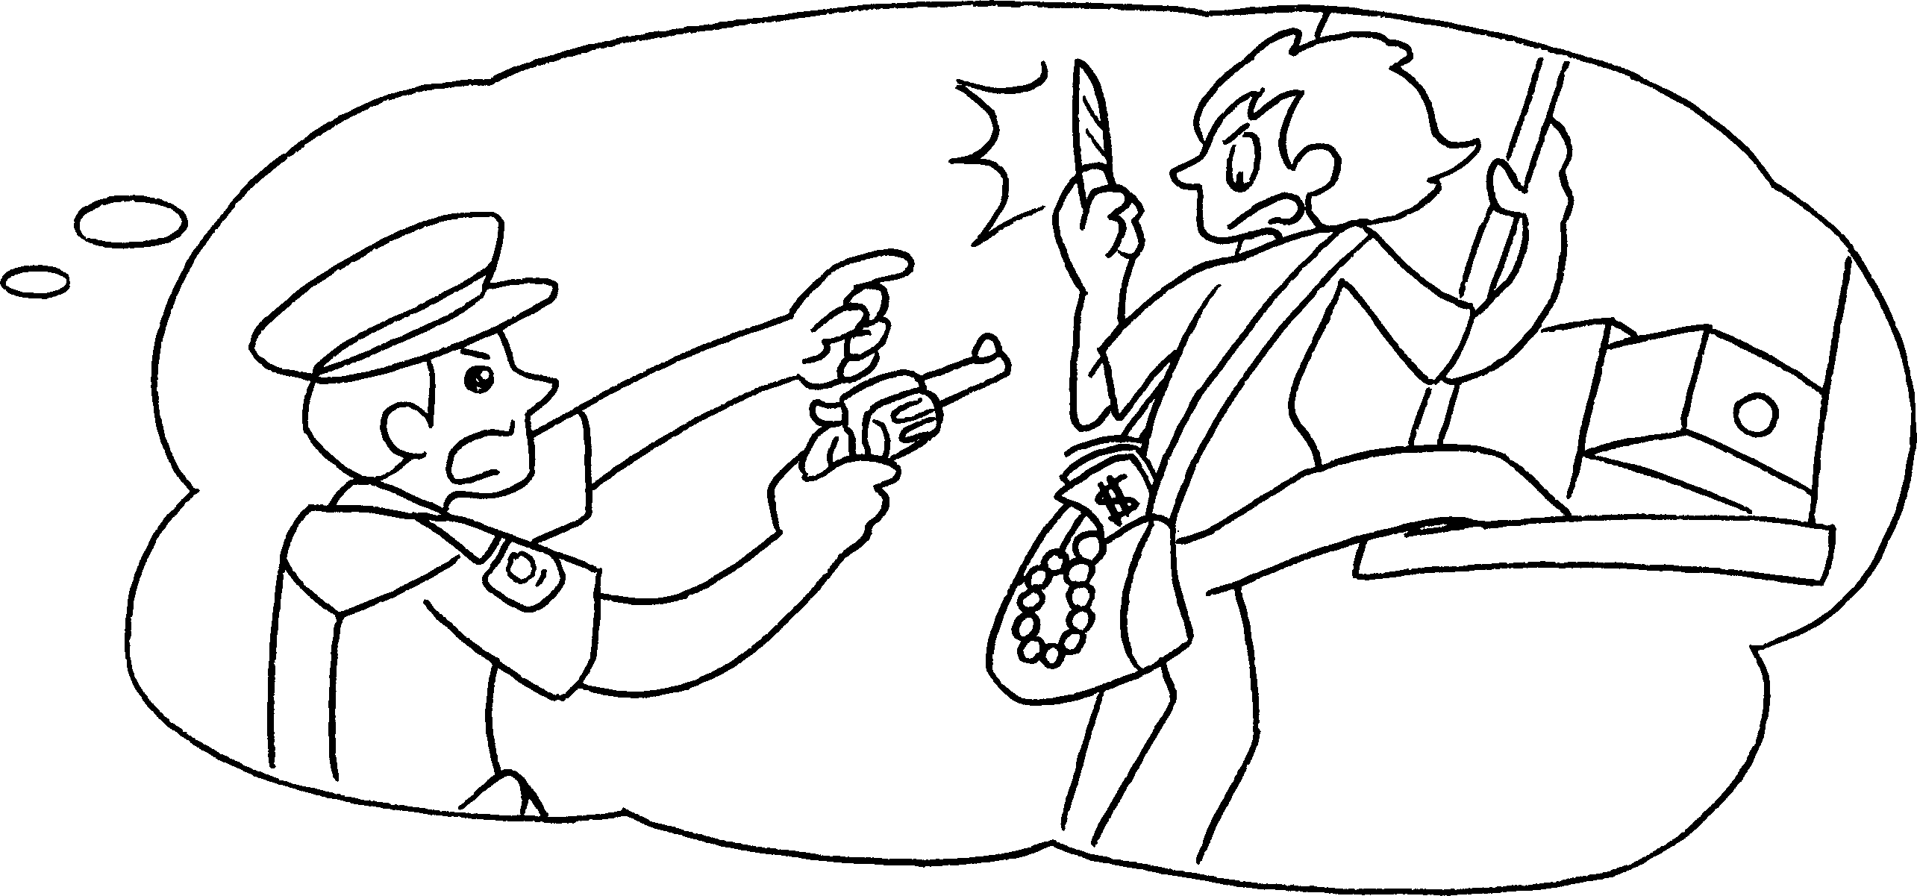
A : What is your ( father’s / fathers ) job?
B : He’s a policeman. He ________________ ( catch )
bad people.


Book 2A Chapter 6 Graded Worksheets

Worksheet 2⬇⬇
- ( fathers / father’s )
puts
- ( mother’s / mothers )
serves
- ( mother’s / mothers )
helps
- ( father’s / fathers )
catches

