A
B
Circle and write.
B

serve catch help put
A

1 | 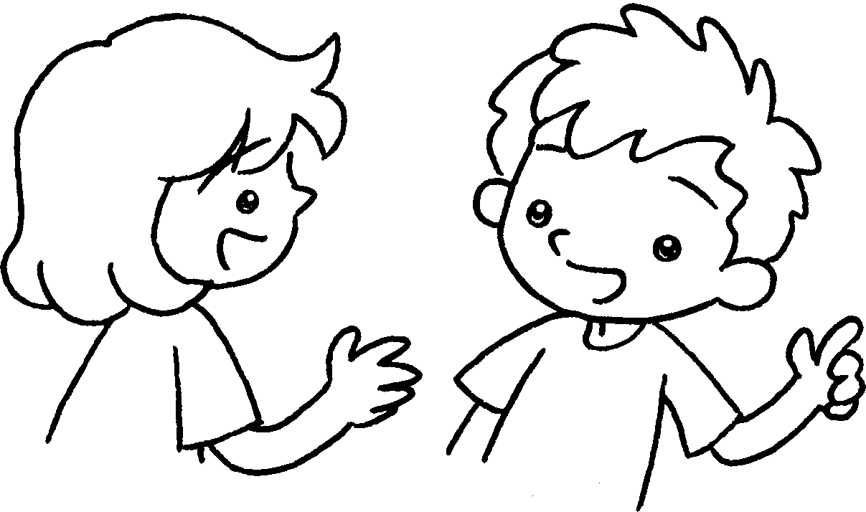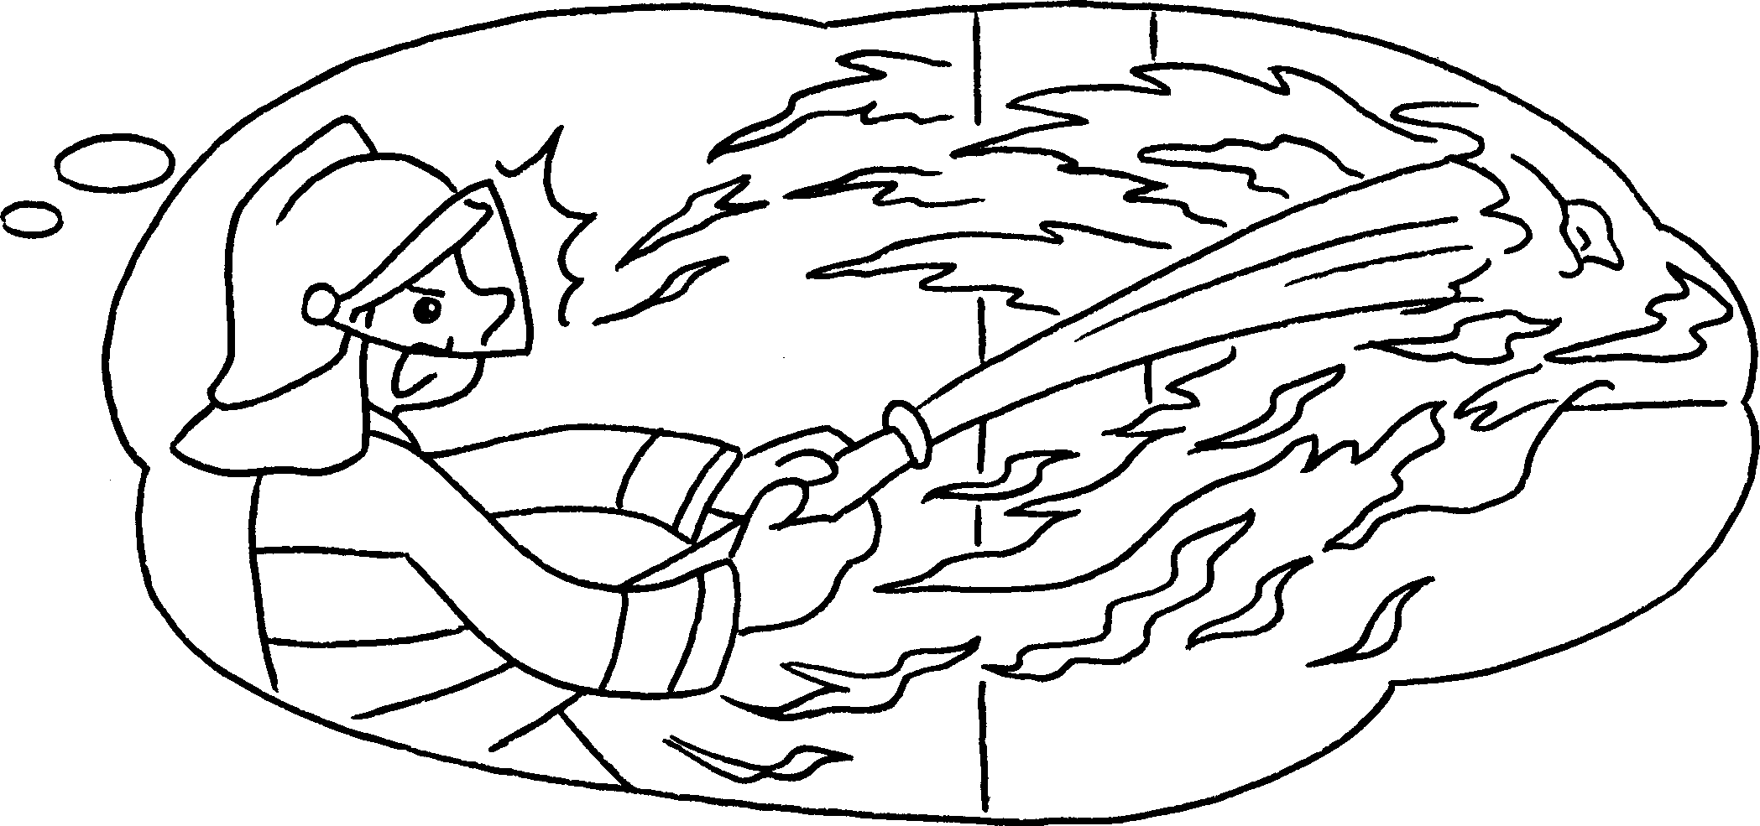
A : What is your ( fathers / father’s / father ) job?
A
B : He’s a fireman. He _____________ out fires.
2 | 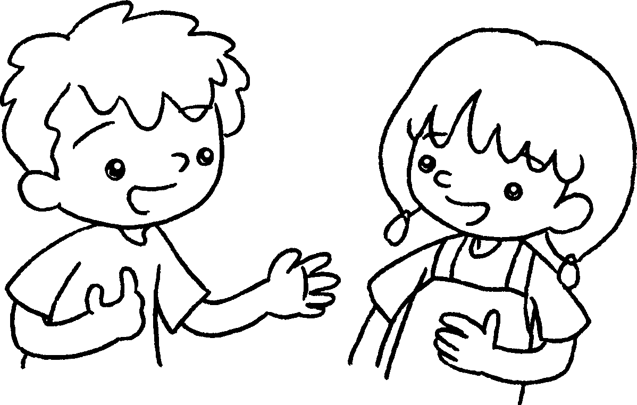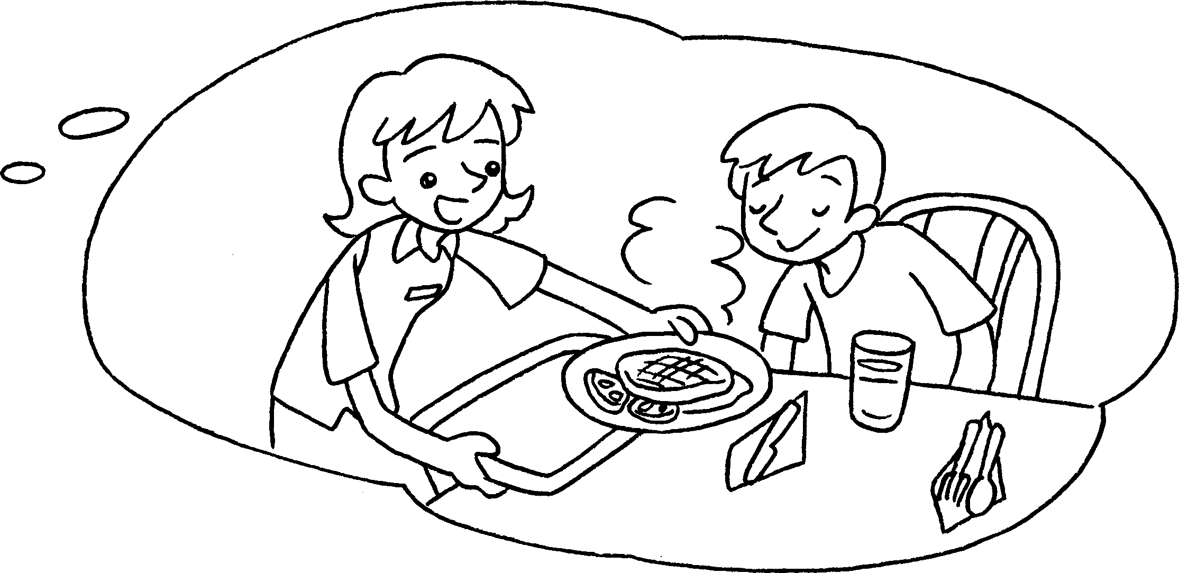  B  B  A
A : What is your ( mother / mother’s / mothers ) job?
B : She’s a ______________ . She ____________ food to people.
3 | 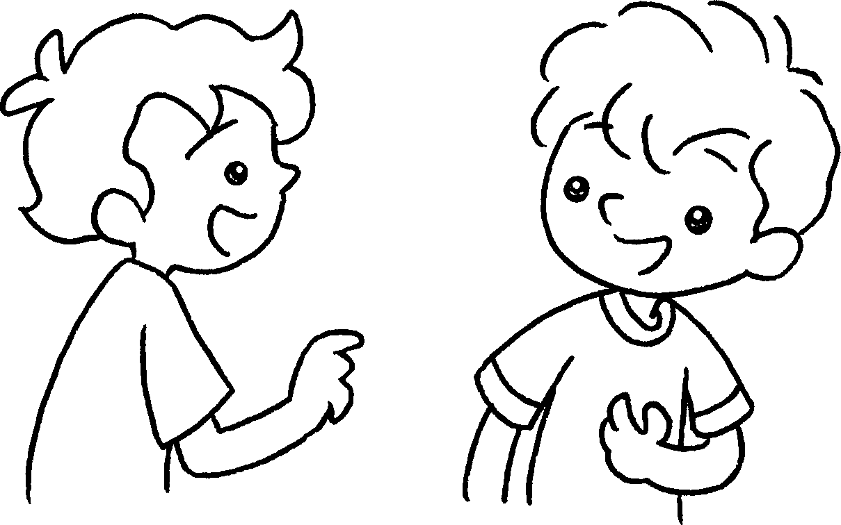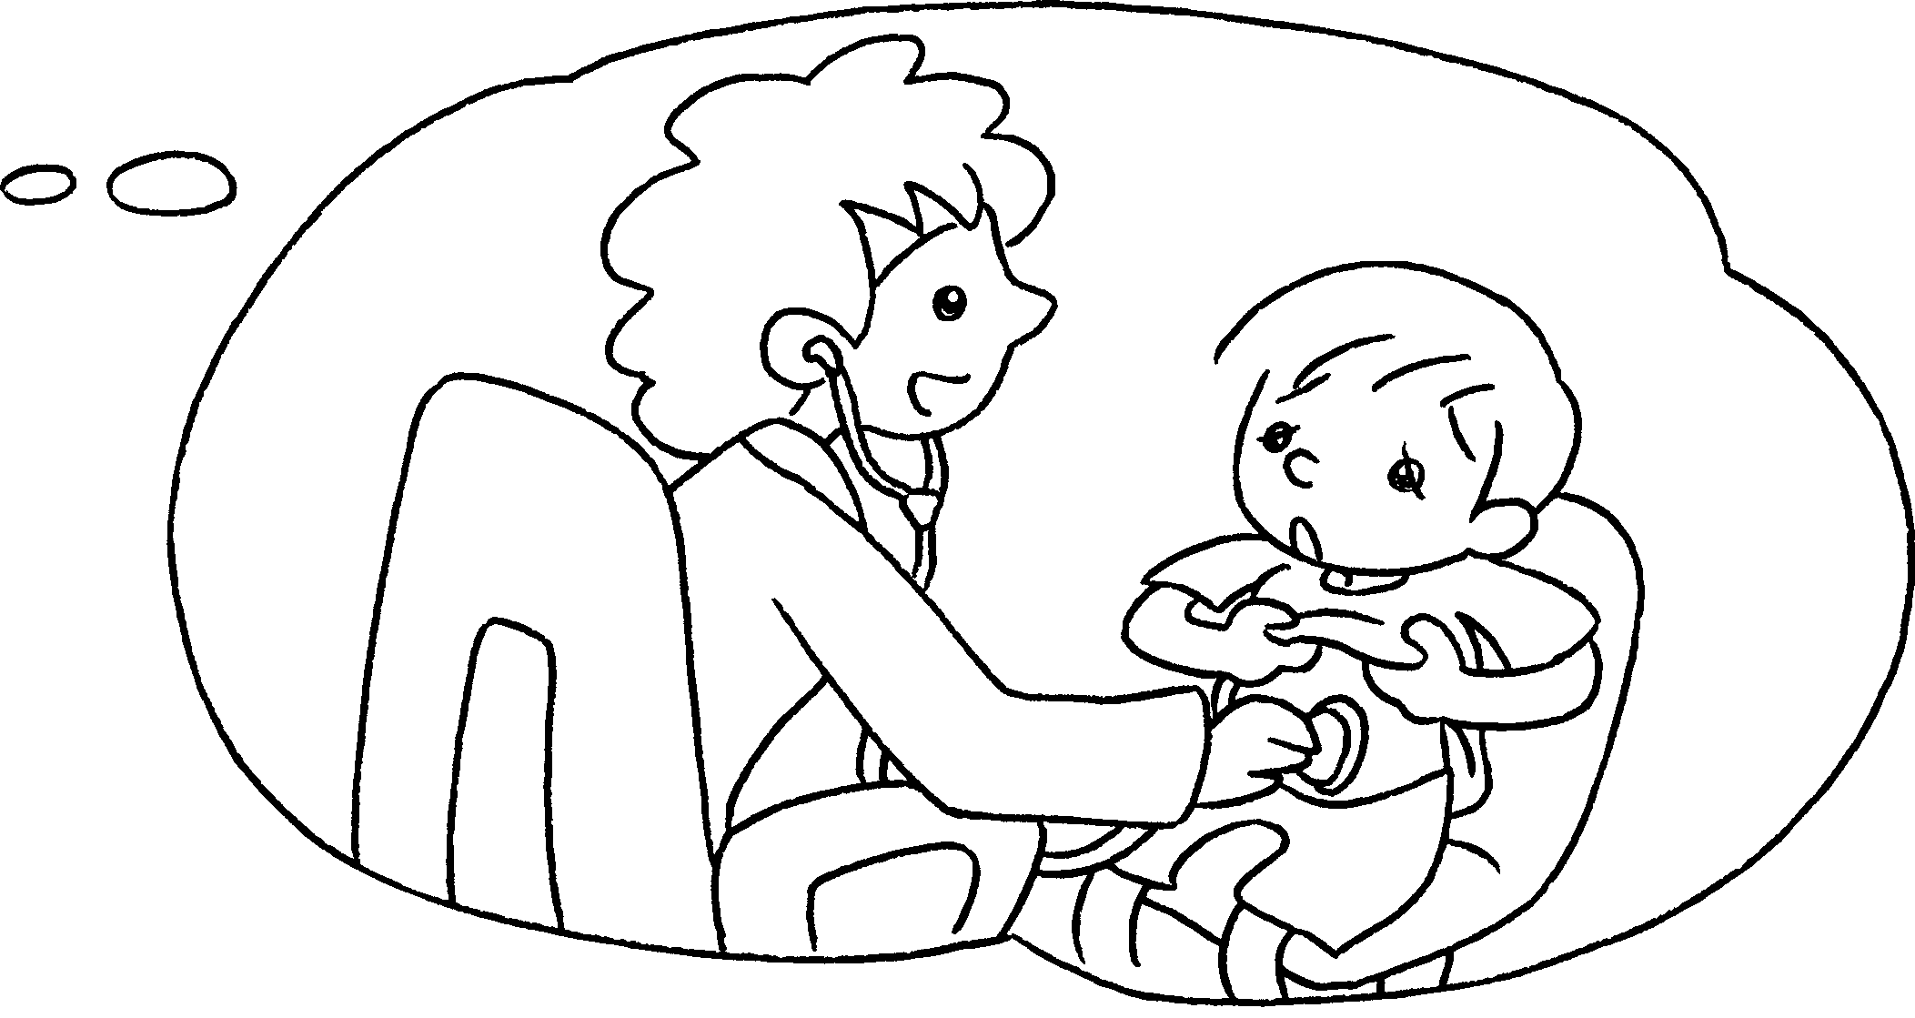  B
A : What is your ( mother’s / mother / mothers ) job?
A
B : She’s __________________ . She ________________
sick people.
4 | 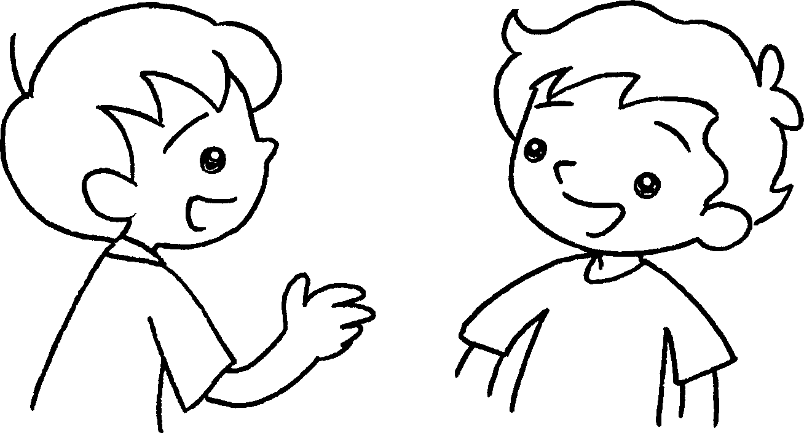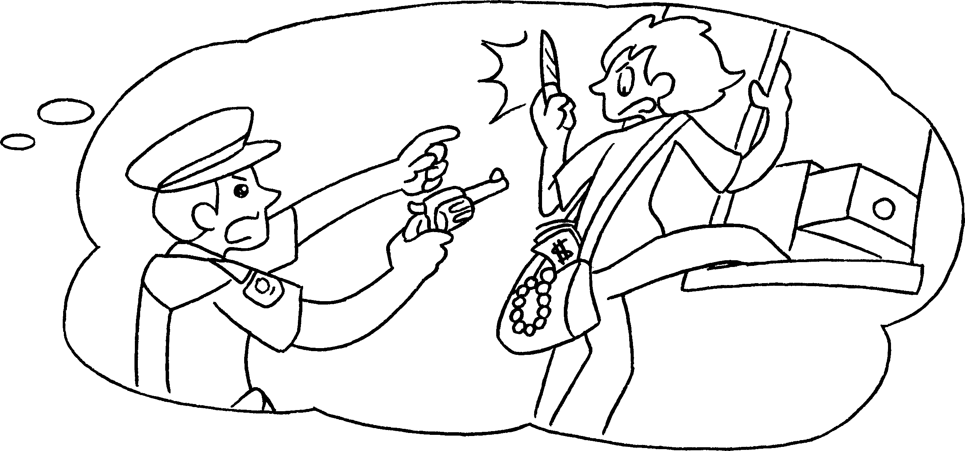
A : What is your ( father’s / fathers / father ) job?
B : He’s _____________________ . He ________________ bad people.


Book 2A Chapter 6 Graded Worksheets
Worksheet 2⬇⬇⬇
- ( fathers / father’s / father )
puts
- ( mother / mother’s / mothers )
waitress serves
- ( mother’s / mother / mothers )
a doctor helps
- ( father’s / fathers / father )
a policeman catches

