Circle the correct answers.

 | Do you have any brothers or sisters?
…
1 |  |  | ( Yes / No ), I have one brother.
2 |   …  …  … | … | ( Yes / No ), I have no brothers ( and / or ) sisters.
3 | 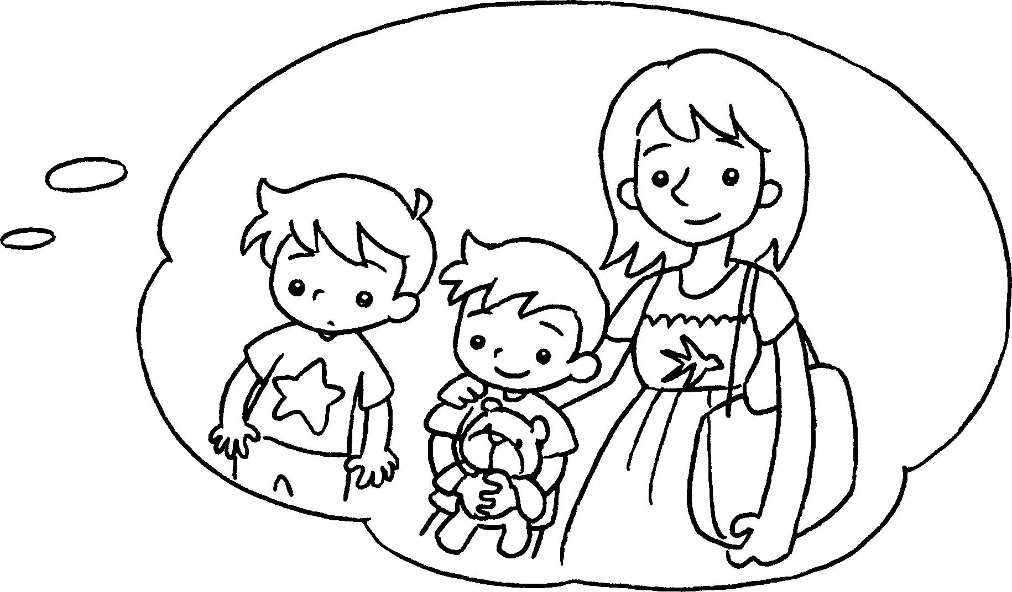 |  | ( Yes / No ), I have two brothers ( and / or ) one sister.
4 |  |  | ( Yes / No ), I have one brother ( and / or ) three sisters.
5 | 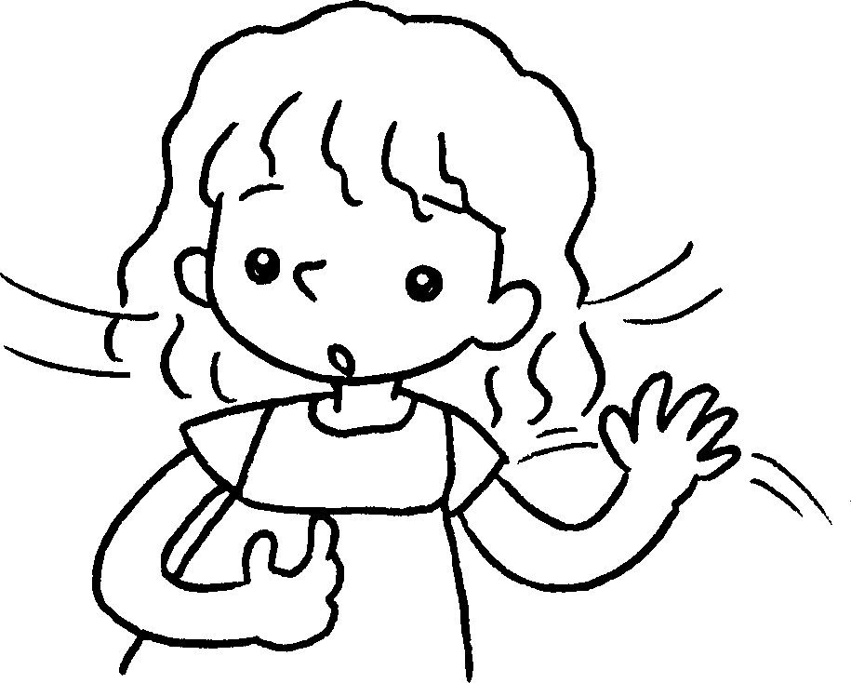 |  | ( Yes / No ), I have no brothers ( and / or ) sisters.



Book 2A Chapter 6 Graded Worksheets
Worksheet 3⬇
- ( Yes / No )
- ( Yes / No )
( and / or )
- ( Yes / No )
( and / or )
- ( Yes / No )
( and / or )
- ( Yes / No )
( and / or )

