Finish the answers.

and or

 |  |  | Do you have any brothers or sisters?
1 |  |   … |  |  | Yes, I have one ______________ .
2 |  |   …  … |  |  | _________ , I have no brothers  _________ sisters.
3 |  | 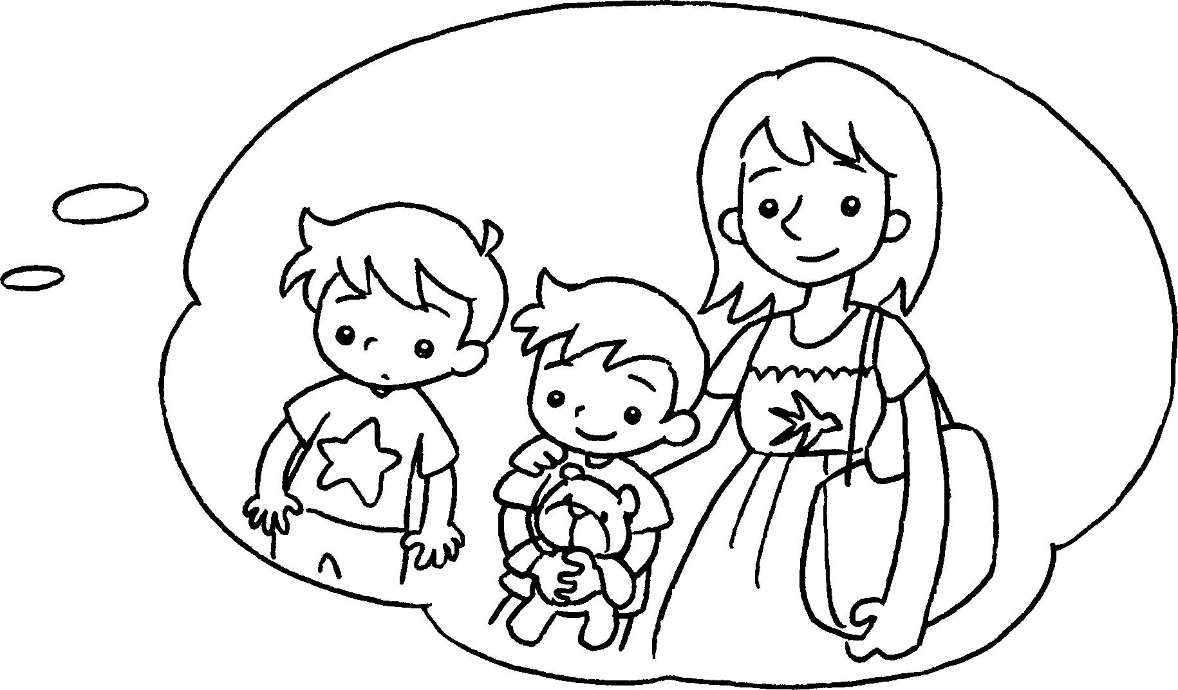  … |  |  | __________ , I have two brothers  __________ one sister.
4 |  | 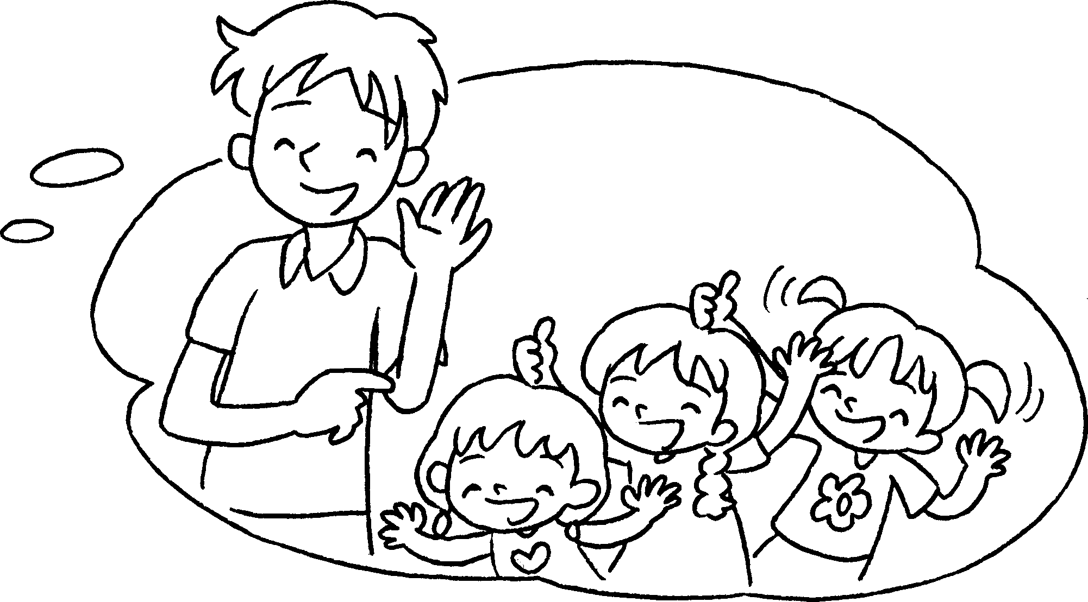 |  |  | ___________ , I have ___________  ________________________ three sisters.
5 |  | 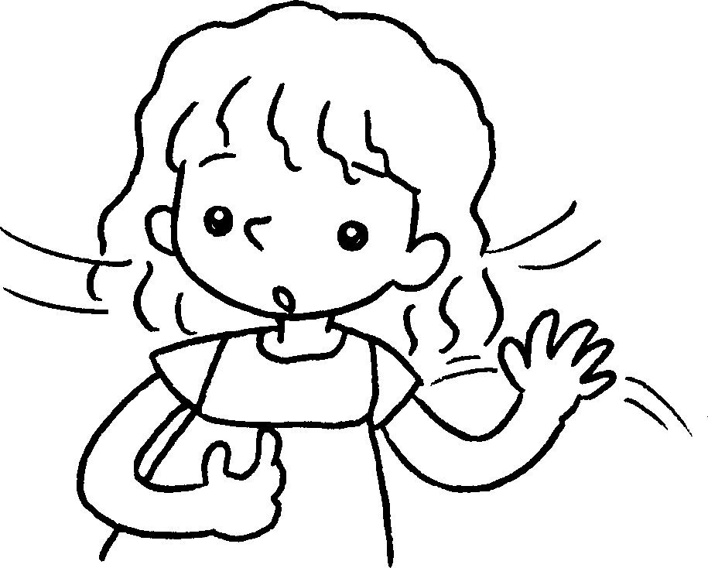 |  | … | ___________ , I have no brothers  _____________________________ .



Book 2A Chapter 6 Graded Worksheets
Worksheet 3⬇⬇
- brother
2 No or
3 Yes and
4 Yes one brother and
5 No or sisters

