Finish the answers.
…

 | Do you have any brothers or sisters?

1 |  |  | Yes, I have one _____________ .
2 |   …  … |  | __________ , I have no brothers  __________ sisters.
3 | 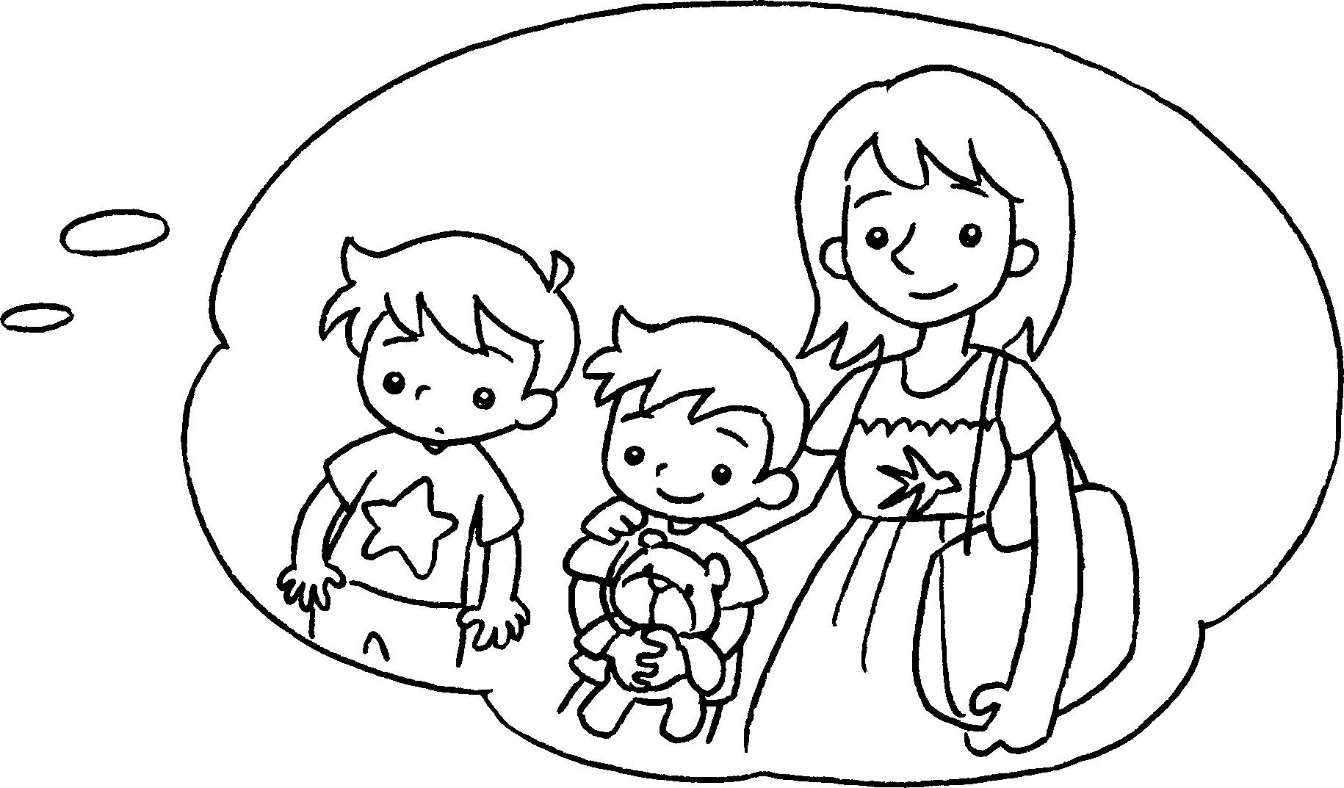 |  | __________ , I have two brothers  ______________________________ .
4 | 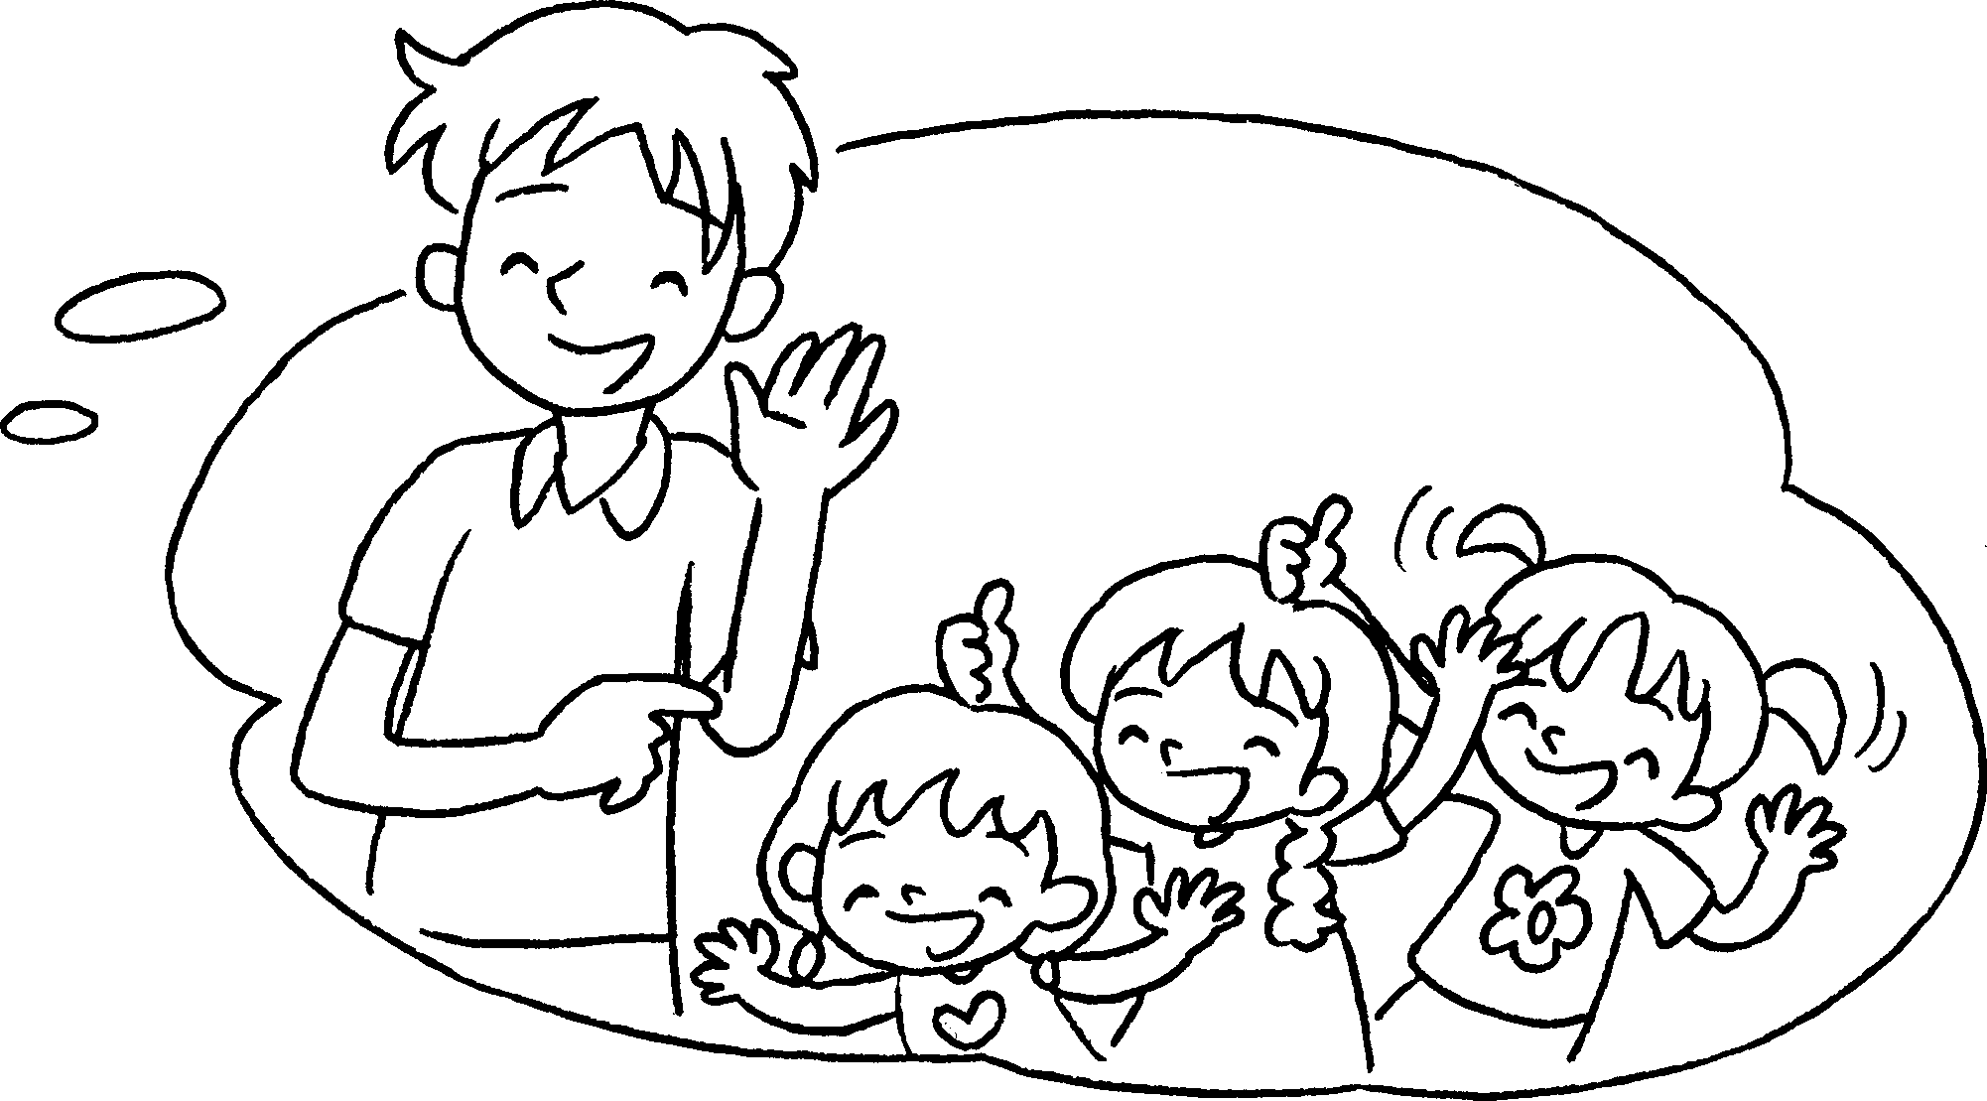 |  | __________ , I have one _______  _____________________________ .
5 | 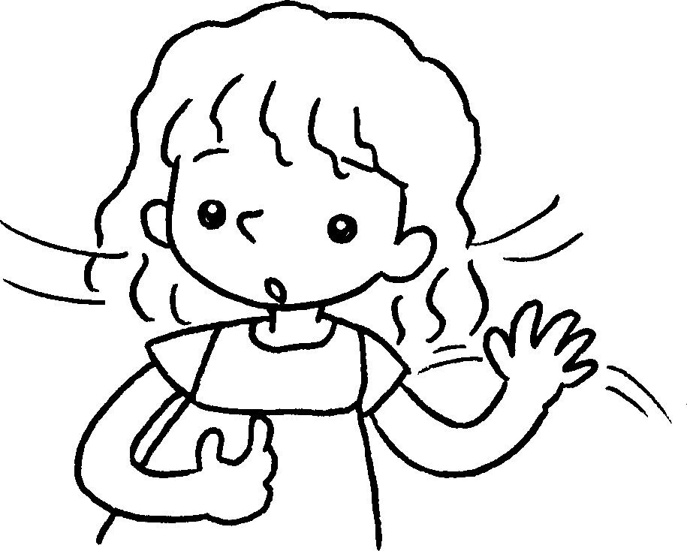  …  … |  | ______________________________  ______________________________



Book 2A Chapter 6 Graded Worksheets
Worksheet 3⬇⬇⬇
- brother
- No or
- Yes and one sister
- Yes brother and three sisters
- No, I have no brothers or sisters.

