Choose and write.

clear | feed |  | fold |  | hang up |  | make
set |  | sweep |  | walk |  | water

1 | 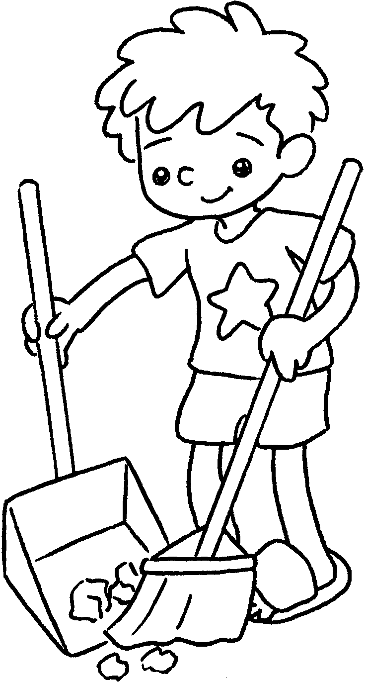 |  | 2 |  | 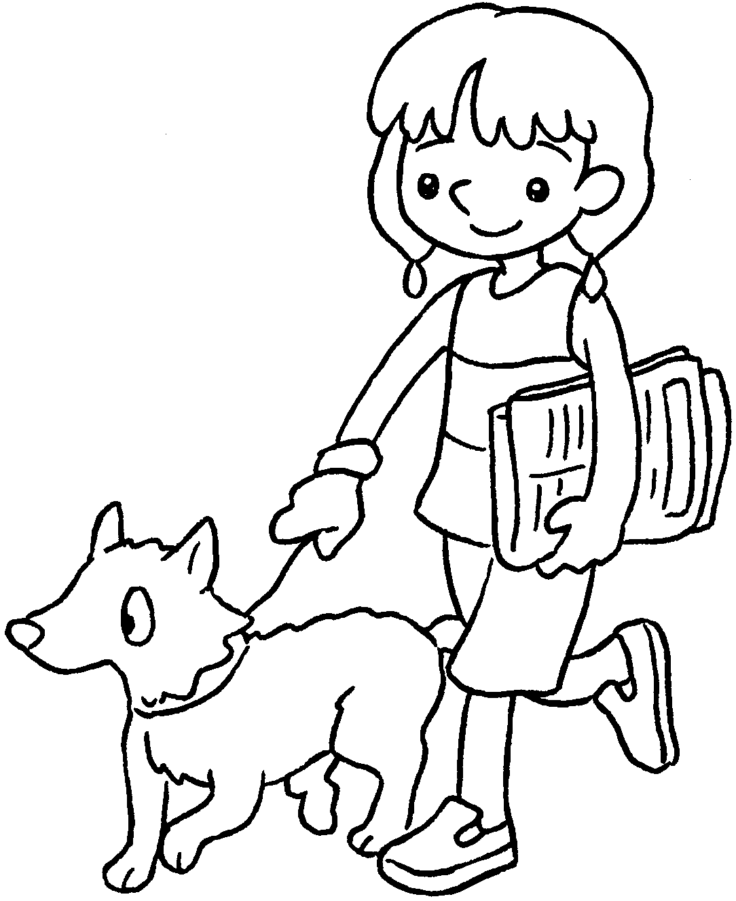 |  | 3 |  | 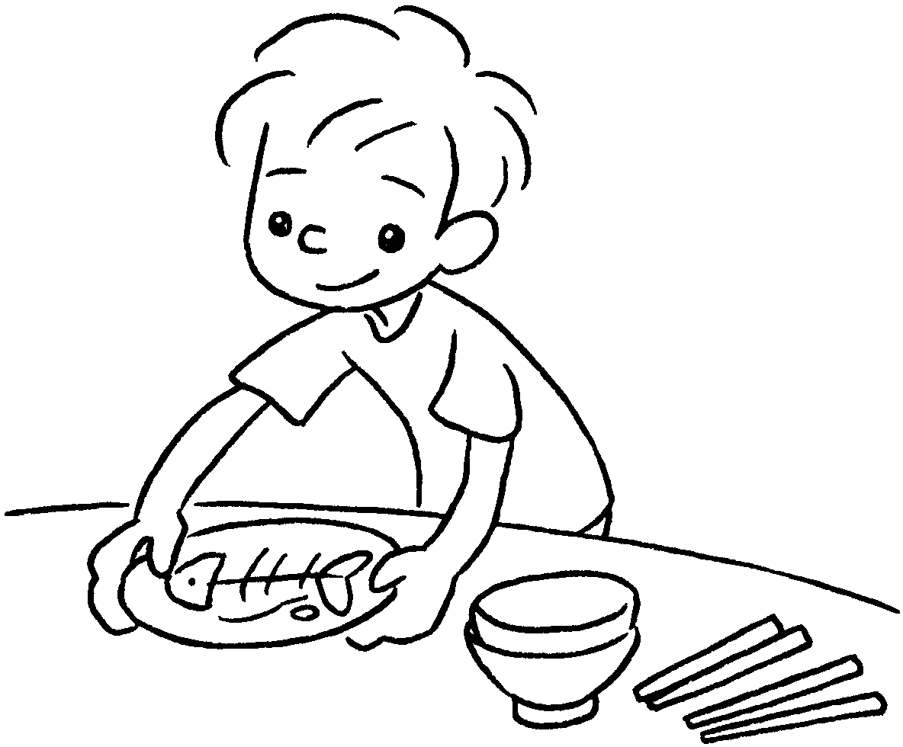
 | the floor |  |  |  | the dog |  |  |  | the table
4 | 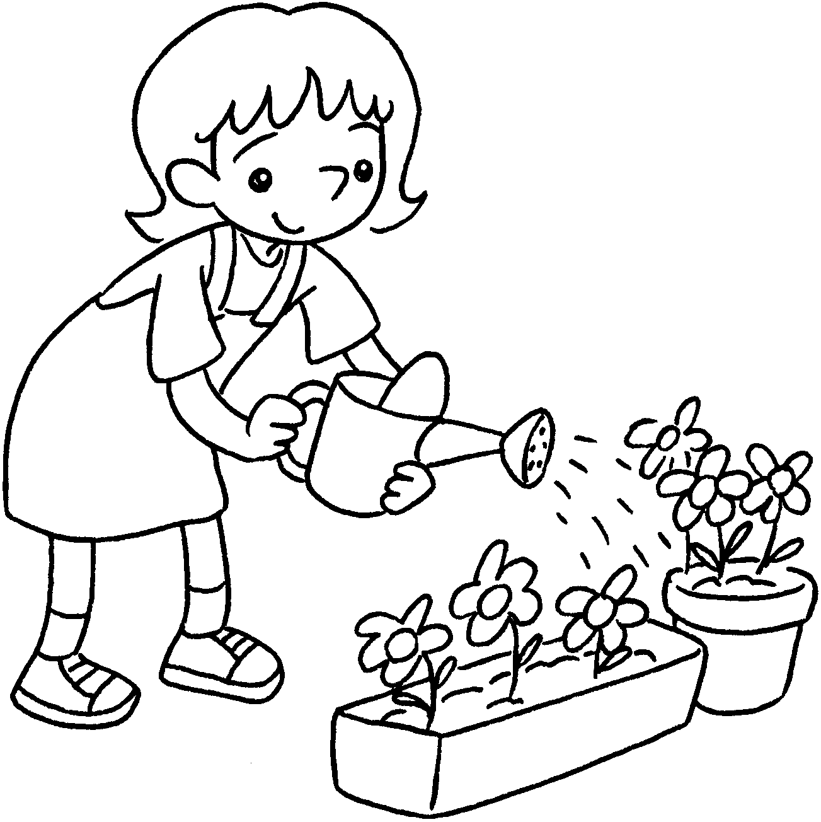 |  | 5 |  | 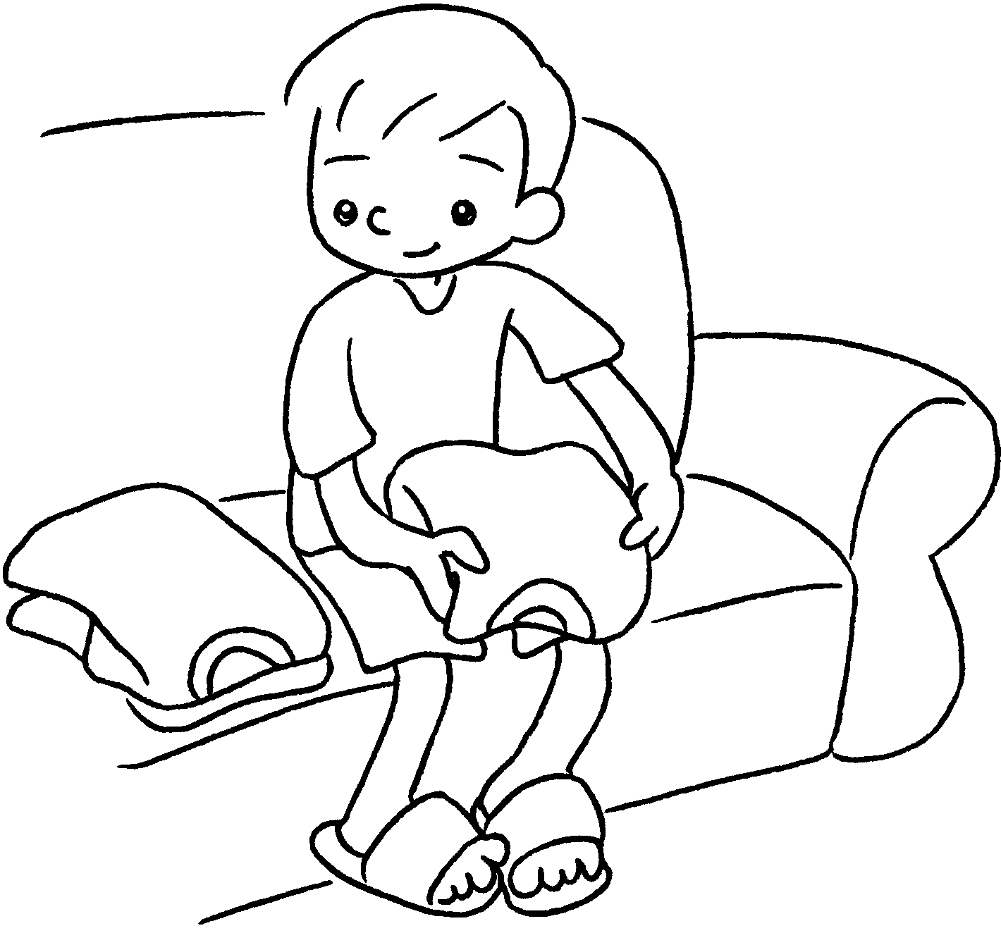 |  | 6 |  | 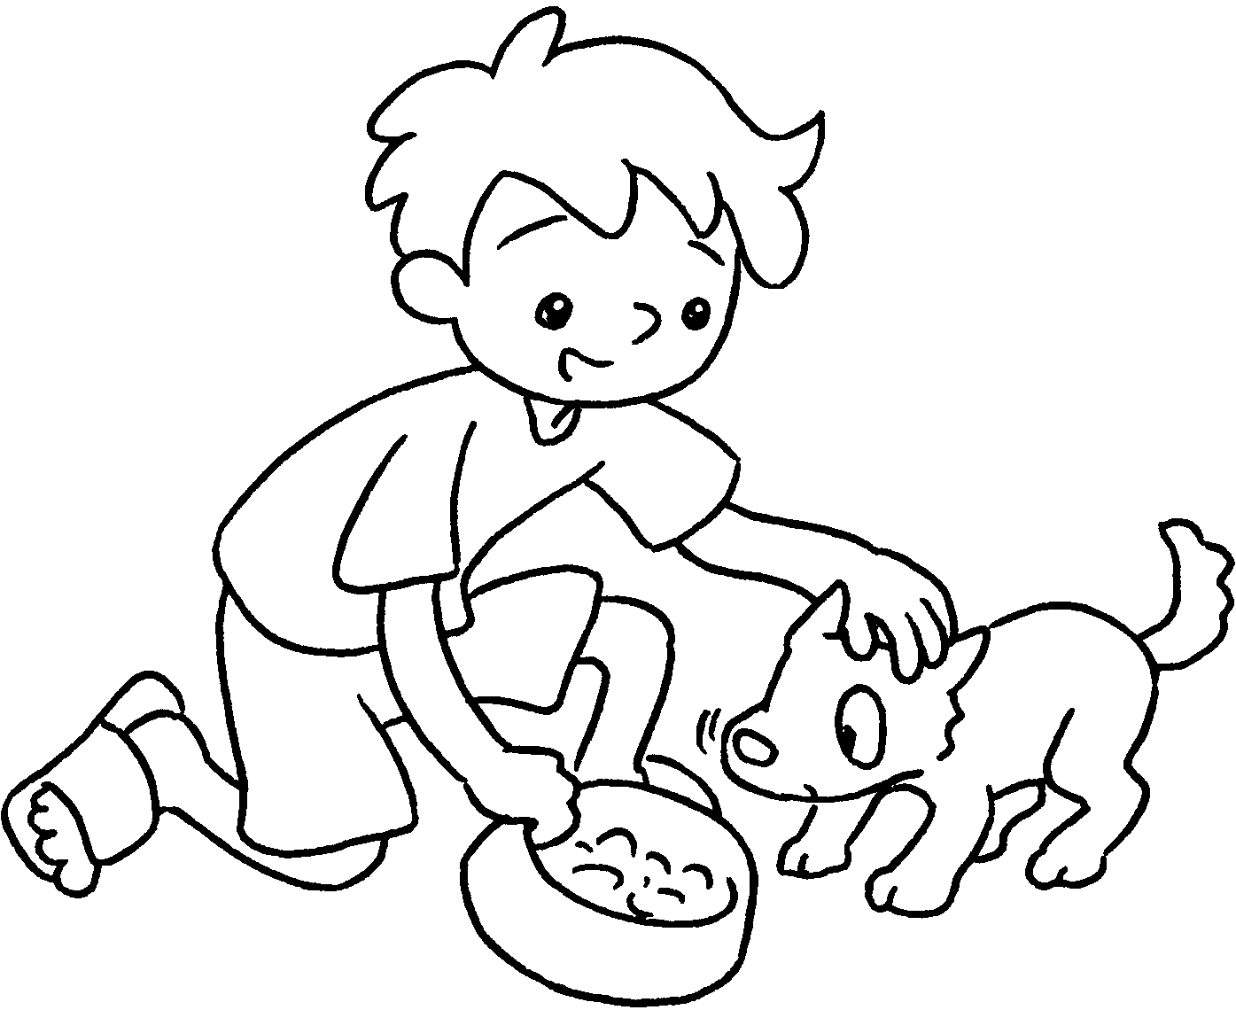
 |  | the plants |  |  |  | the clothes |  |  |  | the dog
7 | 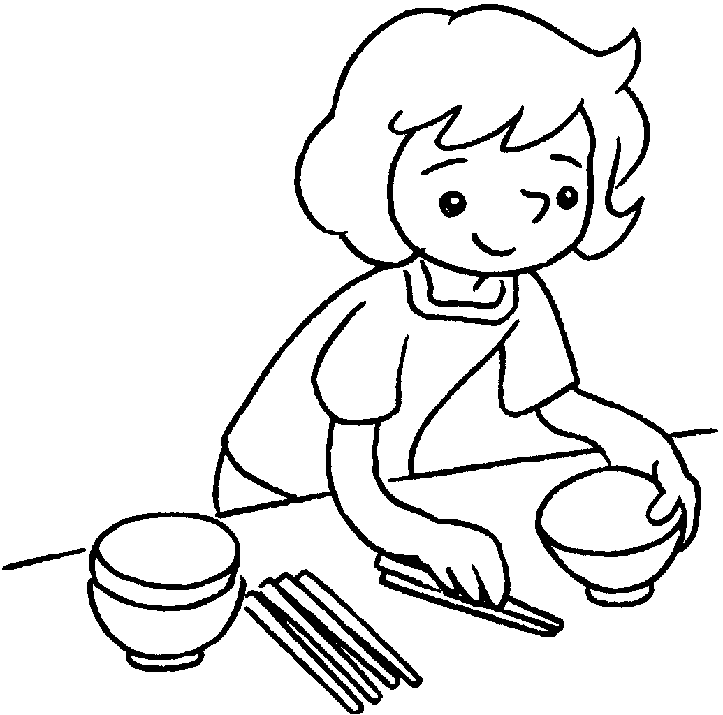 |  | 8 |  | 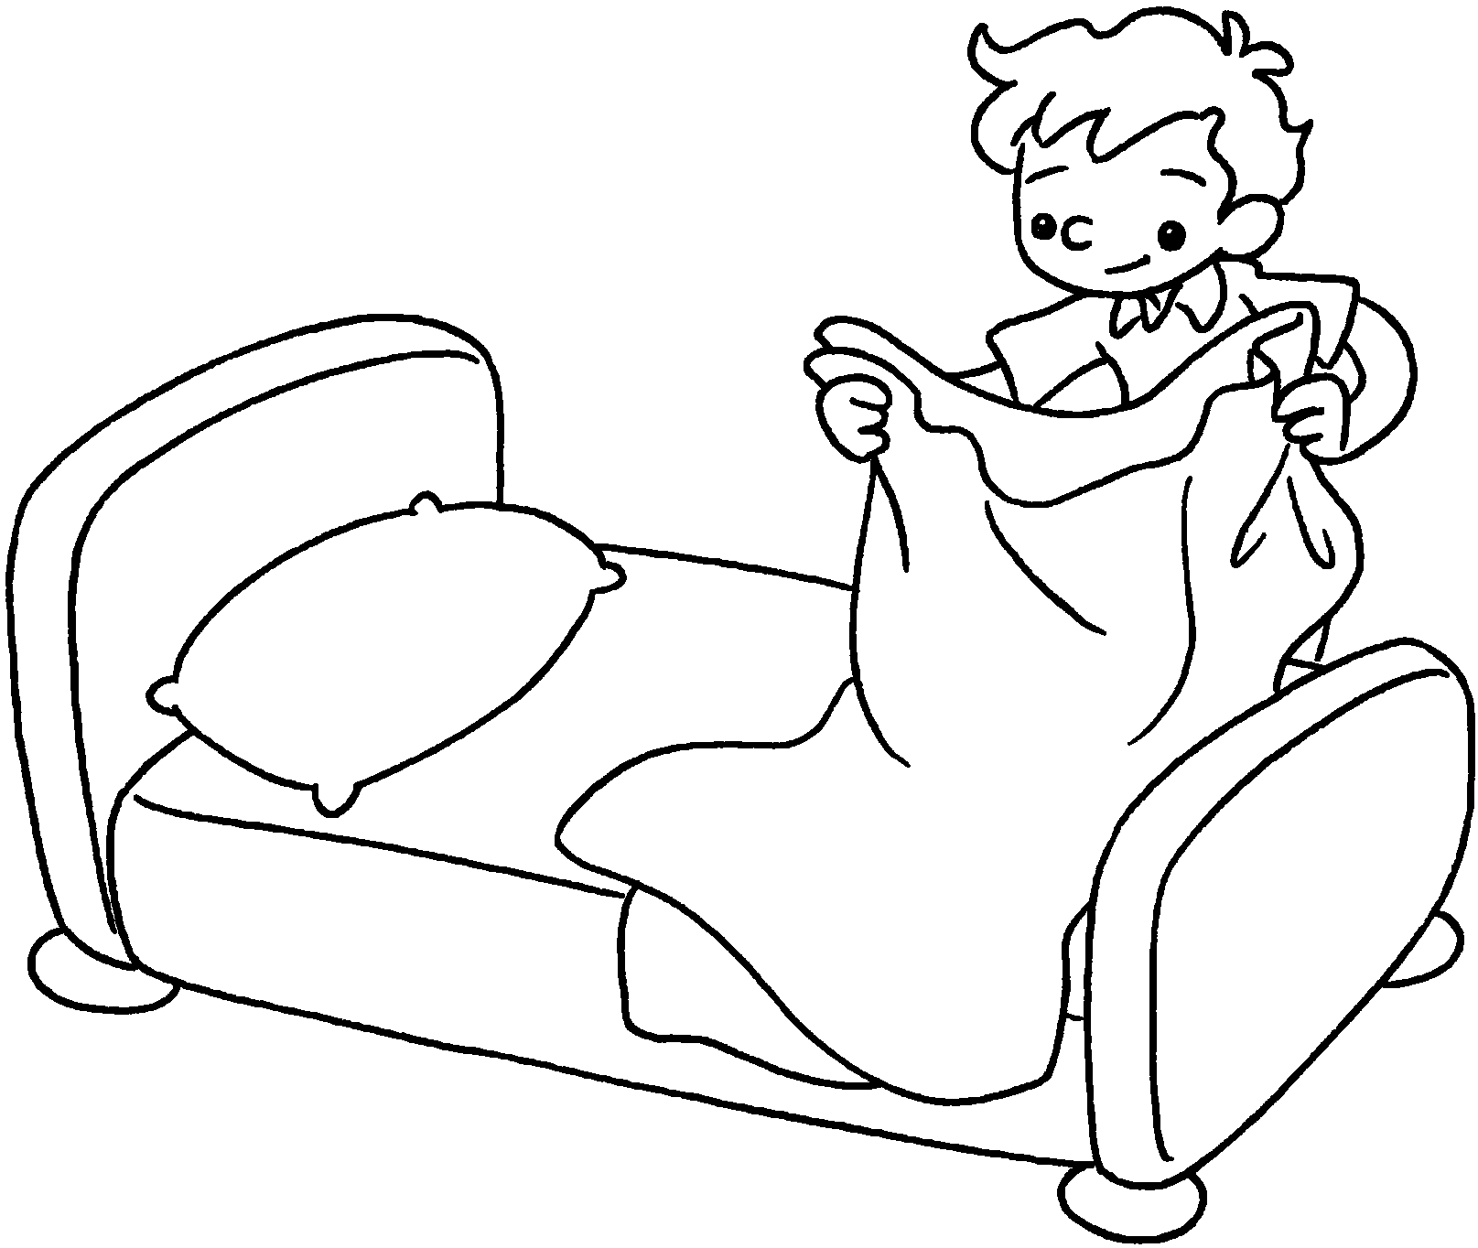 |  | 9 |  | 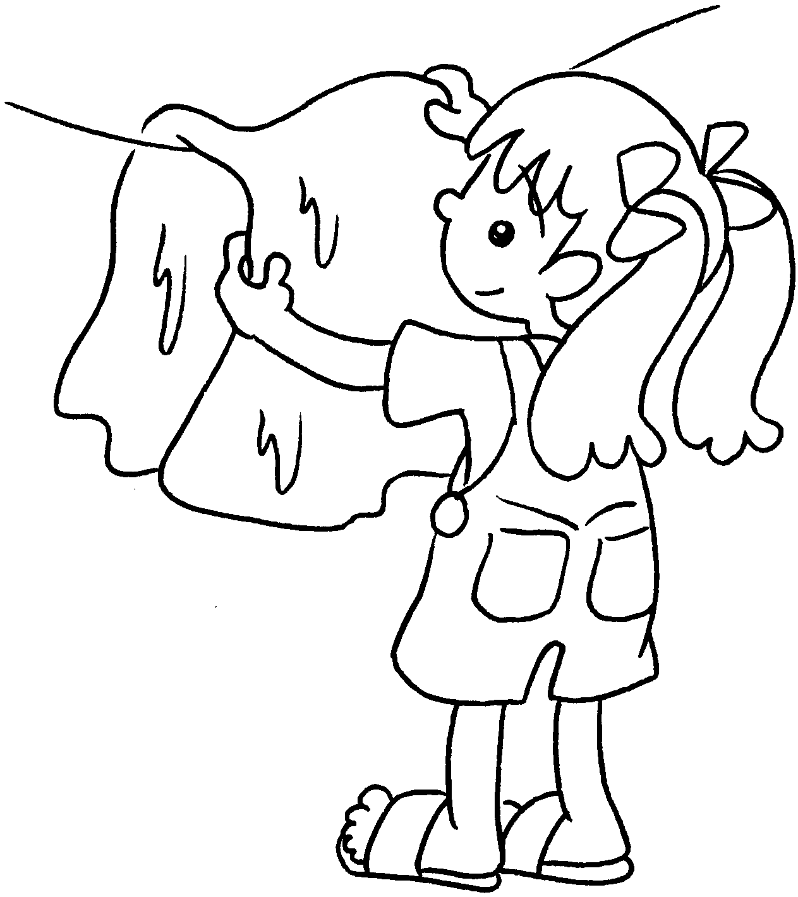
 | the table |  |  |  | the bed |  |  |  | the washing

Book 2B Chapter 1 Graded Worksheets

Worksheet 1⬇
- sweep 2 walk 3 clear
4 water 5 fold 6 feed
7 set 8 make 9 hang up

Book 2B Chapter 1 Graded Worksheets
Worksheet 1⬇⬇
- s w e e p 2 w a l k 3 c l e a r
4 w a t e r 5 f o l d 6 f e e d
7 s e t 8 m a k e 9 h a n g u p

Book 2B Chapter 1 Graded Worksheets
Worksheet 1⬇⬇⬇
- sweep 2 walk 3 clear
4 water 5 fold 6 feed
7 set 8 make 9 hang up

