How do you help at home? Fill in the missing letters.

1 | 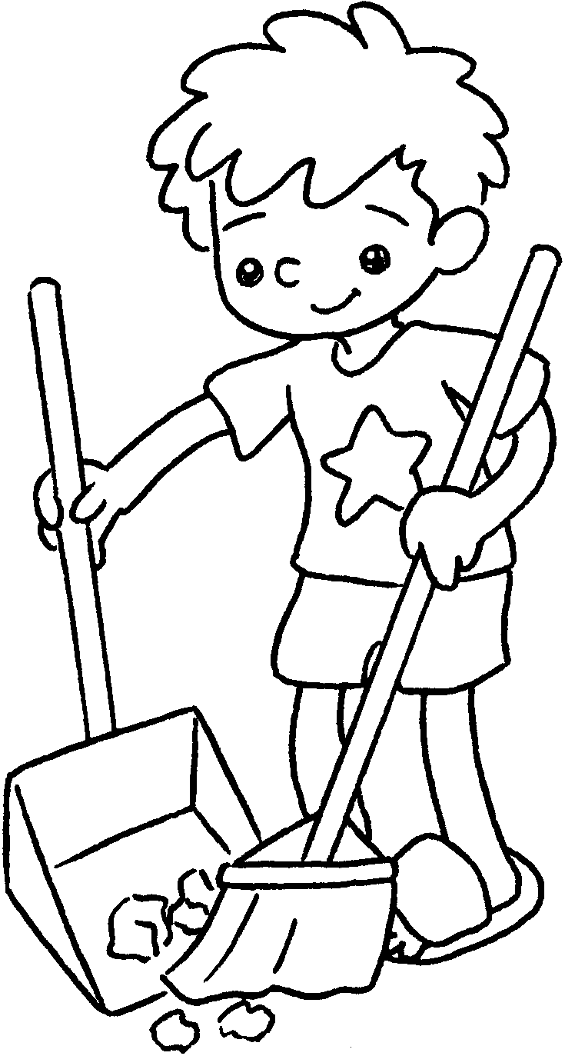 |  | 2 |  | 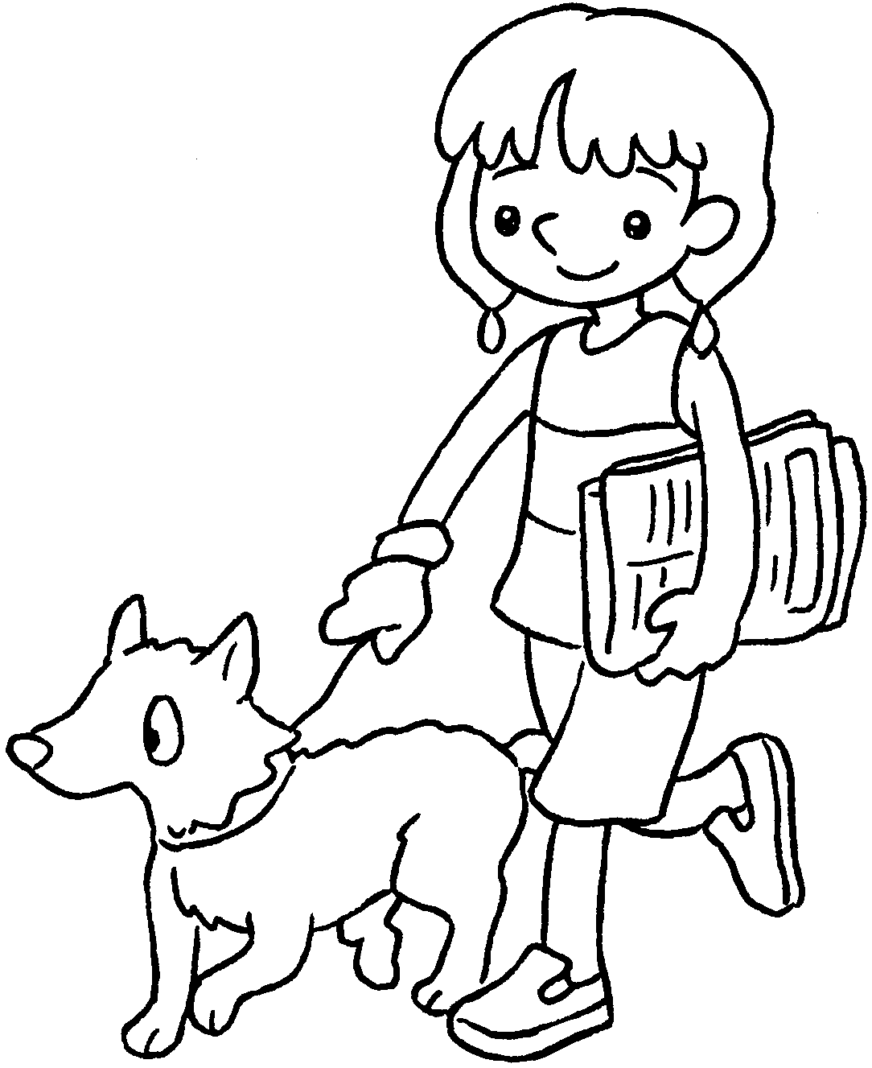 |  | 3 |  | 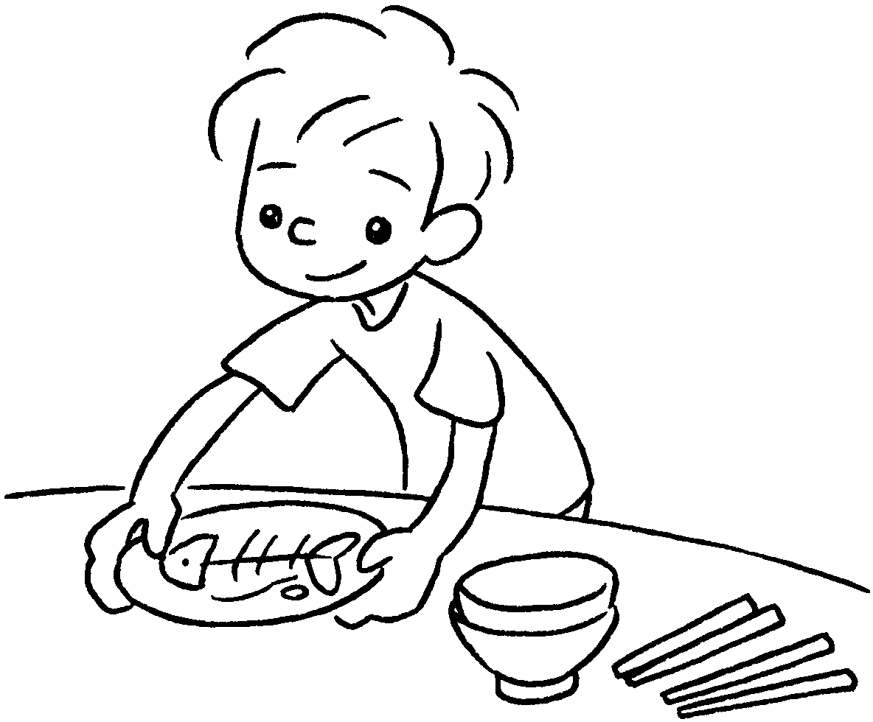
 | I s __ __ __ __  the floor. |  |  |  | I w __ __ __  the dog. |  |  |  | I c __ __ __ __  the table.
4 | 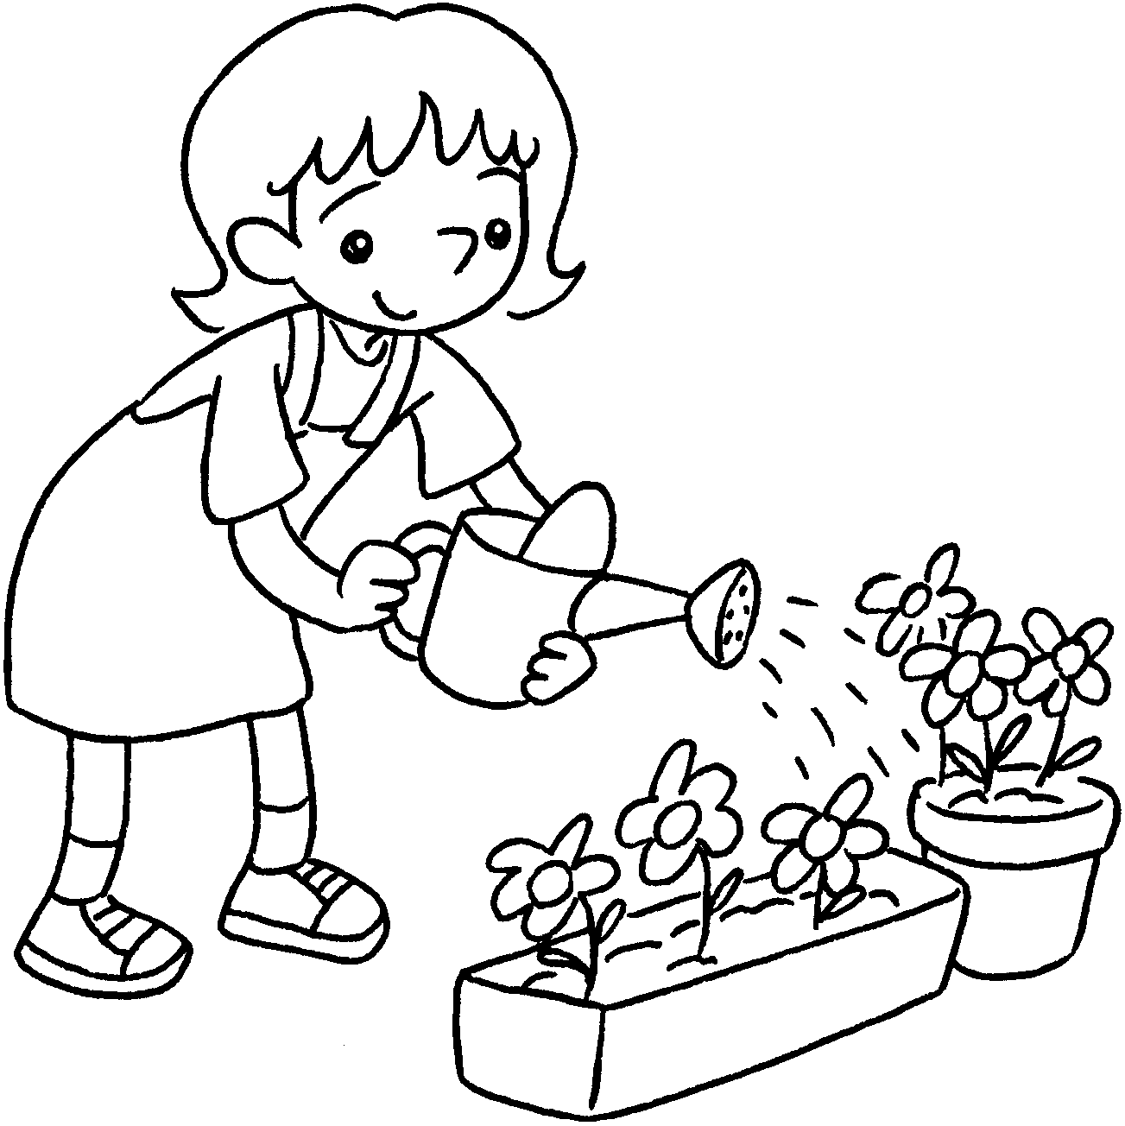 |  | 5 |  | 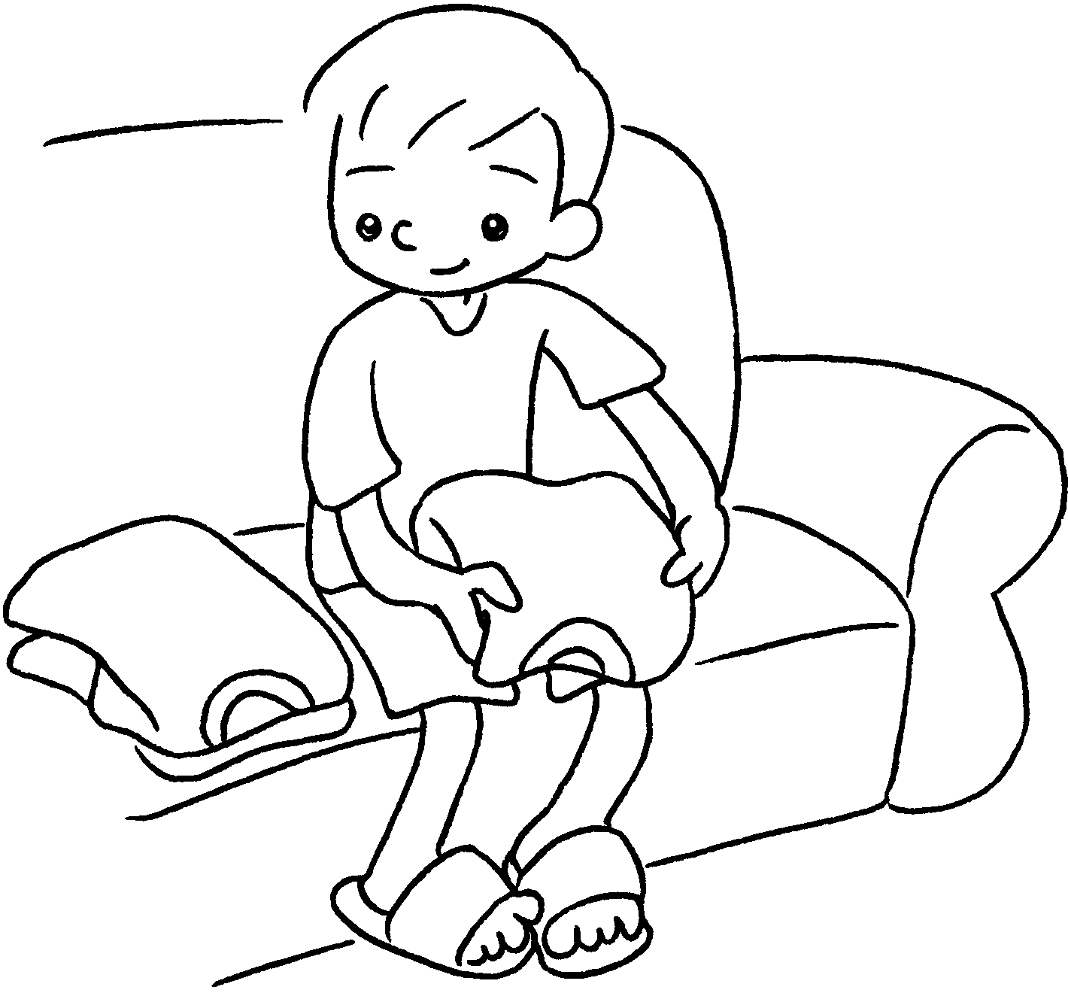 |  | 6 |  | 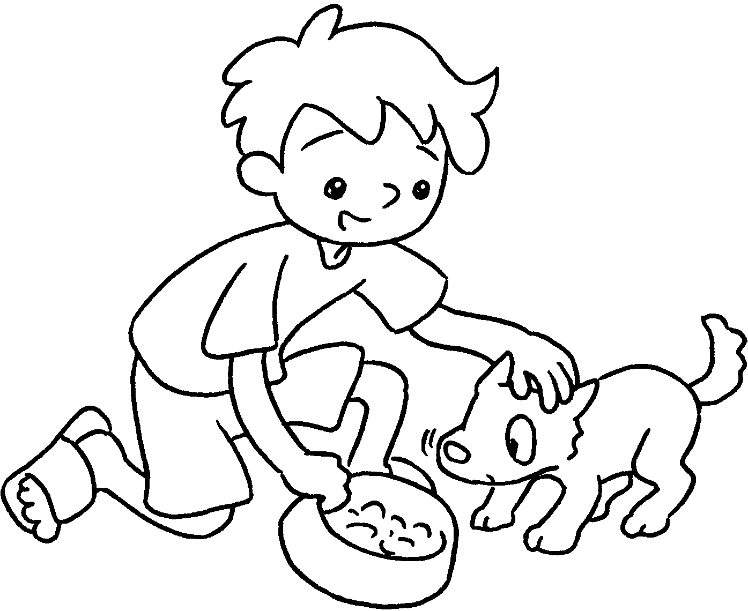
 |  | I w __ __ __ __  the plants. |  |  |  | I f __ __ __  the clothes. |  |  |  | I f __ __ __  the dog.
7 |  |  | 8 |  | 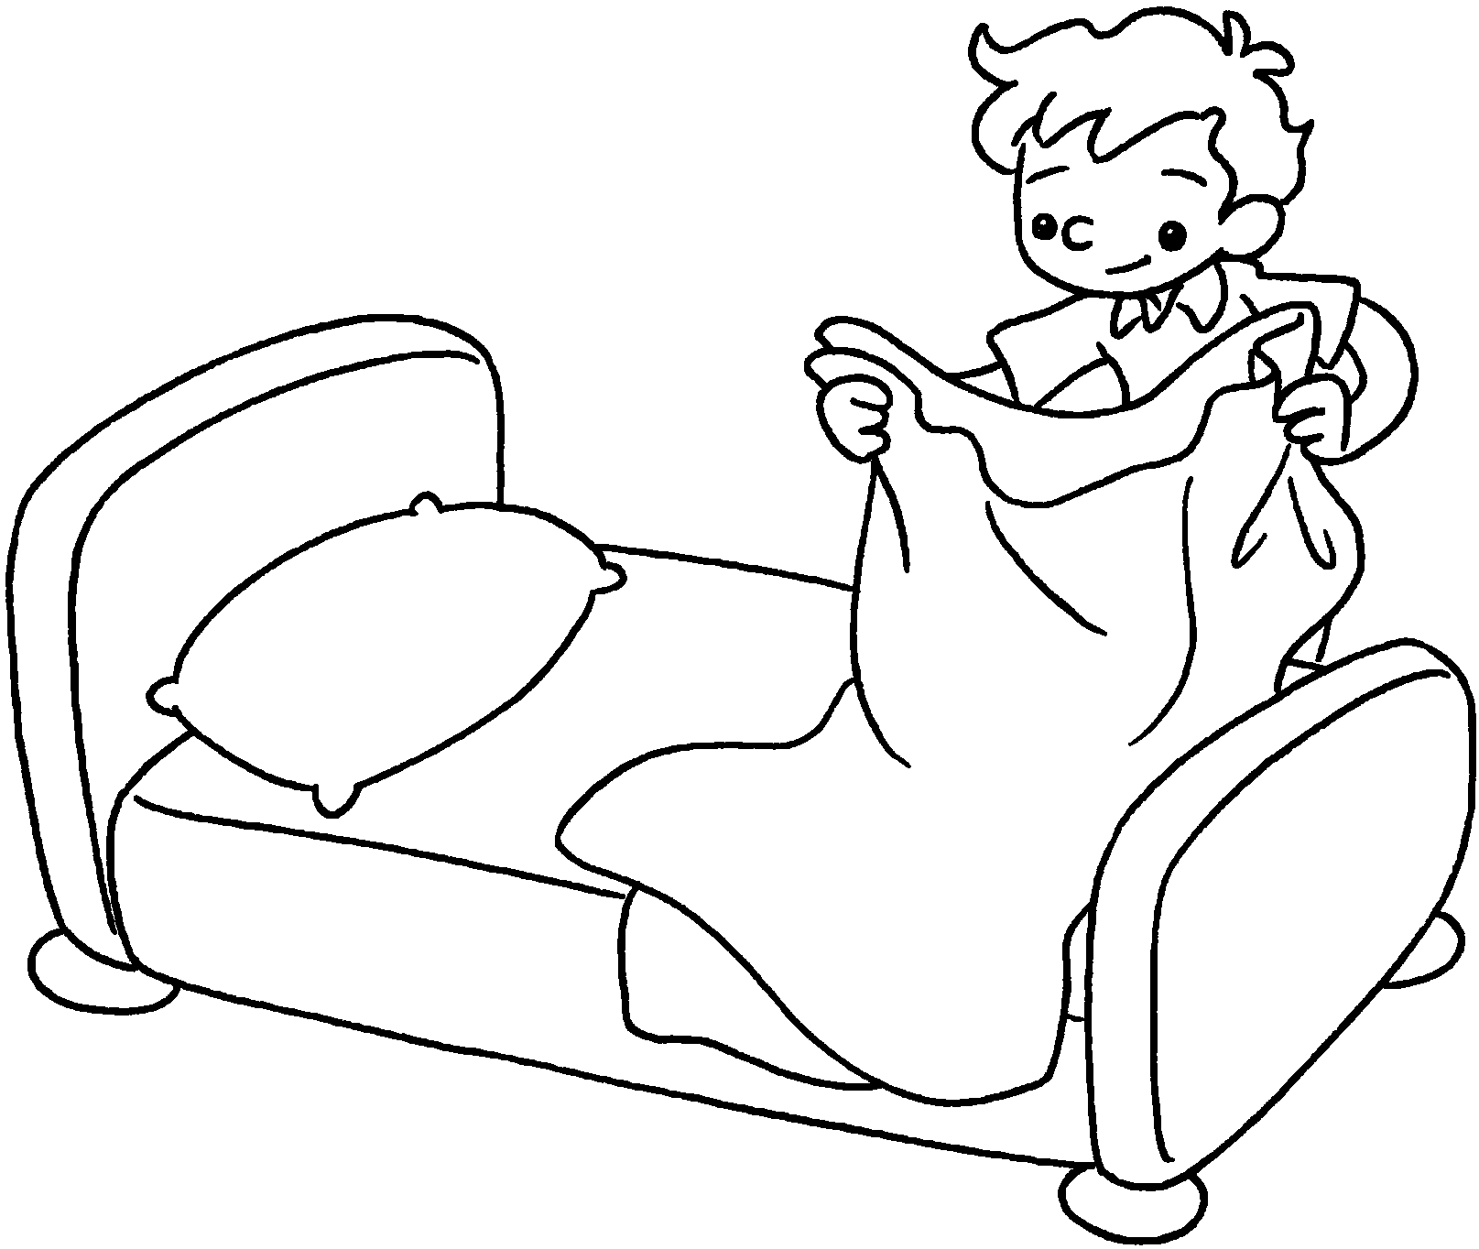 |  | 9 |  | 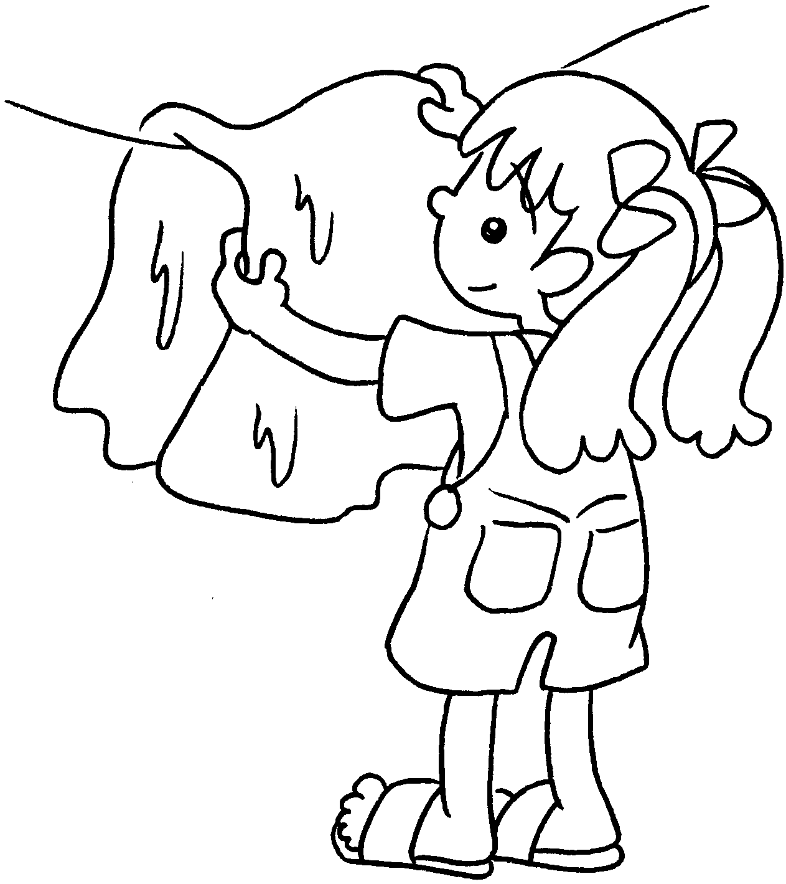
 | I s __ __ the table. |  |  |  | I m __ __ __ the bed. |  |  |  | I h __ __ __ u __  the washing.

Book 2B Chapter 1 Graded Worksheets

Worksheet 1⬇⬇
- s w e e p 2 w a l k 3 c l e a r
4 w a t e r 5 f o l d 6 f e e d
7 s e t 8 m a k e 9 h a n g u p

