How do you help at home? Write.

1 | 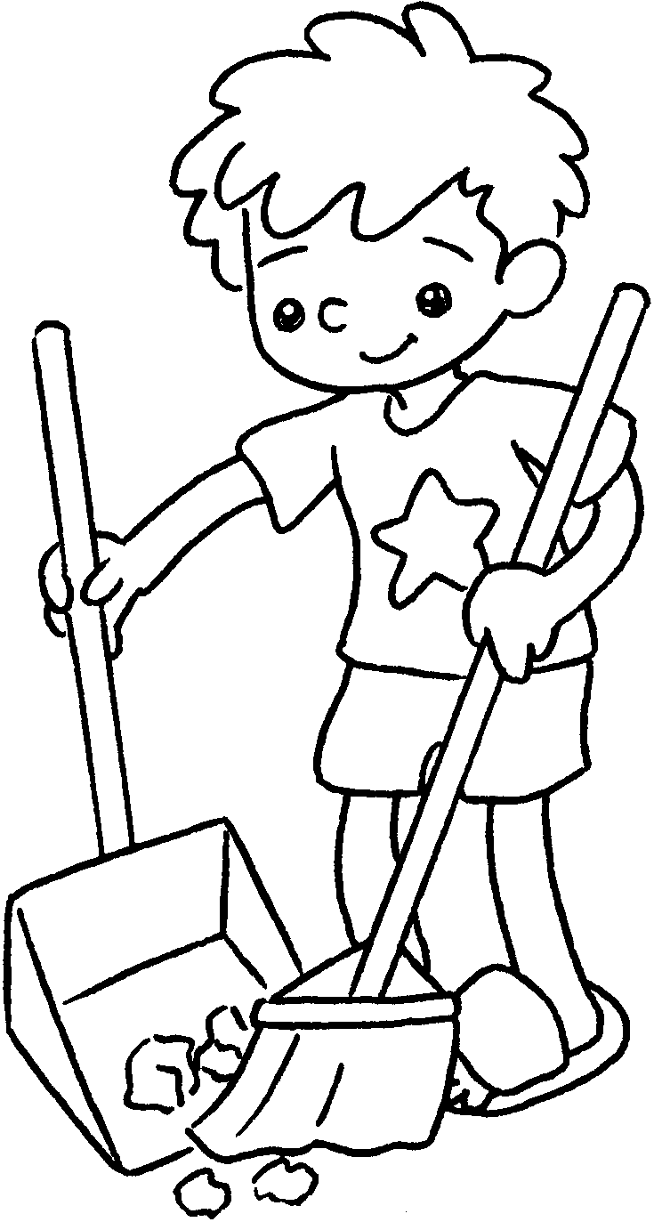 | 2 | 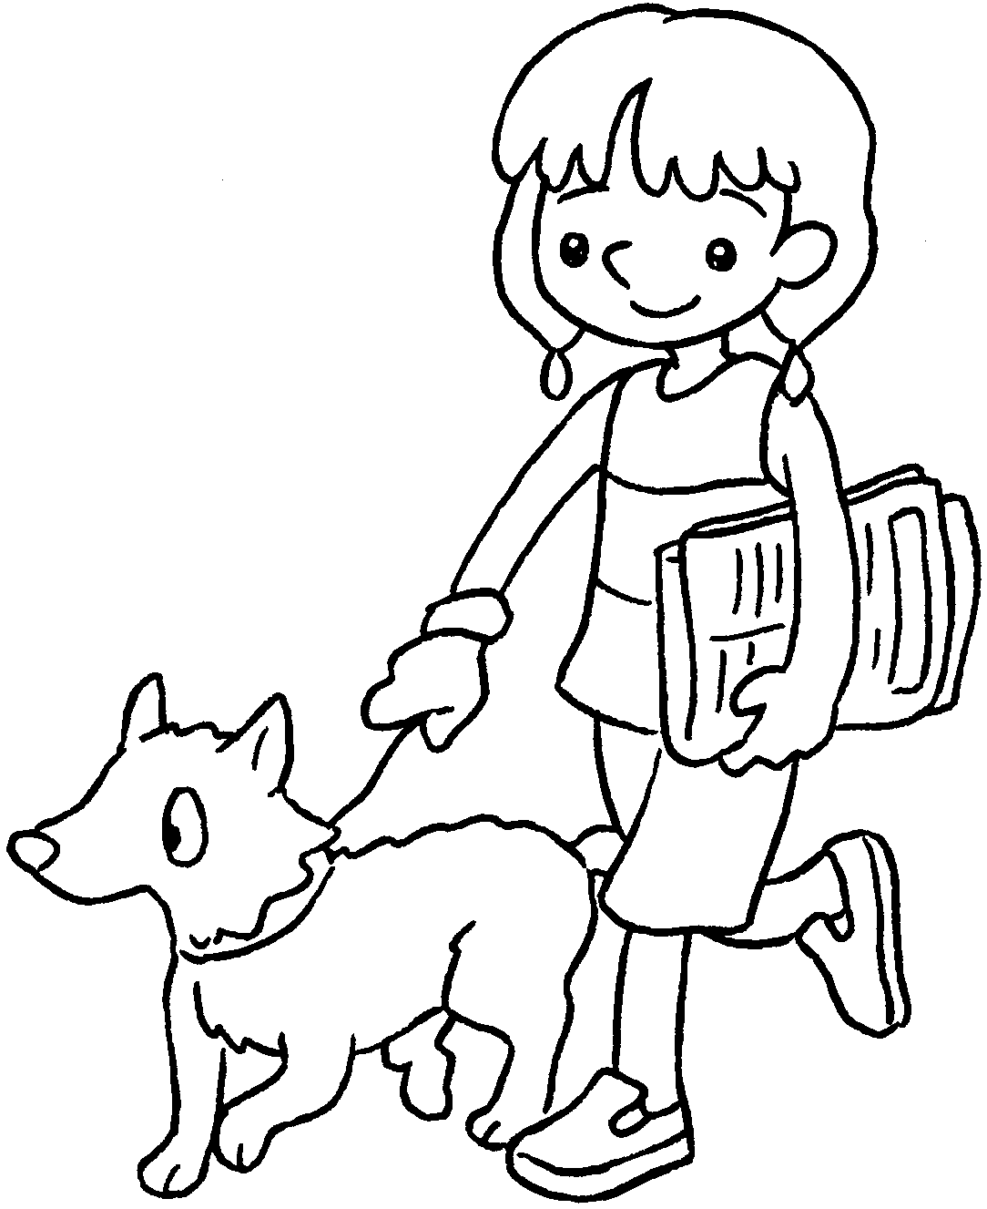 | 3 | 
 | I s  the floor. |  | I w  the dog. |  | I c  the table.

4 | 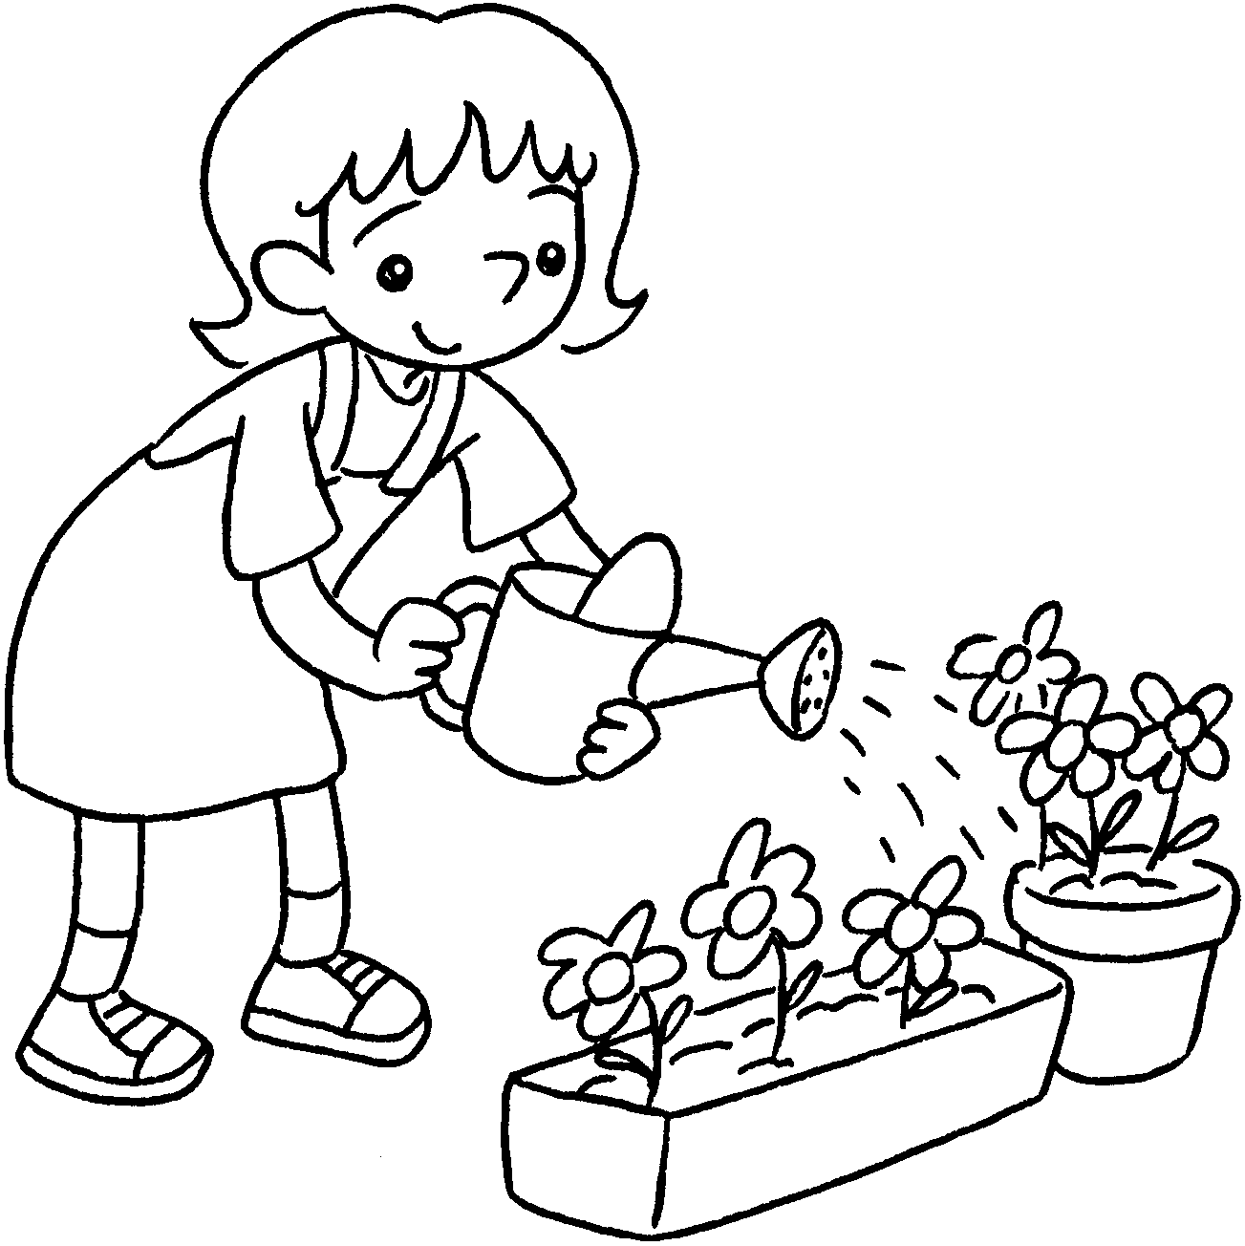 |  | 5 |  | 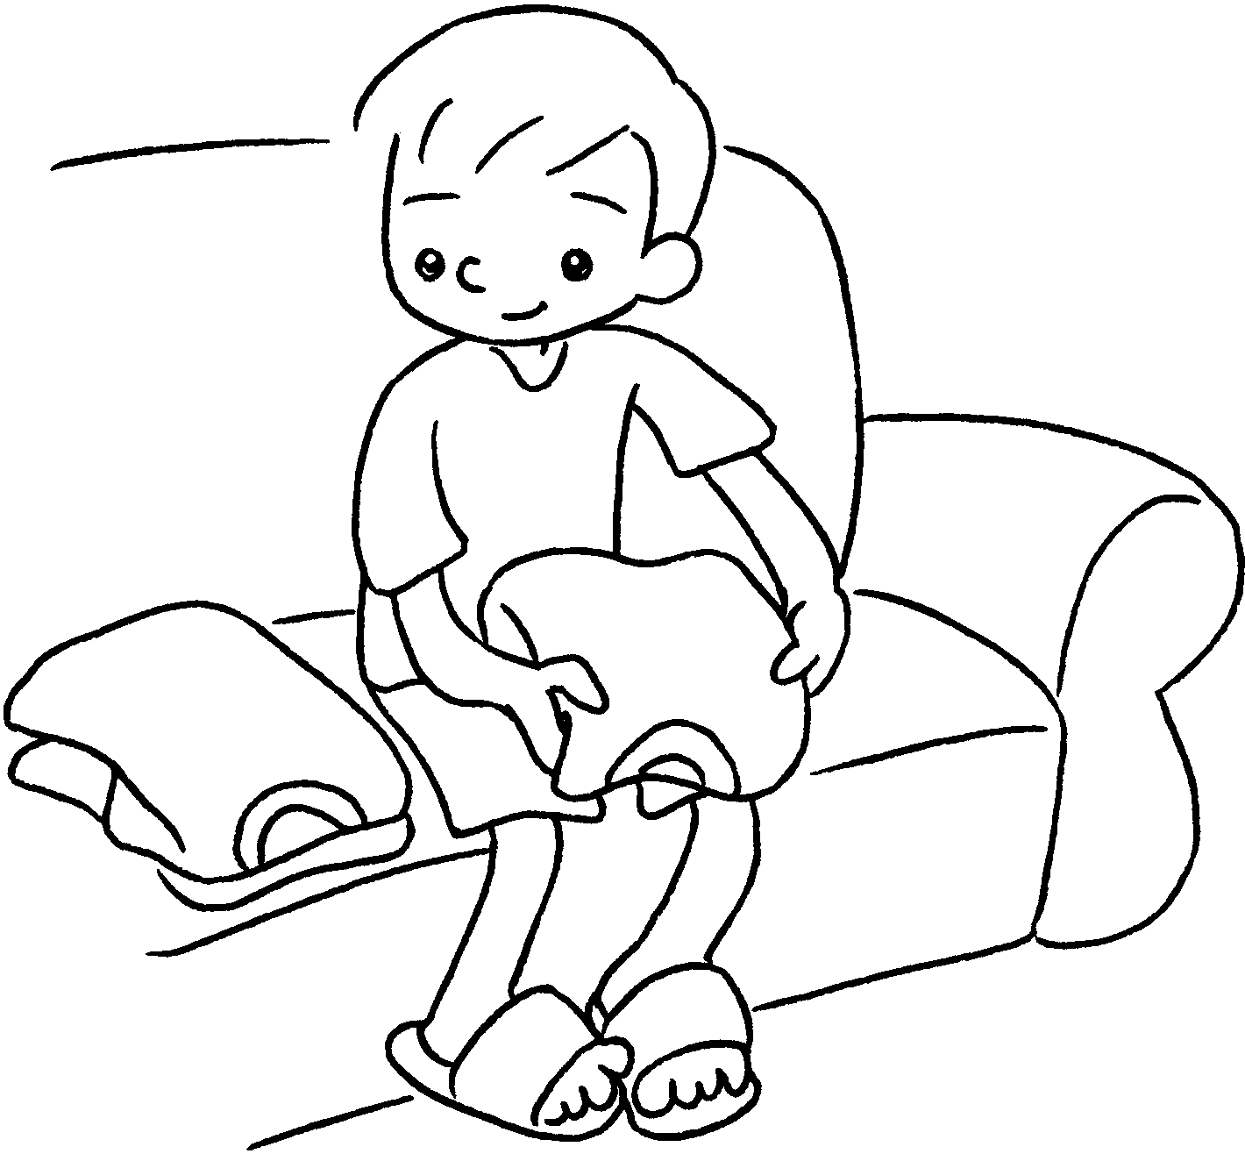 |  | 6 |  | 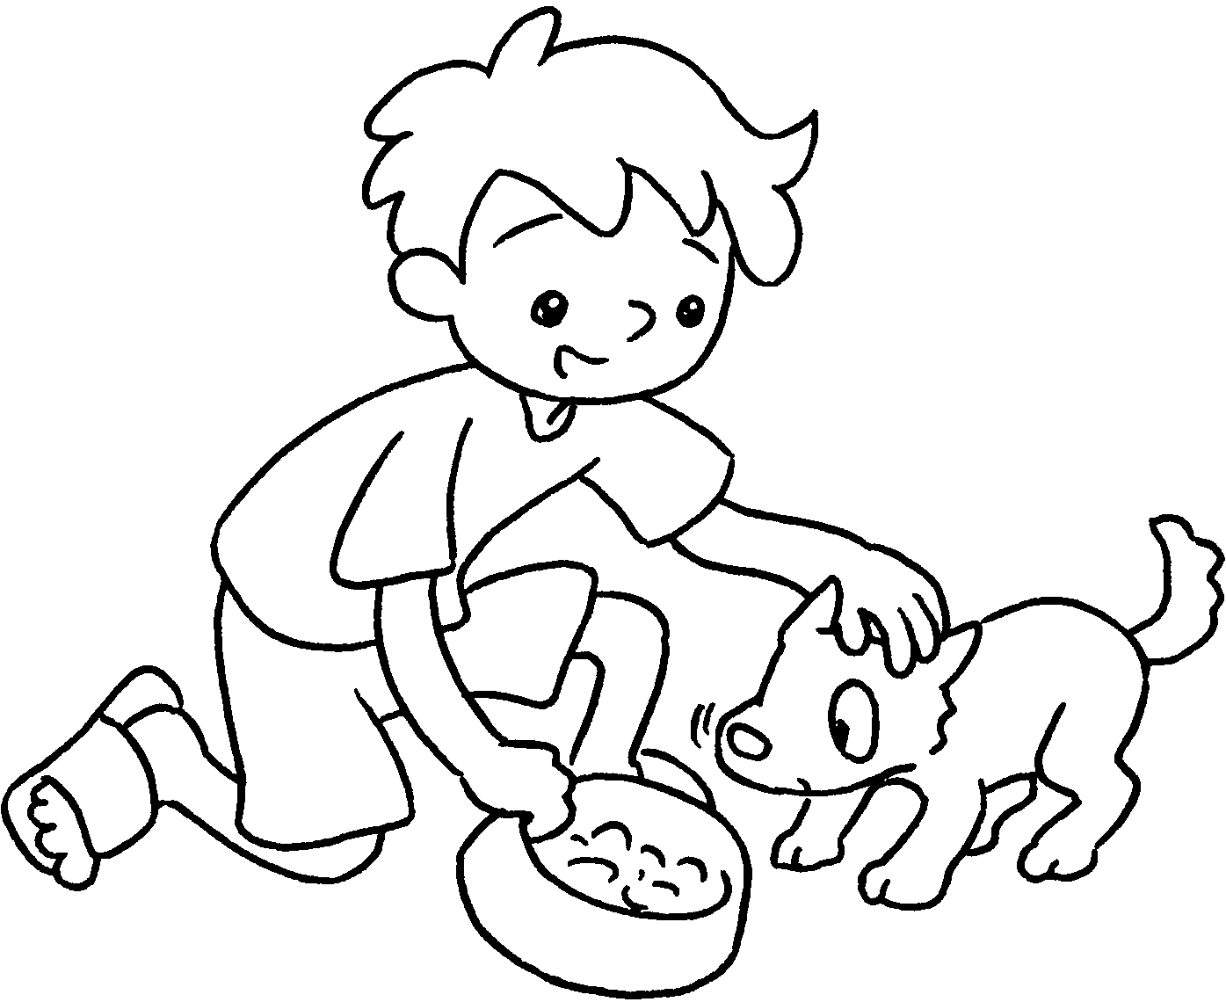
 |  | I ______________  the plants. |  |  |  | I _____________  the clothes. |  |  |  | I ______________  the dog.

7 |  | 8 | 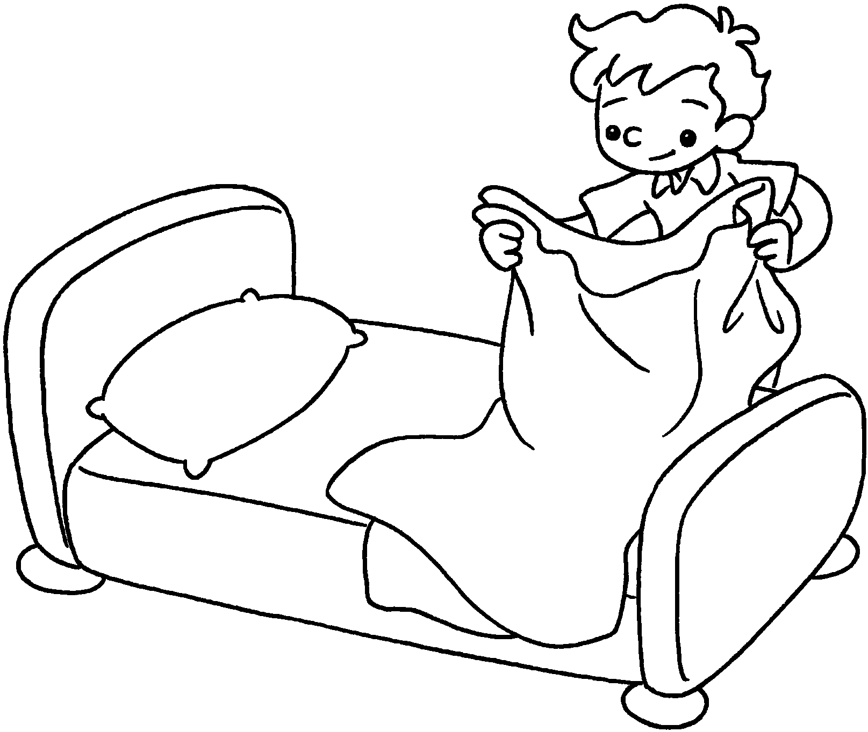 | 9 | 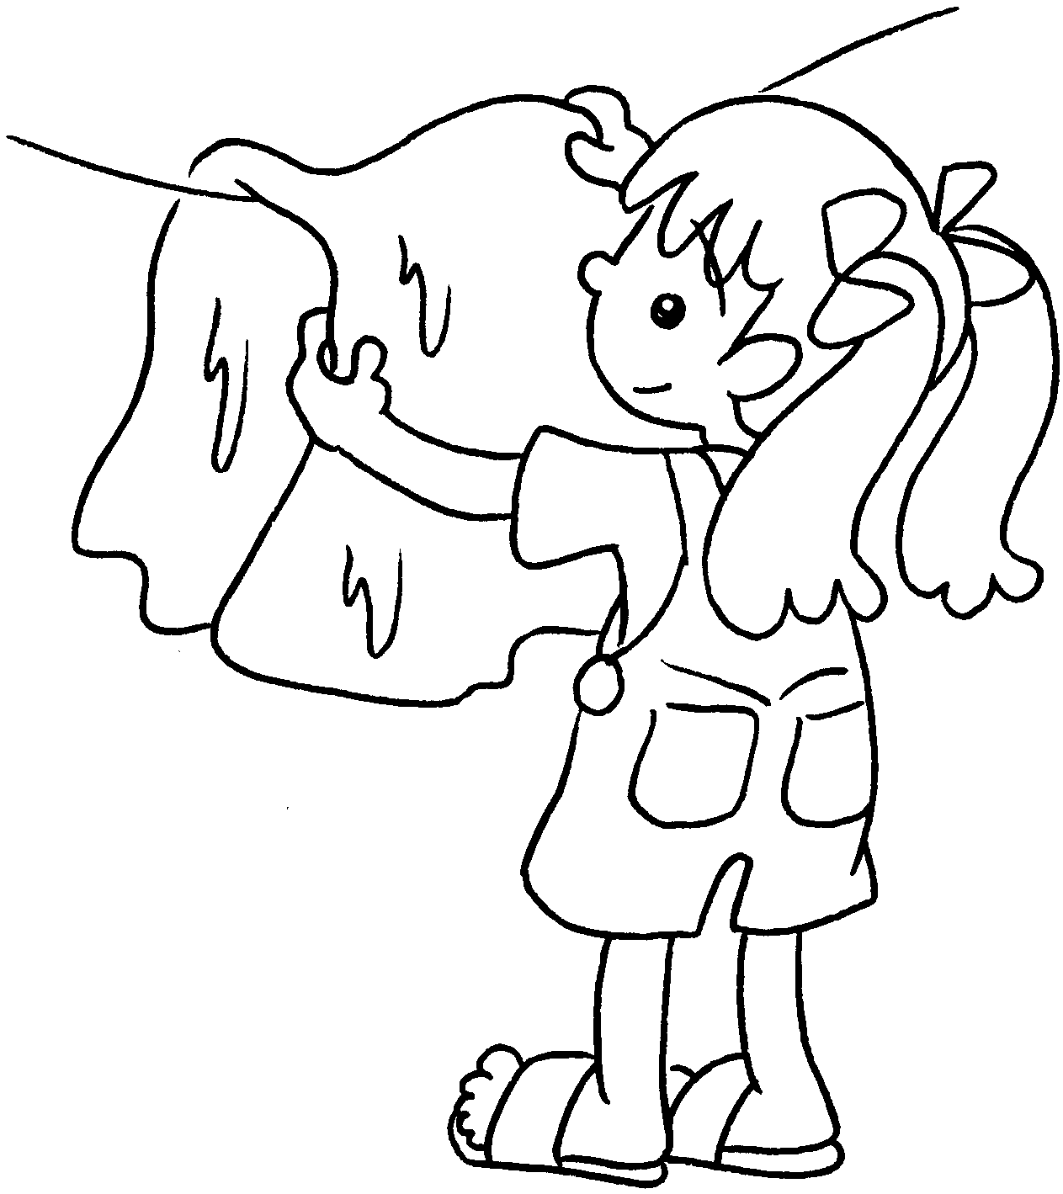
 | I ______________  the table. |  | I _____________  the bed. |  | I ______________  the washing.

Book 2B Chapter 1 Graded Worksheets

Worksheet 1⬇⬇⬇
- sweep 2 walk 3 clear
4 water 5 fold 6 feed
7 set 8 make 9 hang up

