Choose and write.
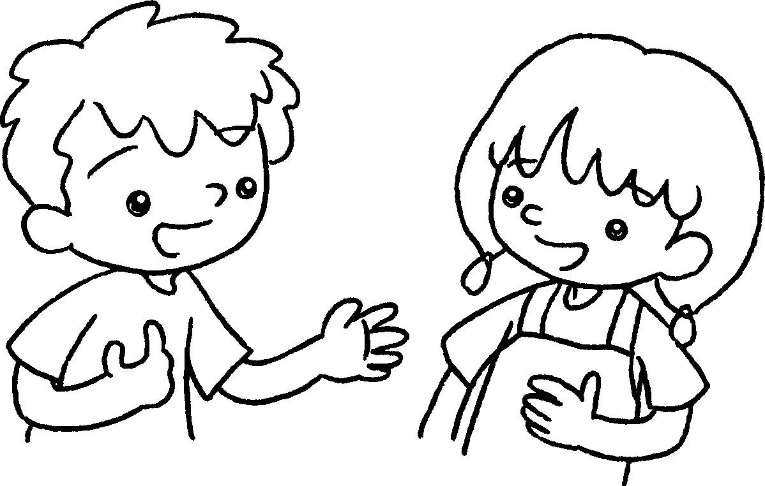
I do
I don’t
Do you
A
B
1  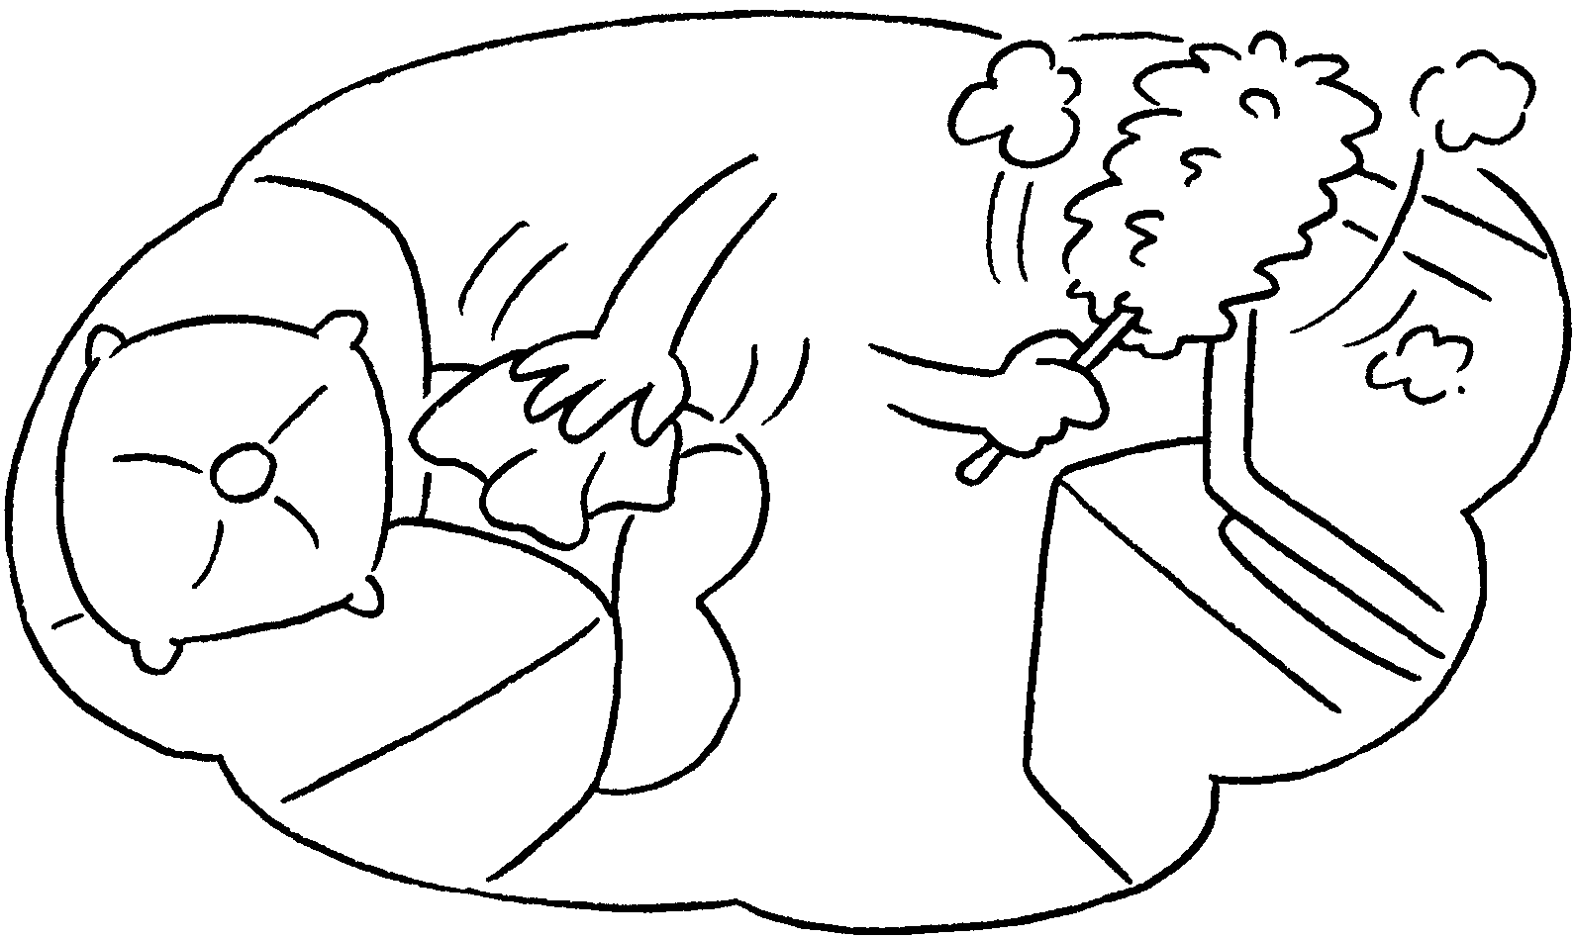 | ✓ | A : Do you help at home?  B : Yes, .
2  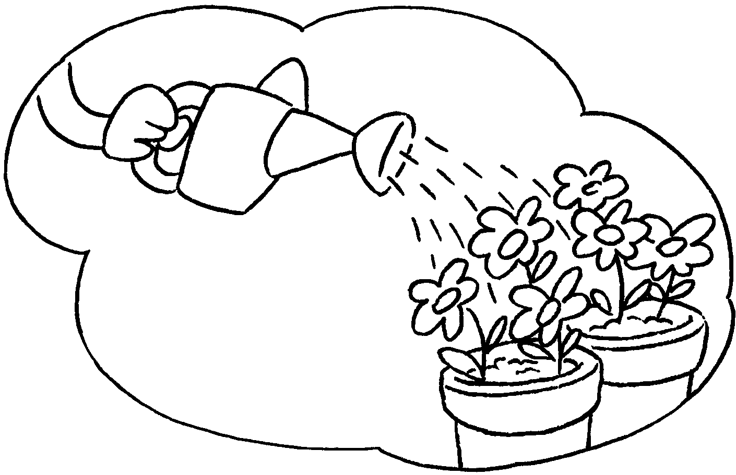 | ✗ | A : Do you water the plants?  B : No, .
3  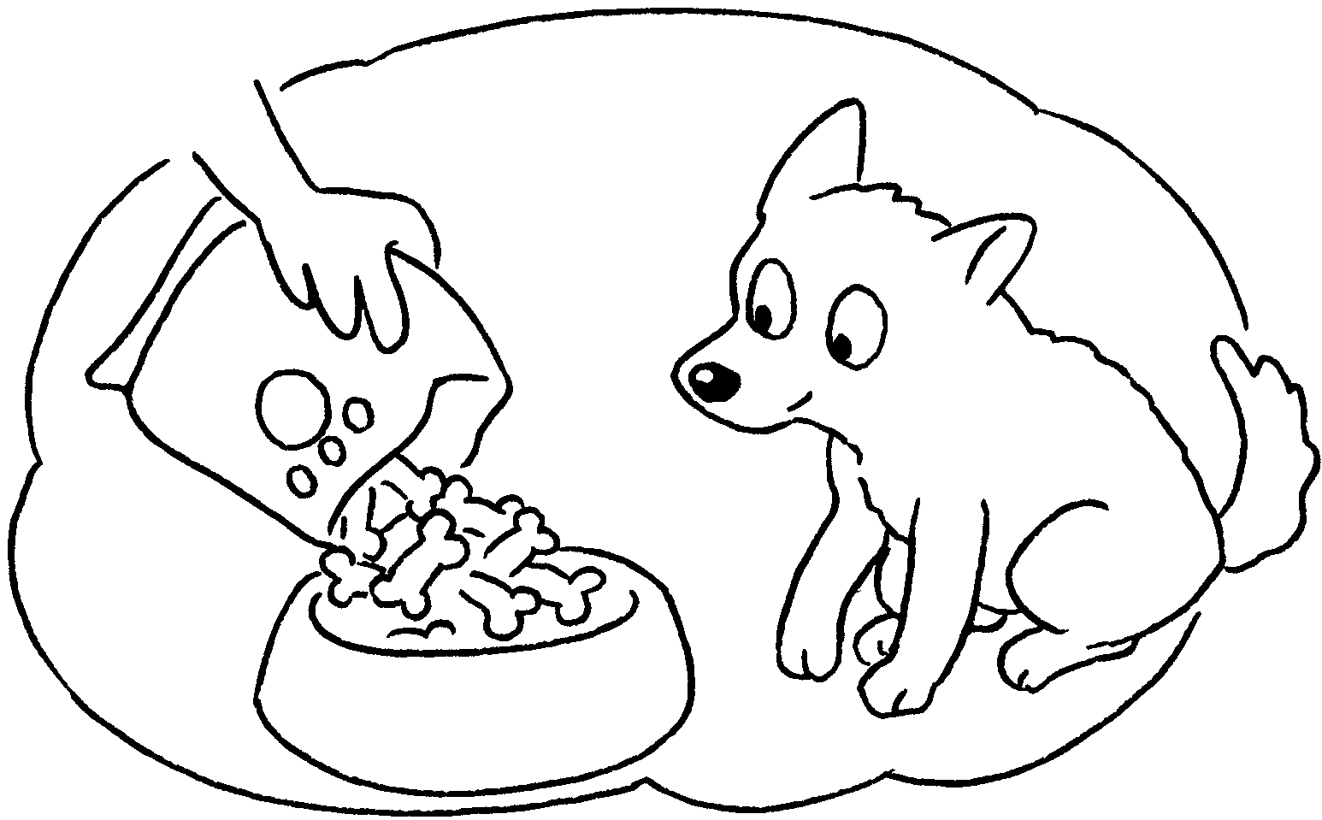 | ✓ | A : feed the  dog?  B : Yes, I do.
4  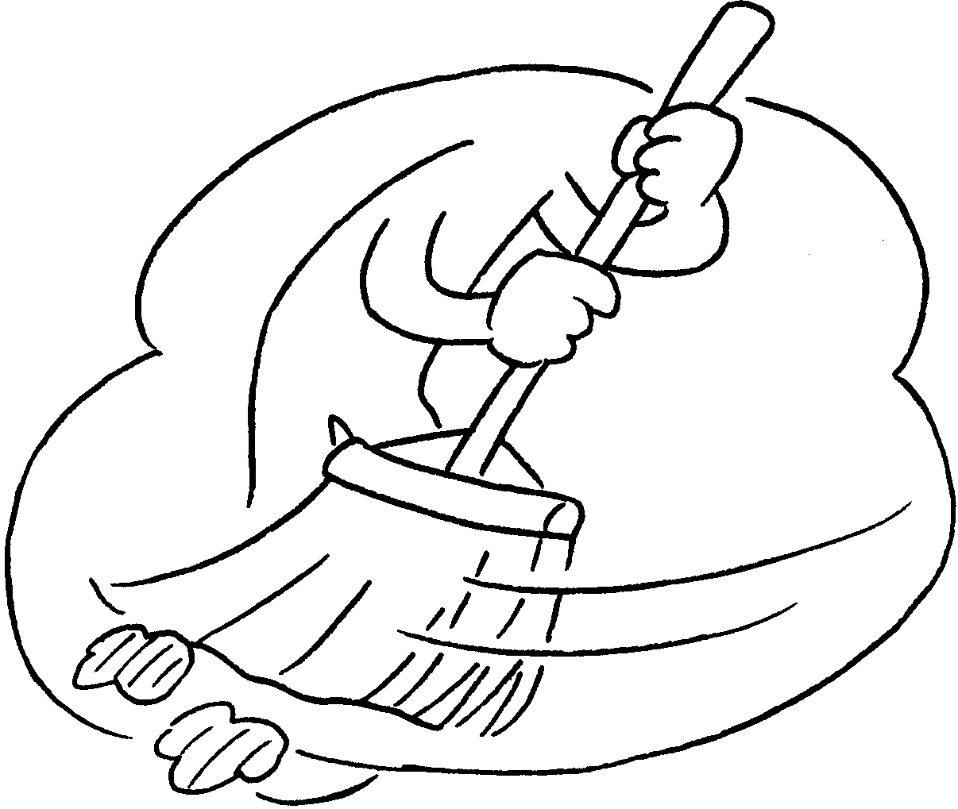 | ✓ | A : sweep the floor?  B : Yes, .
5  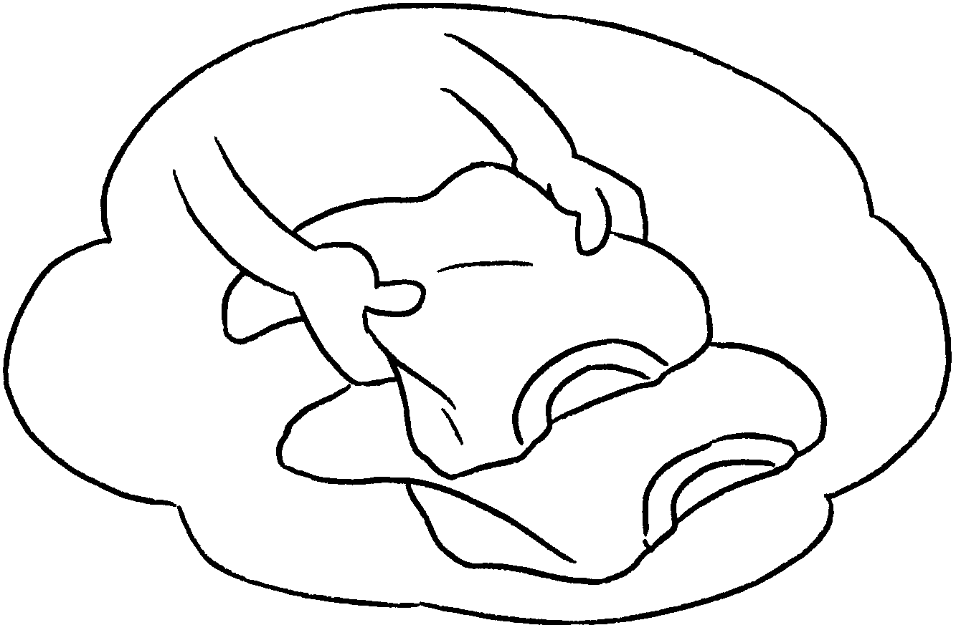 | ✗ | A : fold the  clothes?  B : No, .


Book 2B Chapter 1 Graded Worksheets
Worksheet 2⬇
- I do
- I don’t
- Do you
- Do you
I do
5 Do you
I don’t

