Ask and answer the questions.
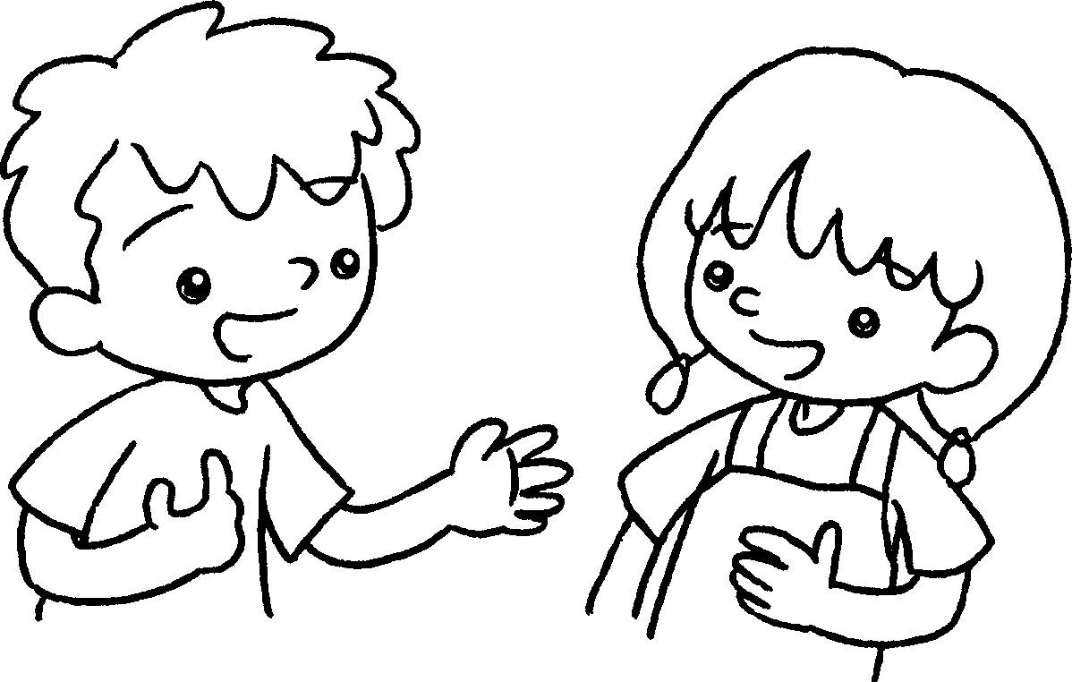
A
B
1  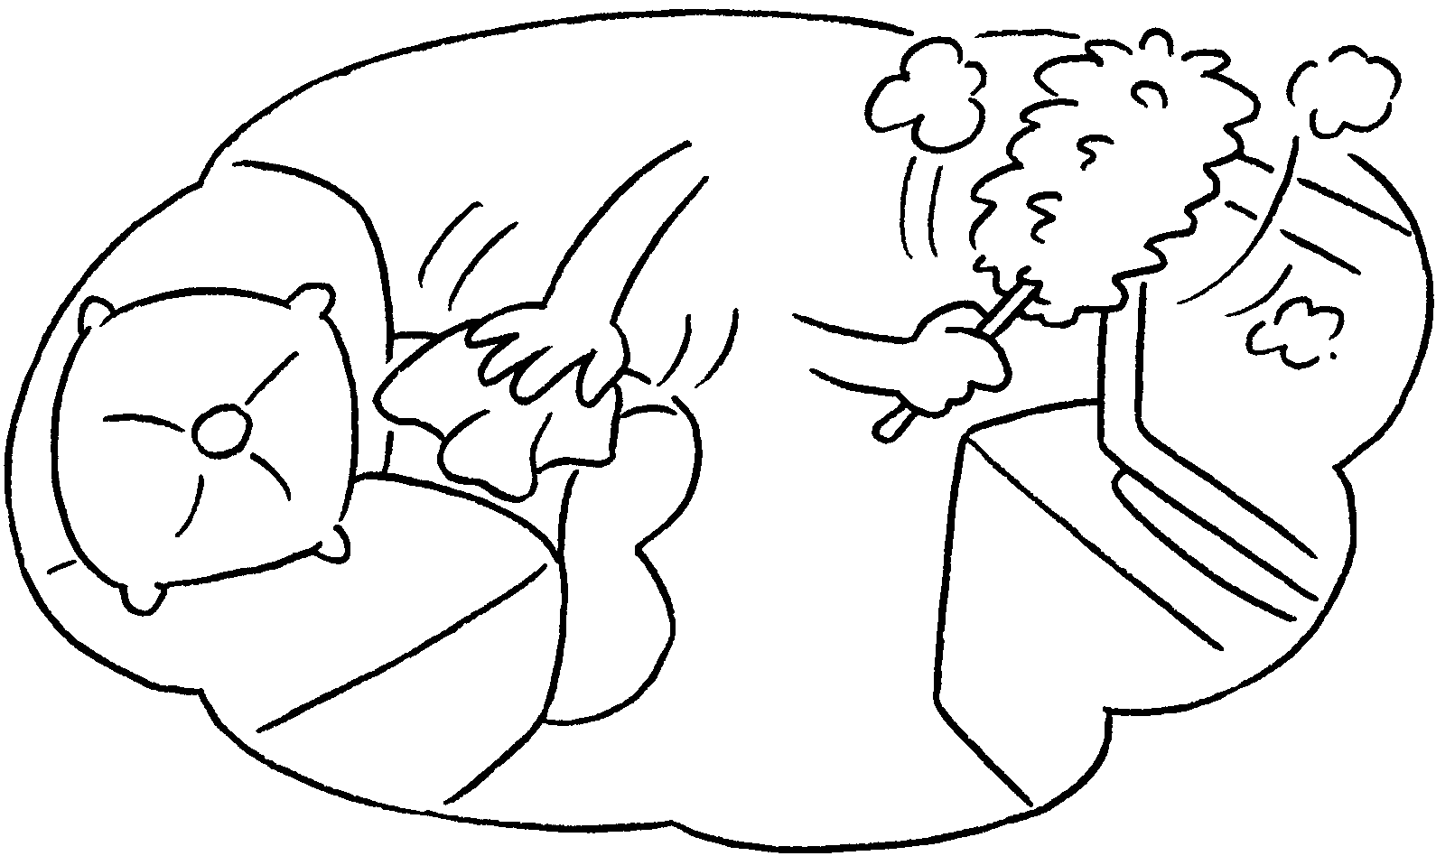 | ✓ | A : Do you help at home?  B : Yes, I .
2  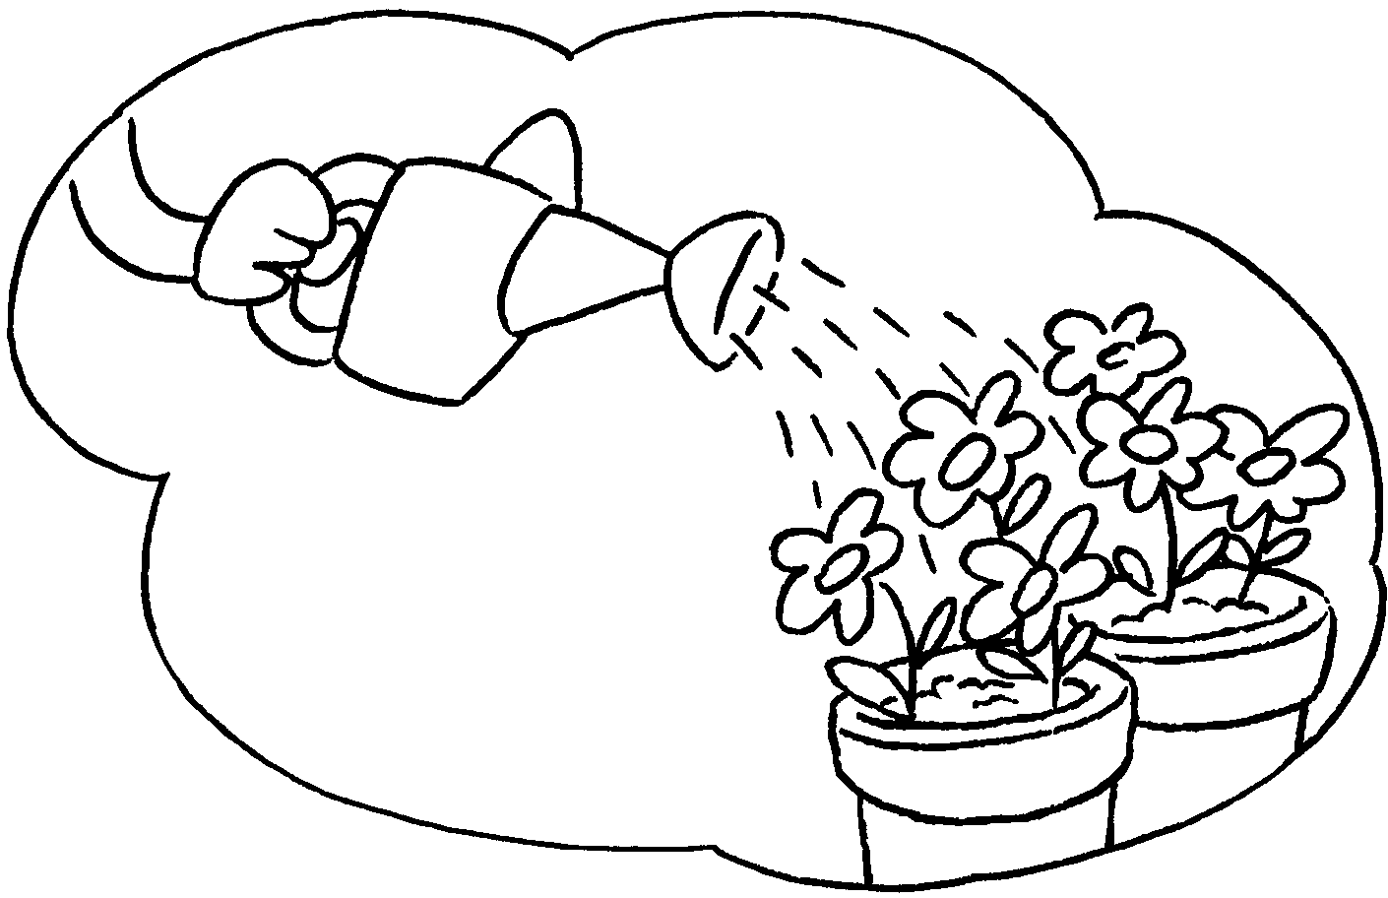 | ✗ | A : Do you the plants?  B : No, I .
3  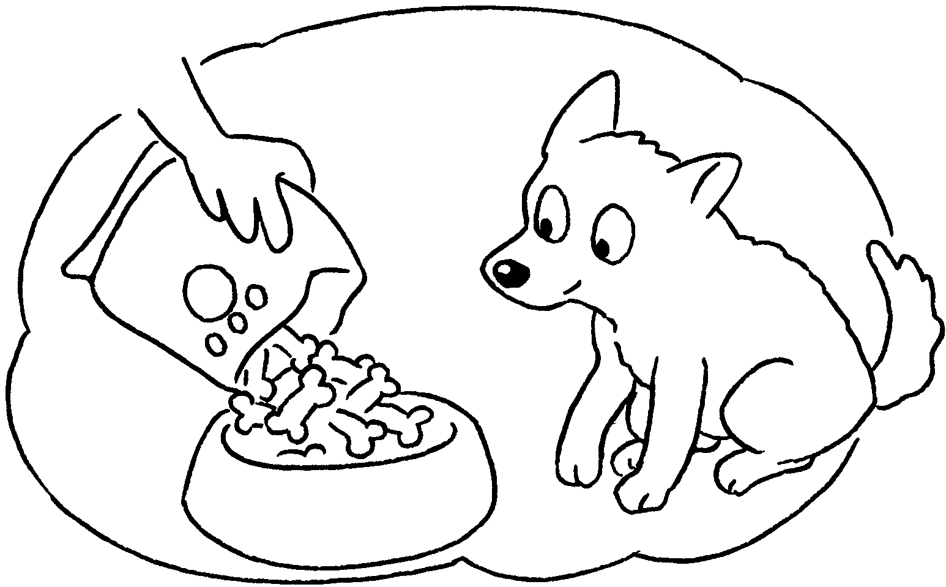 | ✓ | A :  the dog?  B :
4  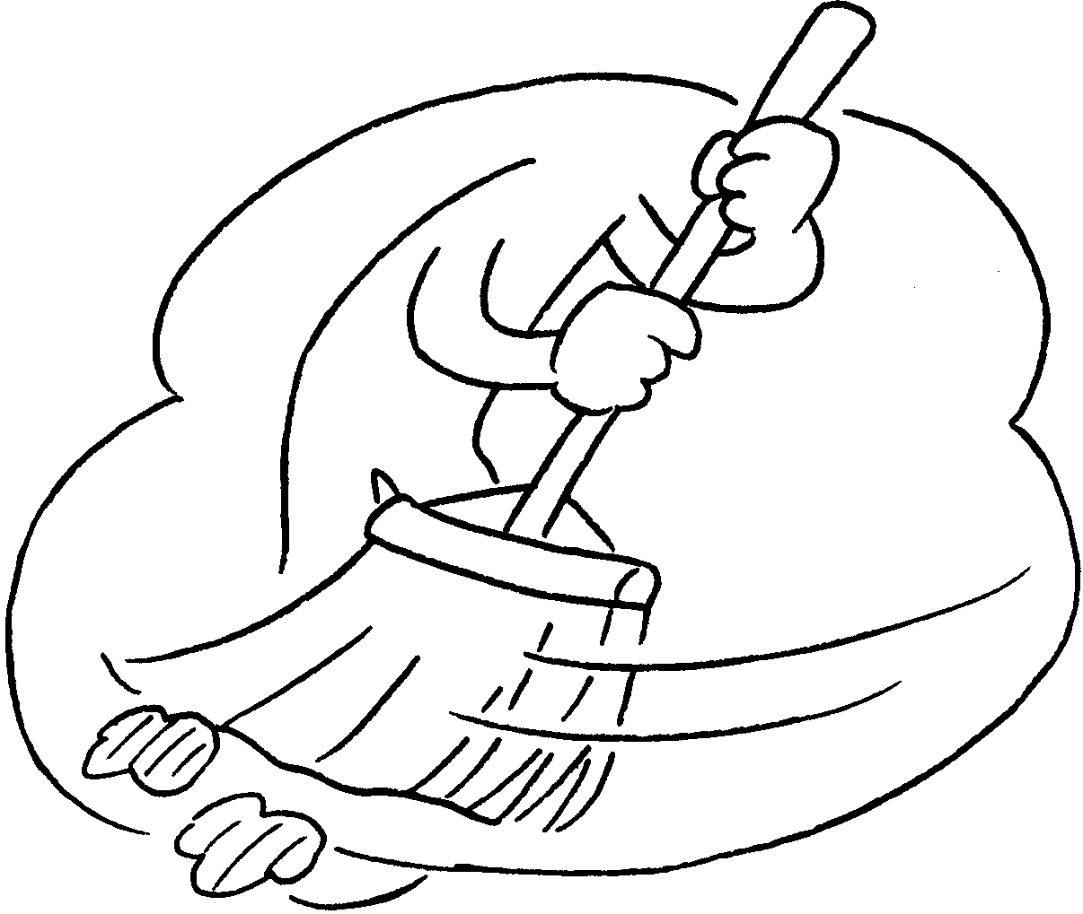 | ✓ | A :  the floor?  B :
5  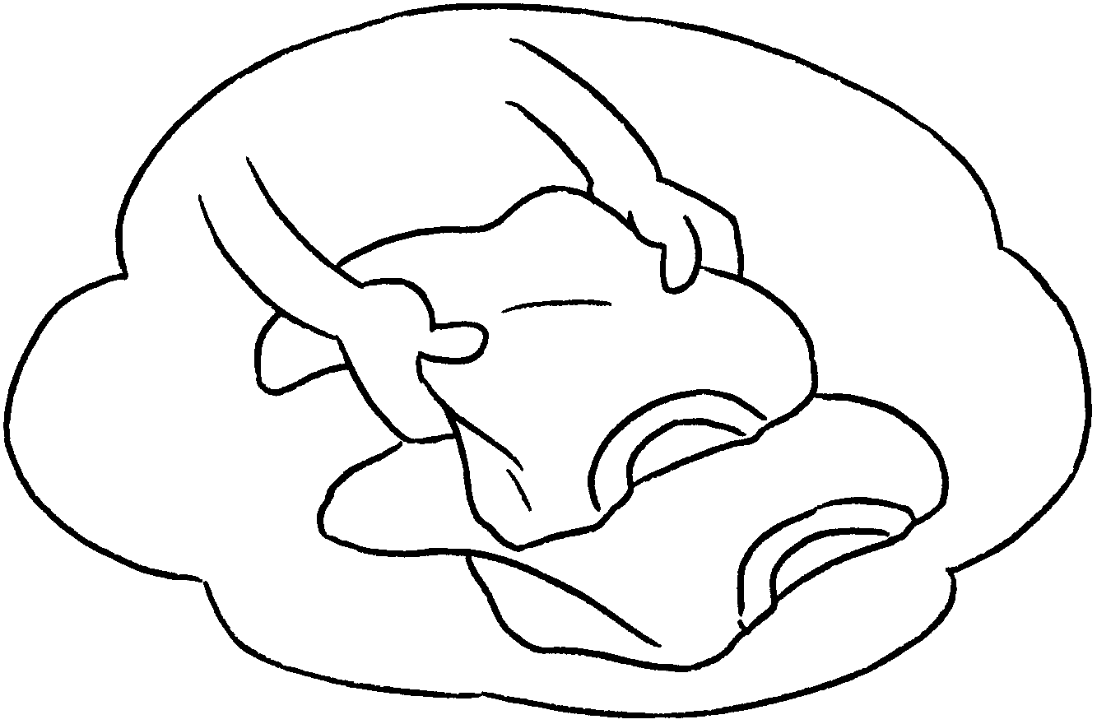 | ✗ | A :  B :


Book 2B Chapter 1 Graded Worksheets
Worksheet 2⬇⬇⬇
1 do
2 water
don’t
- Do you feed
Yes, I do.
- Do you sweep
Yes, I do.
- Do you fold the clothes?
No, I don’t.

