Choose and write.
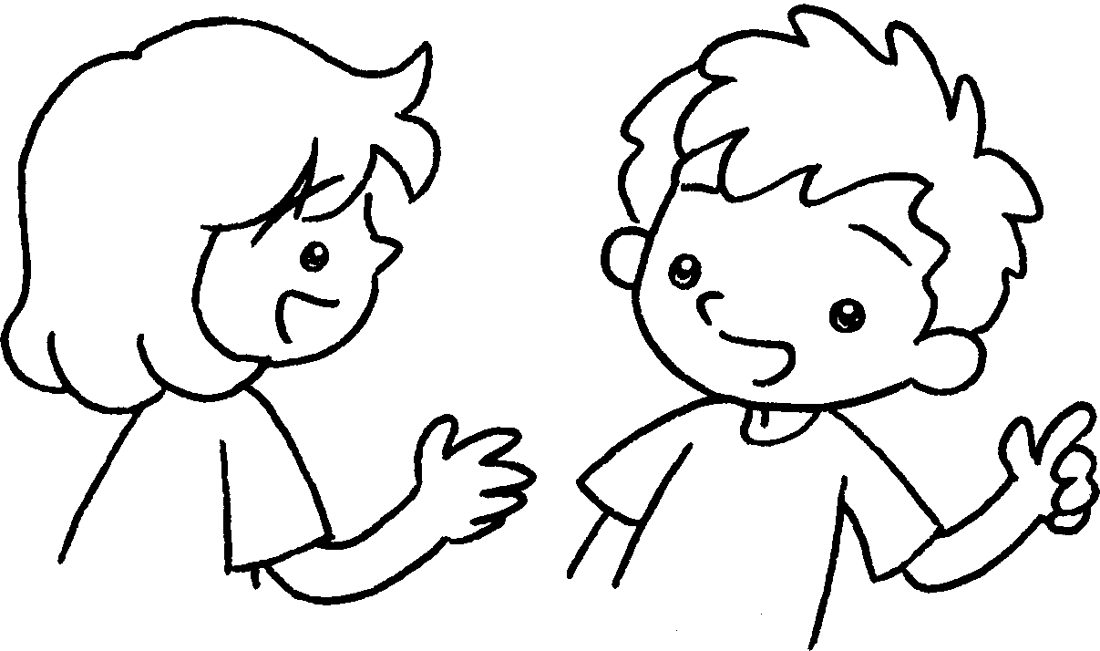
Does
he / she does
he / she doesn’t

A
B
1  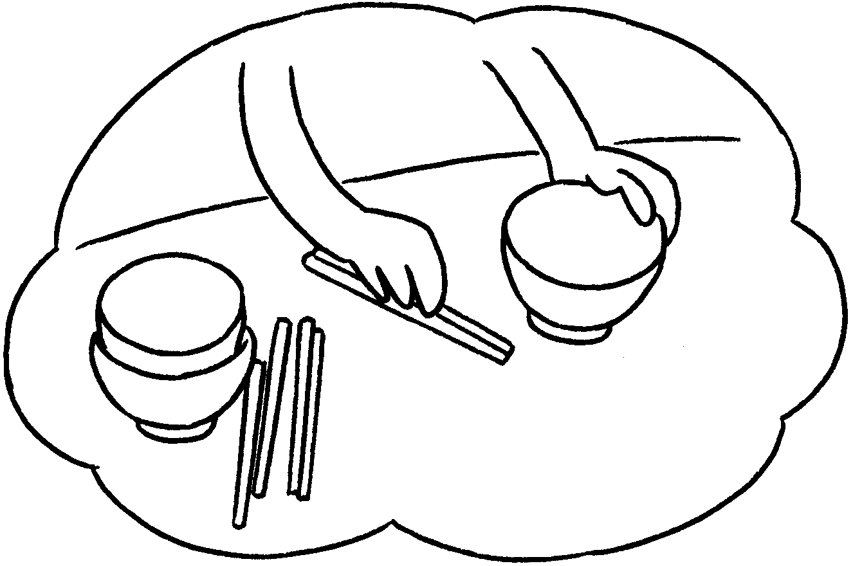 | ✗ | A : Does your sister set the table?  B : No, .
2  ✓  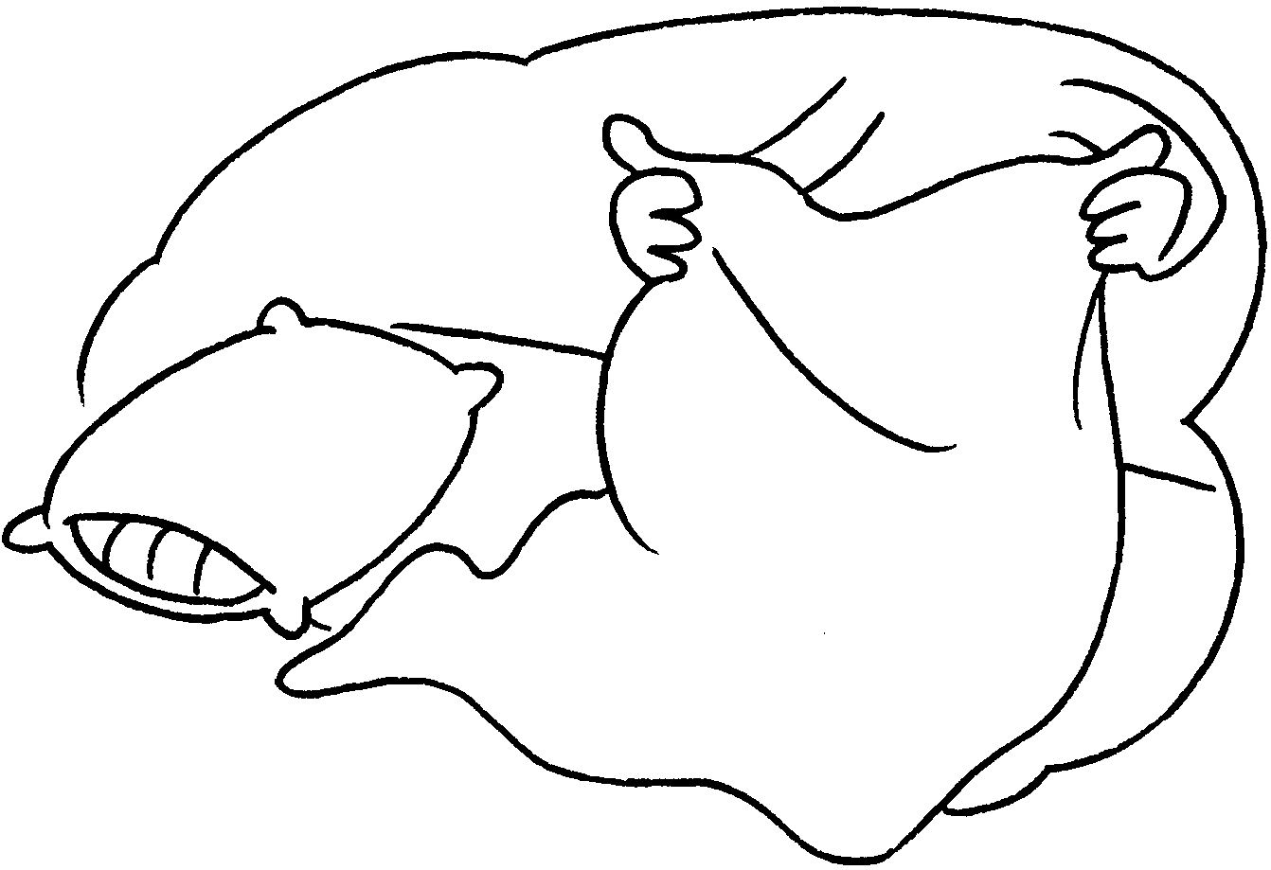 |  | A : Does your brother make the  bed?  B : Yes, .
3  ✓  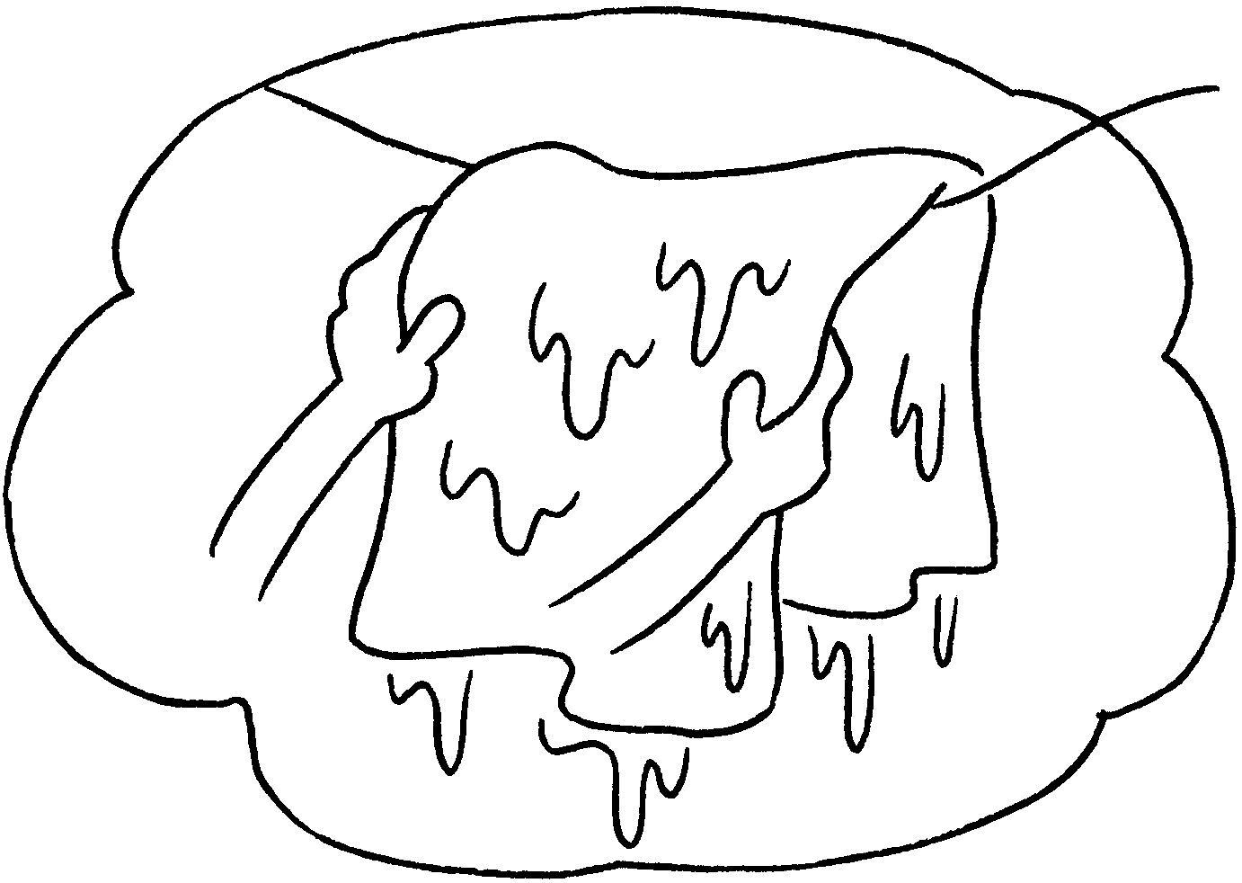 |  | A : Kitty  hang up the washing?  B : Yes, she does.
4  ✗  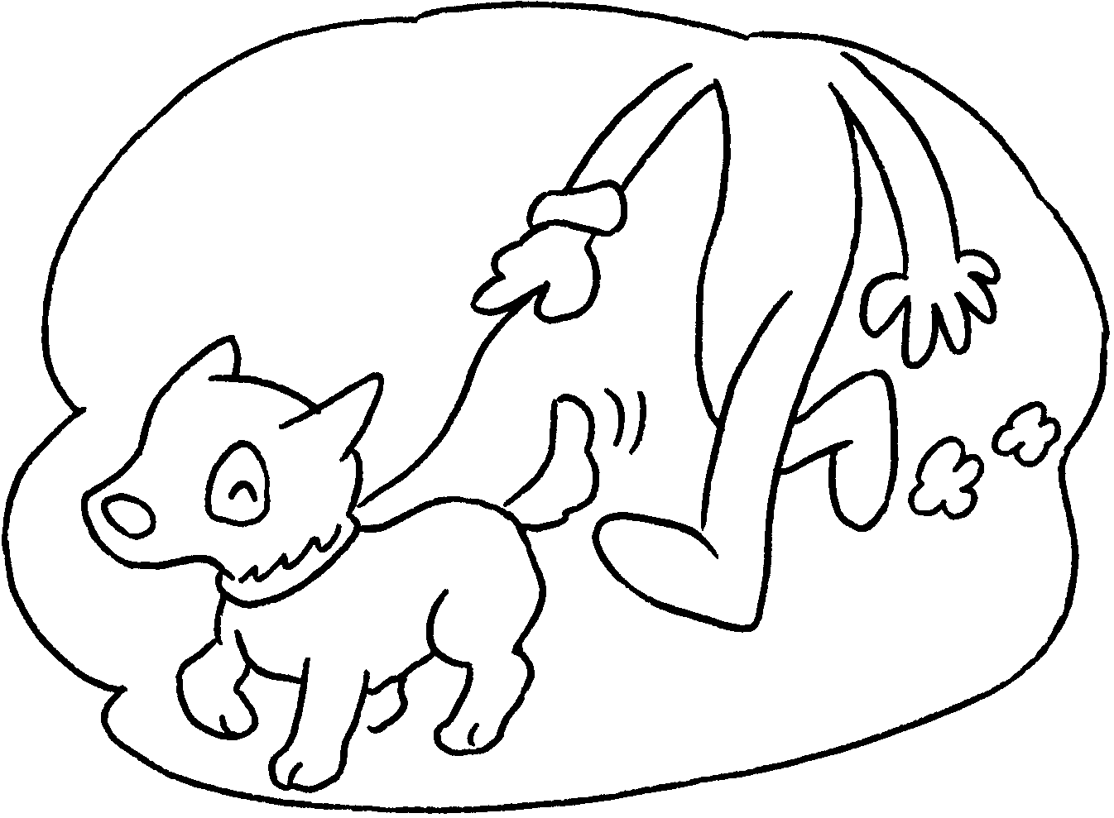 |  | A : Sam walk the dog?  B : No, .
5  ✓  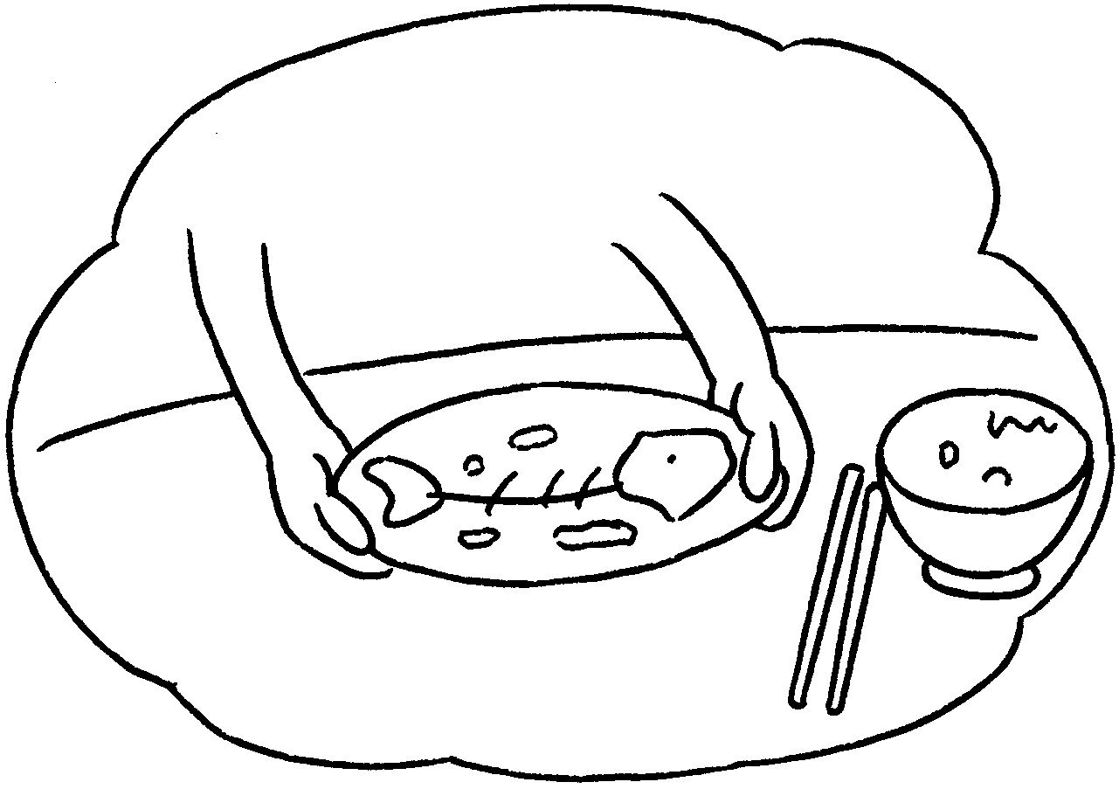 |  | A : Susan  clear the table?  B : Yes, .



Book 2B Chapter 1 Graded Worksheets
Worksheet 3⬇
- she doesn’t
- he does
- Does
- Does
he doesn’t
5 Does
she does

