Ask and answer the questions.
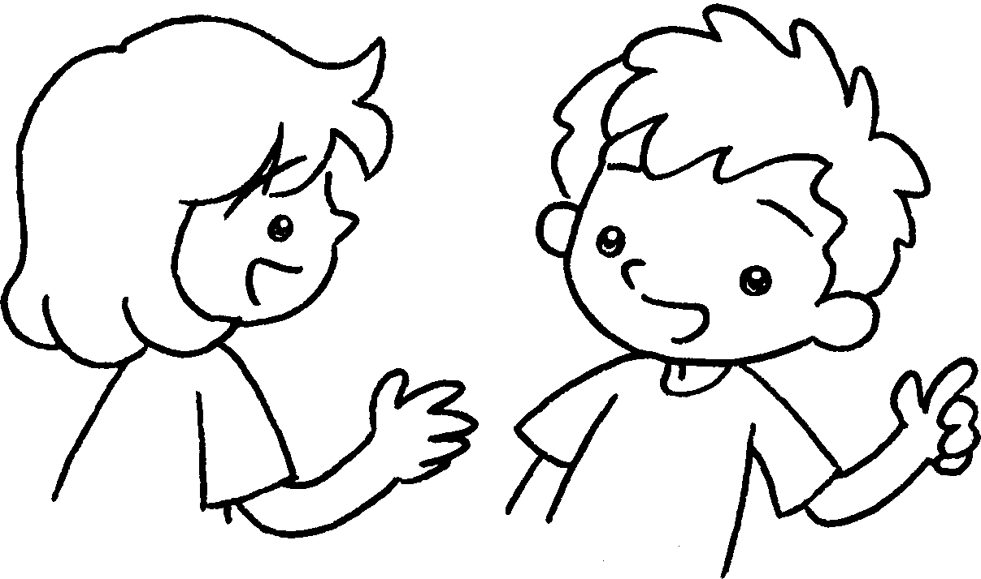
does
doesn’t
clear walk hang up make
A
B
1  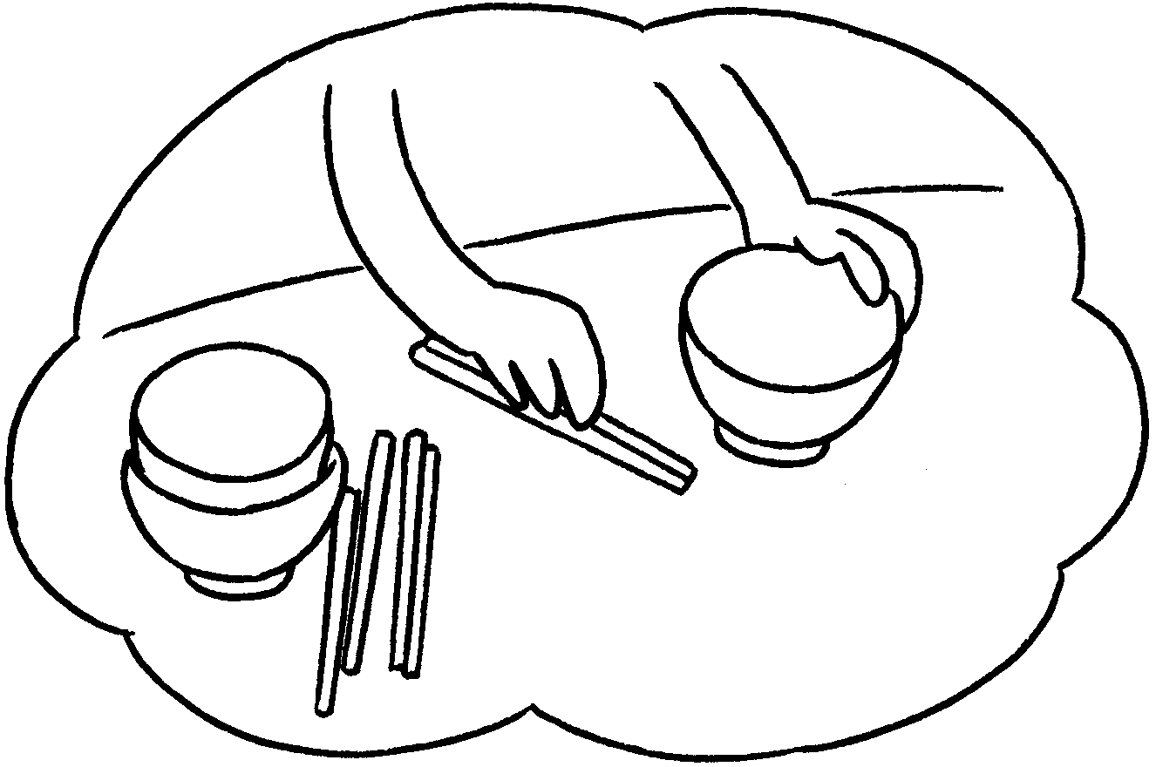 | ✗ | A : Does your sister set the table?  B : No, she .
2  ✓  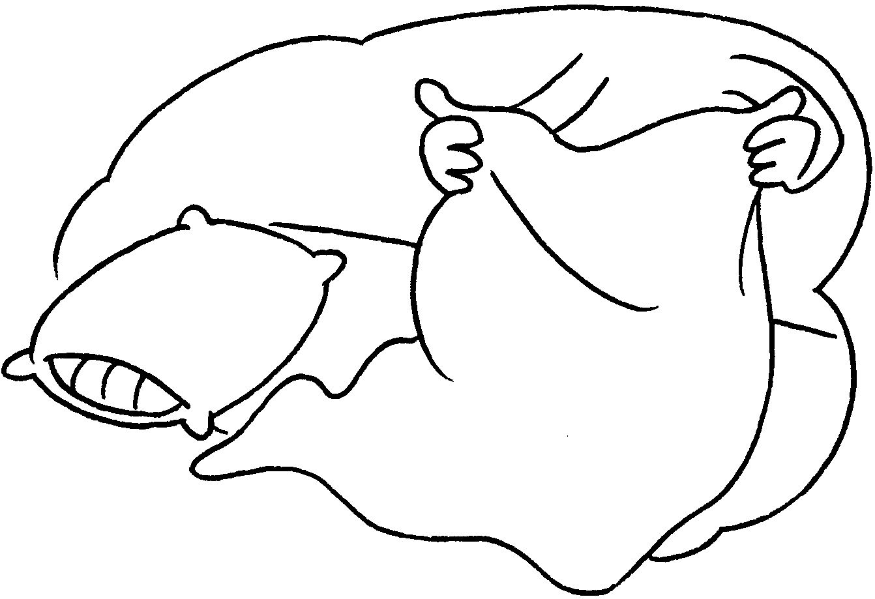 |  | A : your brother  the bed?  B : Yes, .
3  ✓  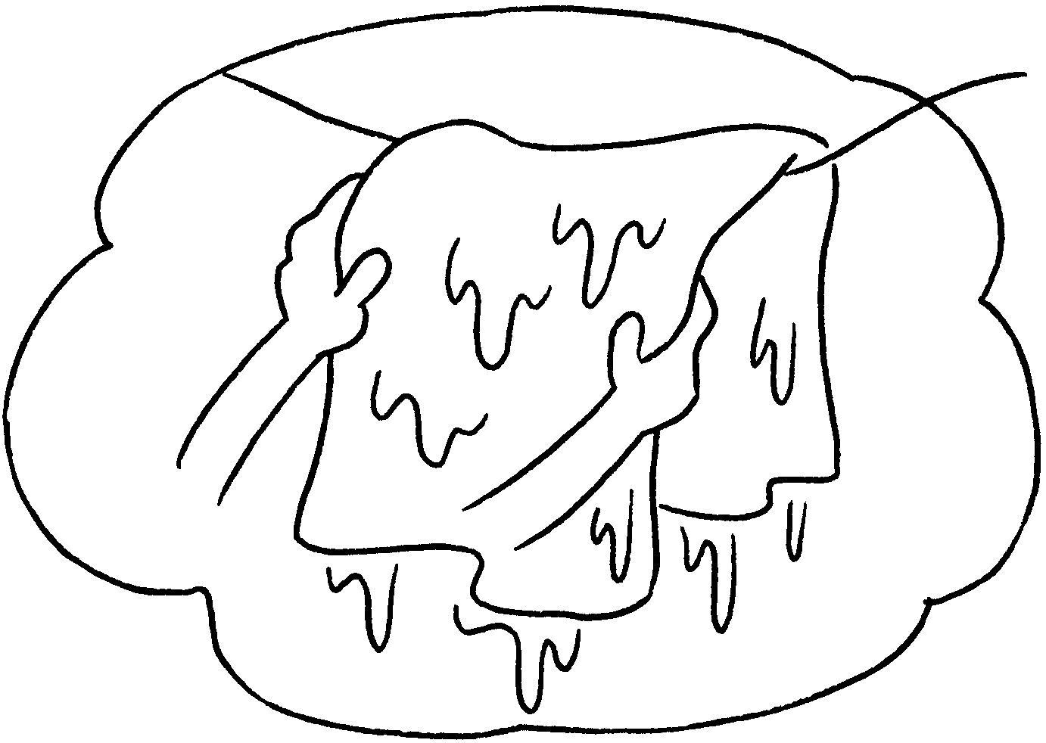 |  | A : Kitty  the washing?  B :
4  ✗  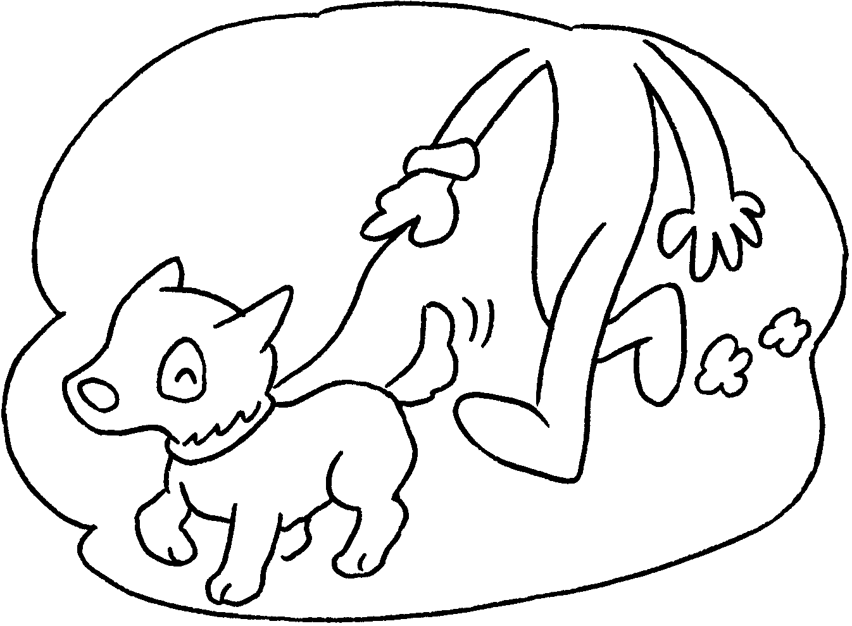 |  | A : Sam the dog?  B :
5  ✓  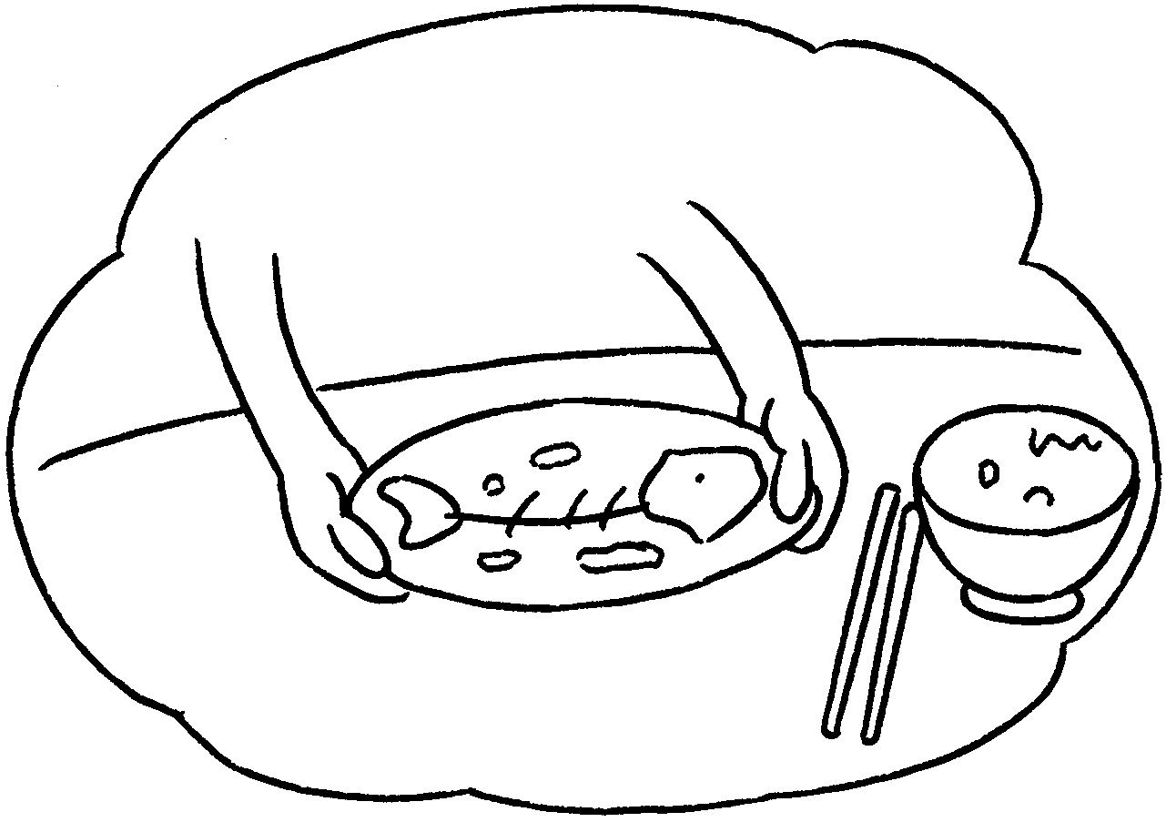 |  | A : Susan  the table?  B :



Book 2B Chapter 1 Graded Worksheets
Worksheet 3⬇⬇
- doesn’t
- Does make
he does
- Does hang up
Yes, she does.
- Does walk
No, he doesn’t.
- Does clear
Yes, she does.

