Ask and answer the questions.
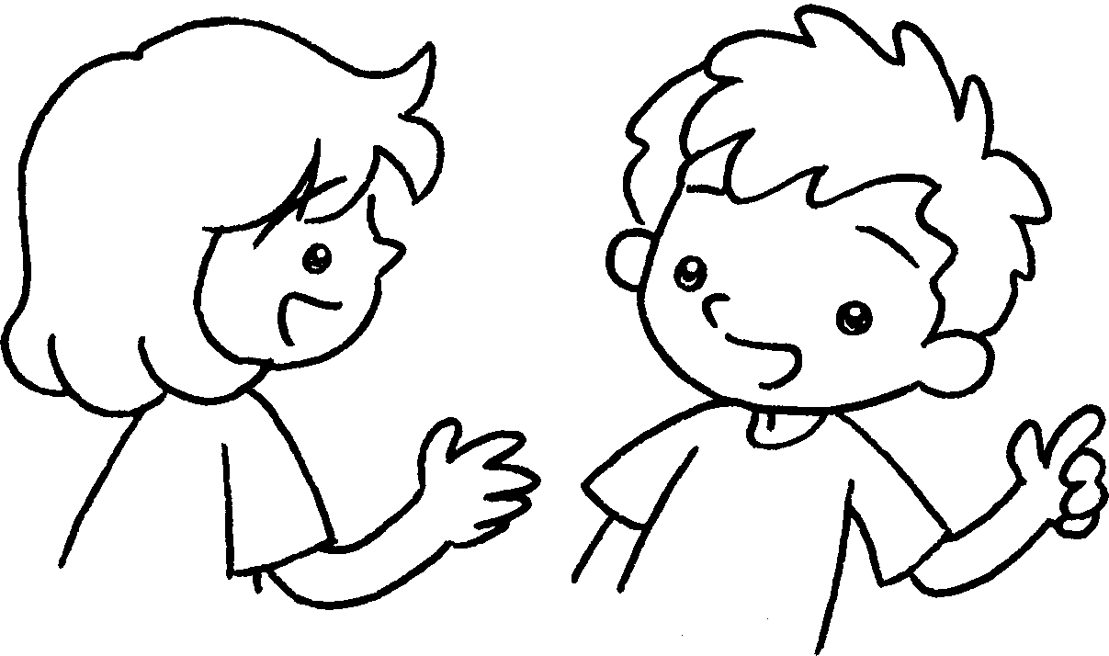
A
B
1  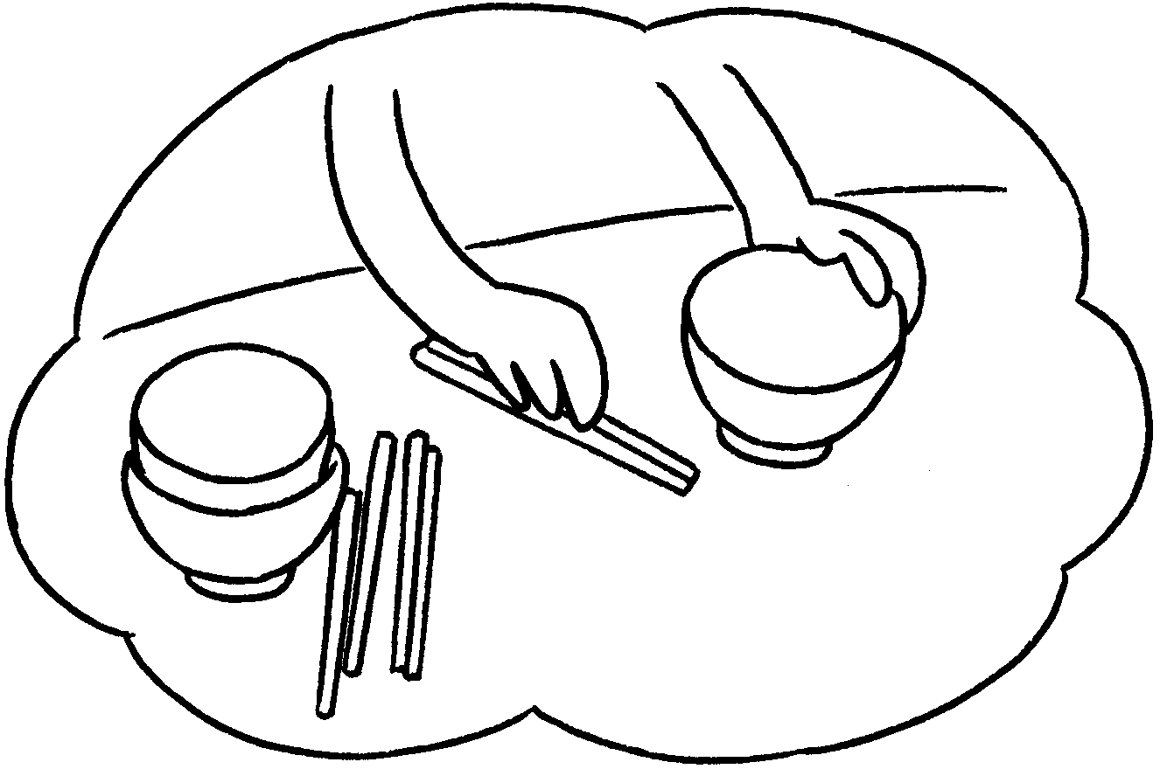 | ✗ | A : Does your sister set the table?  B : No, she .
2  ✓  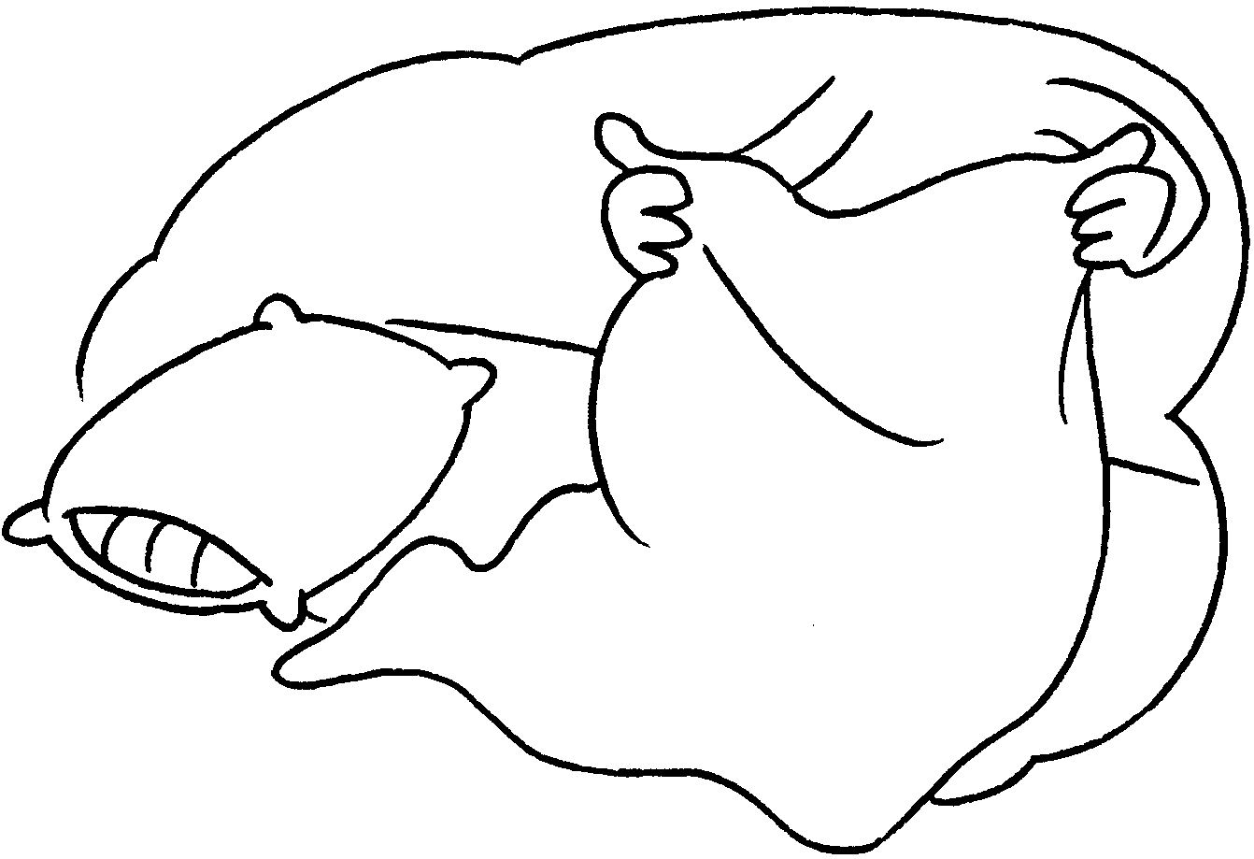 |  | A : Does your brother the bed?  B : Yes, does.
3  ✓  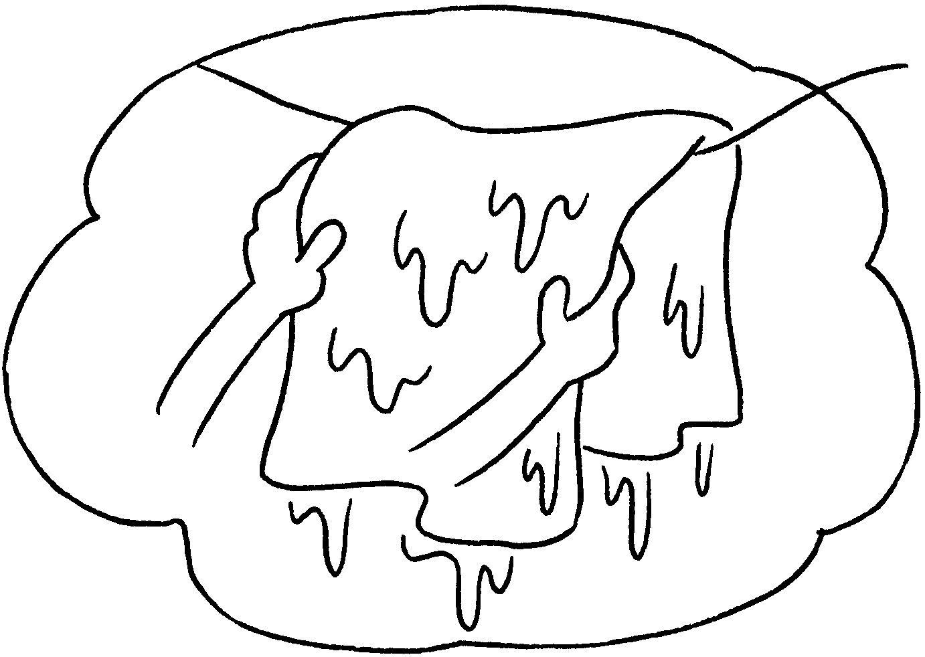 |  | A : Kitty  the washing?  B :
4  ✗  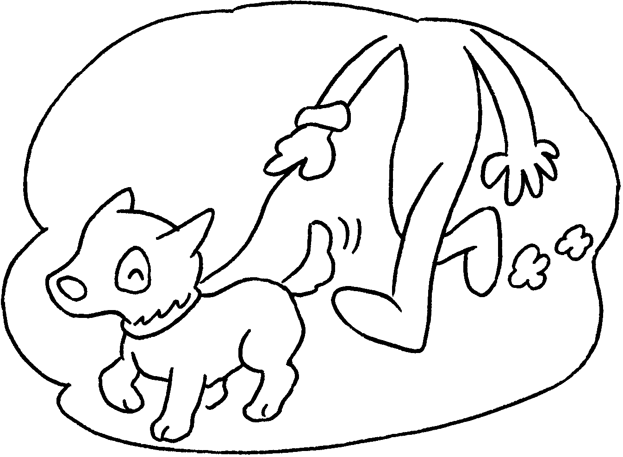 |  | A : Sam  ?  B :
5  ✓  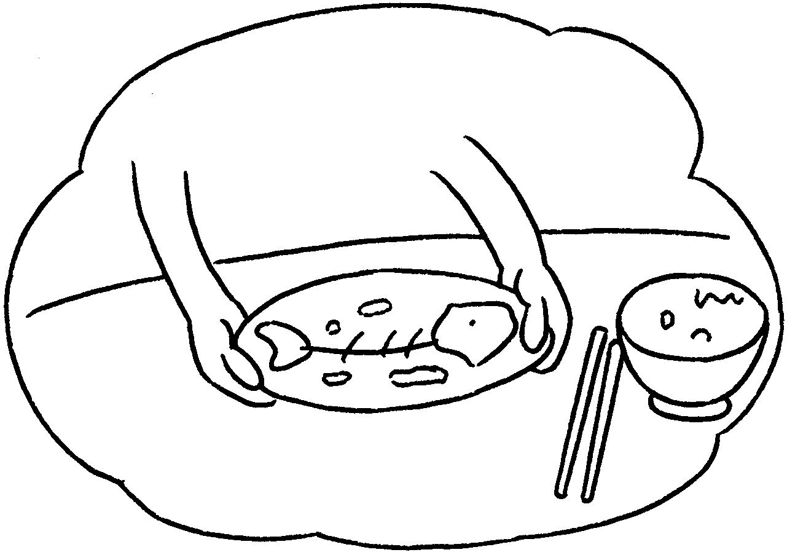 |  | A : Susan  ?  B :


Book 2B Chapter 1 Graded Worksheets
Worksheet 3⬇⬇⬇
1 doesn’t
2 make
he
3 Does hang up
Yes, she does.
4 Does walk the dog
No, he doesn’t.
- Does clear the table
Yes, she does.

