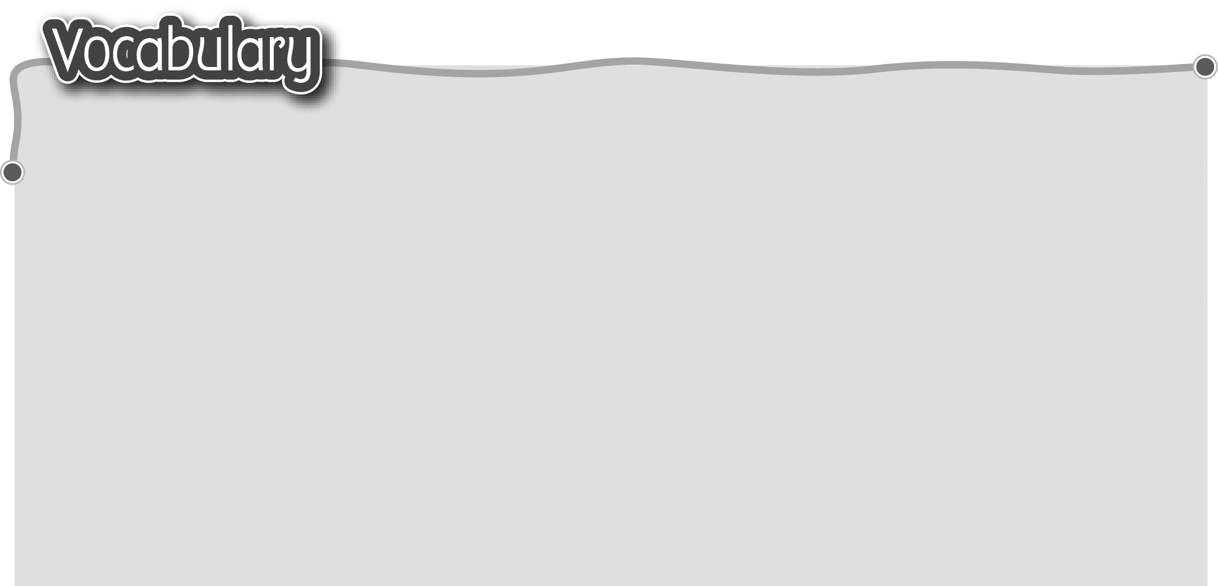
1 housework 家務 6 fold the clothes 摺疊衣服
2 make the bed 整理床舖 7 set the table 在桌上擺好餐具
3 sweep the floor 掃地 8 clear the table 收拾桌子
4 water the plants 9 walk the dog 帶狗散步
給植物澆水 10 feed the dog 餵狗
5 hang up the washing
掛起已洗的衣物
The words marked with * have different meanings in other contexts. You can look up those meanings in a dictionary.
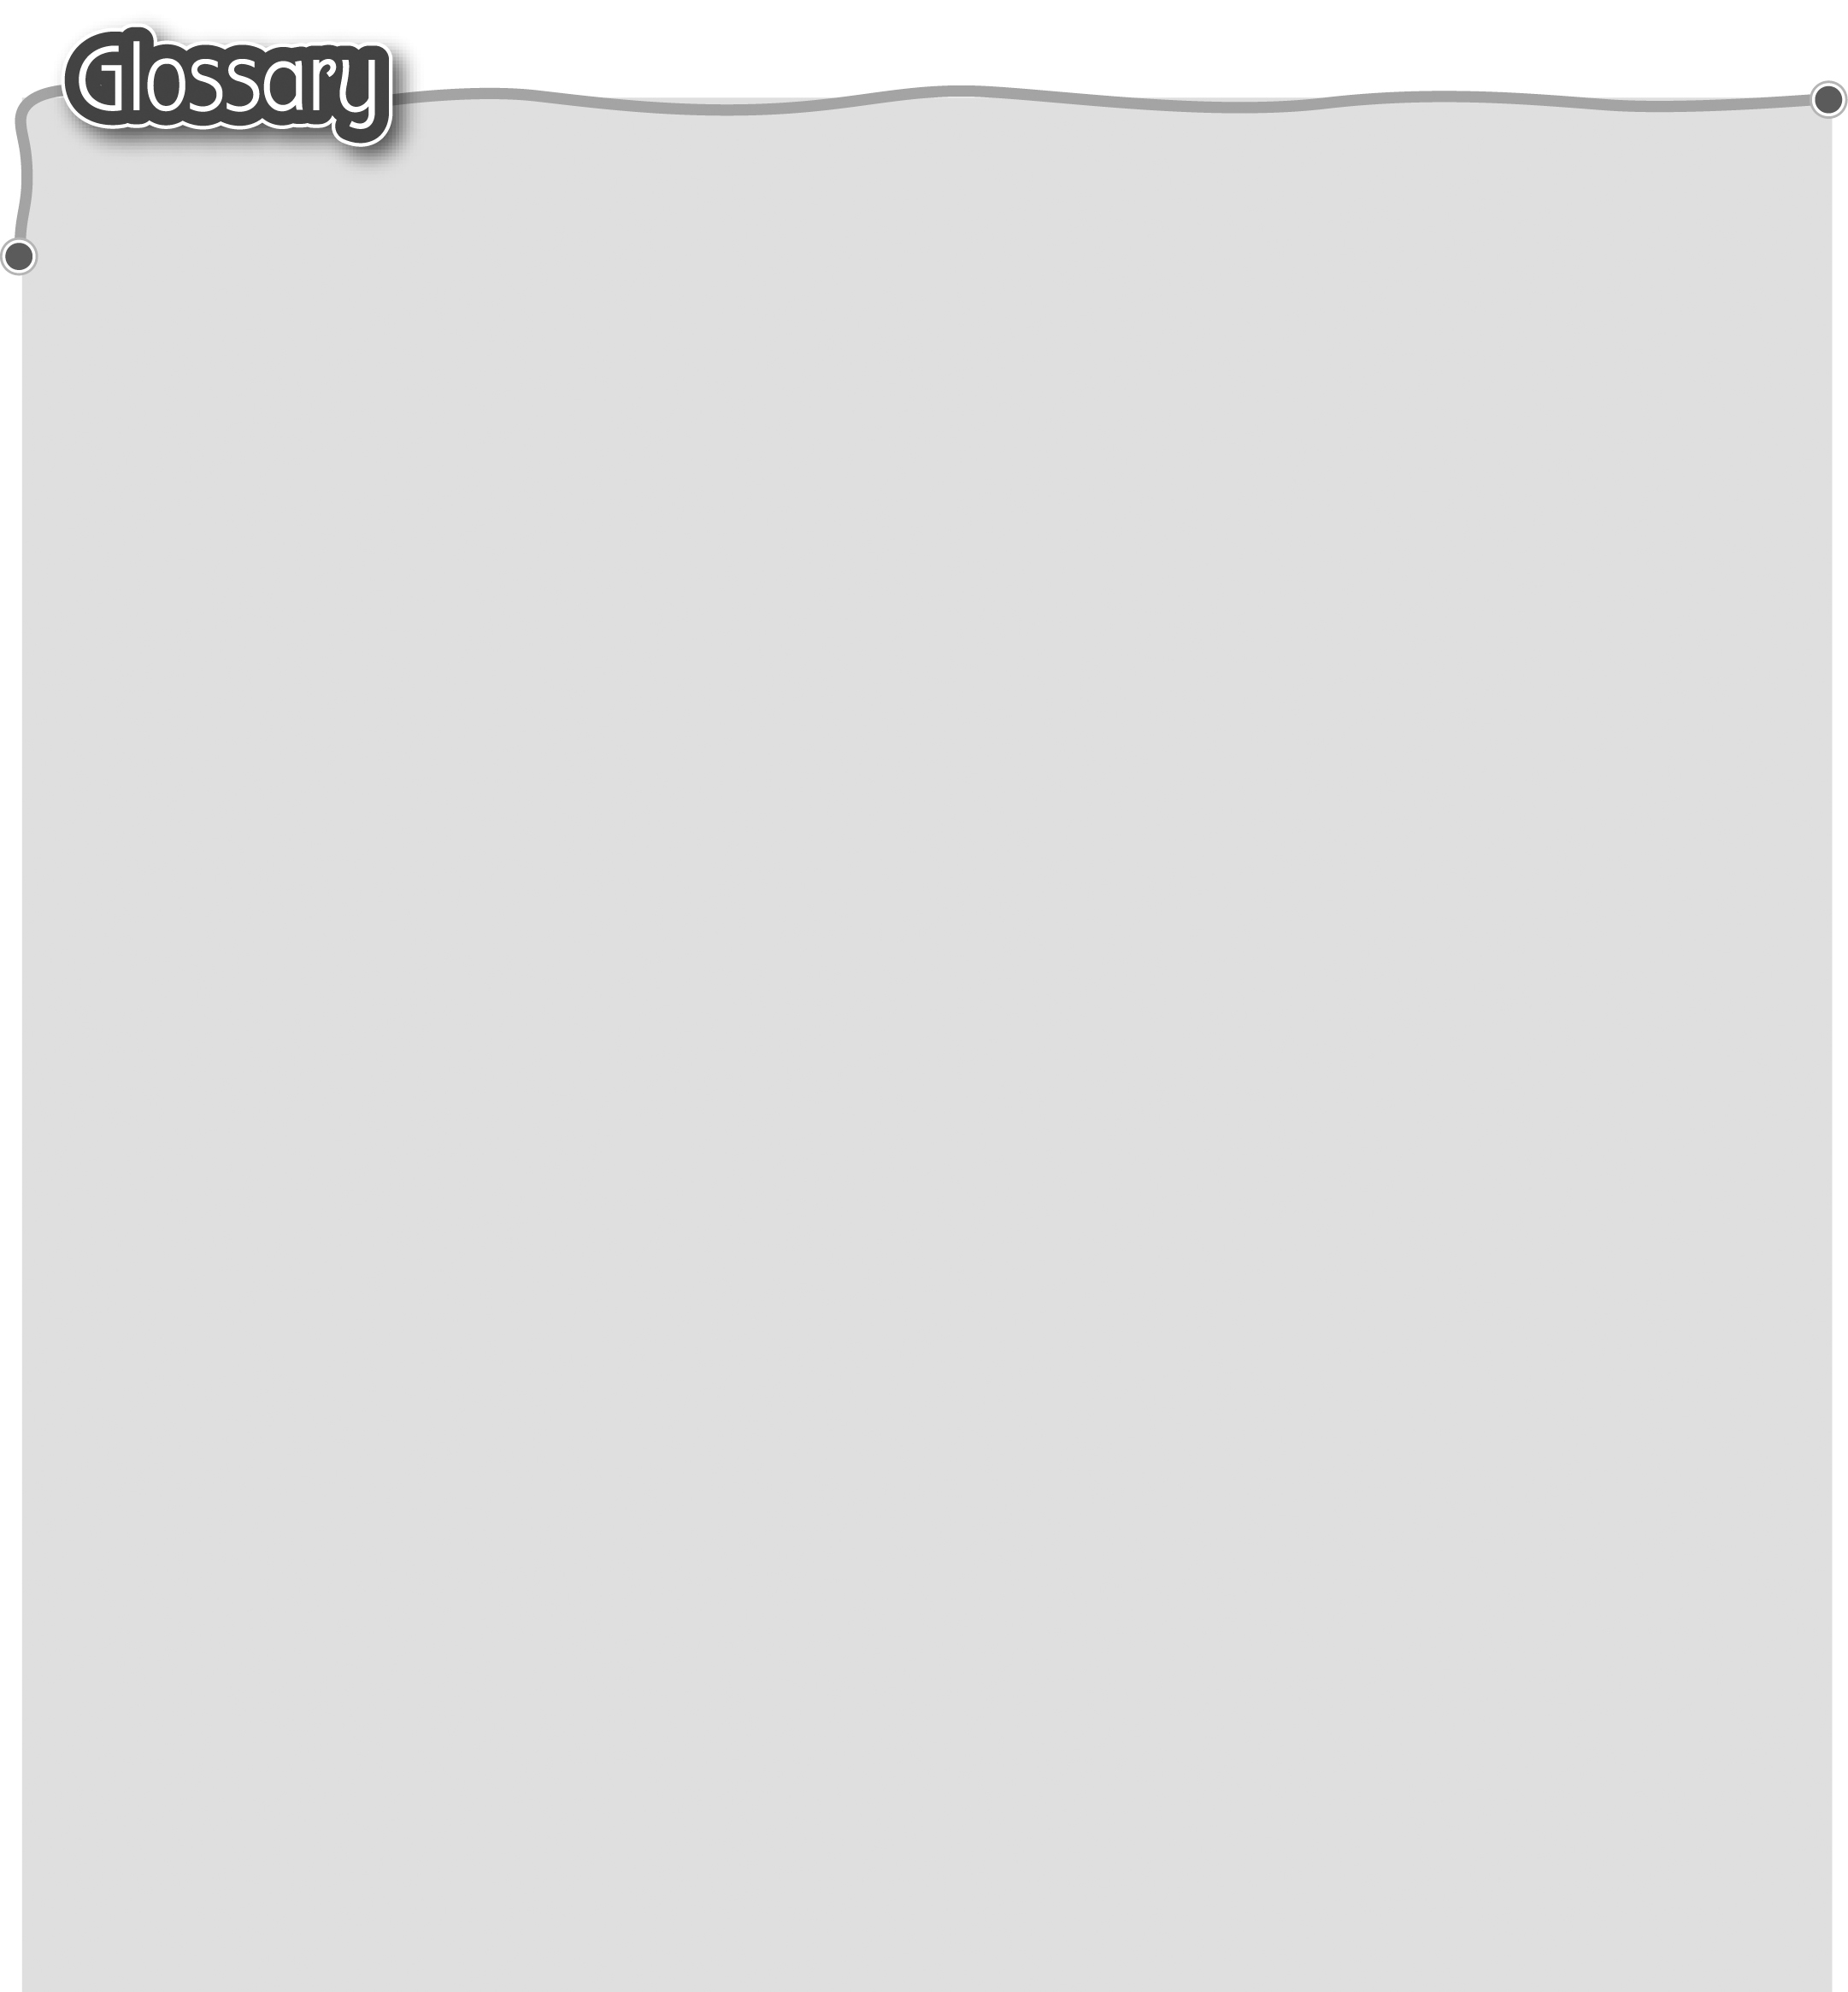
1 ask* (p.2) 詢問 10 written / words / text / story
2 bedroom (p.2) 睡房 by … (p.9) 由……著作
3 living room (p.2) 客廳 11 illustrator (p.9) 插圖師
4 bathroom (p.3) 浴室 12 illustrated / illustrations /
5 dining room (p.3) 飯廳 pictures / artwork by … (p.9)
- help at home (p.5) 由……畫插圖
幫忙做家務 13 school life (p.9) 校園生活
7 book cover (p.9) 書本封面 14 parent (p.9) 家長
8 title* (p.9) 書名 15 favourite (p.9) 最喜愛
9 author (p.9) 作者

