Choose and write.

hard-working | polite | tidy | helpful
lazy | rude | untidy | honest

1 | 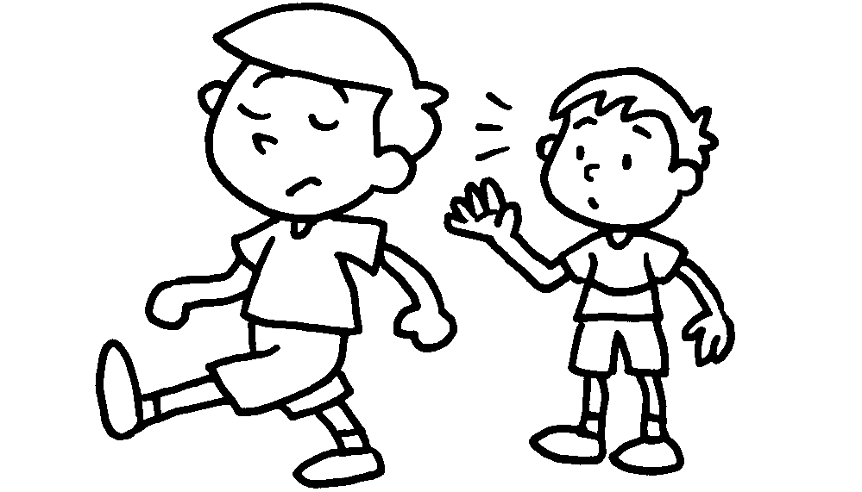 |  | 2 | 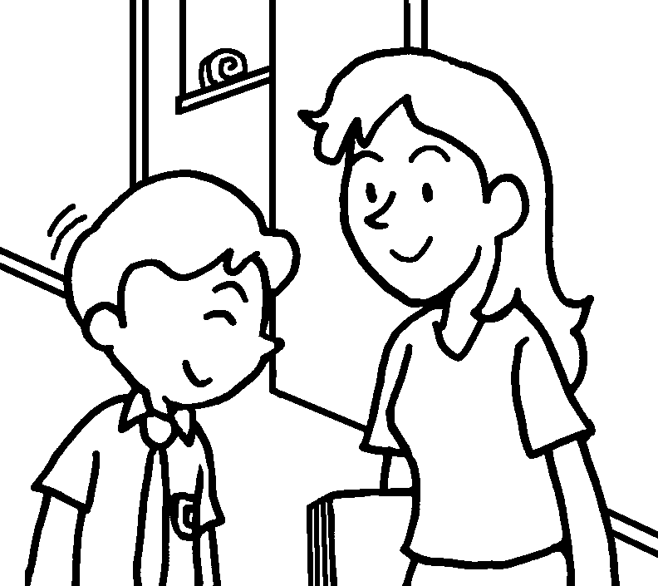
3 | 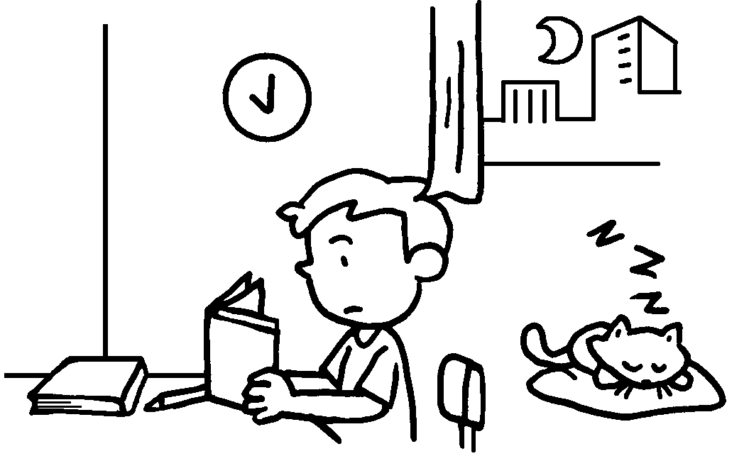 |  | 4 | 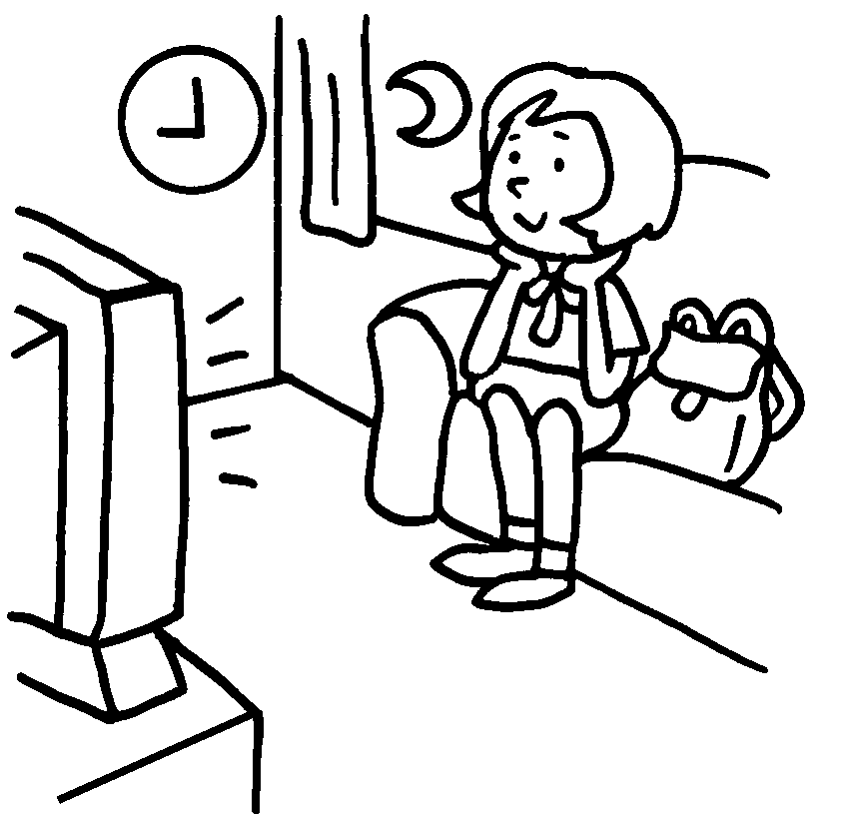
5 | 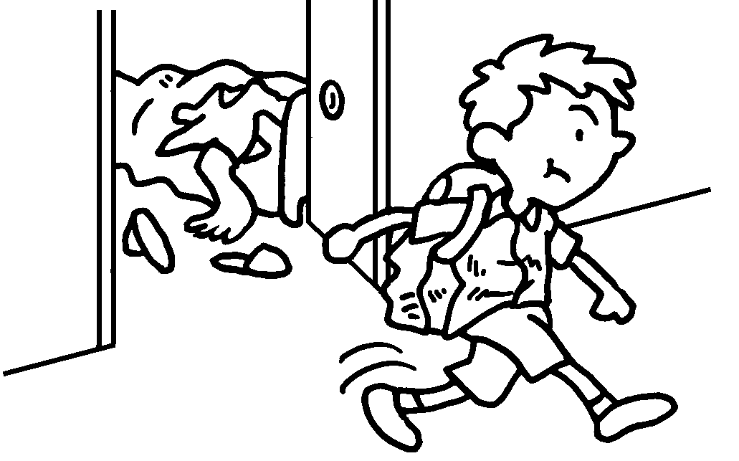 |  | 6 | 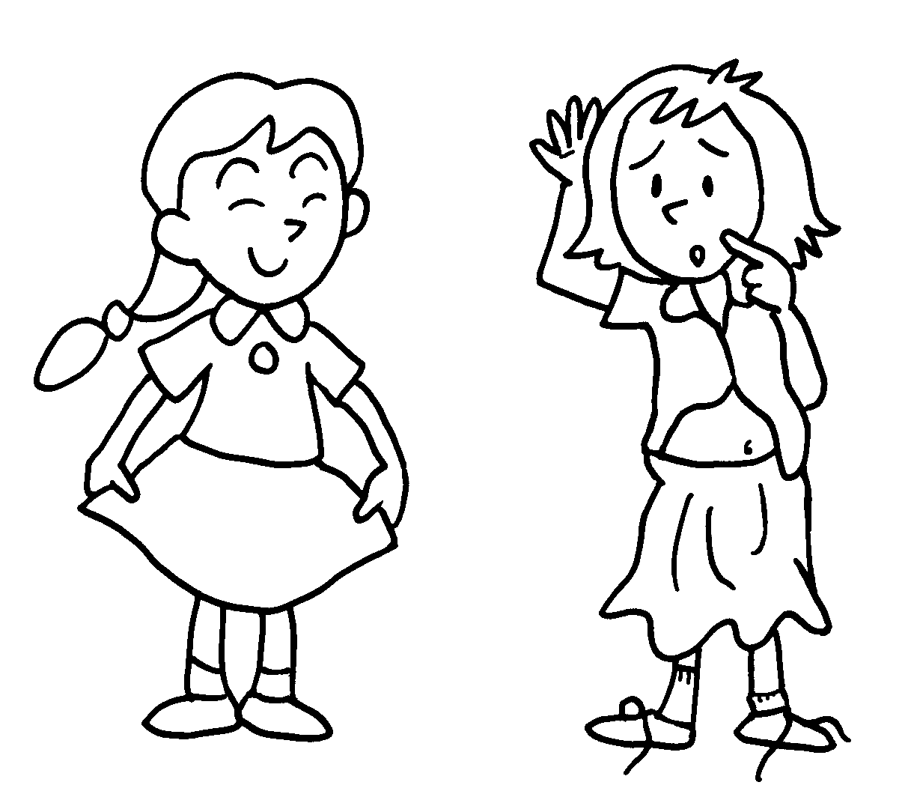
7 | 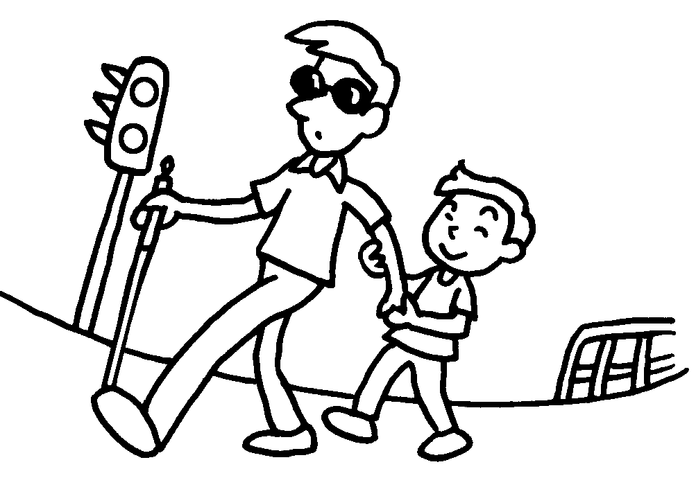 |  | 8 | 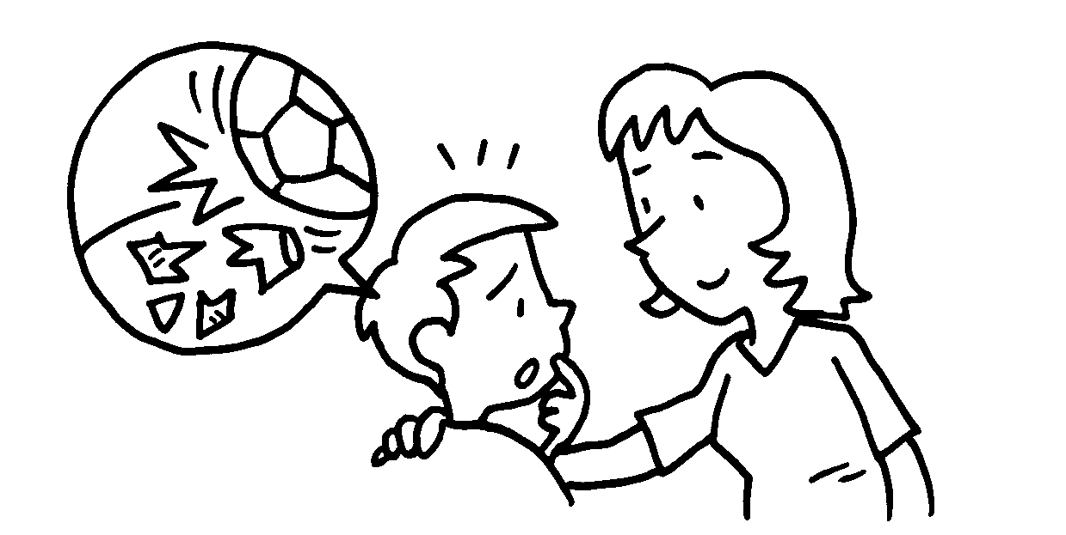

Book 2B Chapter 2 Graded Worksheets

Worksheet 1⬇
1 rude 2 polite
3 hard-working 4 lazy
5 untidy 6 tidy
7 helpful 8 honest

