Look at the pictures. Fill in the missing letters.

1 | 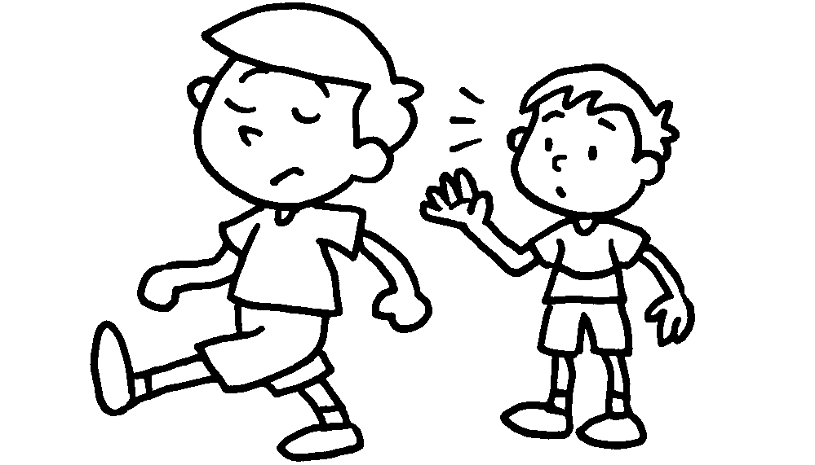 |  | 2 | 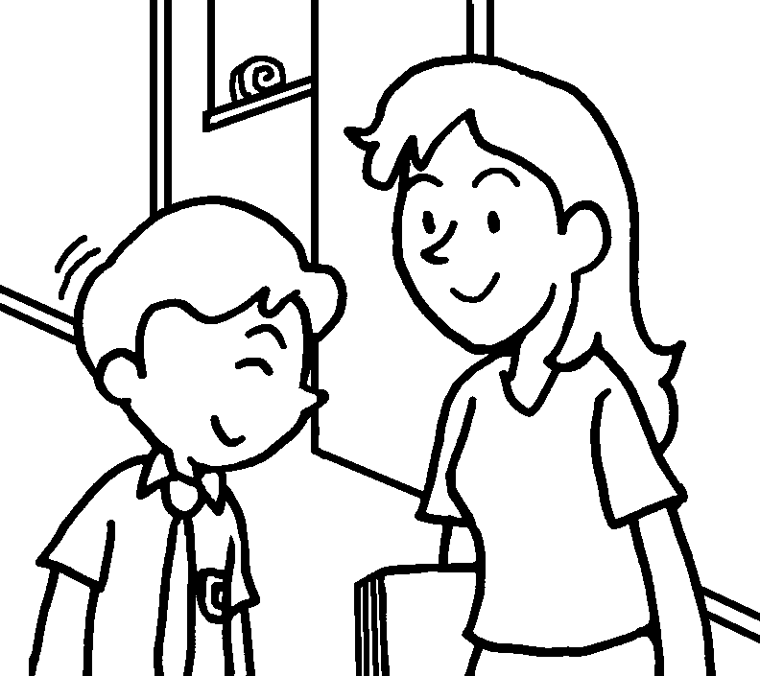
 | Sam is ru __ __ . |  | Terry is p __ __ __ __ __.
3 | 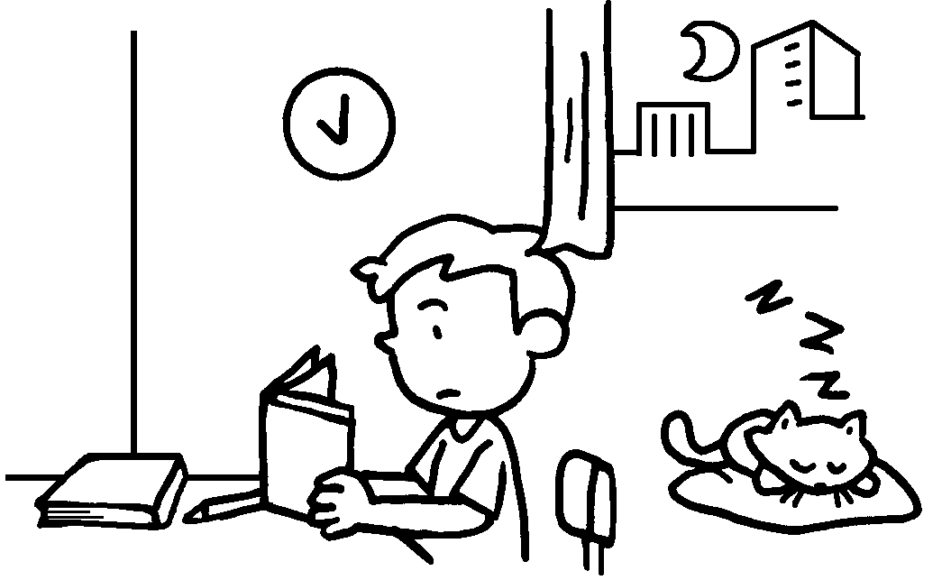 |  | 4 | 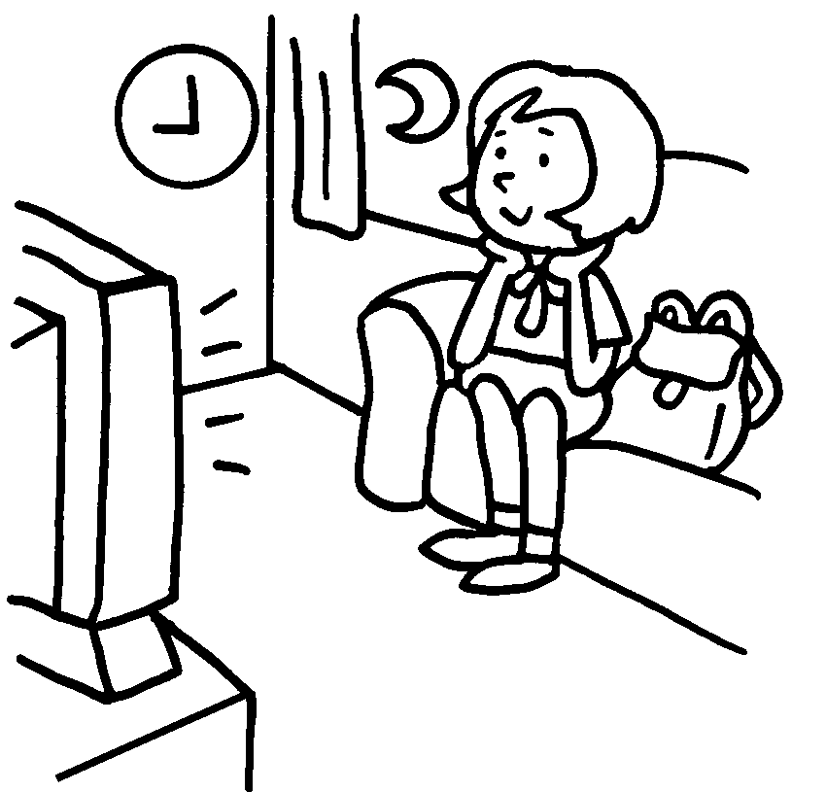
 | Tom is ha __ __ -wo __ __ ing. |  |  | May is l __ __ __ .
5 | 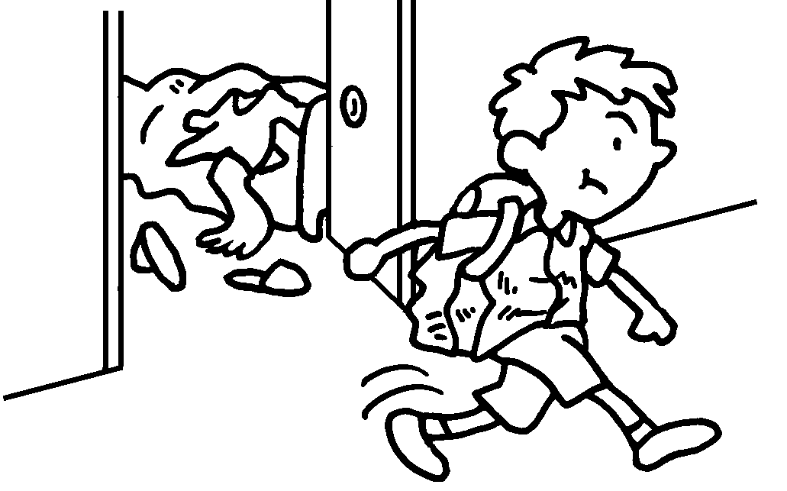 |  | 6 | 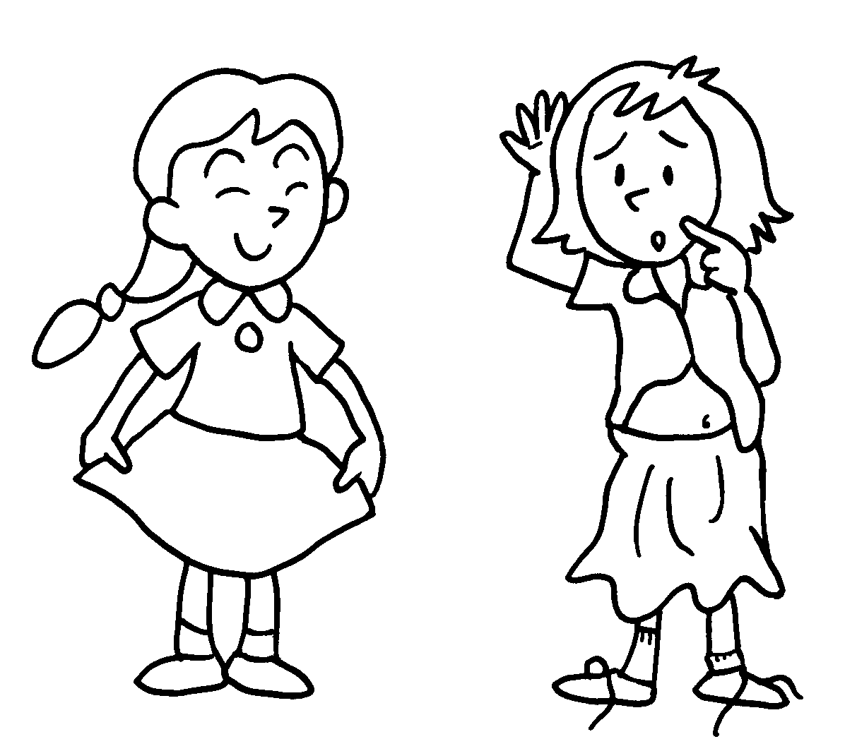
 | Dan is u __ __ __ __ __ . |  |  | Alice is t __ __ __ .
7 | 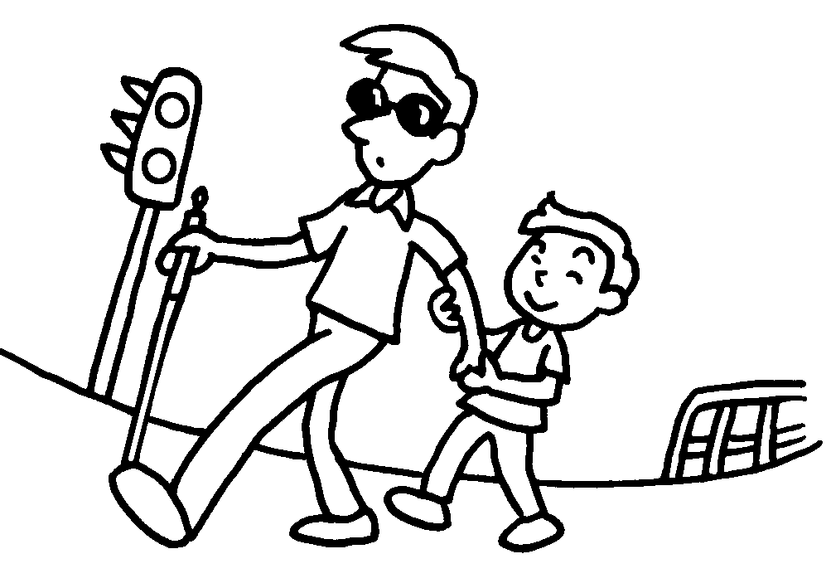 |  | 8 | 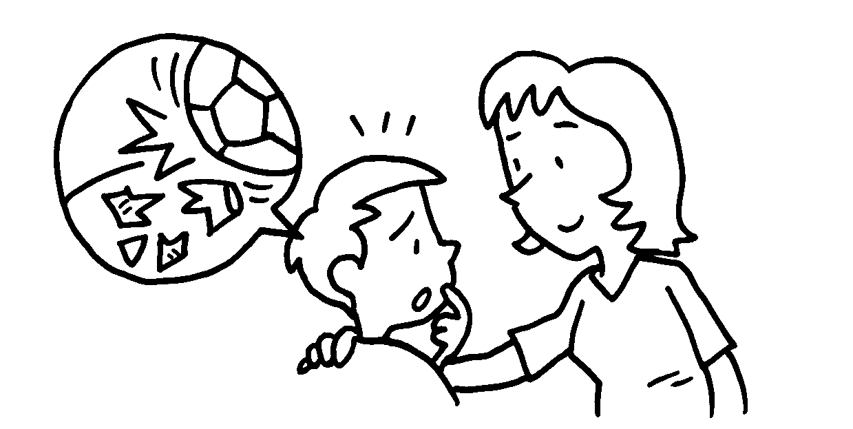
 | Ben is h __ __ __ __ __ __ . |  |  | Roy is h __ __ __ __ __ .

Book 2B Chapter 2 Graded Worksheets

Worksheet 1⬇⬇
1 ru d e 2 p o l i t e
3 ha r d-wor king 4 l a z y
5 u n t i d y 6 t i d y
7 h e l p f u l 8 h o n e s t

