Look at the pictures and fill in the blanks.

1 | 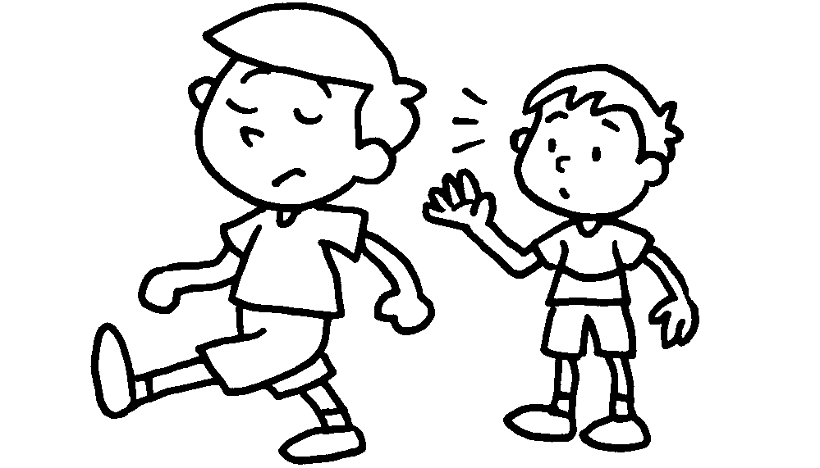 |  | 2 | 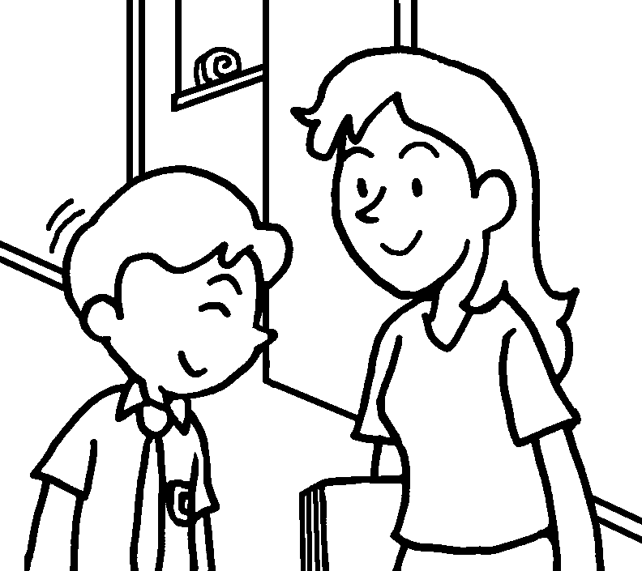
 | Sam is .  rude |  |  | Terry is p .
3 | 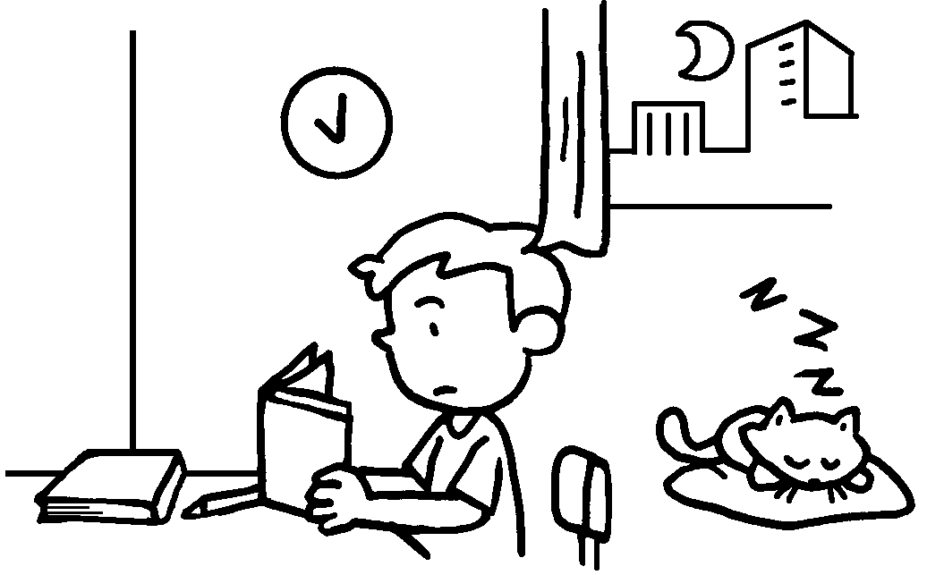 |  | 4 | 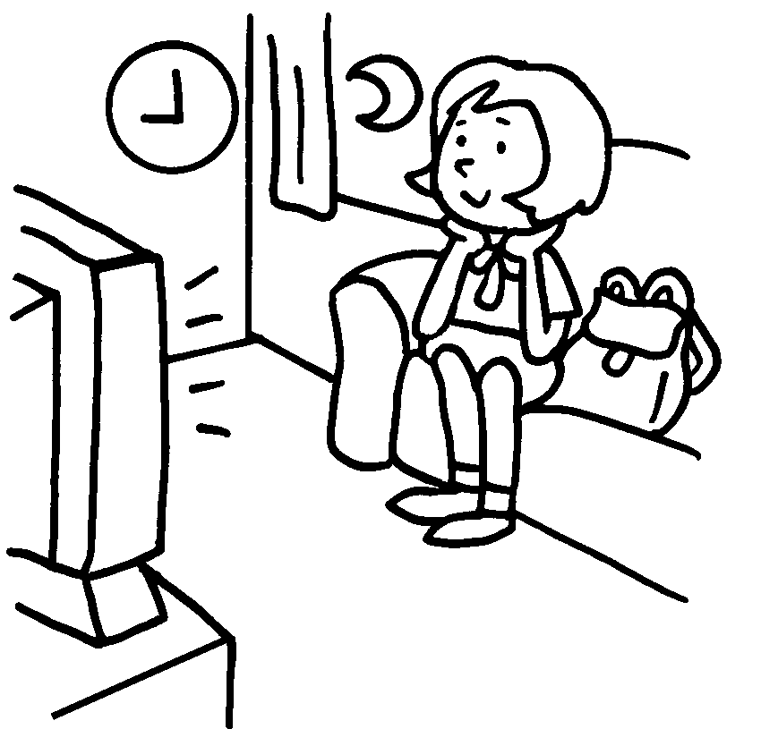
 | Tom is h . |  |  | May is l .
5 | 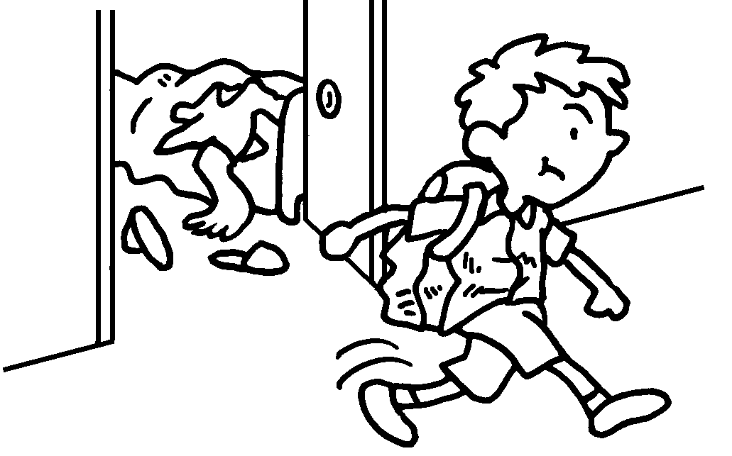 |  | 6 | 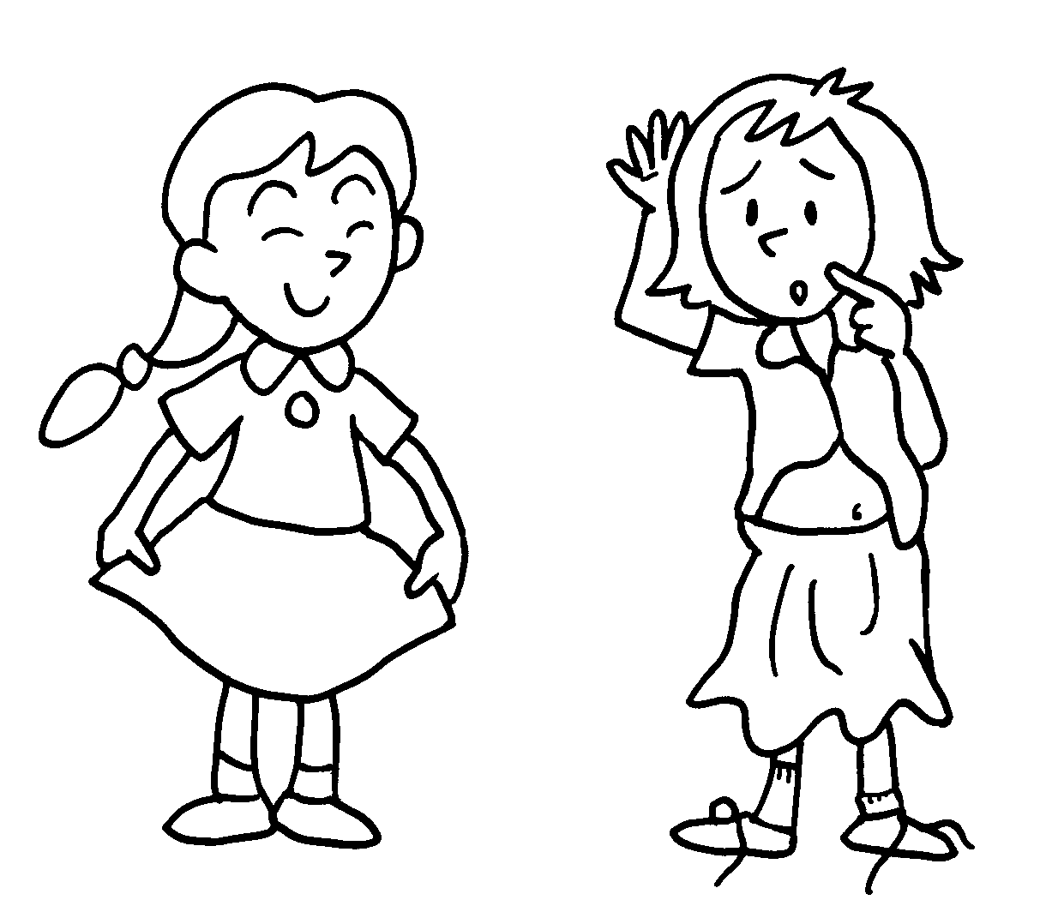
 | Dan is . |  |  | Alice is .
7 | 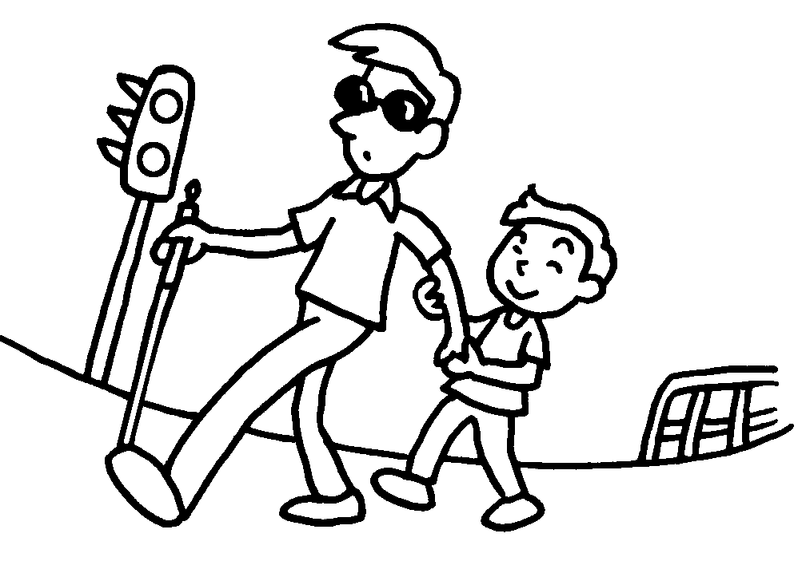 |  | 8 | 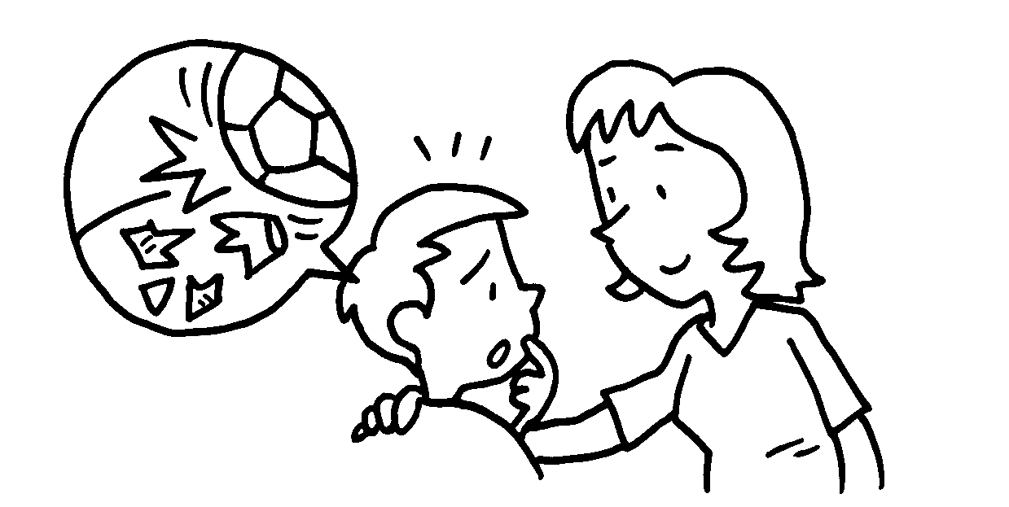
 | Ben is . |  |  | Roy is .

Book 2B Chapter 2 Graded Worksheets

Worksheet 1C⬇⬇⬇
2 polite
3 hard-working 4 lazy
5 untidy 6 tidy
7 helpful 8 honest

