Fill in the blanks. Use the simple present tense.

play do watch read study

1 | 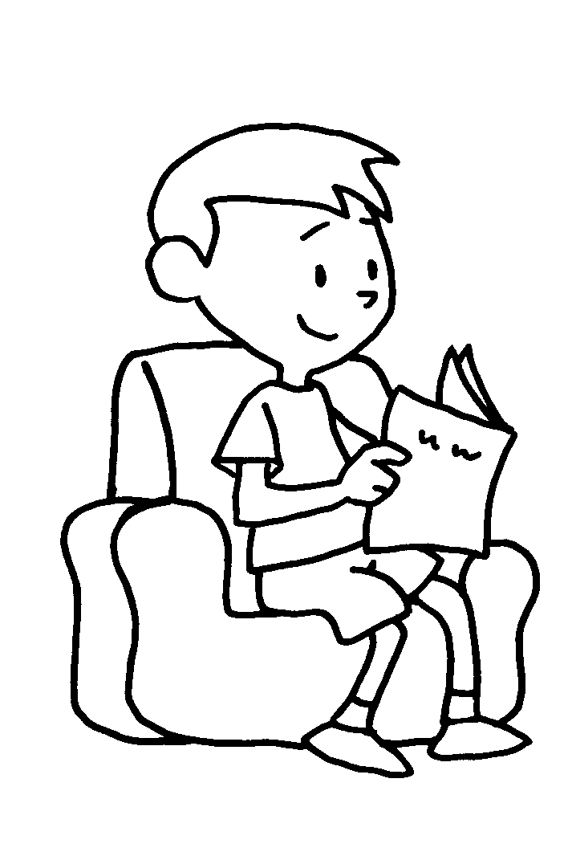 | Paul a book  every day.
2 | 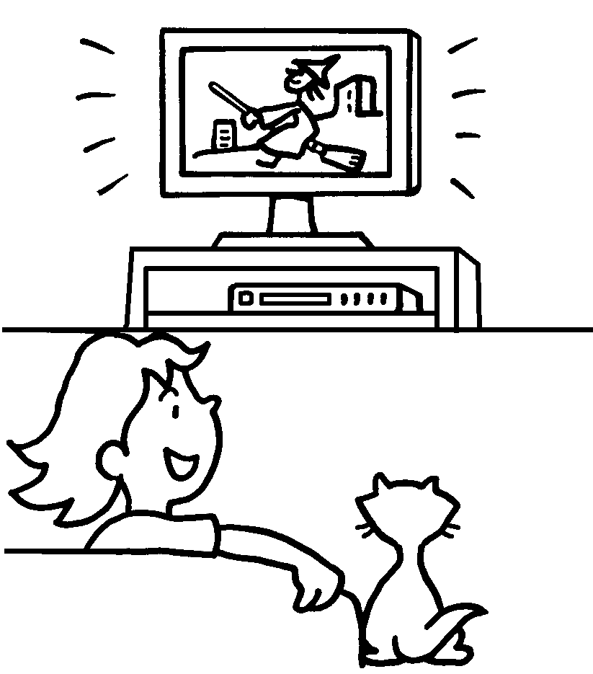 | Carol TV  every day.
3 | 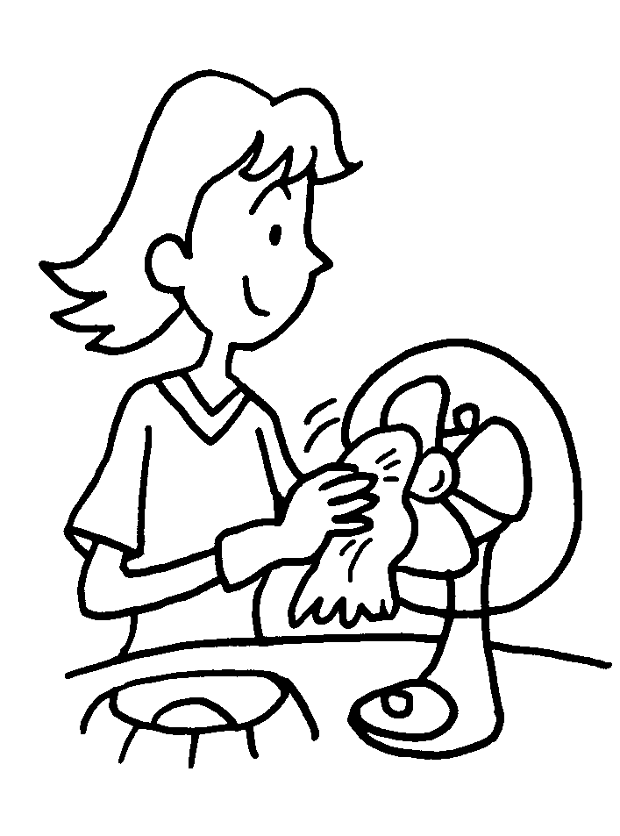 | Kelly housework  every week.
4 | 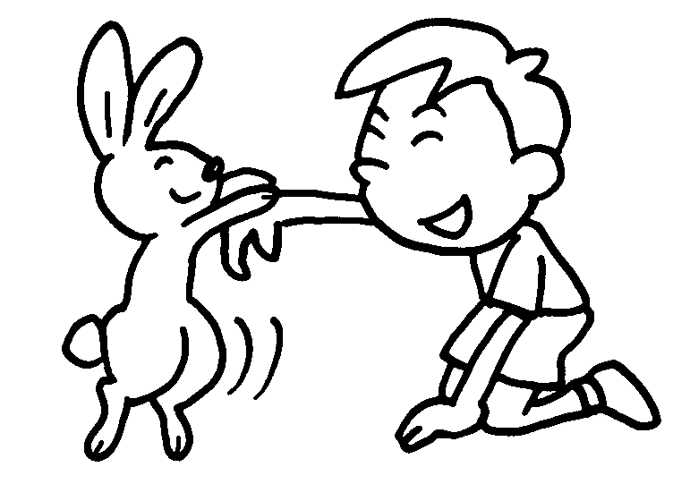 | Peter with his  rabbit every day.
5 | 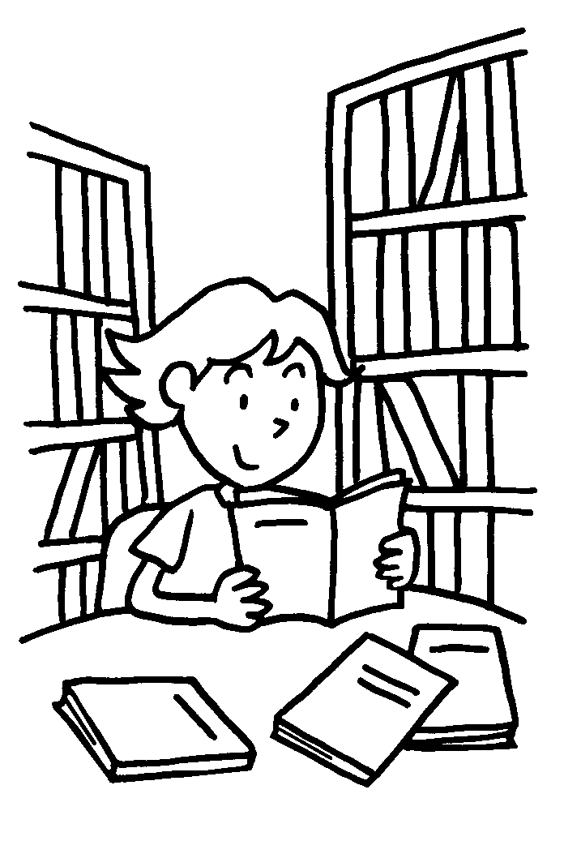 | My sister in  the library every week.

Book 2B Chapter 2 Graded Worksheets

Worksheet 2⬇⬇
- reads
- watches
- does
- plays
- studies

