Fill in the blanks. Use the simple present tense.
1 | 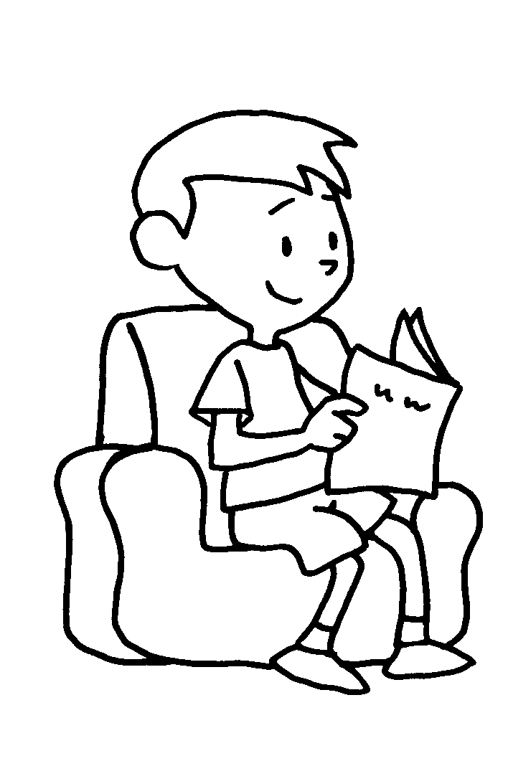 | Paul r a book  every day.
2 | 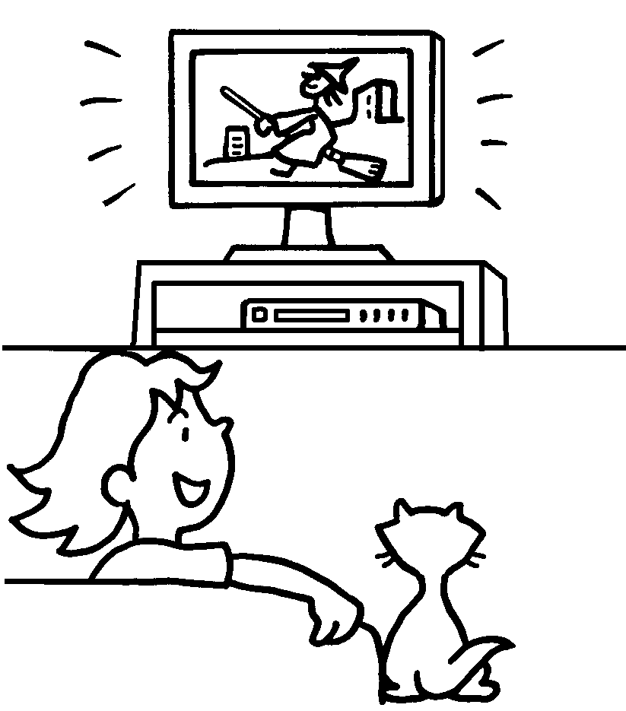 | Carol w TV  every day.
3 | 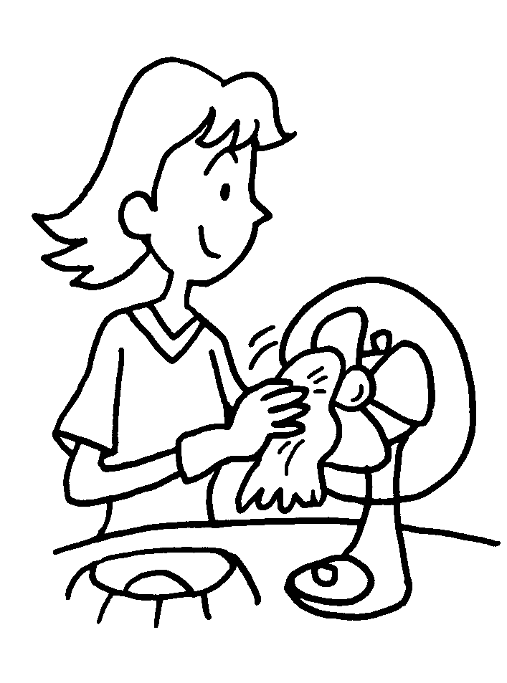 | Kelly d housework every week.
4 | 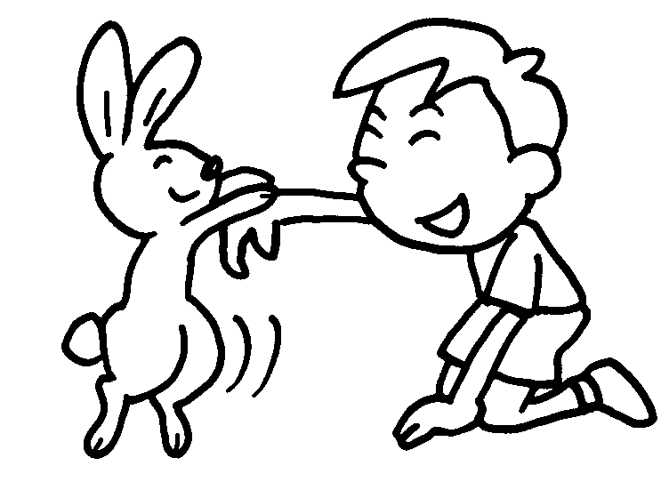 | Peter p with his  rabbit every day.
5 | 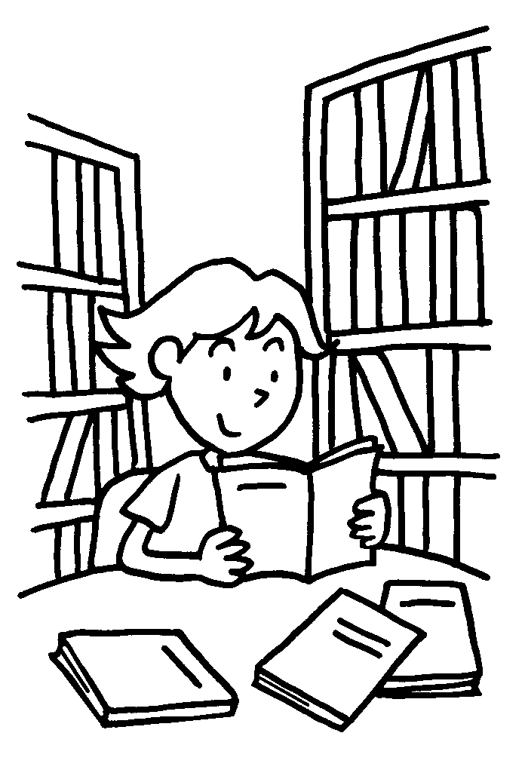 | My sister s in  the library every week.

Book 2B Chapter 2 Graded Worksheets

Worksheet 2⬇⬇⬇
- reads
- watches
- does
- plays
- studies

