Circle the correct answers.

1 | 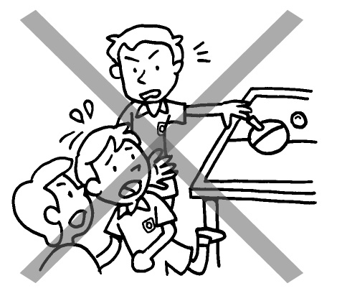 | Billy ( do / does ) not push other children.
2 | 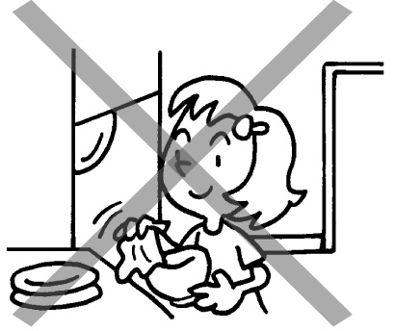 | Lucy ( does / do ) not dry the dishes.
3 | 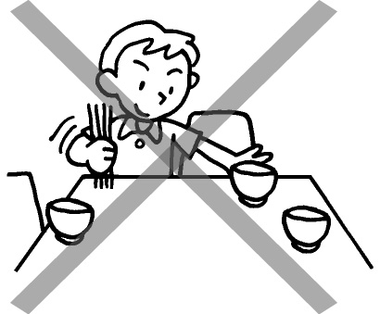 | Paul does not ( sets / set ) the table.
4 | 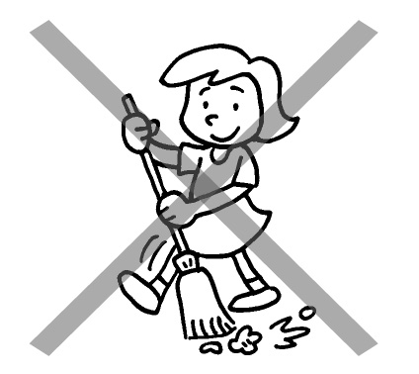 | Mary does not ( sweep / sweeps ) the floor.
5 | 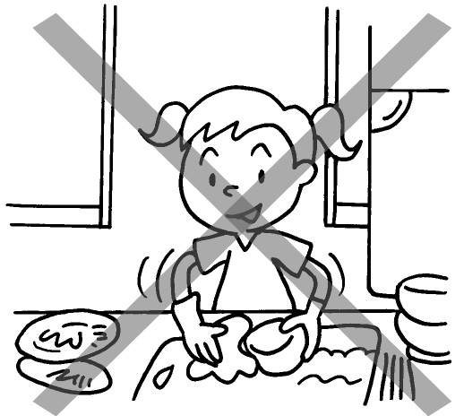 | Joey ( do / does ) not  ( washes / wash ) the dishes.
6 | 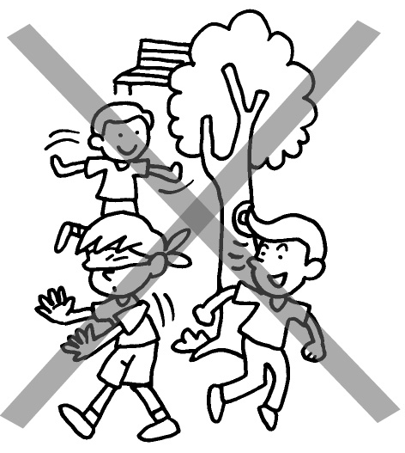 | Tom ( does / do ) not ( play / plays ) with his friends.

Book 2B Chapter 2 Graded Worksheets

Worksheet 3⬇
- ( do / does )
- ( does / do )
- ( sets / set )
- ( sweep / sweeps )
- ( do / does ) ( washes / wash )
6 ( does / do ) ( play / plays )

