Fill in the blanks. Use the simple present tense.

1 | 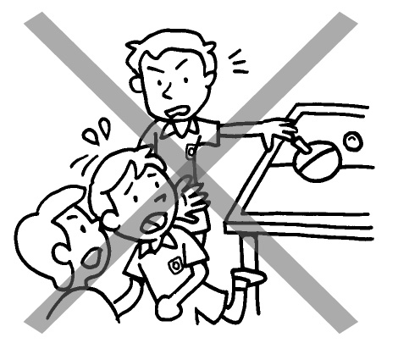 | Billy does not ____________ ( push ) other children.
2 | 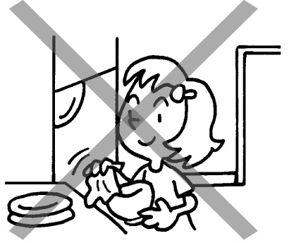 | Lucy does not ___________ ( dry )  the dishes.
3 | 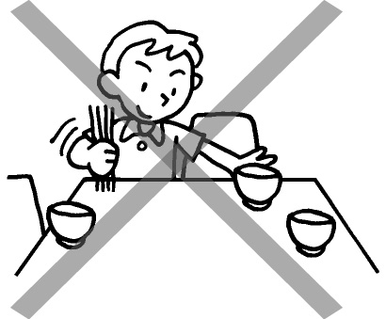 | Paul _____________________ ( set )  the table.
4 | 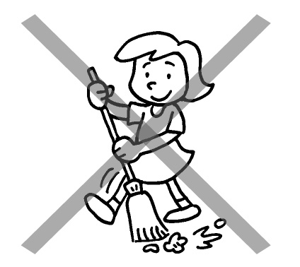 | Mary _____________________ ( sweep ) the floor.
5 | 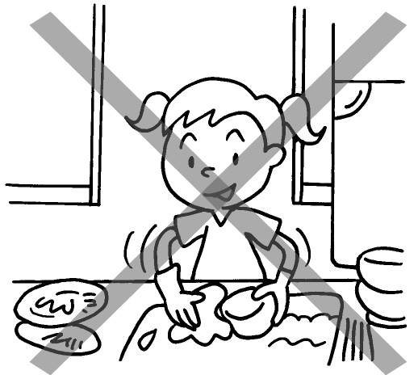 | Joey _____________________ ( wash ) the dishes.
6 | 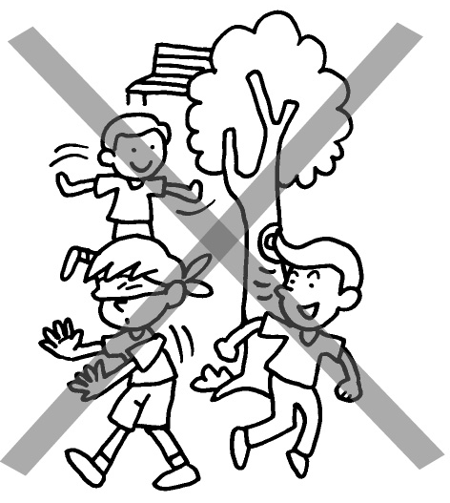 | Tom _______________________ ( play ) with his friends.

Book 2B Chapter 2 Graded Worksheets

Worksheet 3⬇⬇
- push
- dry
- does not set
- does not sweep
- does not wash
- does not play

