Fill in the blanks. Use the simple present tense.

play sweep wash push dry set

1 | 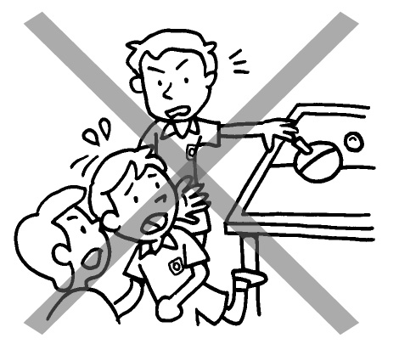 | Billy does not ____________ other children.
2 | 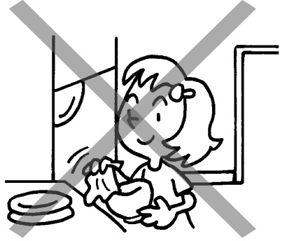 | Lucy does not ___________ the dishes.
3 | 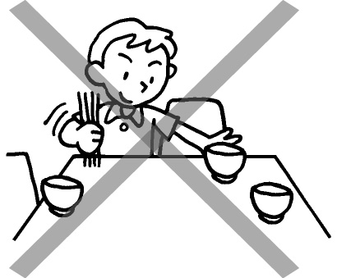 | Paul _________________________ the table.
4 | 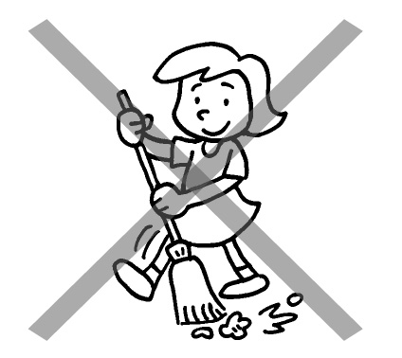 | Mary _________________________ the floor.
5 | 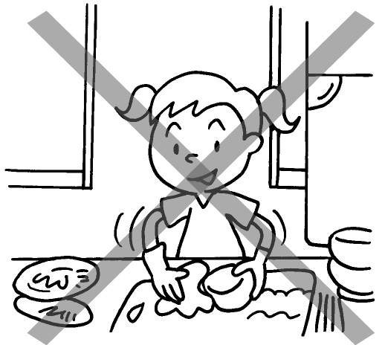 | Joey __________________________ the dishes.
6 | 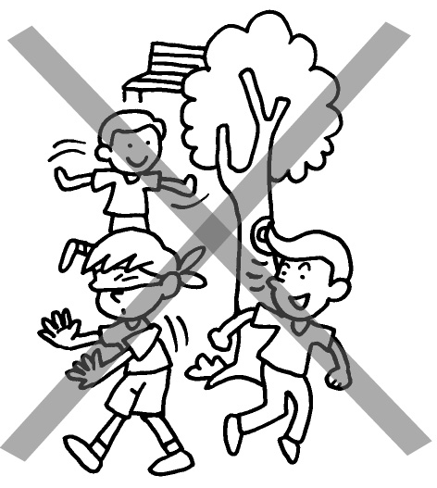 | Tom ______________________________ with his friends.

Book 2B Chapter 2 Graded Worksheets

Worksheet 3⬇⬇⬇
- push
- dry
- does not set
- does not sweep
- does not wash
- does not play

