Choose and write.
Brownies | church | Cub Scouts
drawing lessons | grandma | grandpa
grandparents | piano lessons | tutor

1 | 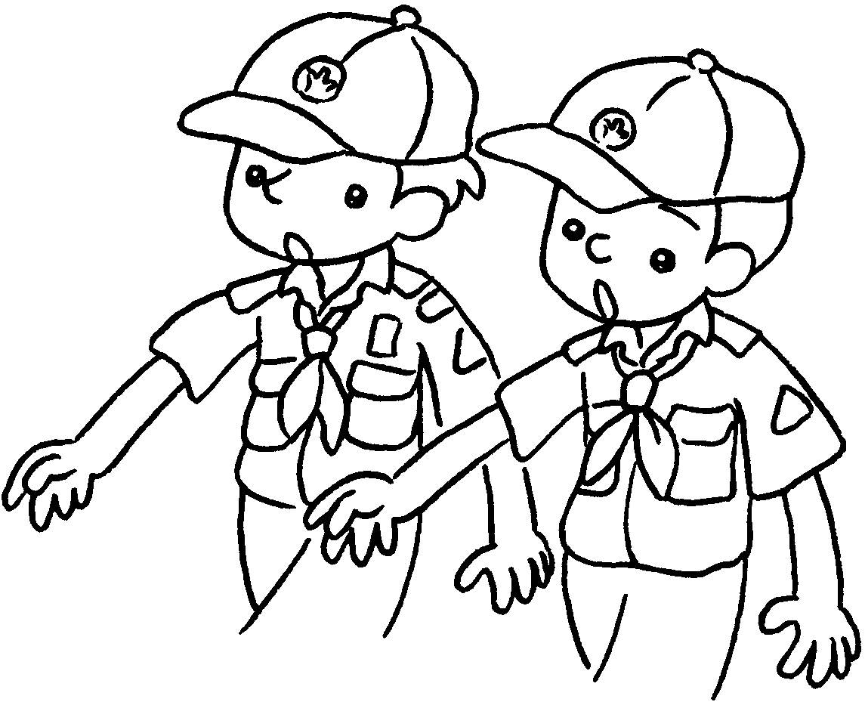 | 2 | 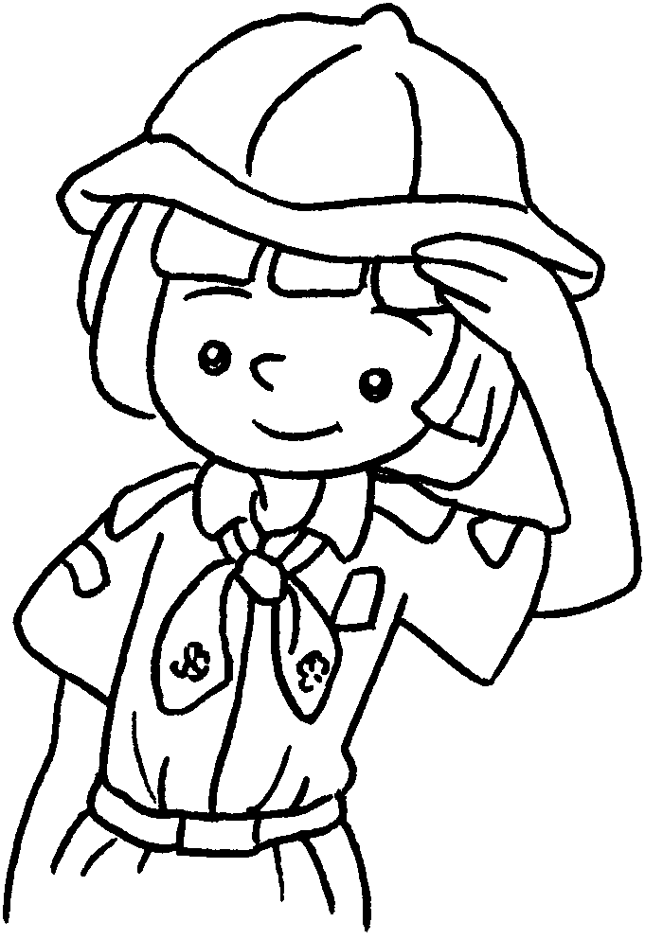 | 3 | 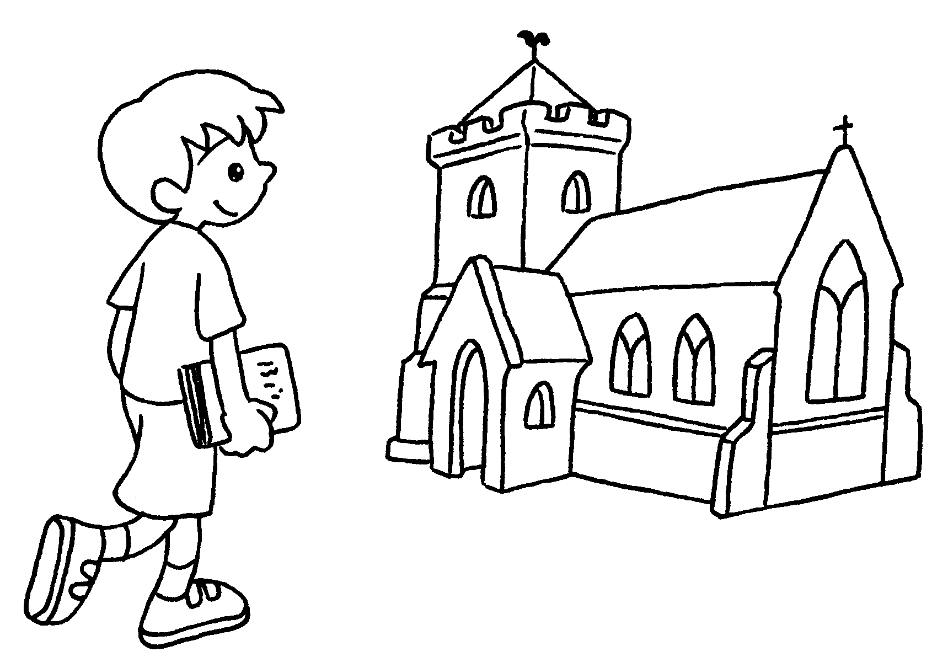
4 | 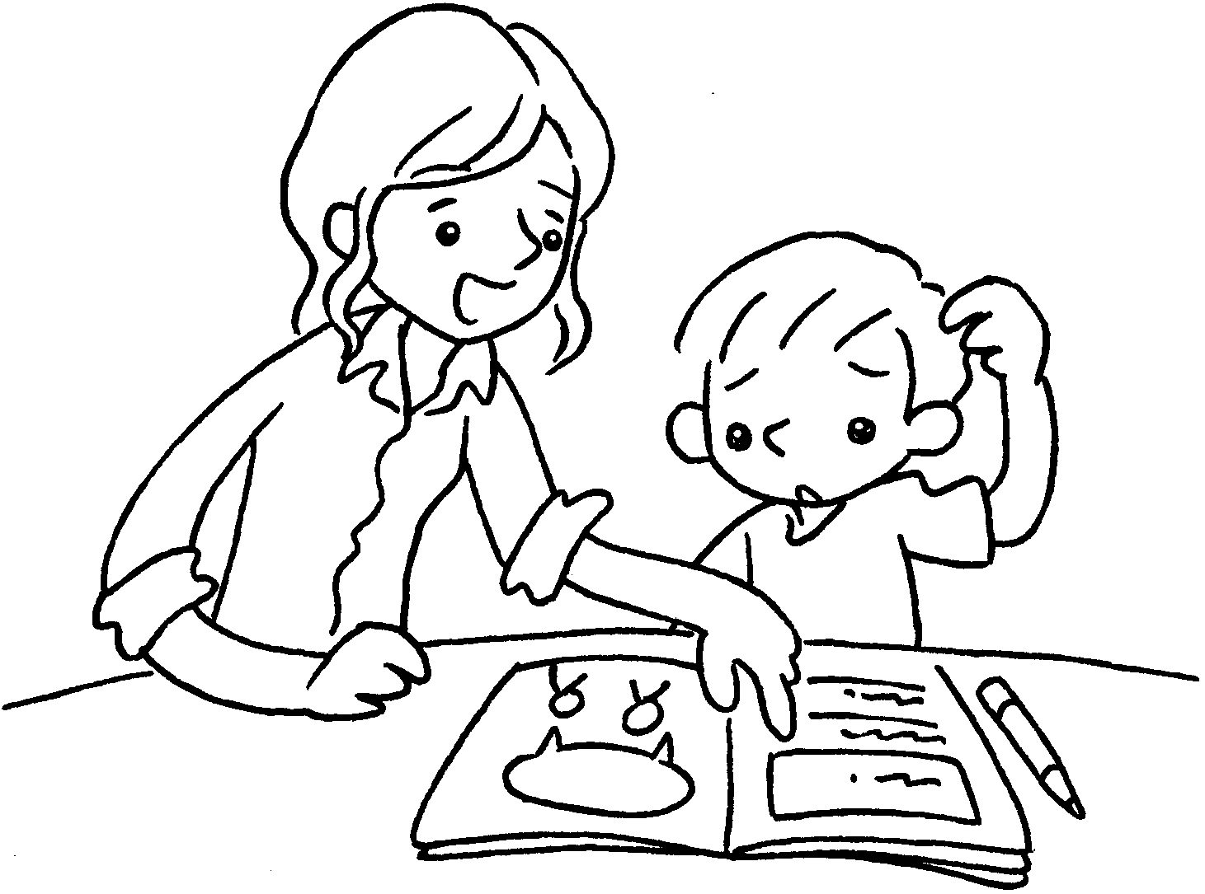 | 5 | 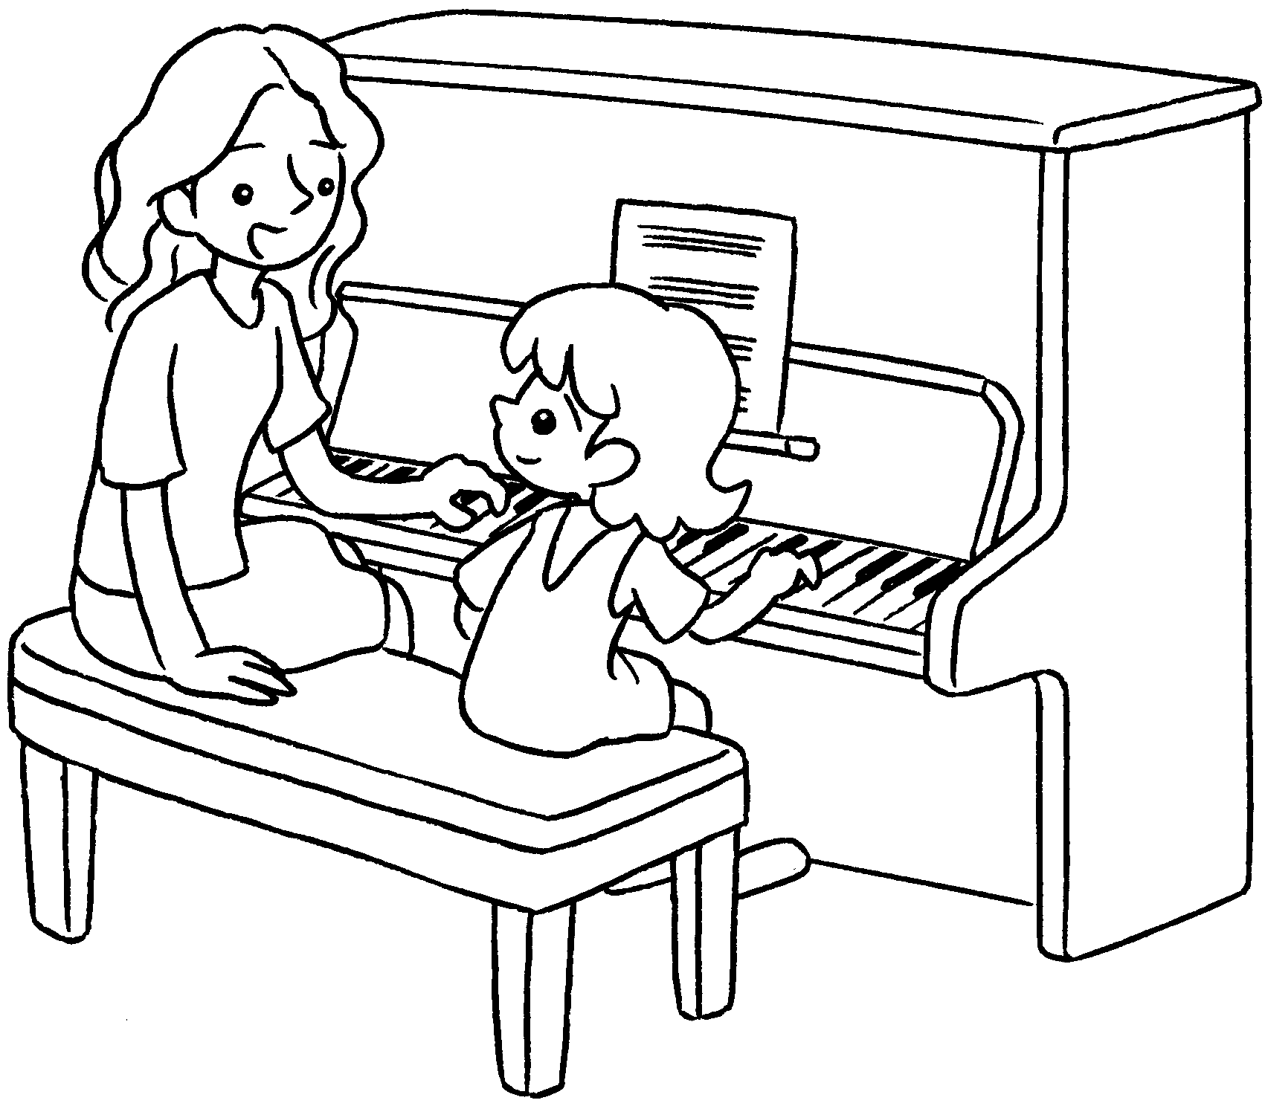 | 6 | 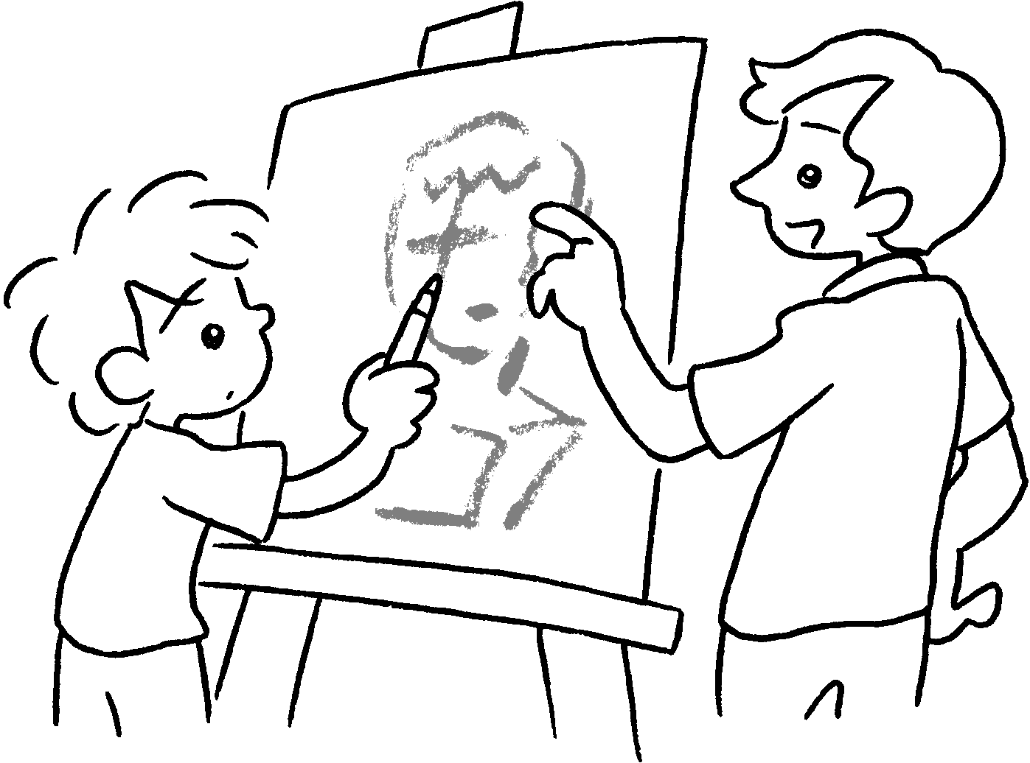
7 | 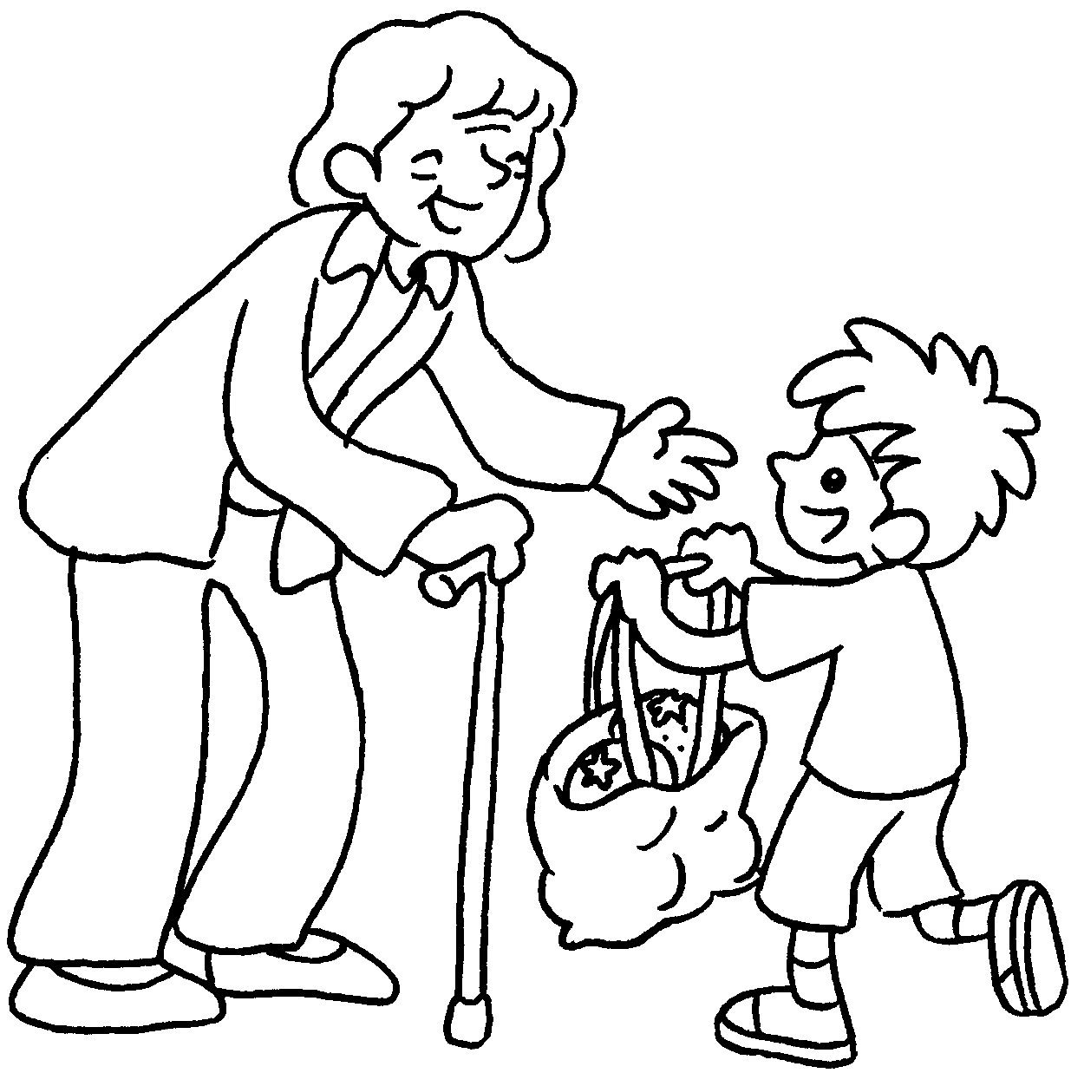 | 8 | 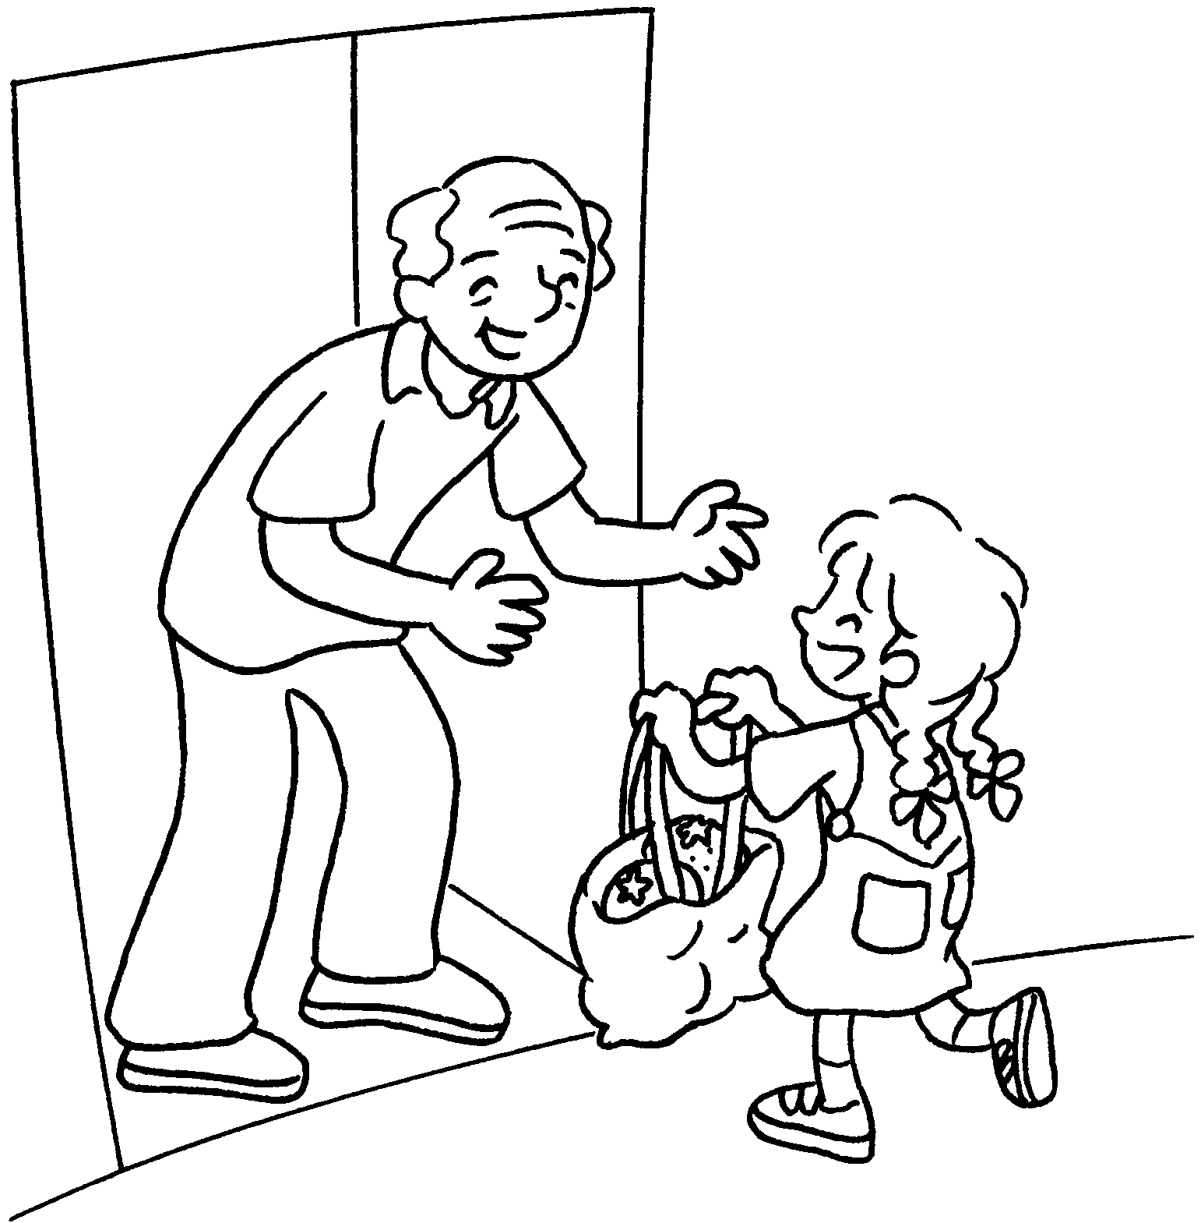 | 9 | 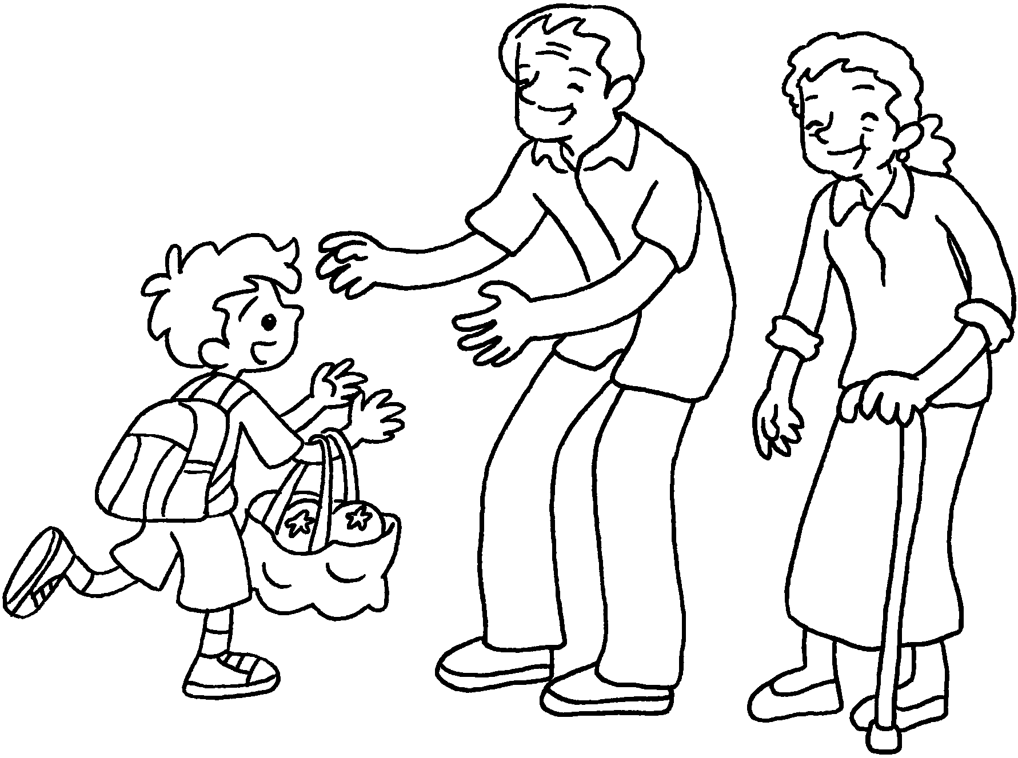

1 | go to |  | 2 | go to
3 | go to |  | 4 | study with my
5 | have |  | 6 | have
7 | visit my |  | 8 | visit my
9 | visit my

Book 2B Chapter 3 Graded Worksheets

Worksheet 1⬇
1 Cub Scouts 2 Brownies
3 church 4 tutor
5 piano lessons 6 drawing lessons
7 grandma 8 grandpa
9 grandparents

