Fill in the missing letters.

1 | 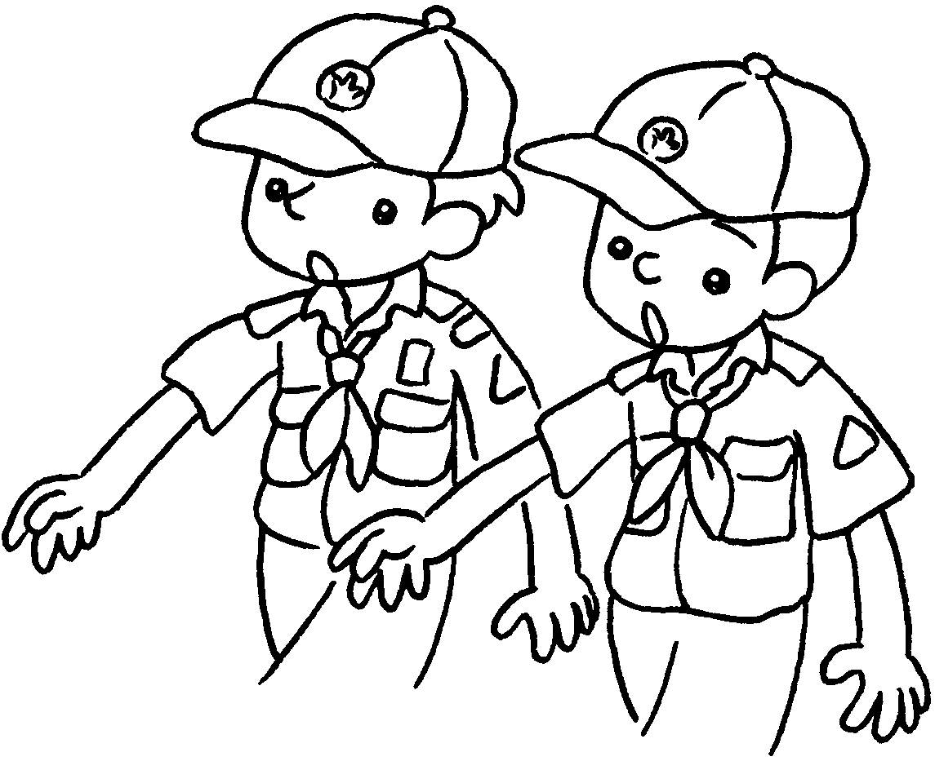 | 2 | 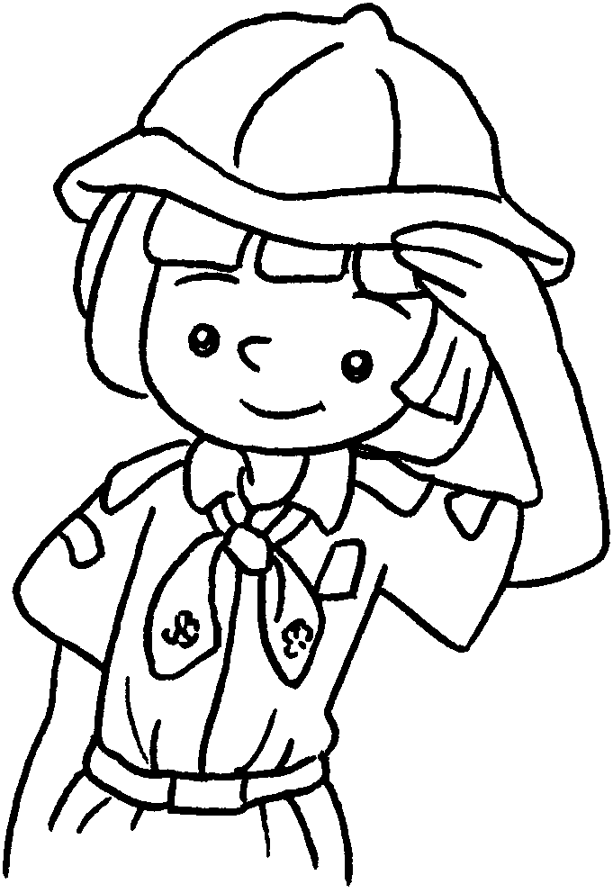 | 3 | 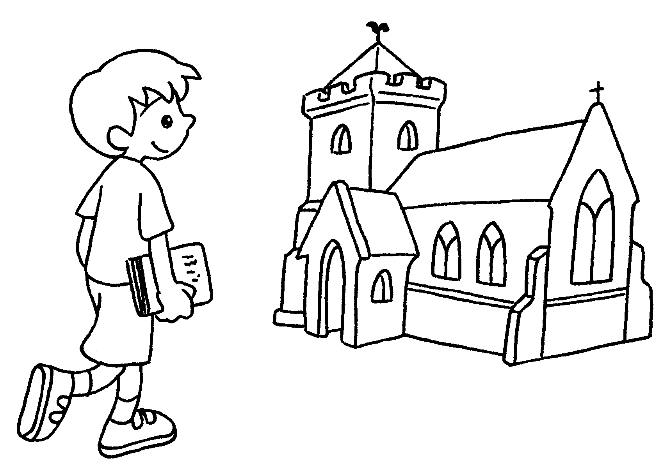
4 | 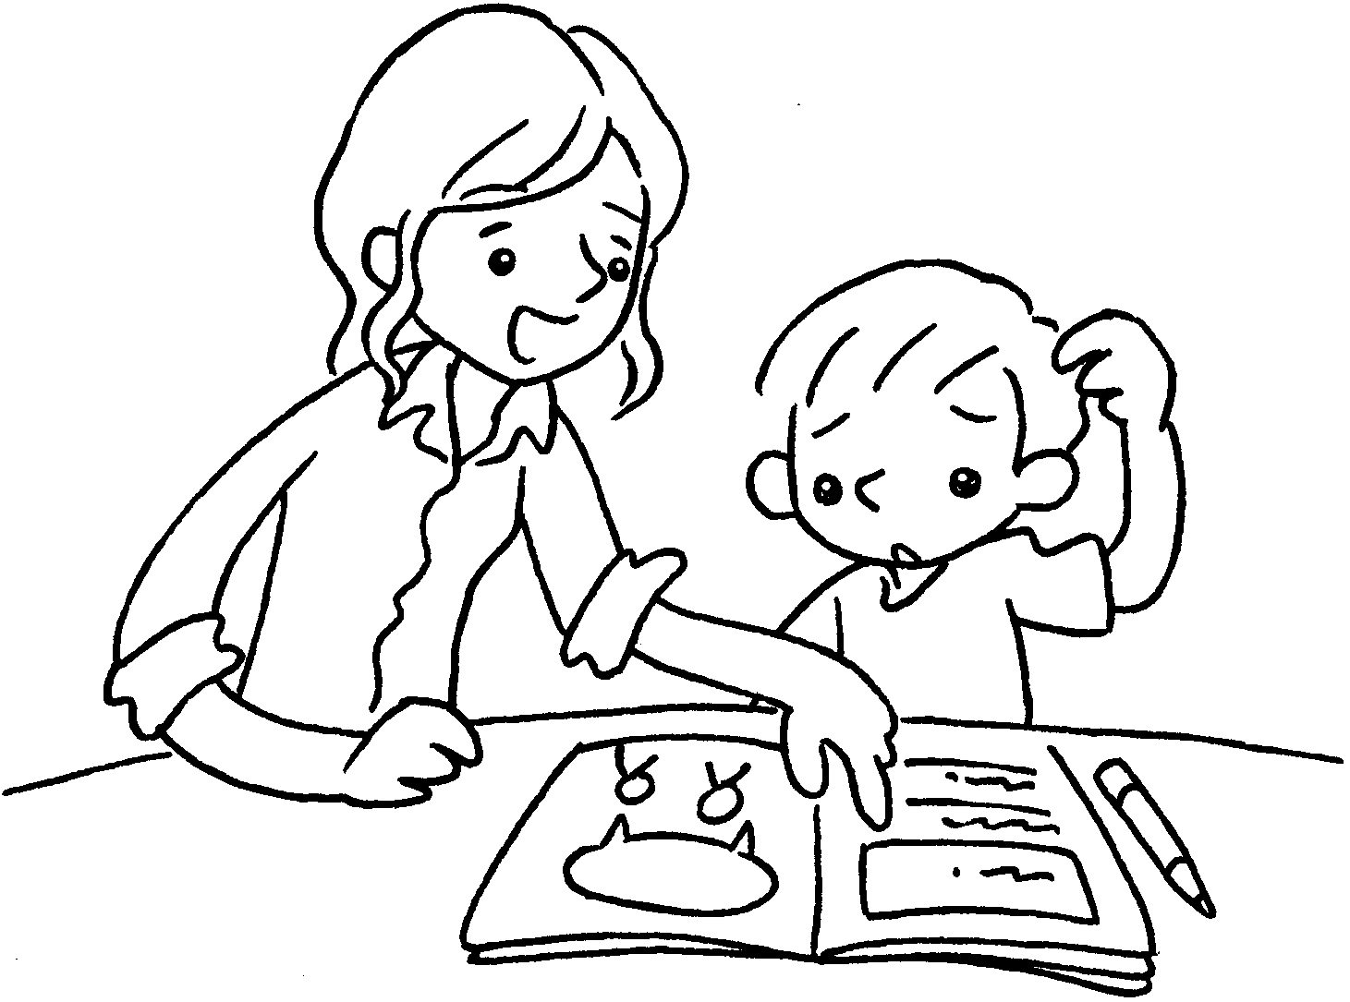 | 5 | 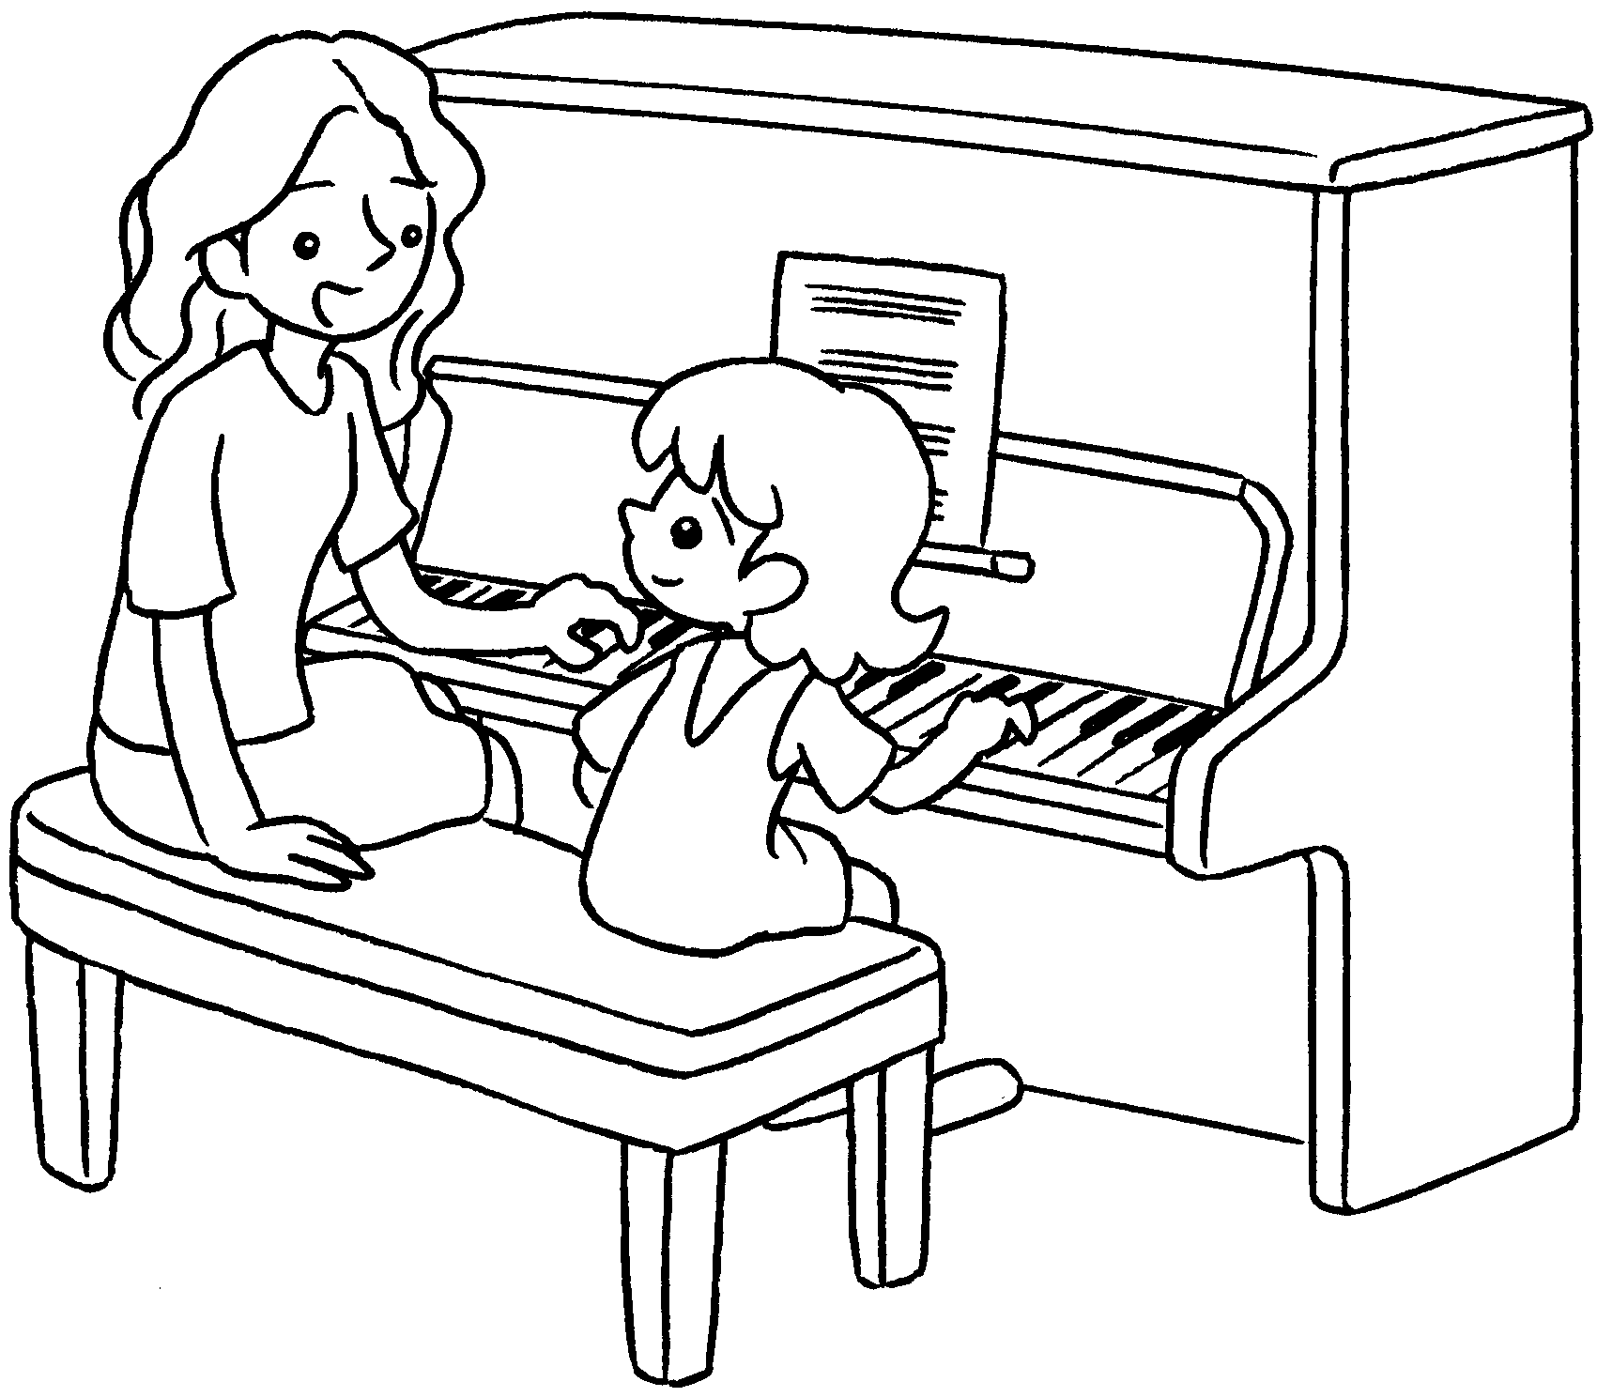 | 6 | 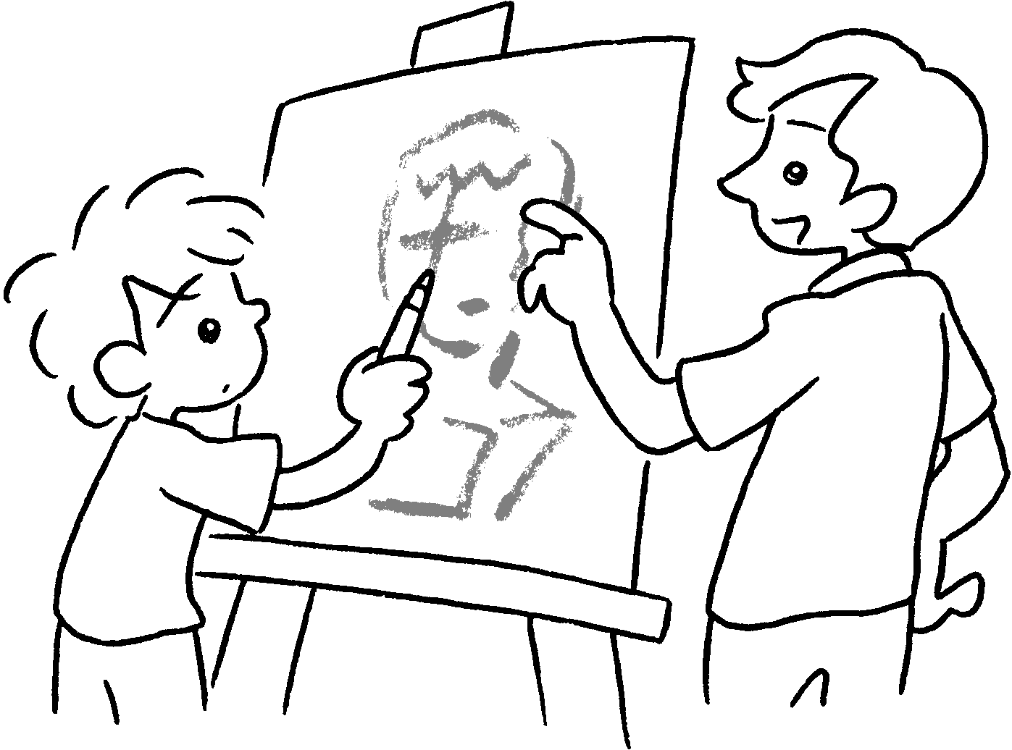
7 | 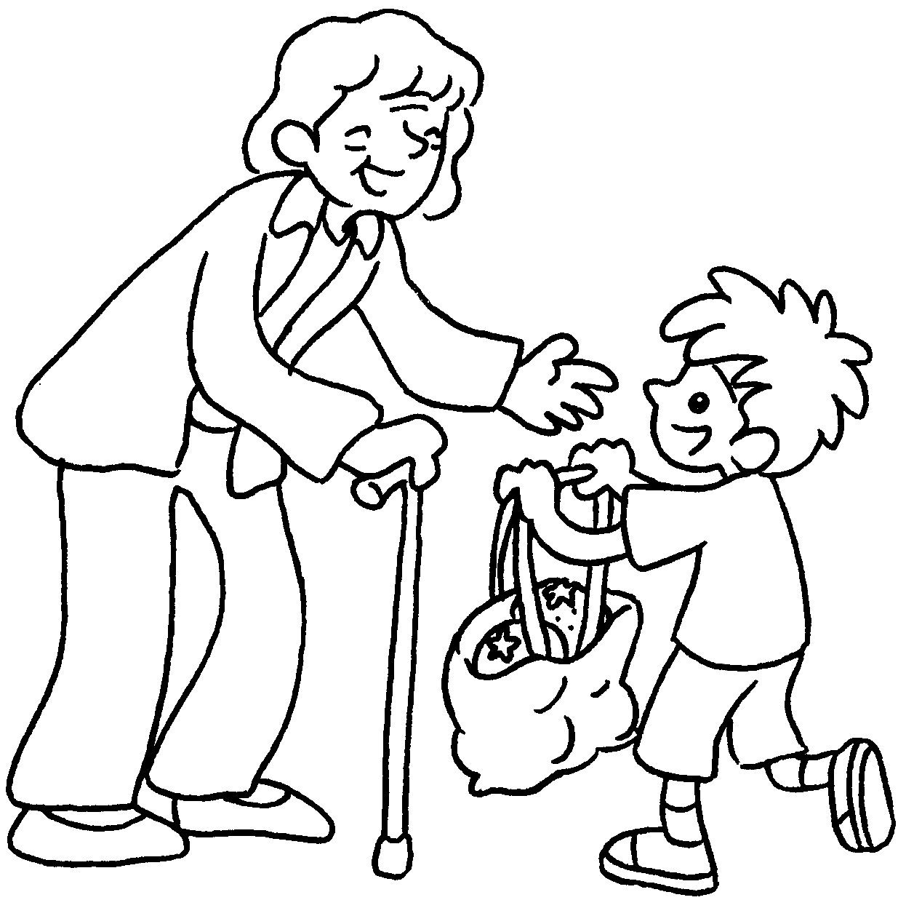 | 8 | 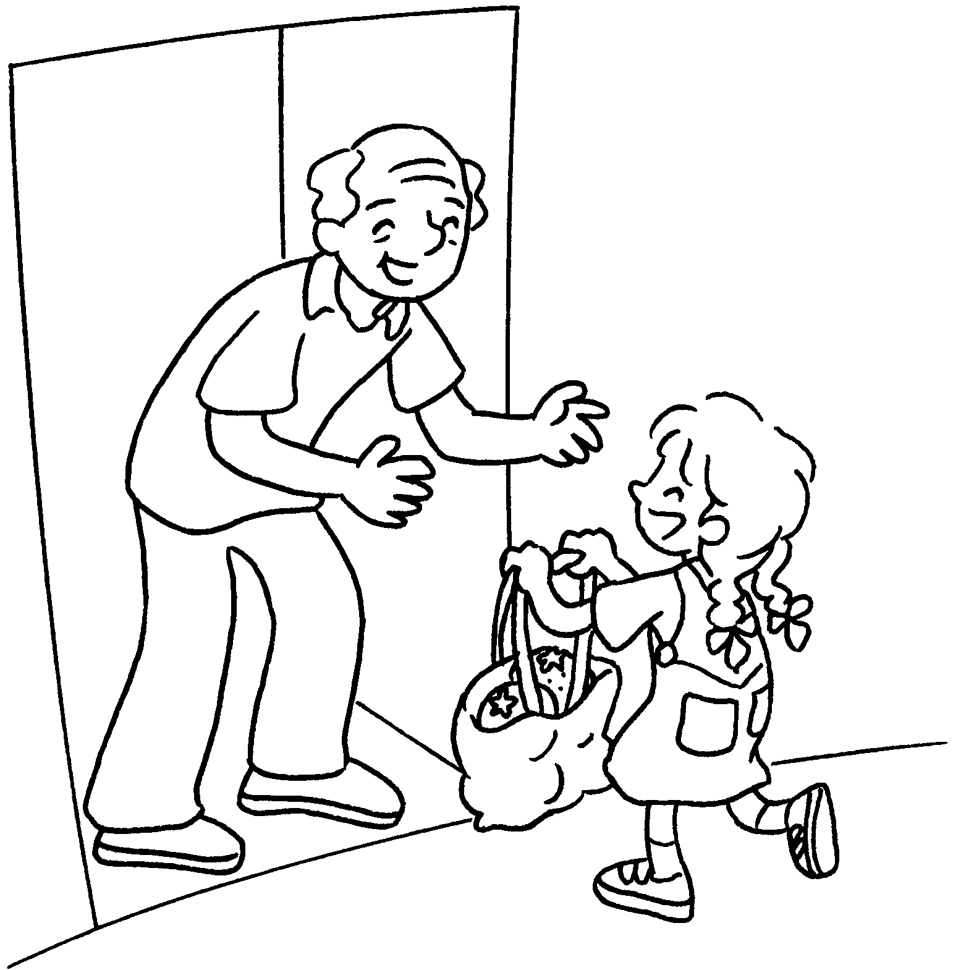 | 9 | 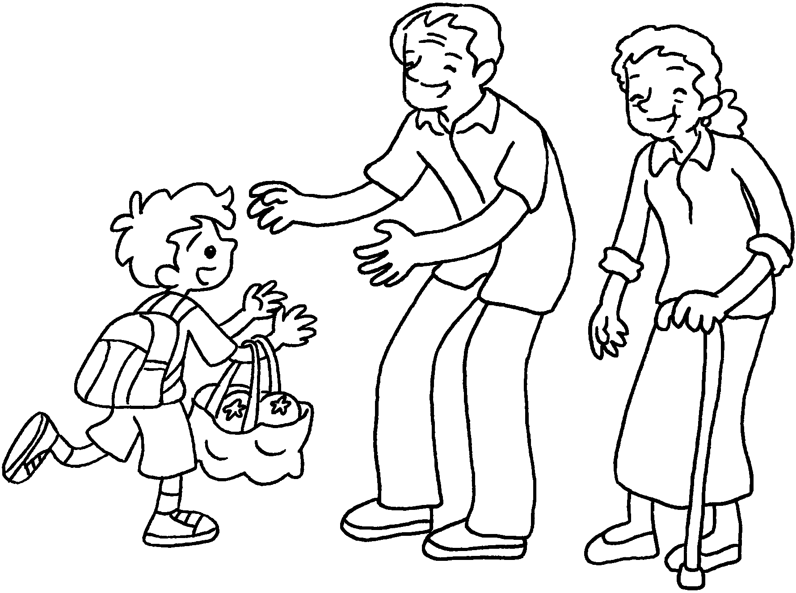

1 | go to Cub S __ __ __ __ __ |  |  |  | 2 |  | go to Br __ __ __ __ __ __
3 | go to c __ __ __ __ __ |  |  |  | 4 |  | study with my tu __ __ __
5 | have p __ __ __ __  l __ __ __ __ __ __ |  |  | 6 |  | have d __ __ __ __ __ __  l __ __ __ __ __ __
7 | visit my g __ __ __ __ __ __ |  |  | 8 |  | visit my g __ __ __ __ __ __
9 | visit my g __ __ __ __ __ __ __ __ __ __ __


Book 2B Chapter 3 Graded Worksheets
Worksheet 1⬇⬇
1 Cub S c o u t s 2 Br o w n i e s
3 c h u r c h 4 tu t o r
5 p i a n o l e s s o n s 6 d r a w i n g l e s s o n s
7 g r a n d m a 8 g r a n d p a
9 g r a n d p a r e n t s

