What do the children do? Write.

1 | 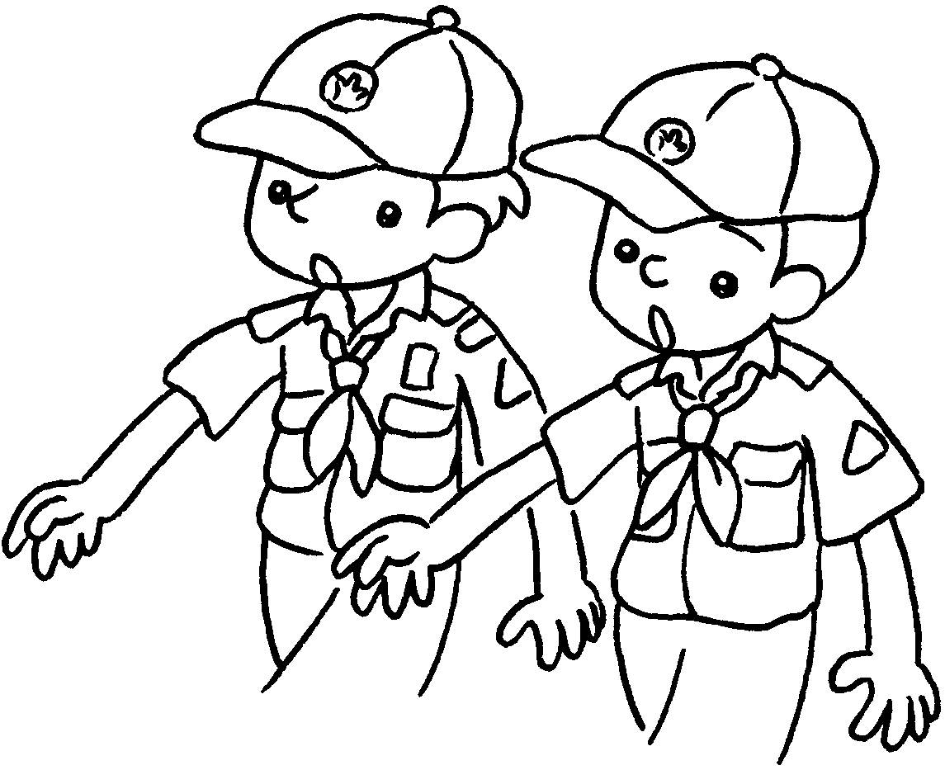 | 2 | 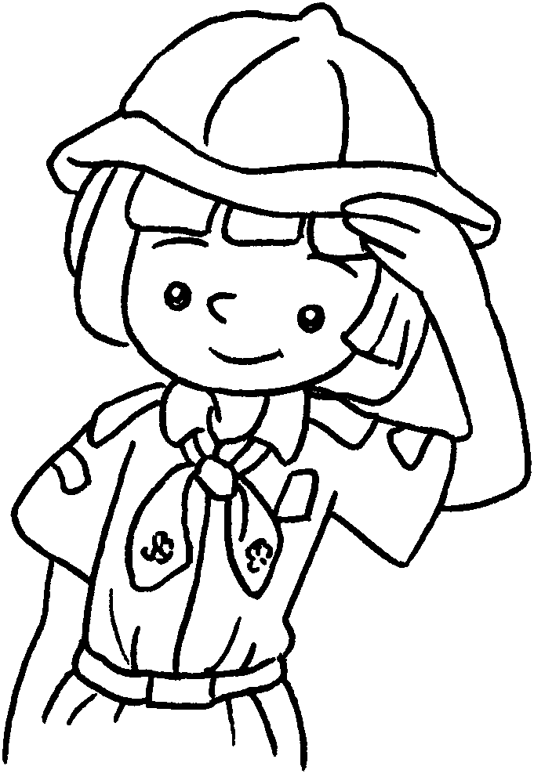 | 3 | 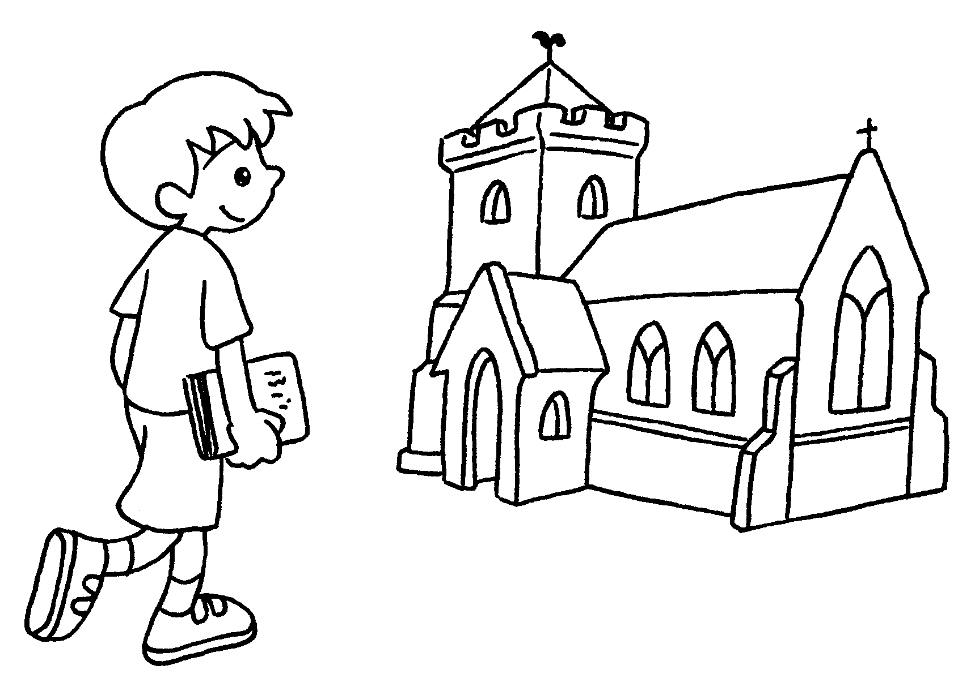
4 | 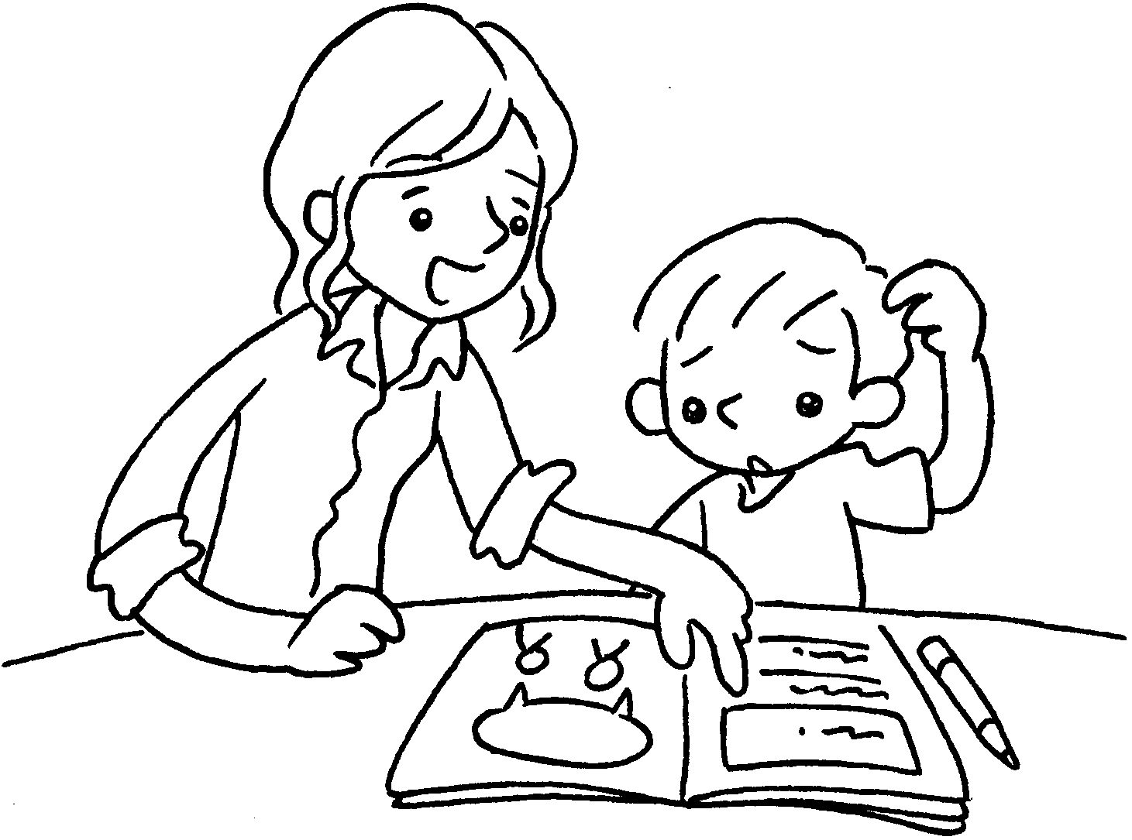 | 5 | 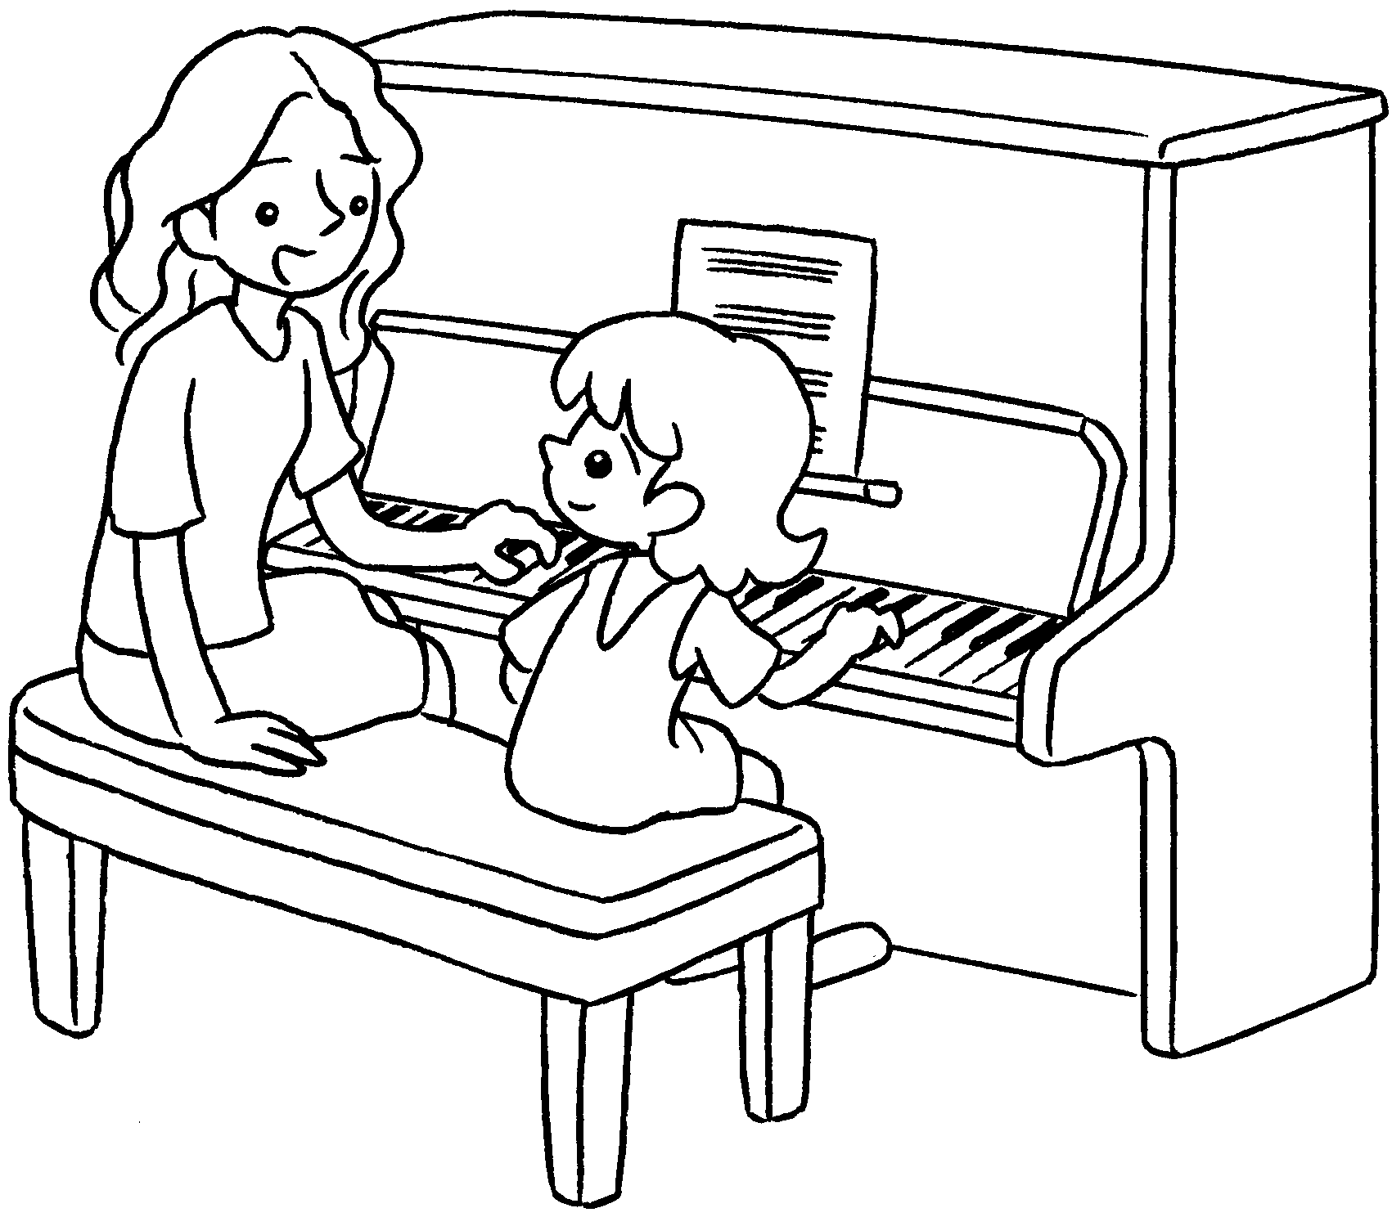 | 6 | 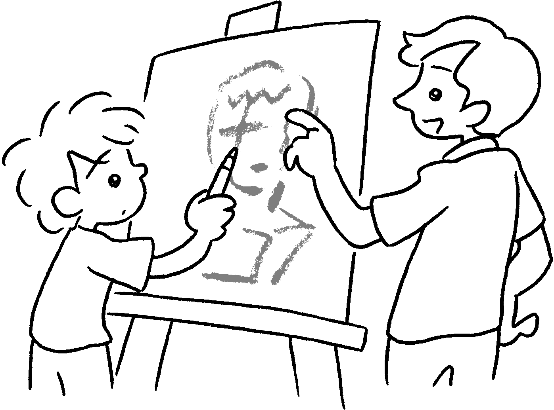
7 | 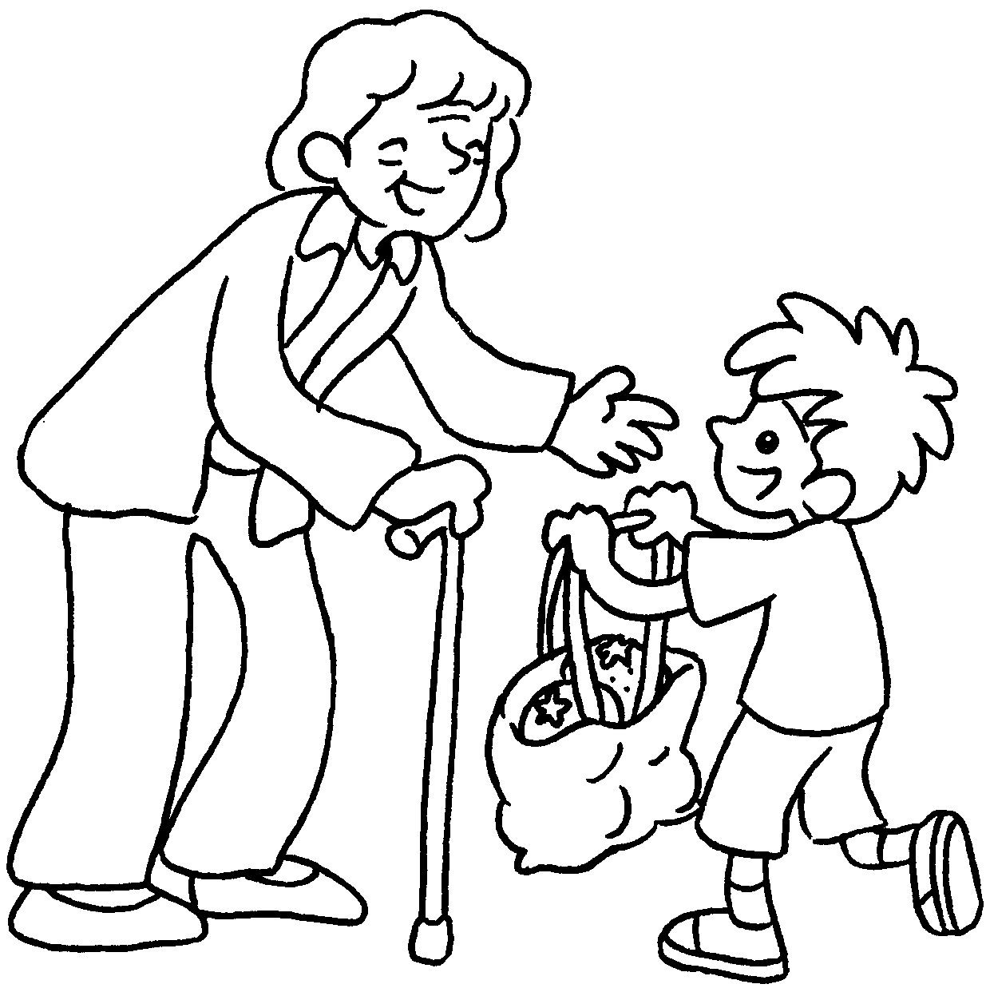 | 8 | 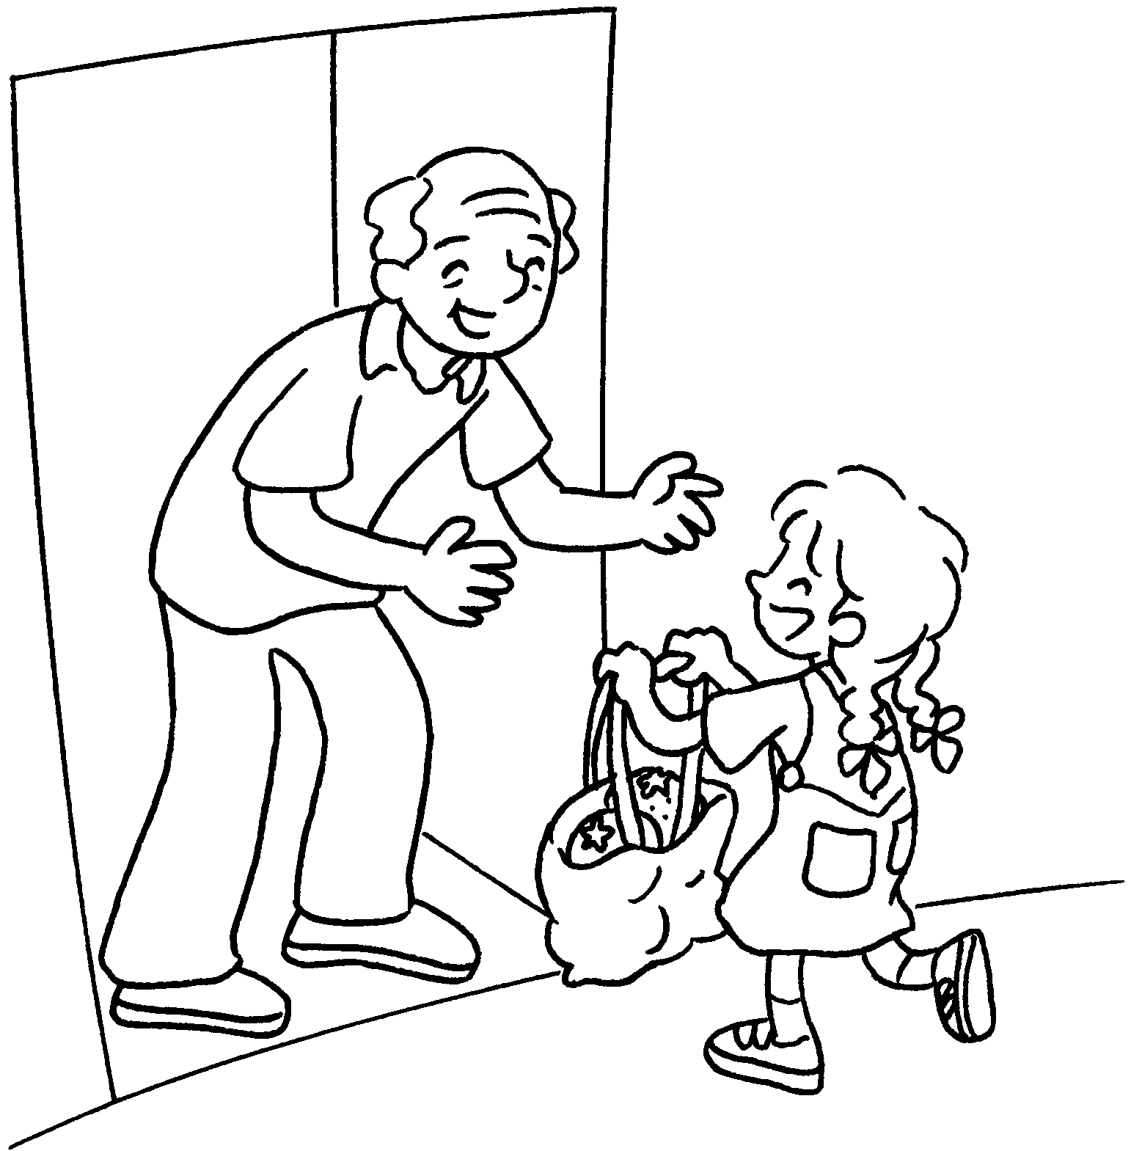 | 9 | 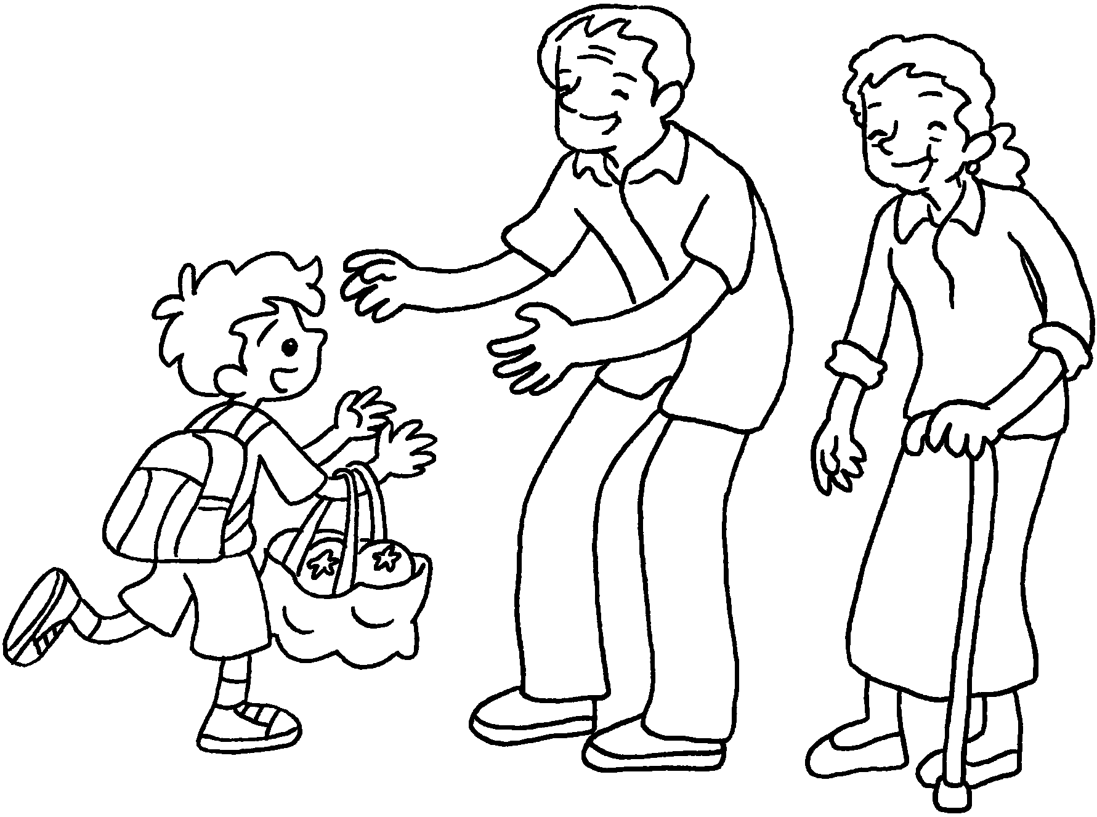

1 | go to C S |  | 2 | go to B
3 | go to |  | 4 | study with my
5 | have  lessons |  | 6 | have  lessons
7 | visit my |  | 8 | visit my
9 | visit my

Book 2B Chapter 3 Graded Worksheets

Worksheet 1⬇⬇⬇
1 Cub Scouts 2 Brownies
3 church 4 tutor
5 piano 6 drawing
7 grandma 8 grandpa
9 grandparents
(Accept any reasonable answers.)

