Choose and write.
Good morning, Kate.
Good morning, Tom.
Good afternoon, Tom.
Goodbye, Tom.
Goodbye, Andy.
on | Mondays  Tuesdays | Wednesdays  Saturdays

1 | 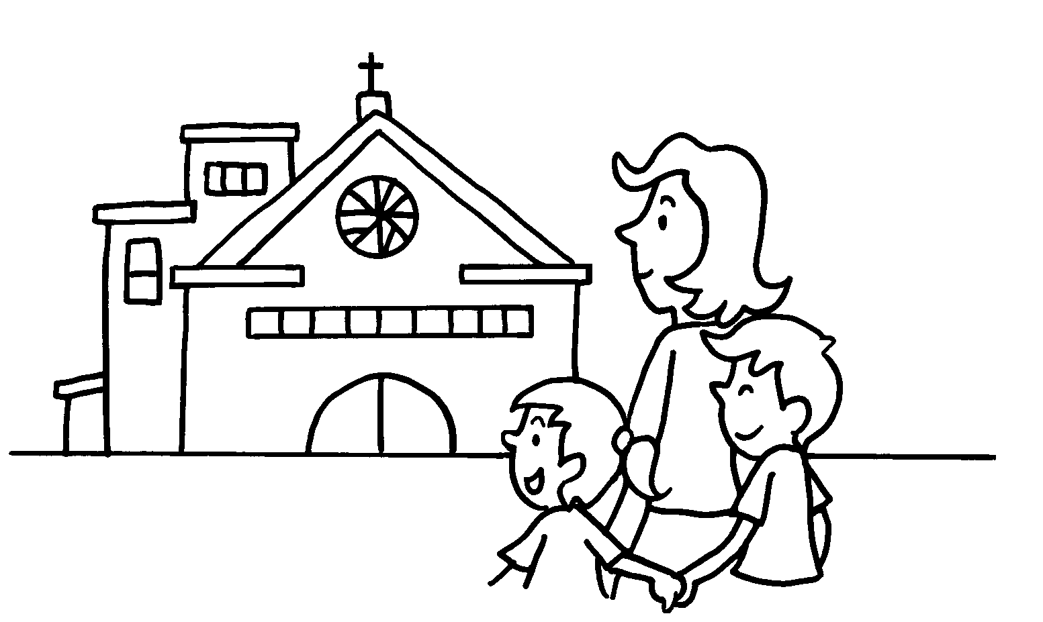  Sun | I go to church Sundays.
2 | 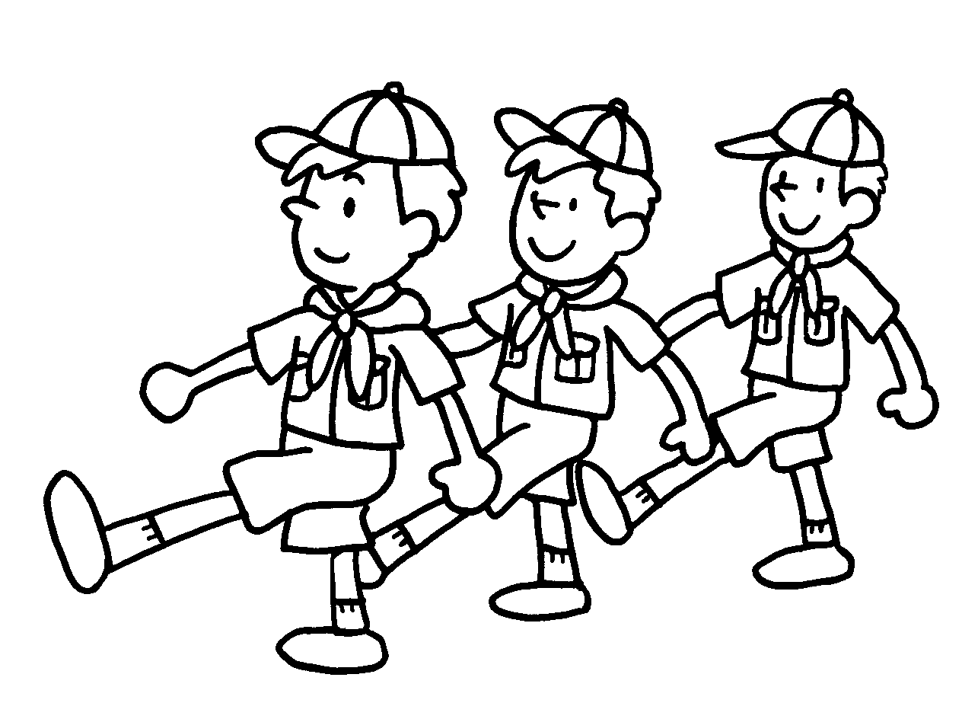  Tue | Mark goes to Cub Scouts on  .
3 | 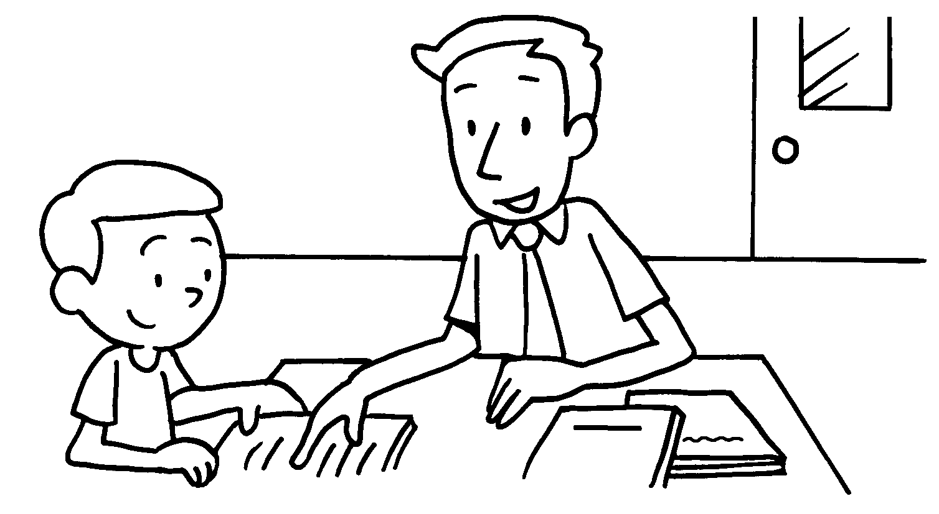  Wed | John studies with his tutor  .
4 | 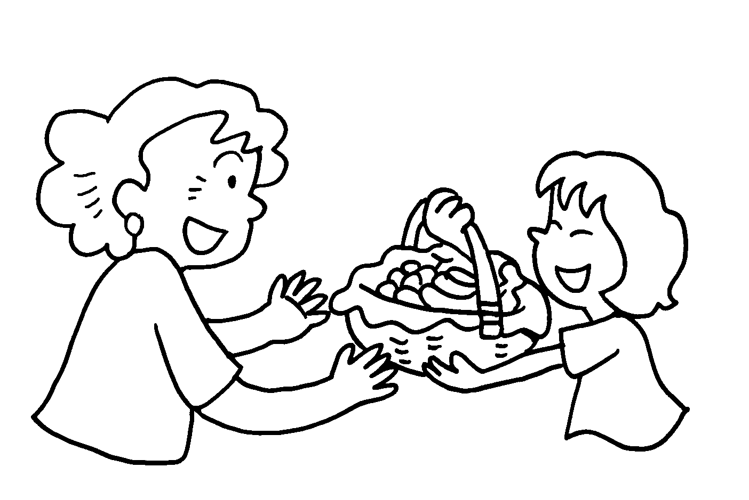  Sat | Susan visits her grandma  .
5 | 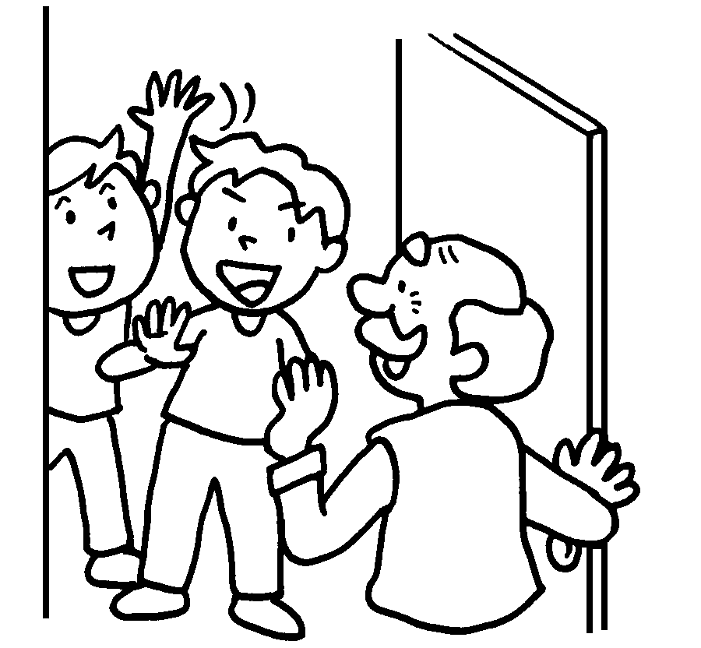  Mon | Billy and Eddy visit their grandpa  .

Book 2B Chapter 3 Graded Worksheets

Worksheet 2⬇
- on
- Tuesdays
- on Wednesdays
- on Saturdays
- on Mondays

