Fill in the blanks.
Good morning, Kate.
Good morning, Tom.
Good afternoon, Tom.
Goodbye, Tom.
Goodbye, Andy.

1 | 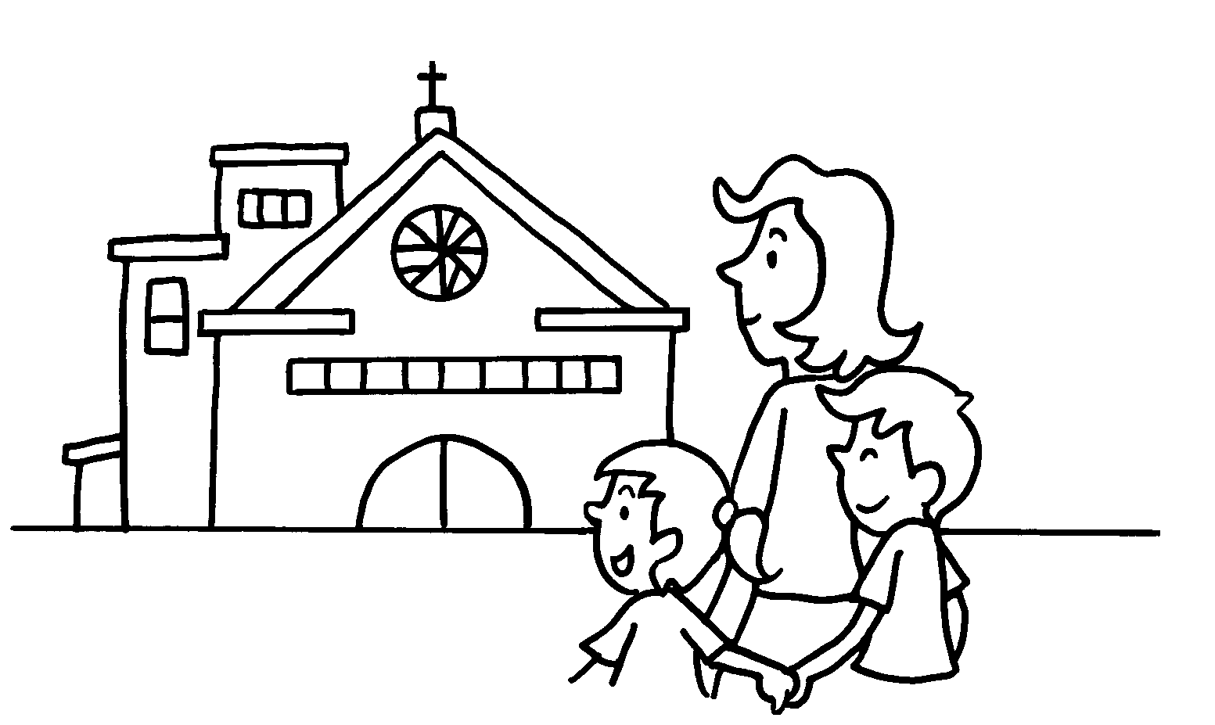  Sun | on  I go to church Sundays.
2 | 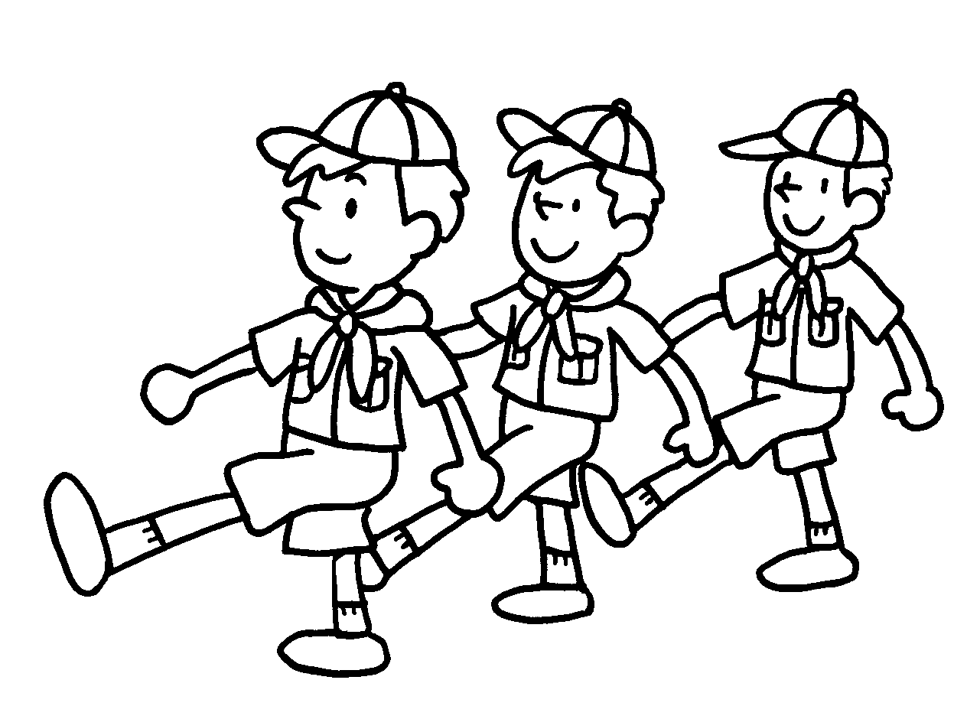  Tue | Mark __________ ( go ) to Cub Scouts ________ Tuesdays.
3 | 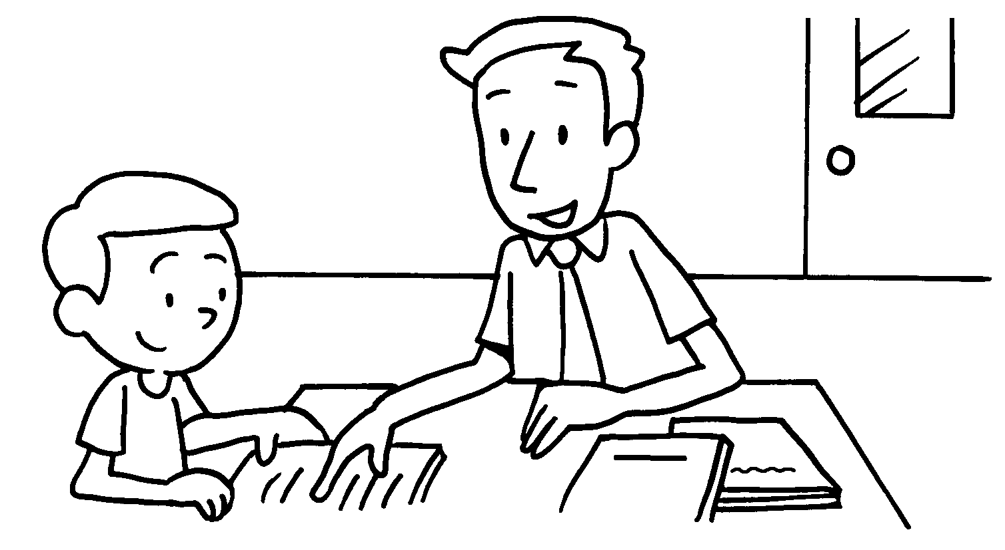  Wed | John ___________ ( study ) with his tutor ___________________________ .
4 | 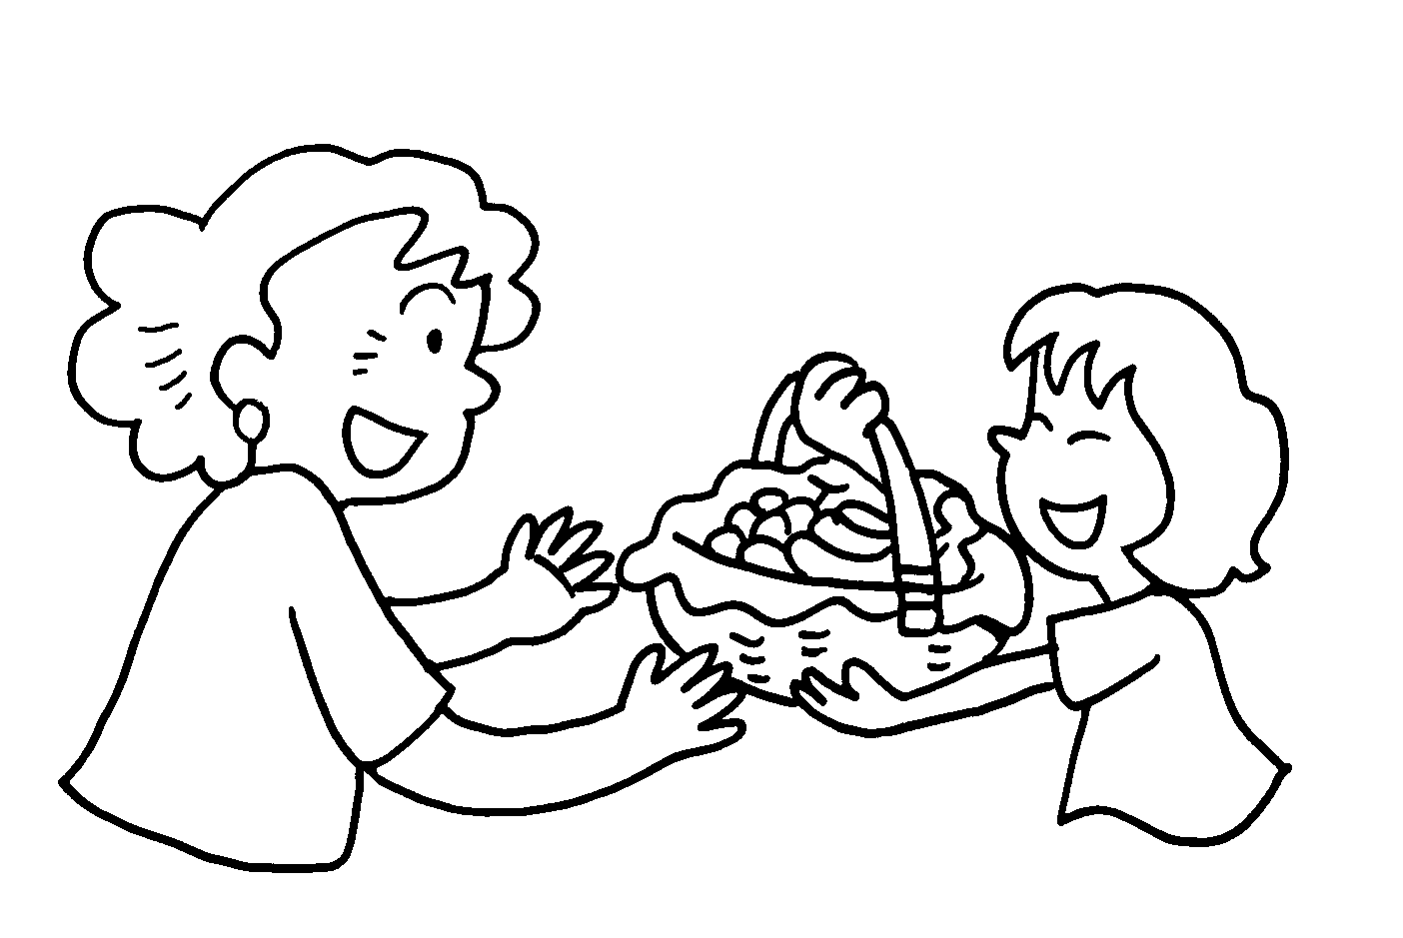  Sat | Susan _____________ ( visit ) her grandma ______________________ .
5 | 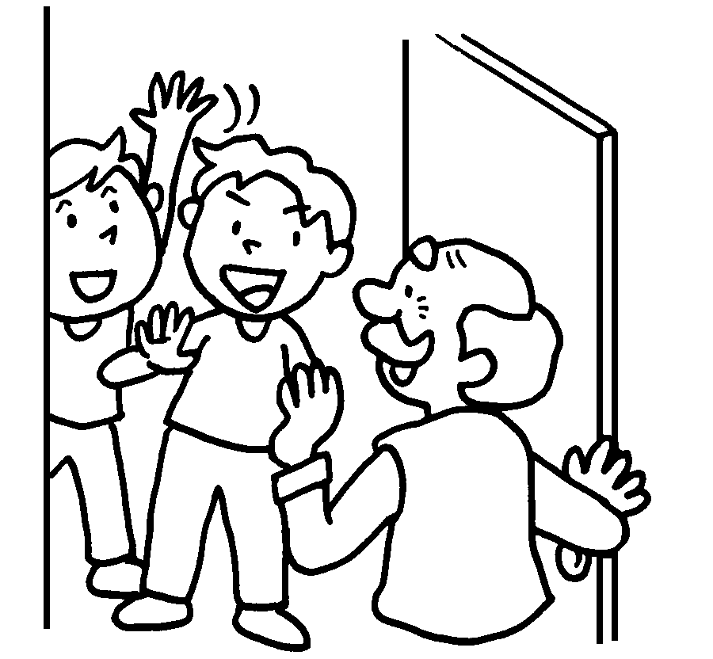  Mon | Billy and Eddy ____________ ( visit ) their grandpa __________________ .


Book 2B Chapter 3 Graded Worksheets
Worksheet 2⬇⬇
- goes on
- studies on Wednesdays
- visits on Saturdays
5 visit on Mondays

