F Finish the questions and answers.

do / does have / has go / goes visit / visits

1  B  A  B | 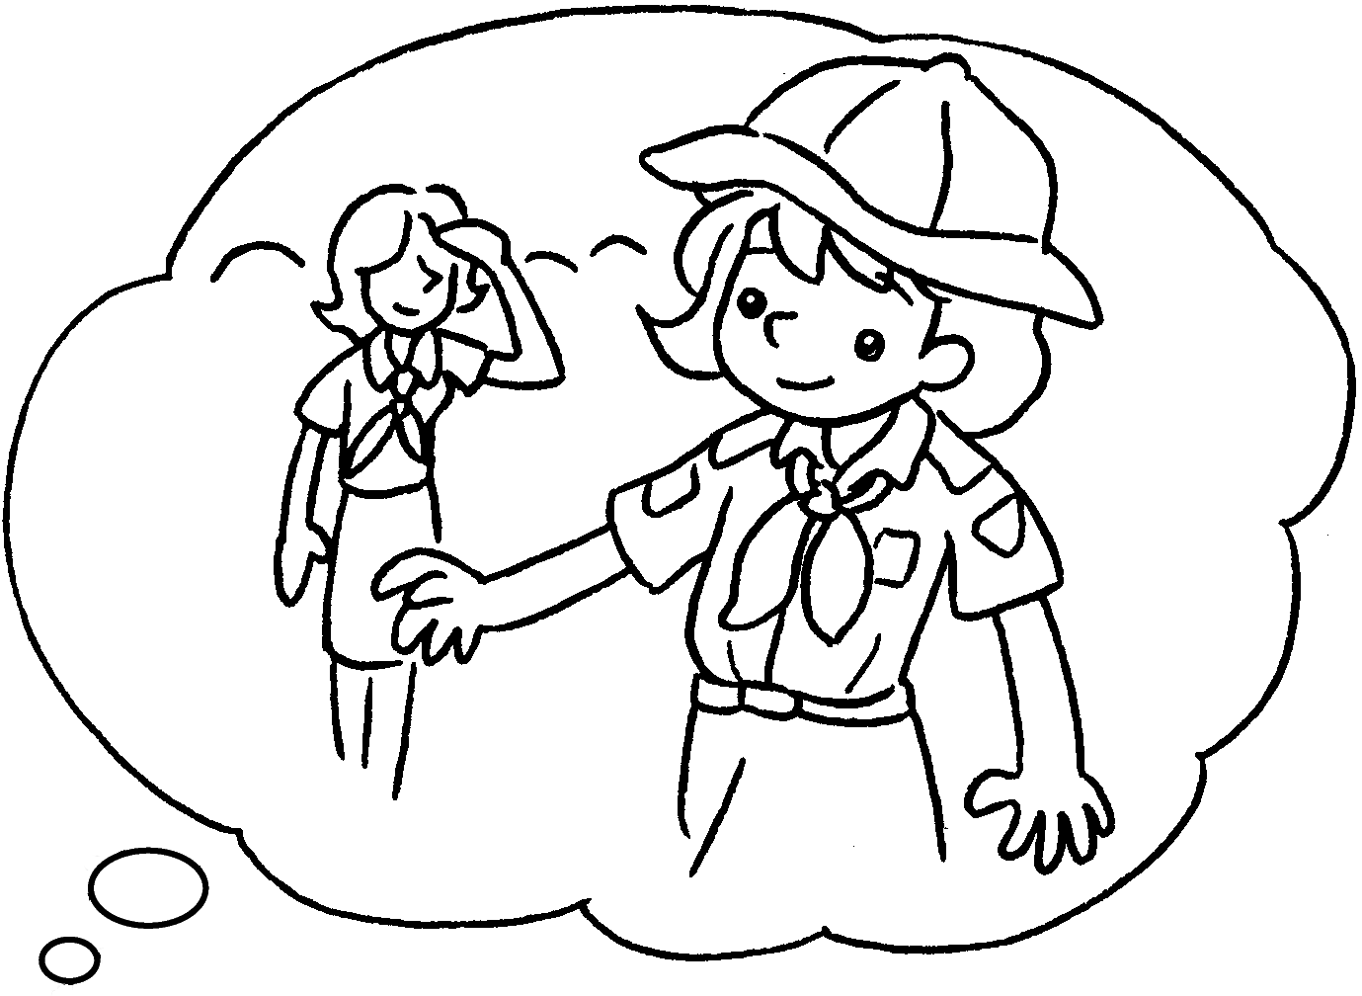  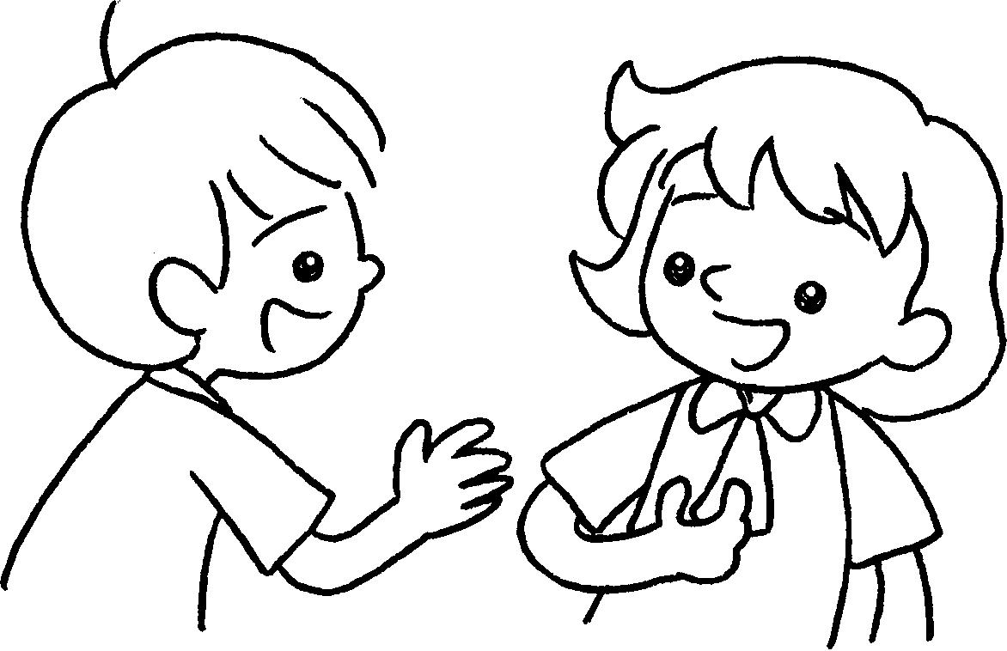 | A : What __________ you do  on Thursdays?  do  B : I ________ to Brownies.
2  A | 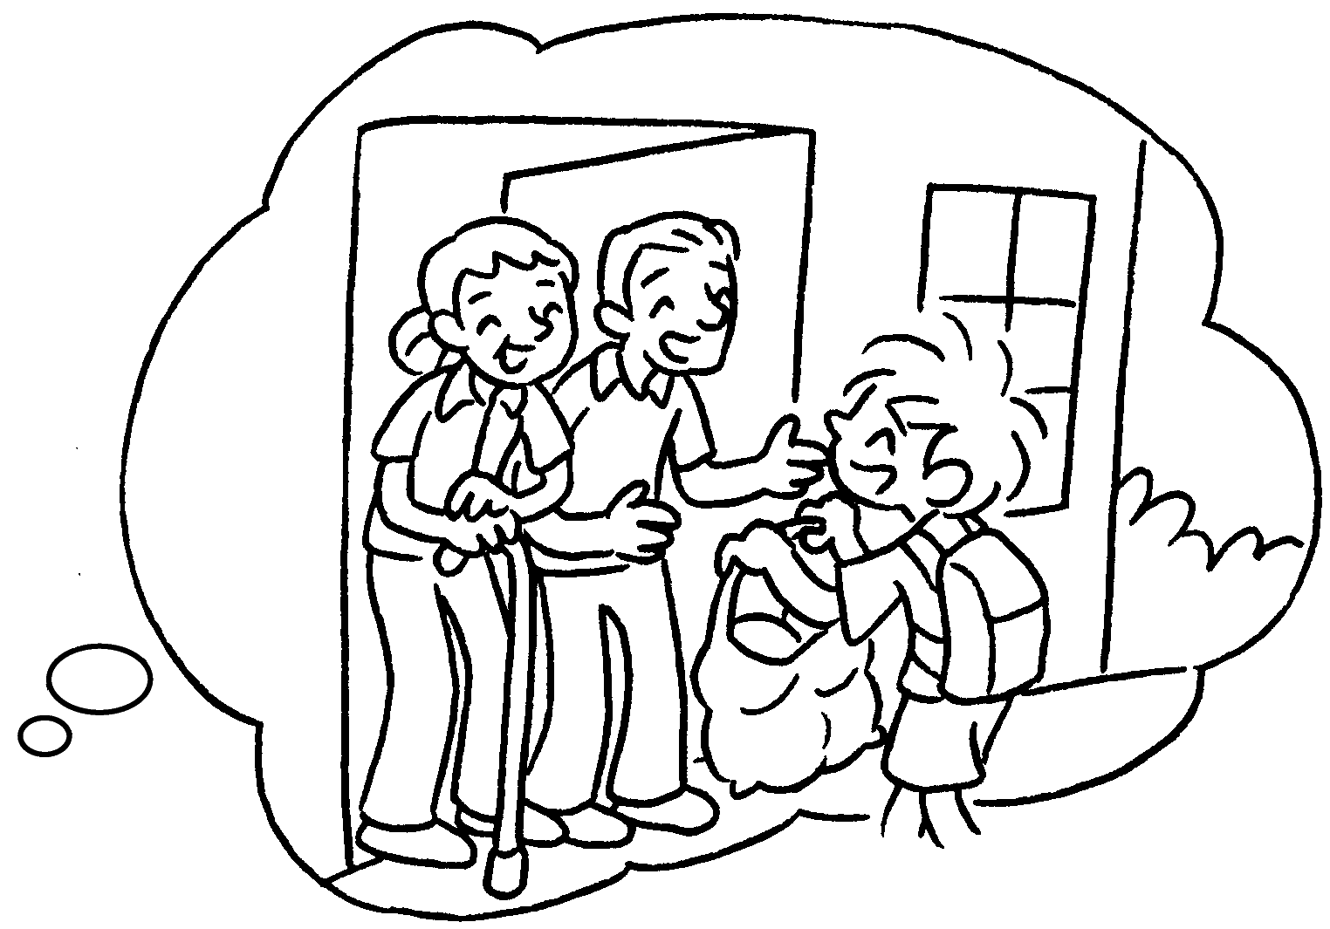  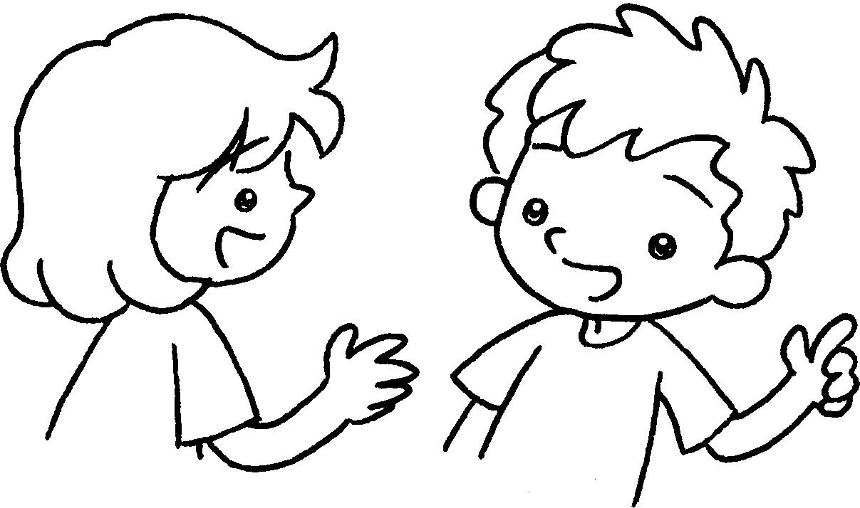 | A : What ________ Peter  do on Mondays?  B : He ________ his grandparents.
3  B  A | 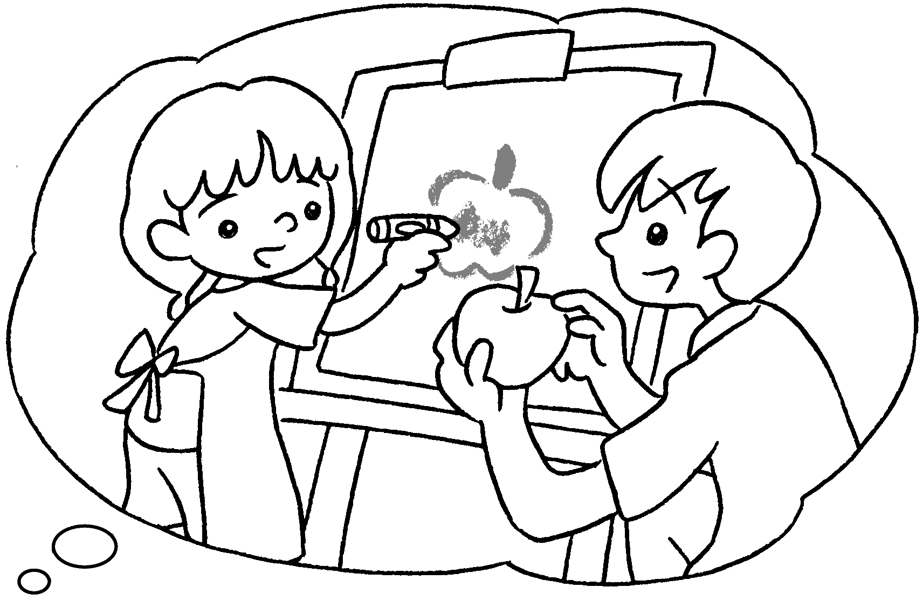  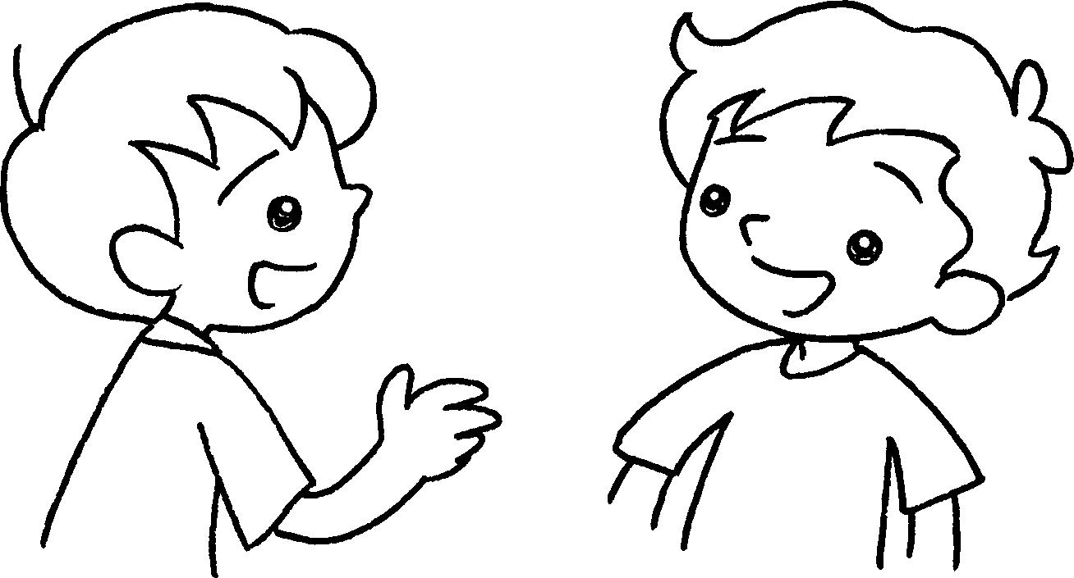 | A : What ________ Amy ________  ______ Sundays?  B : She ________ drawing lessons.
4  B  A | 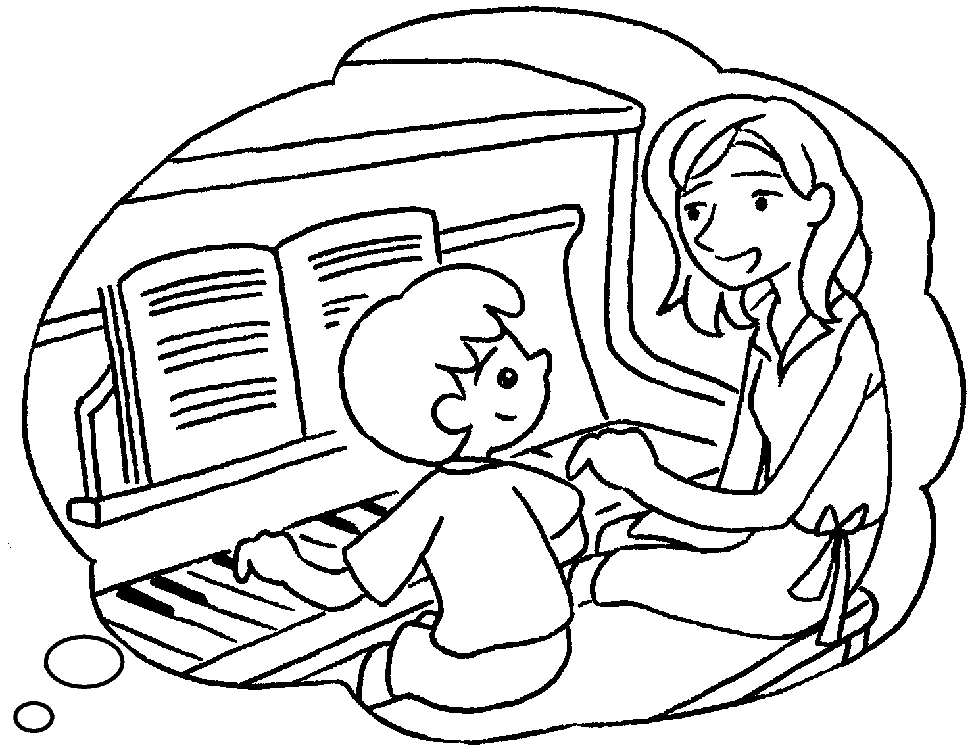  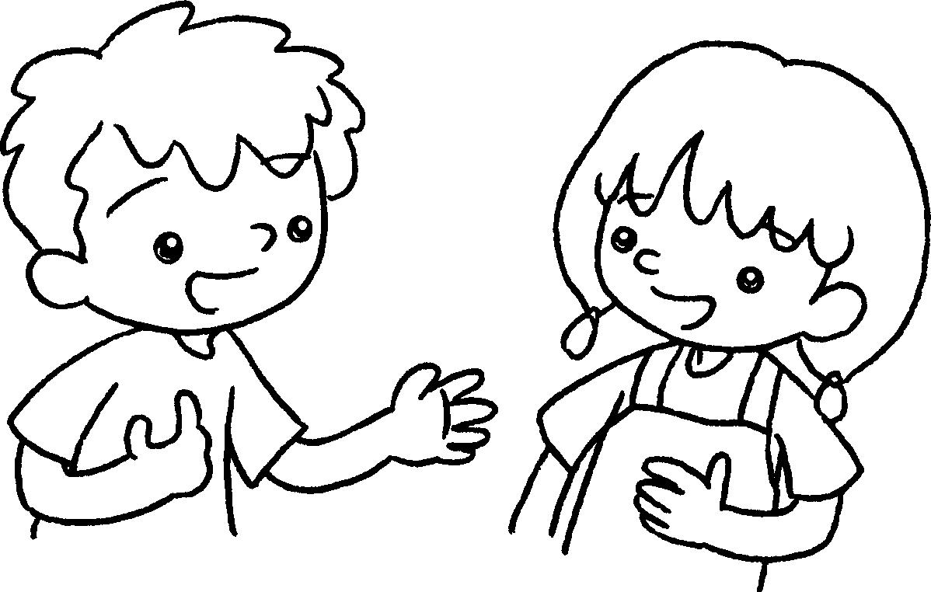 | A : What ________ Ken _________  ______ Fridays?  B : He _________ piano lessons.
5  B  A | 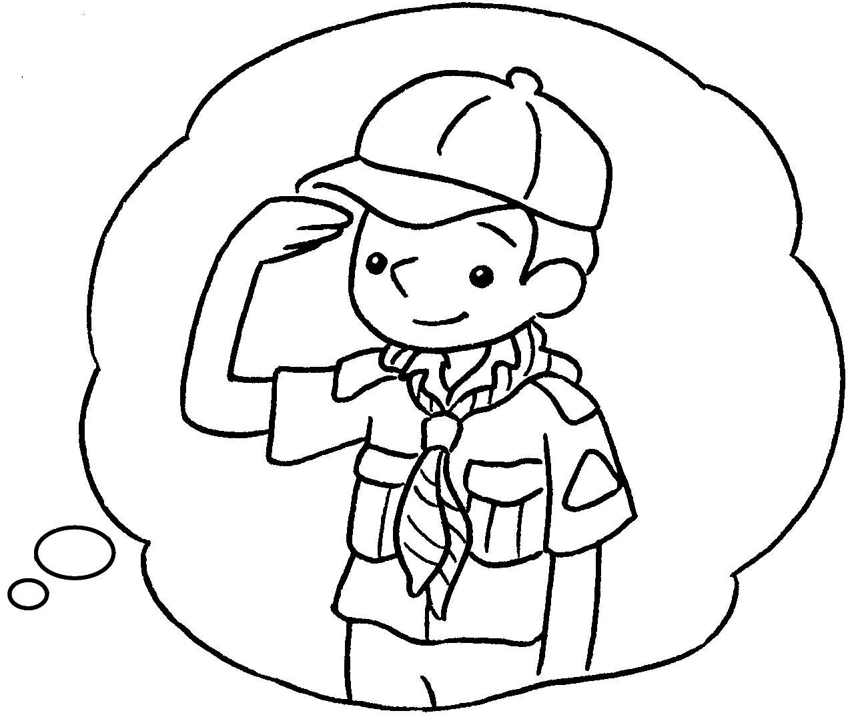  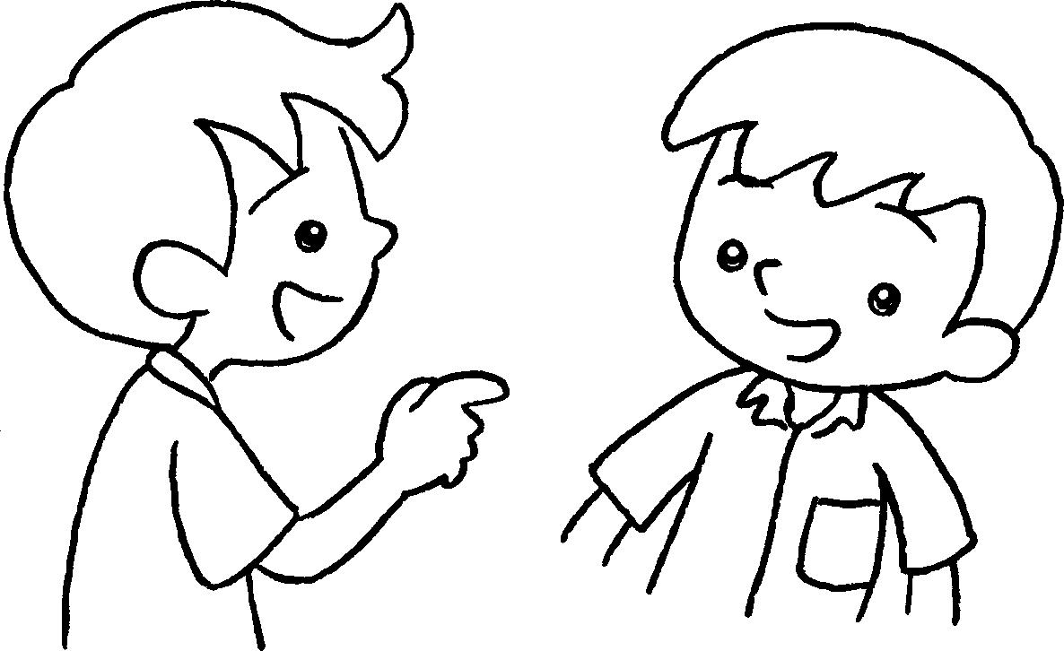 | A : What ________ you ________ _____ Wednesdays?  B : I ___________ to Cub Scouts.


Book 2B Chapter 3 Graded Worksheets
Worksheet 3⬇⬇
- go
- does
visits
3 does do on
has
4 does do on
has
5 do do on
go

