Choose and write.

bed | get up | homework | school

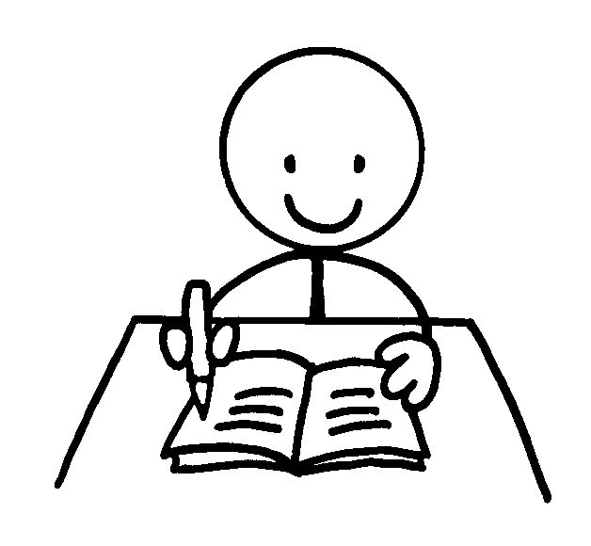  1 |  | 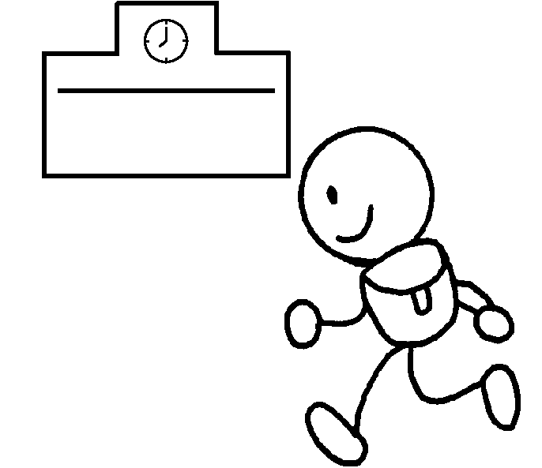  2 |  | 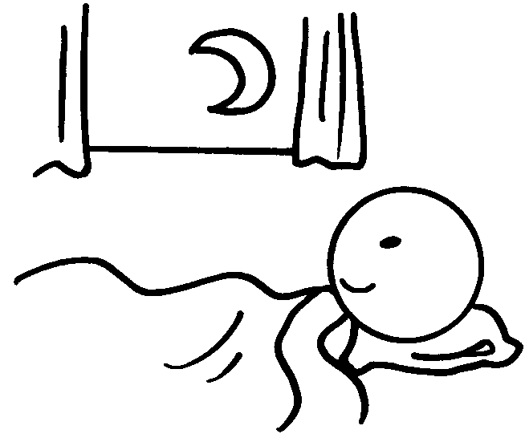  3 |  |  | 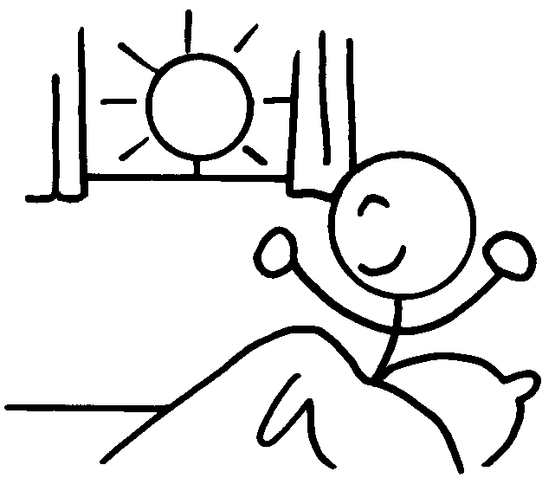  4
1 | do |  |  |  | 2 | go to
3 | go to |  |  |  | 4

breakfast | dinner | lunch

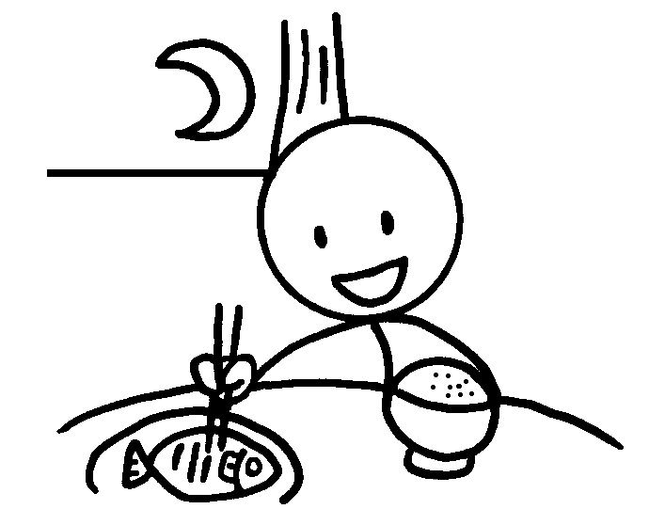  5 |  | 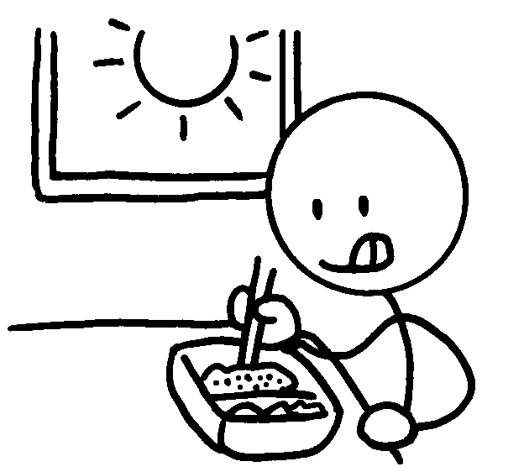  6 |  |  |  |   7
5 | have |  |  | 6 | have
7 | have

teeth | face | bath | shower

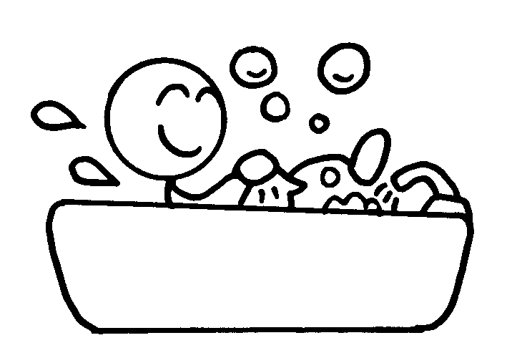  8 |  | 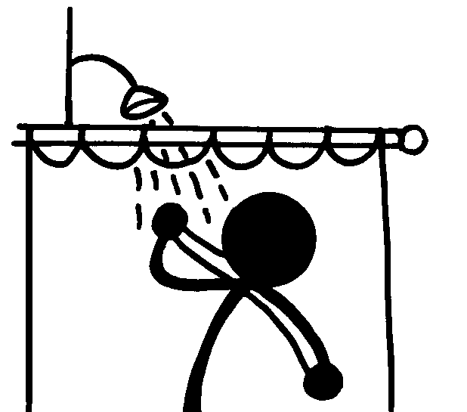  9 |  | 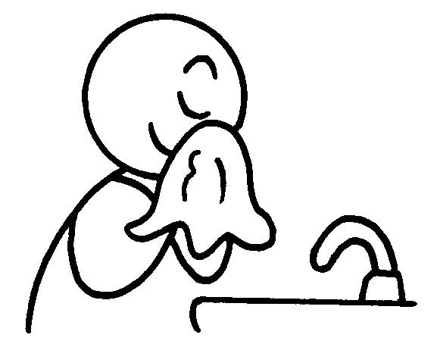  10 |  |  | 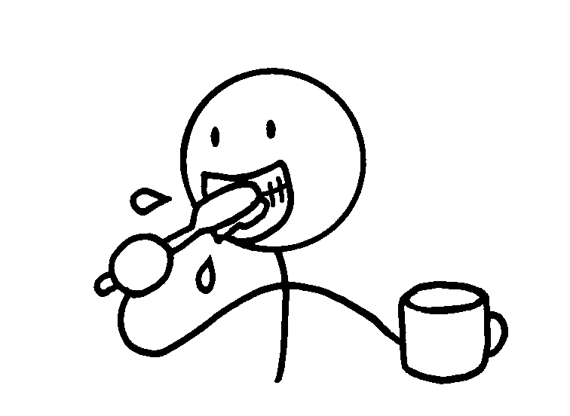  11
8 | have a |  |  |  | 9 | have a
10 | wash my |  |  |  | 11 | brush my


Book 2B Chapter 4 Graded Worksheets
Worksheet 1⬇
- homework 2 school
- bed 4 get up
5 dinner 6 lunch
7 breakfast
8 bath 9 shower
10 face 11 teeth

