Fill in the missing letters.

  1 |  | 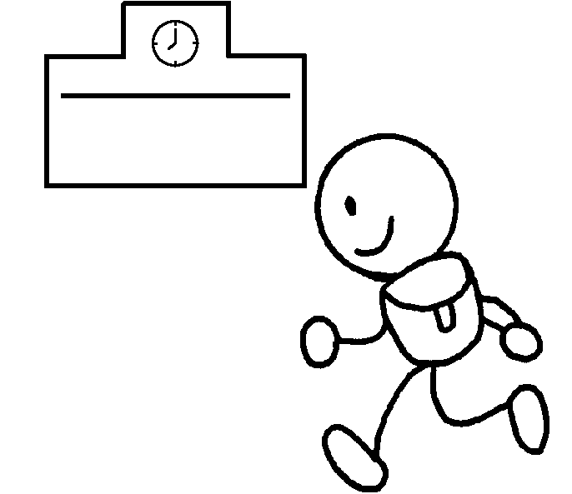  2 |  | 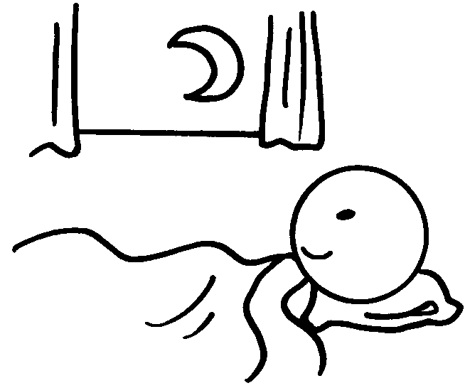  3 |  |  | 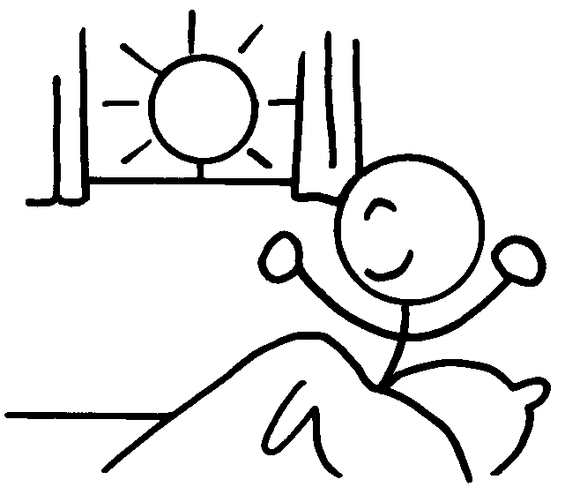  4
1 | do h __ __ __ __ __ __ __ |  |  |  | 2 | go to s __ __ __ __ __
3 | go to b __ __ |  |  |  | 4 | g __ __ u __

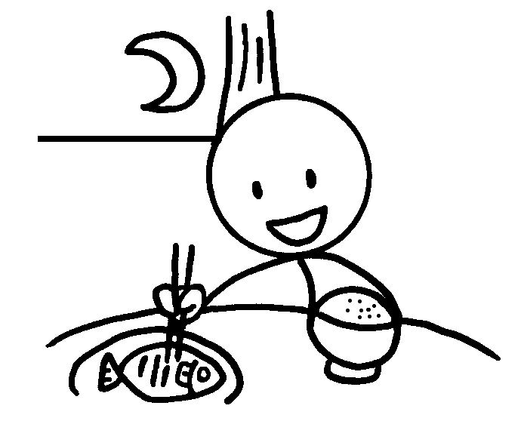  5 |  | 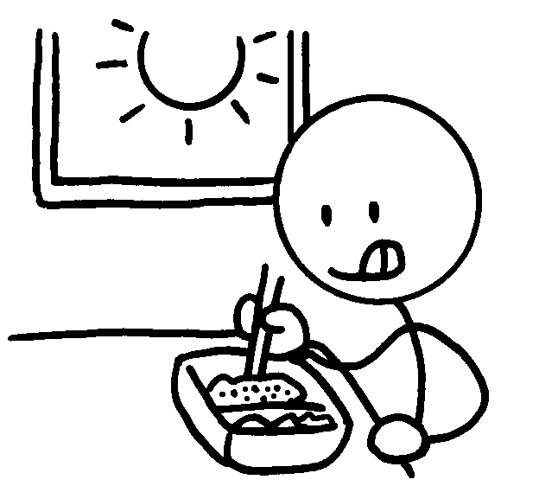  6 |  |  |  |   7
5 | have d __ __ __ __ __ |  |  | 6 | have l __ __ __ __
7 | have b __ __ __ __ __ __ __ __

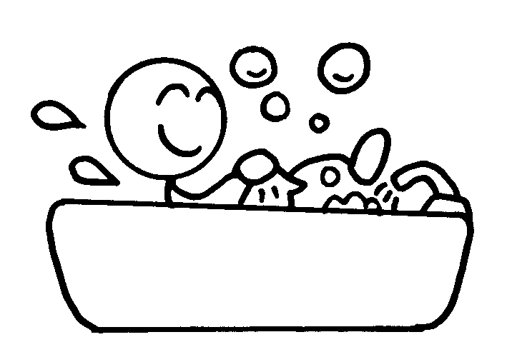  8 |  | 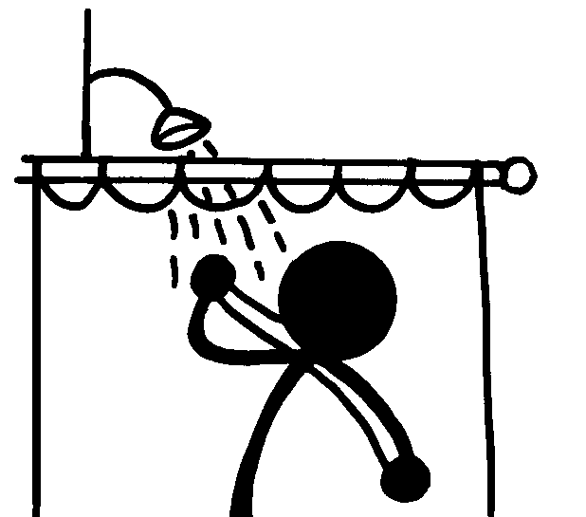  9 |  | 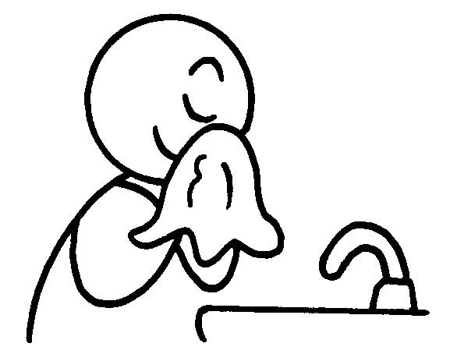  10 |  |  | 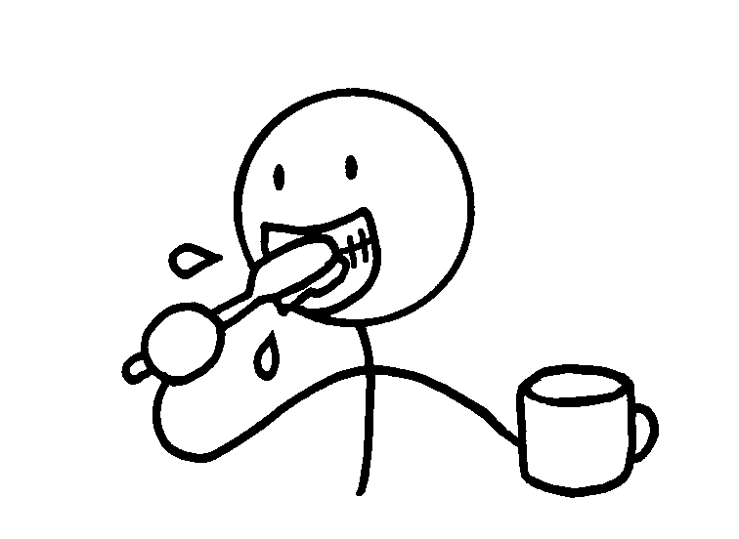  11
8 | have a b __ __ __ |  |  |  | 9 | have a s __ __ __ __ __
10 | wash my f __ __ __ |  |  |  | 11 | brush my t __ __ __ __


Book 2B Chapter 4 Graded Worksheets
Worksheet 1⬇⬇
- h o m e w o r k 2 s c h o o l
3 b e d 4 g e t u p
5 d i n n e r 6 l u n c h
7 b r e a k f a s t
8 b a t h 9 s h o w e r
10 f a c e 11 t e e t h

