Choose and write.

  What time | at | in

1 | 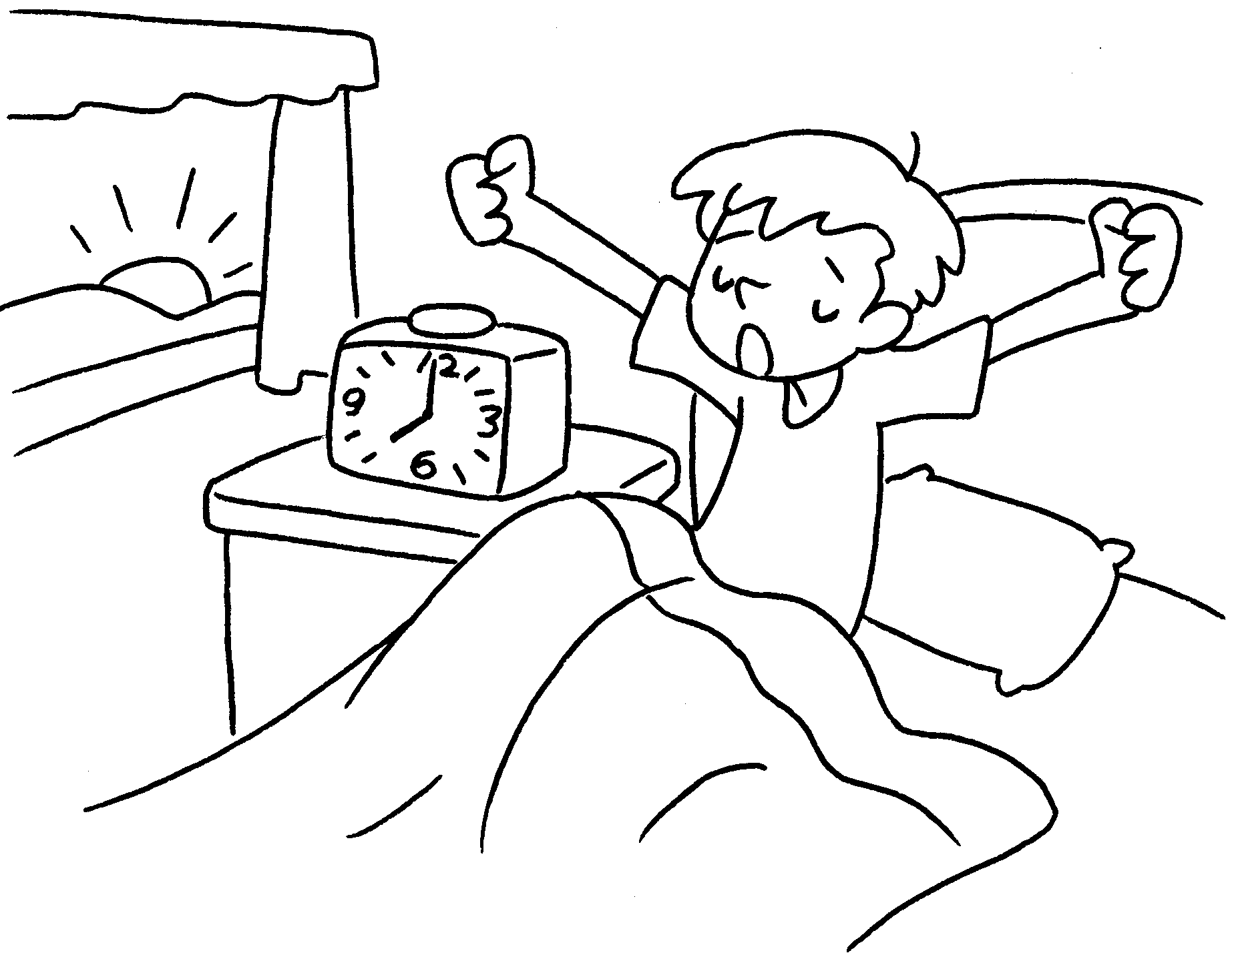 |  | A : What time does Jerry get up?  B : He gets up seven  o’clock.
2 | 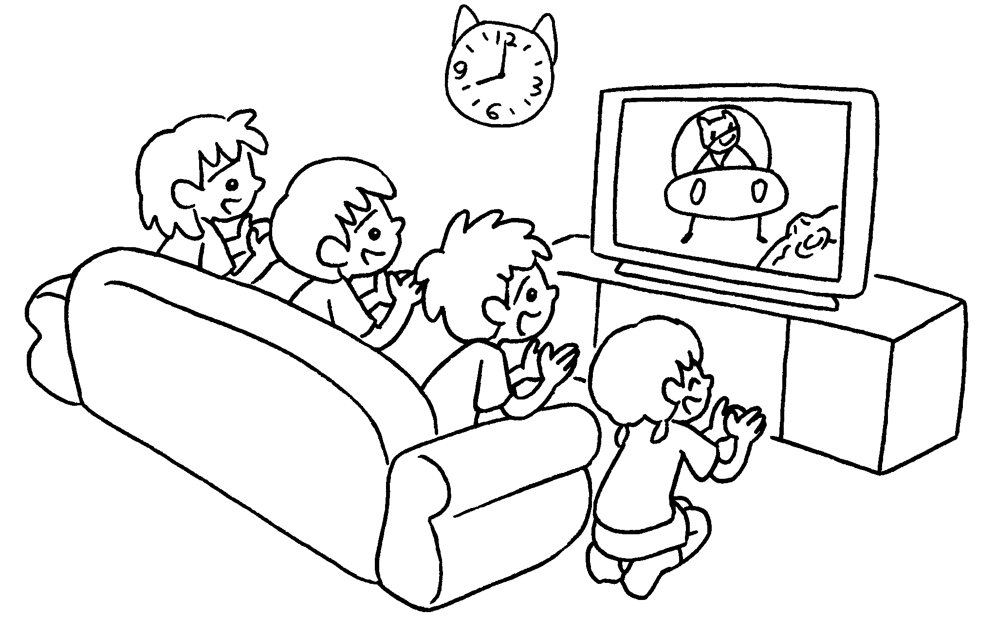 |  | A : do the  children watch TV?  B : They watch TV eight  o’clock night.
3 | 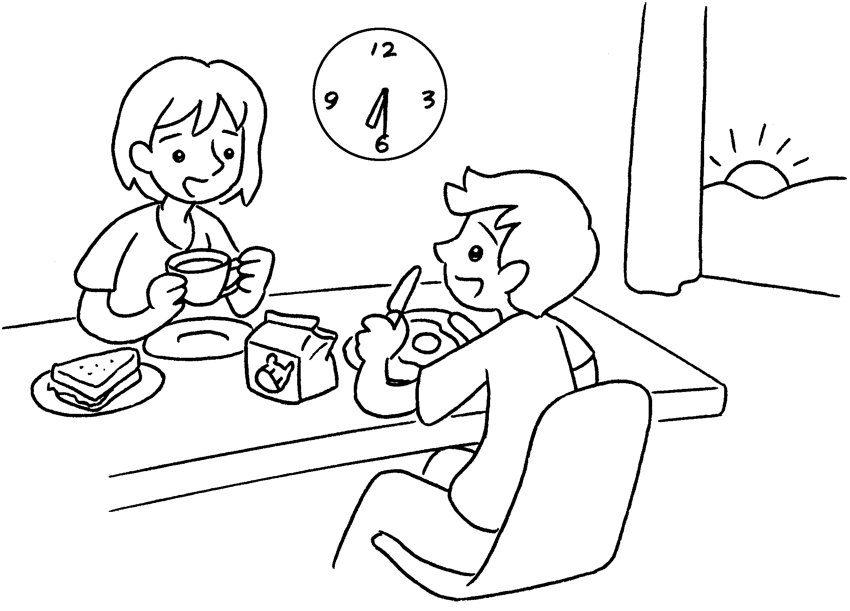 |  | A : do Bill  and Susie have breakfast?  B : They have breakfast  six thirty the morning.
4 | 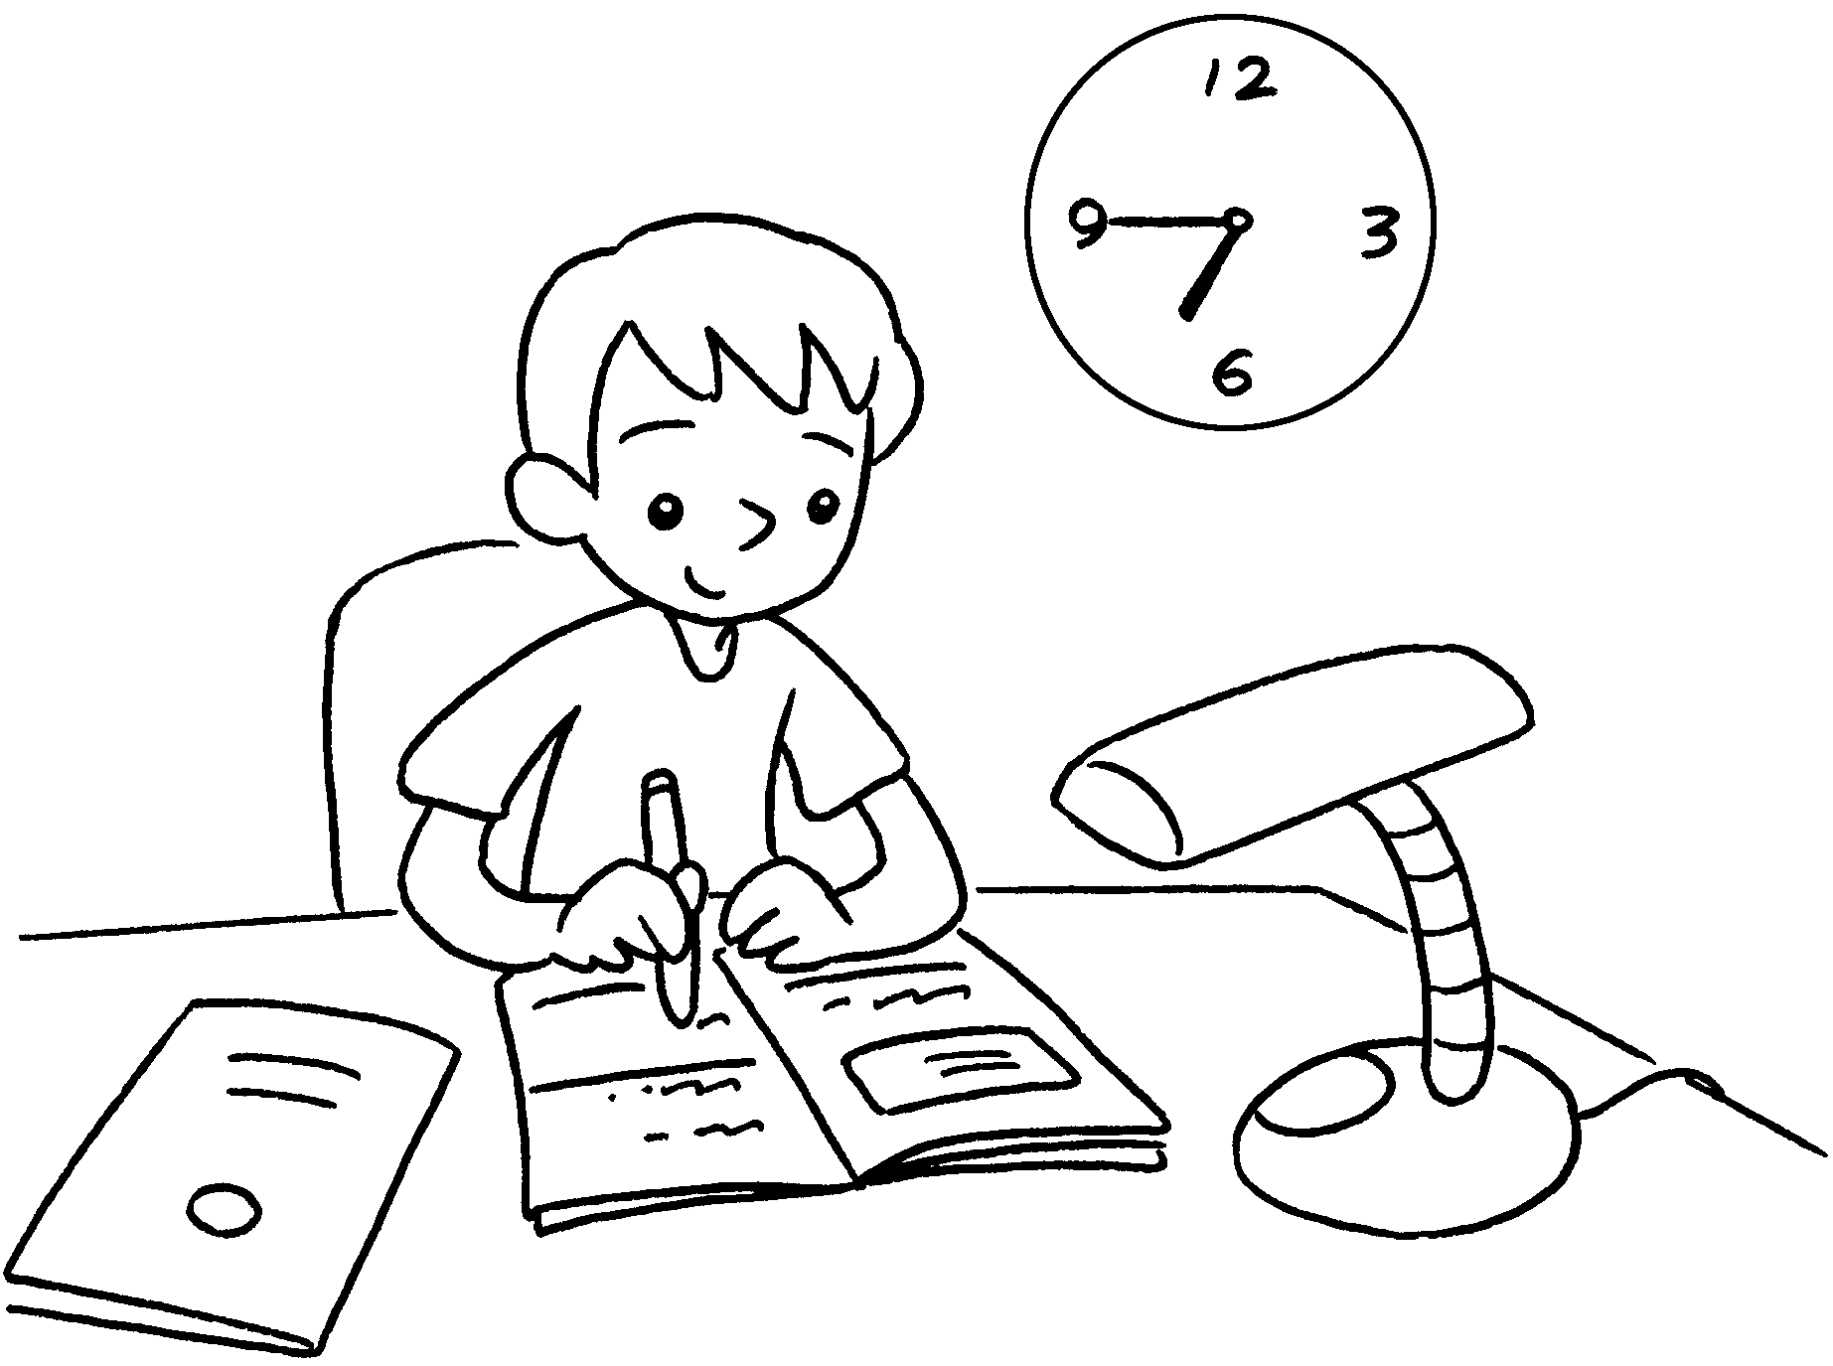 |  | A : does  Andy do his homework?  B : He does his homework  six forty-five  the evening.


Book 2B Chapter 4 Graded Worksheets
Worksheet 3⬇
- at
- What time
at at
- What time
at in
- What time
at in

