Finish the questions and answers.

1 | 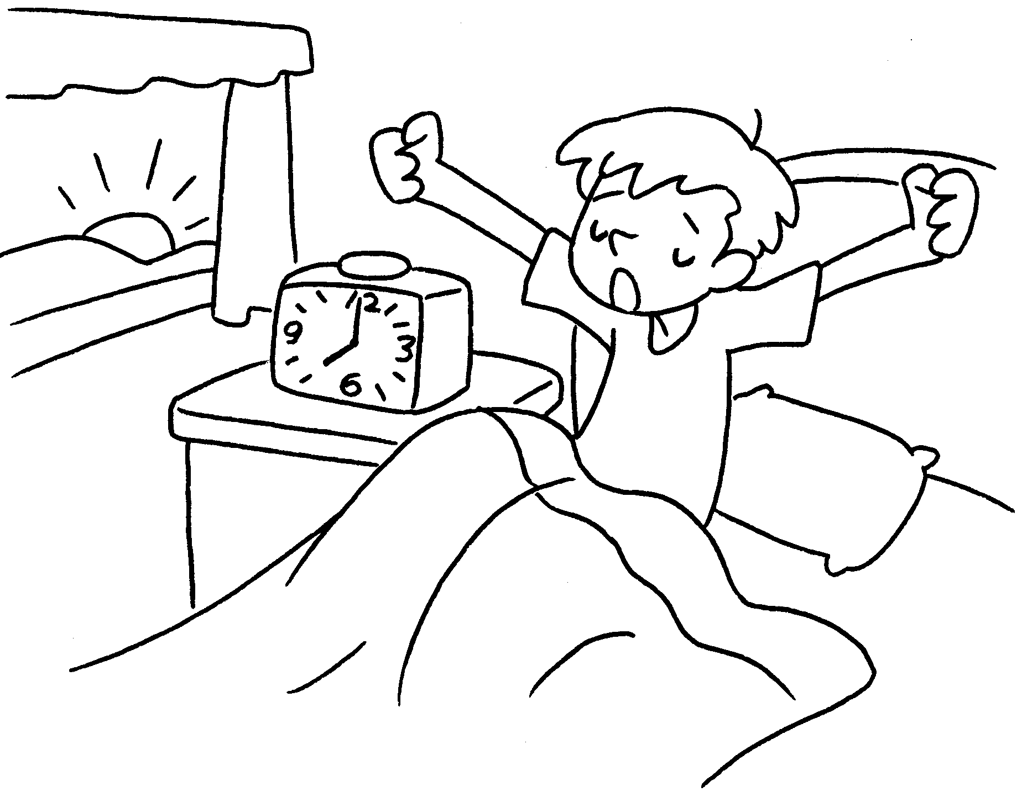 |  | A : What time does Jerry get up?  B : He gets up seven  o’clock.
2 | 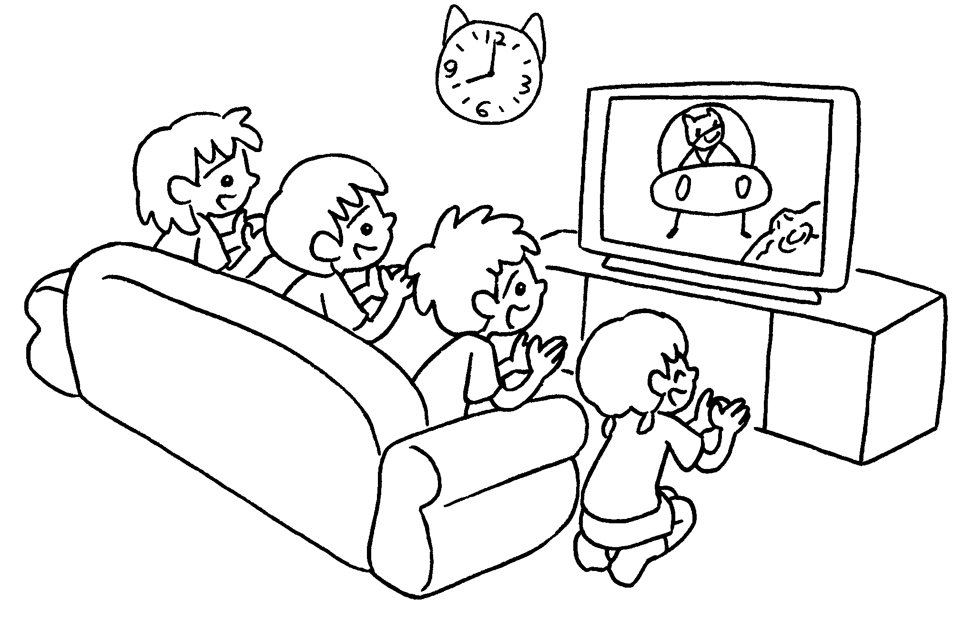  8:00 p.m. |  | A : What time do the children watch TV?  B : They watch TV night.
3 | 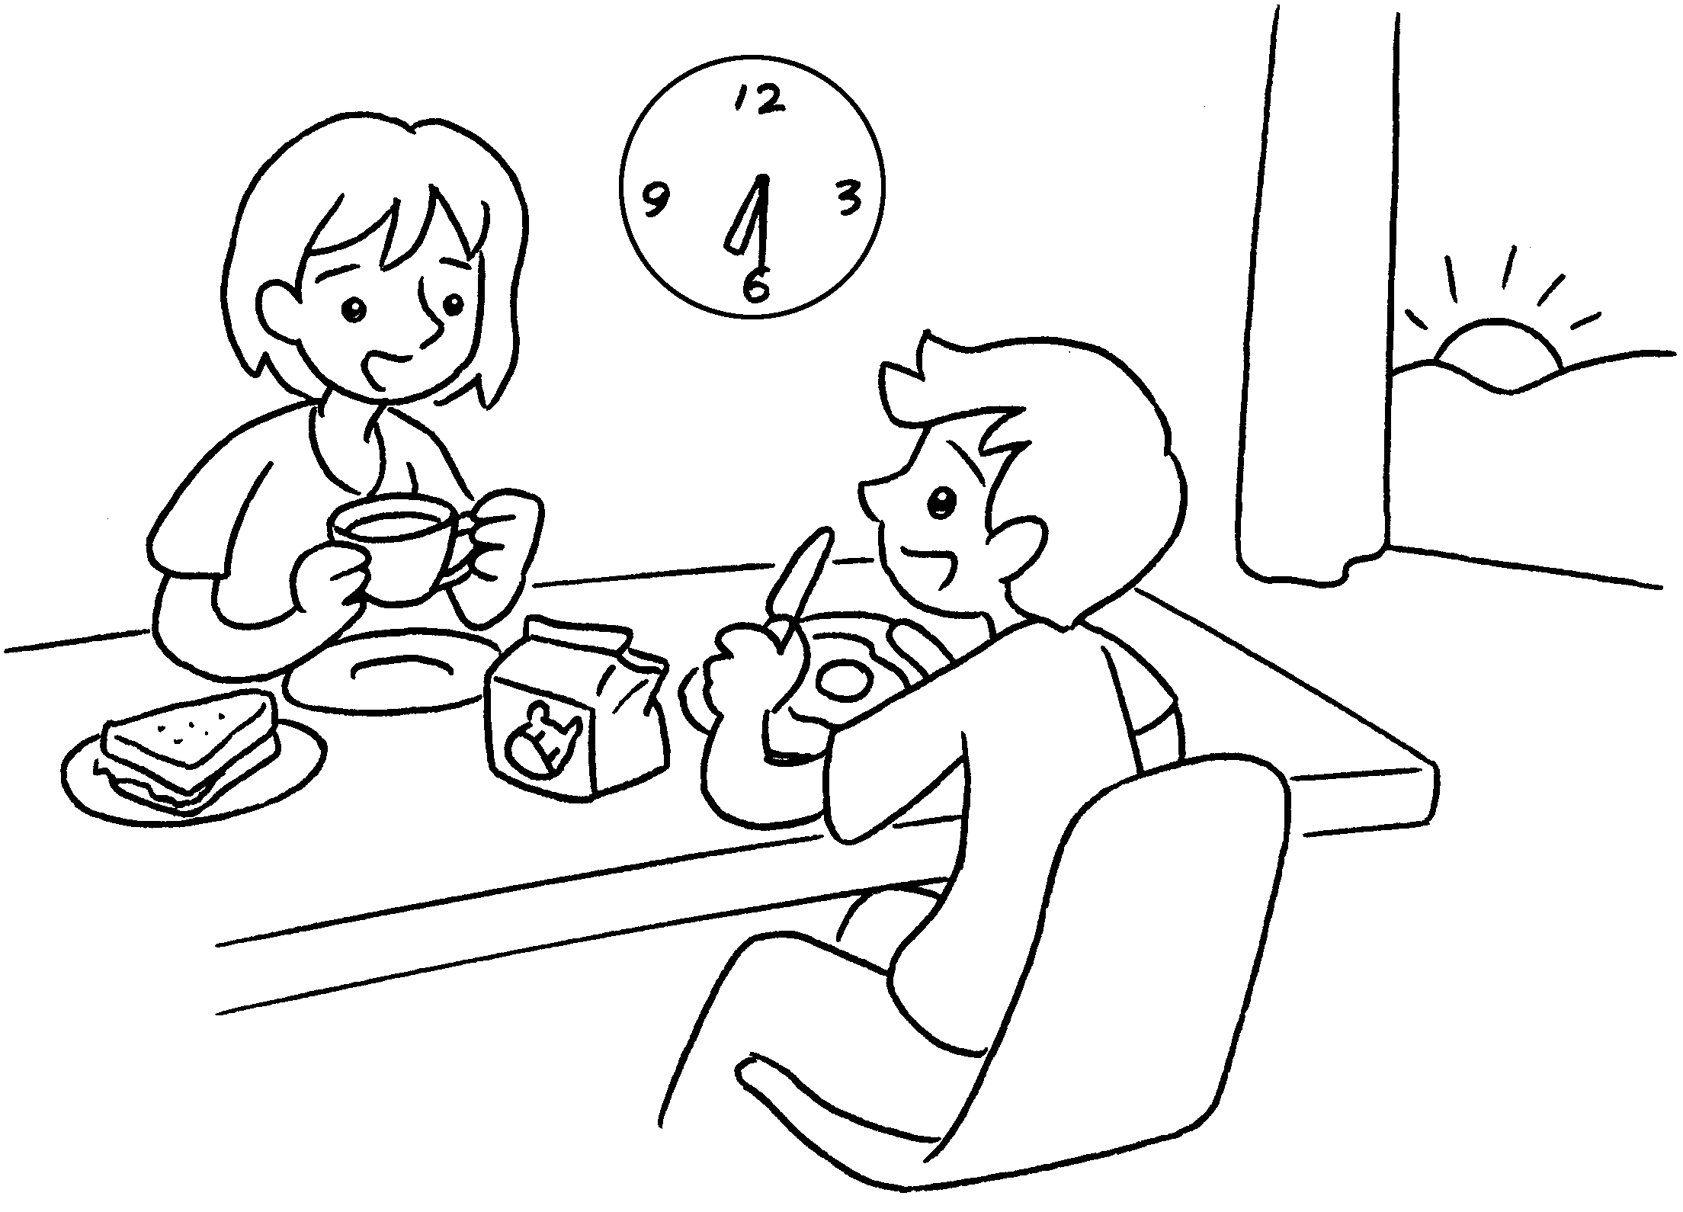  6:30 a.m. |  | A :  Bill and Susie have breakfast?  B : They have breakfast  the morning.
4 | 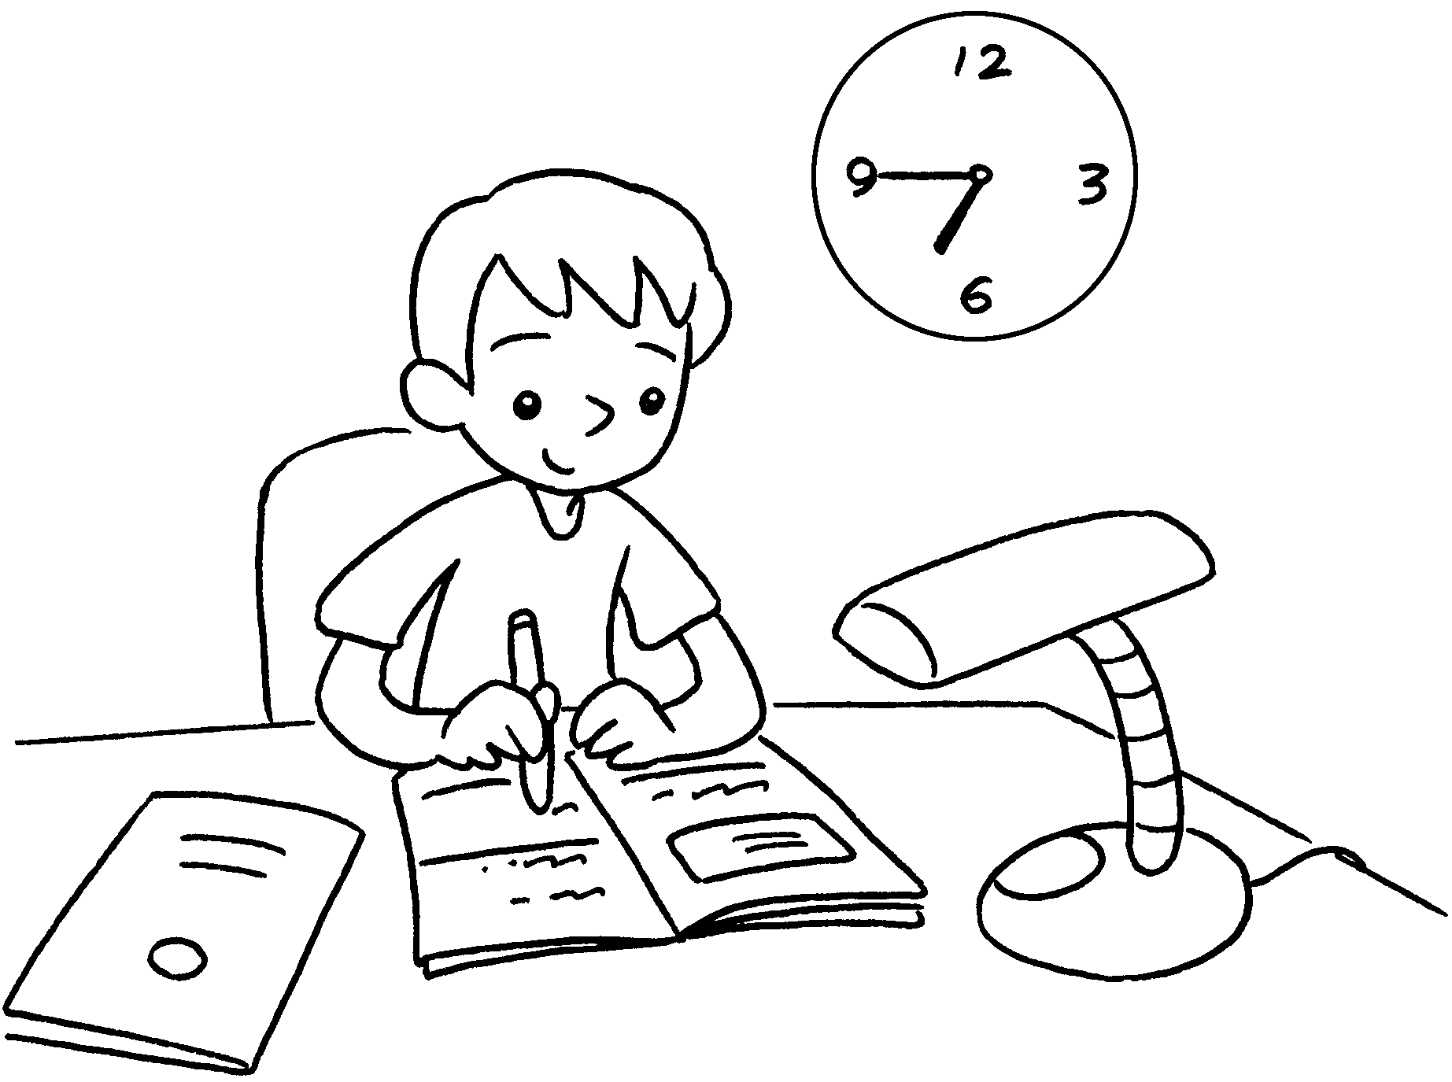  6:45 p.m. |  | A :  Andy do his homework?  B : He does his homework  the evening.


Book 2B Chapter 4 Graded Worksheets
Worksheet 3⬇⬇⬇
- at
2 at eight o’clock at
3 What time do
at six thirty / half past six in
4 What time does
at six forty-five / (a) quarter to seven in

