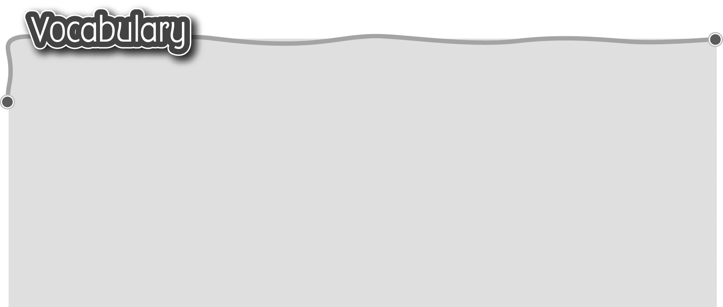
1 daily action 日常活動 6 go to school 上學
2 get up 起床 7 do my homework 做功課
3 brush my teeth 刷牙 8 have a bath / shower
4 wash my face 洗臉 浸浴/淋浴
5 have breakfast / lunch / 9 go to bed 上床睡覺
dinner 吃早餐/午餐/晚餐
The words marked with * have different meanings in other
contexts. You can look up those meanings in a dictionary.
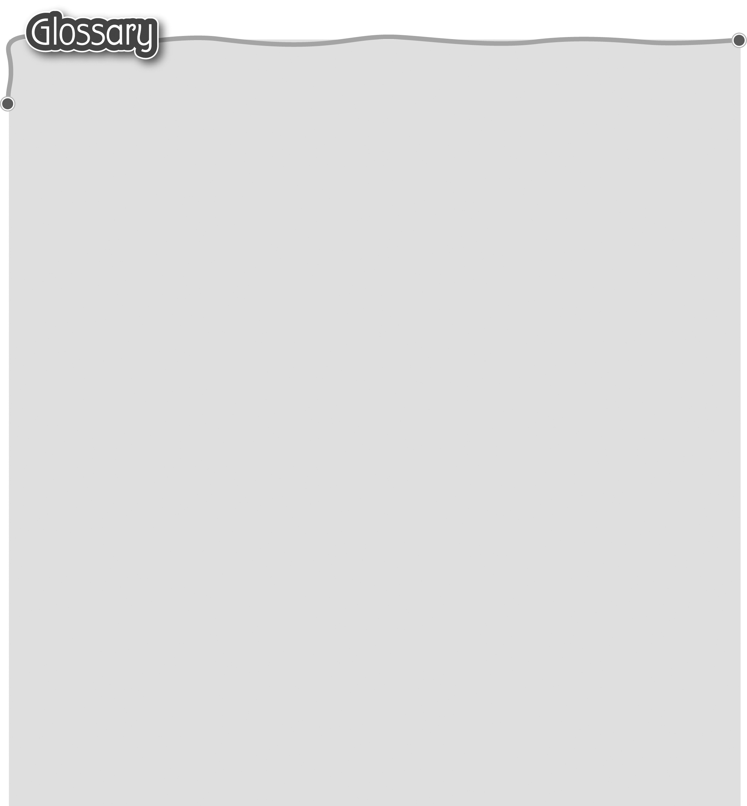
1 o’clock (p.28) ……時 12 in the afternoon (p.29) 下午
2 in the morning (p.28) 早上 13 field* (p.29) 農田
3 congee (p.28) 粥 14 cook dinner (p.29) 煮晚飯
4 half past … (p.28) ……時半 15 at night (p.29) 晚上
5 chicken* (p.28) 雞 16 (be) tired (p.29) 疲倦
6 ox (p.28) 公牛 17 what time (p.31) 幾點
7 walk* (p.29) 步行（動詞） 18 in the evening (p.31) 晚上
8 start* (p.29) 開始（動詞） 19 cooking lesson (p.32) 烹飪課
9 a long way (p.29) 路途遙遠 20 school holiday (p.34) 學校假期
10 clever (p.29) 聰明 21 get into (p.35) 進入
11 mark* (p.29) 分數（名詞）

