Choose and write.
coat | raincoat | sweater | T-shirt
1

2
3
4
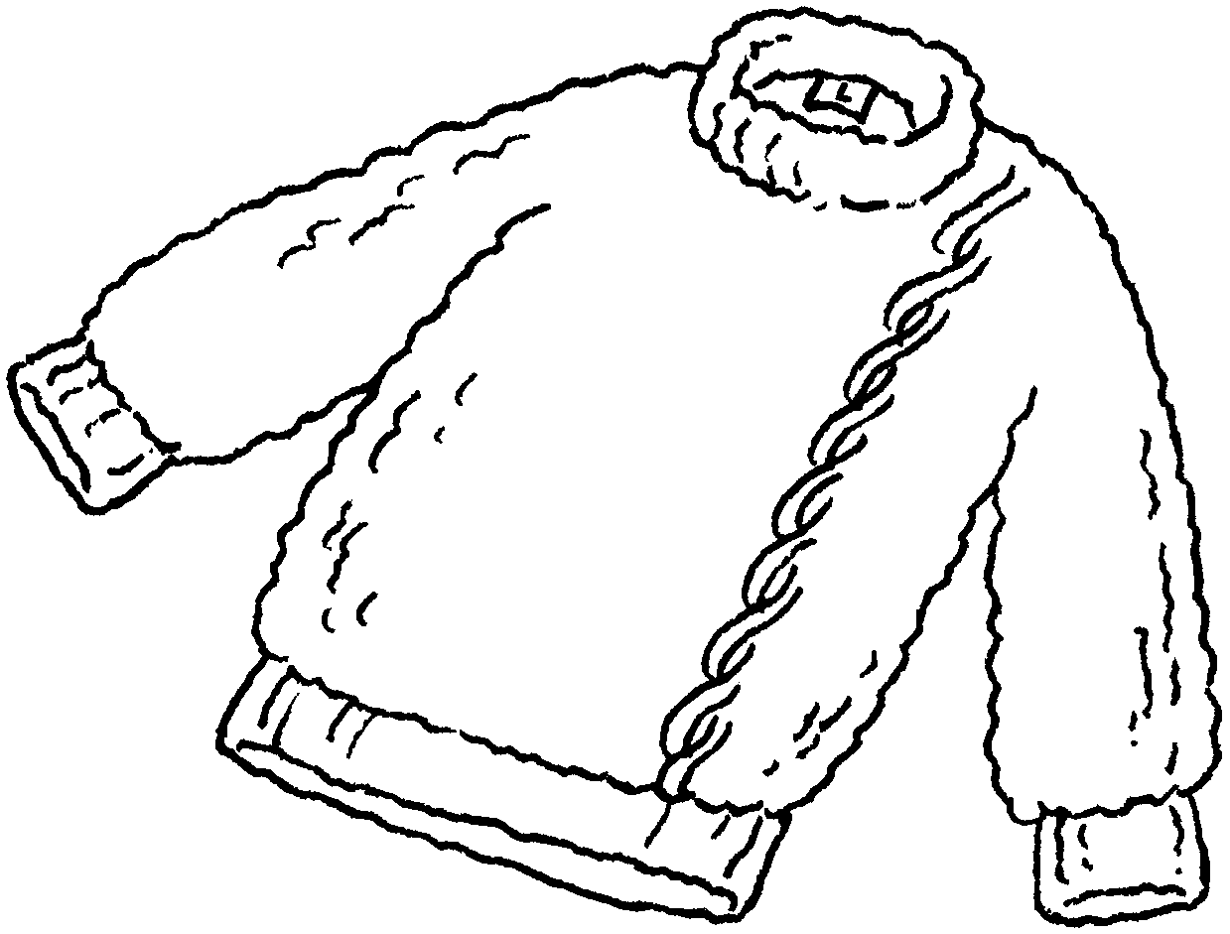 |  | 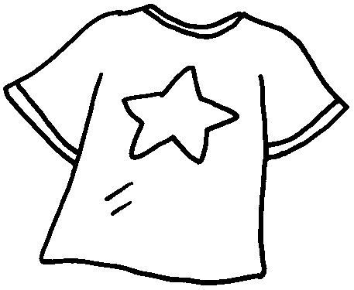 | 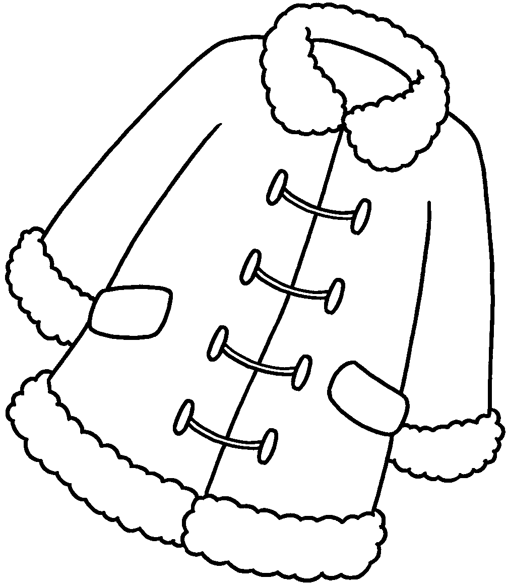 |  | 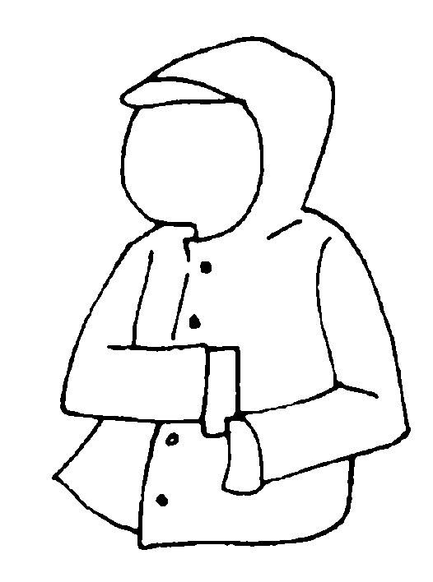
1 | a |  | 2 | a
3 | a |  | 4 | a

boots | cap | gloves
hat | scarf | umbrella

5  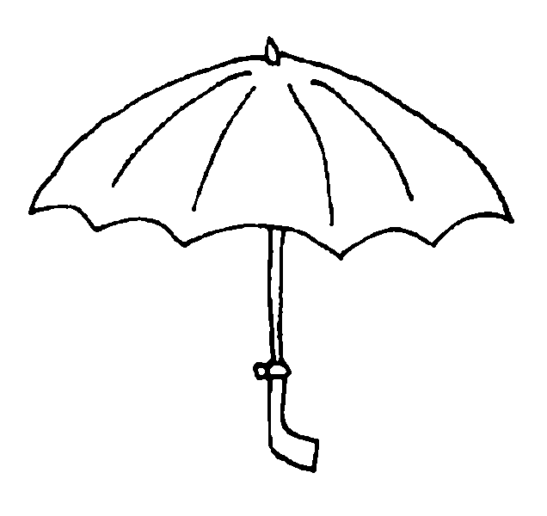  1 |  | 6  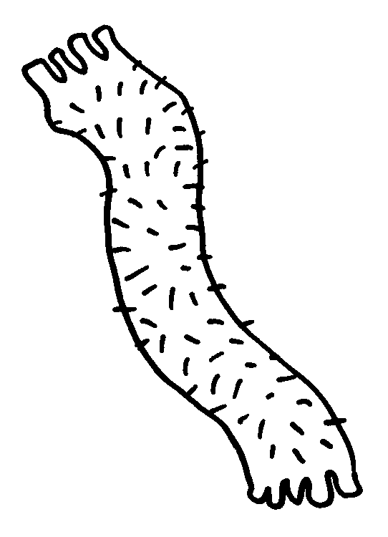 |  |  | 7  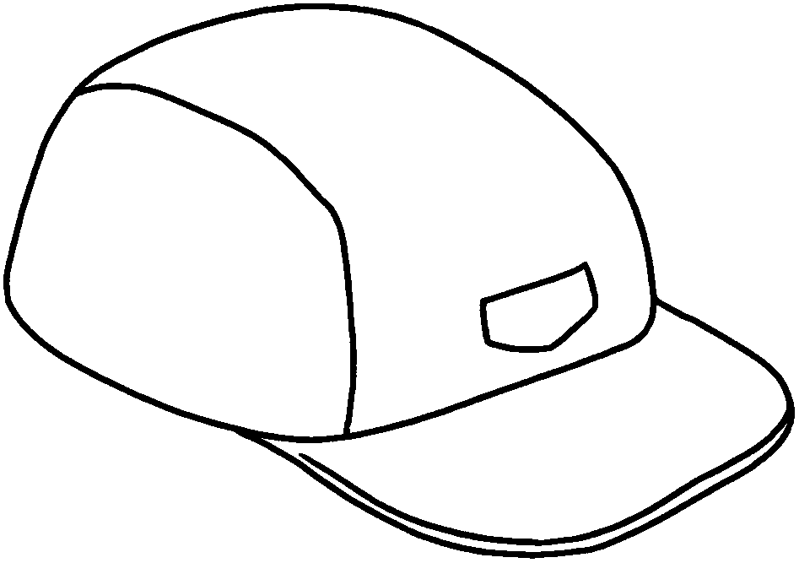
8  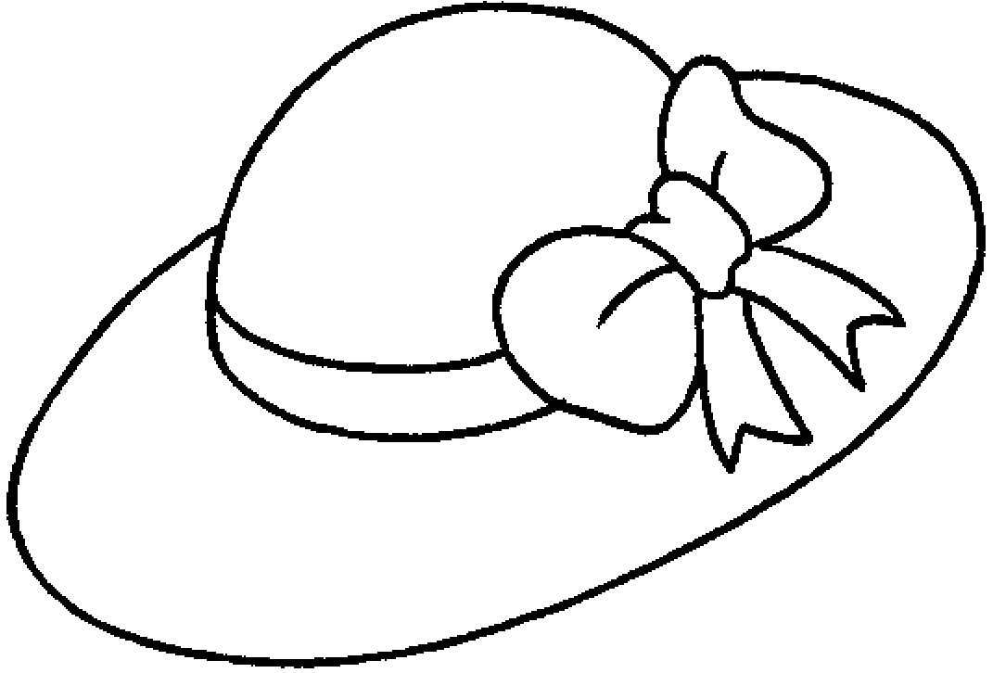  1 |  | 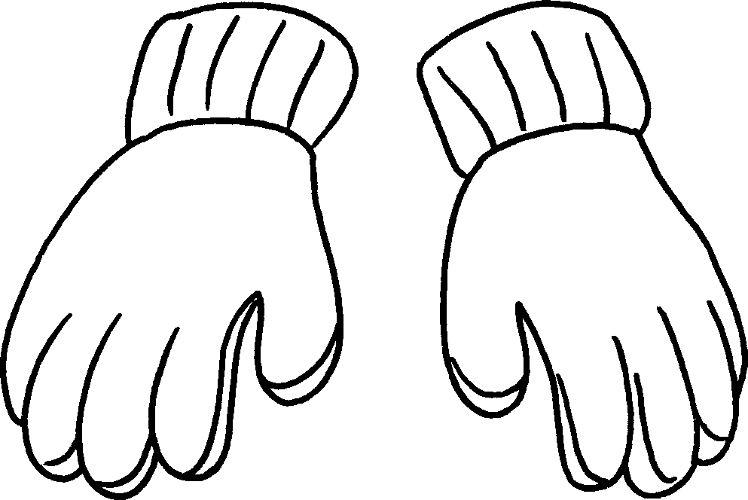  9 |  |  | 10  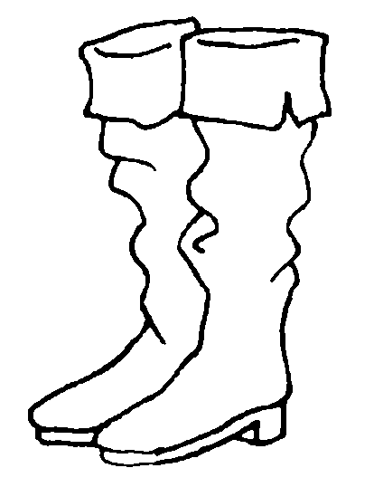
5 | an |  | 6 | a
7 | a |  | 8 | a
9 |  |  | 10

Book 2B Chapter 5 Graded Worksheets

Worksheet 1⬇
1 sweater 2 T-shirt
3 coat 4 raincoat
5 umbrella 6 scarf
7 cap 8 hat
9 gloves 10 boots

