What are they? Write.
1

2
3
4
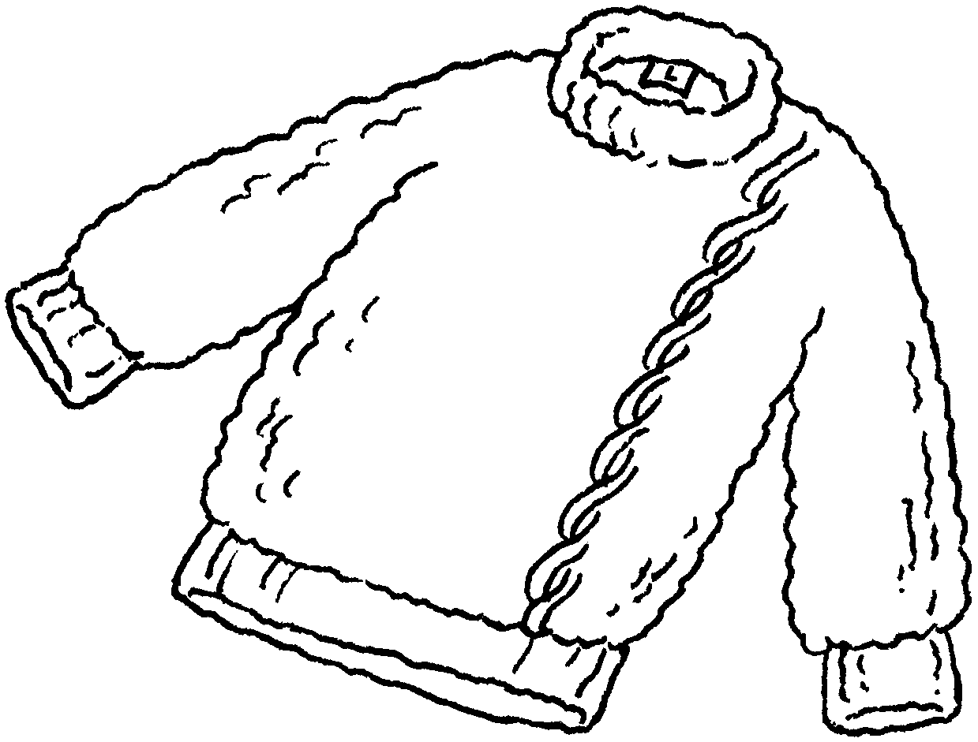 | 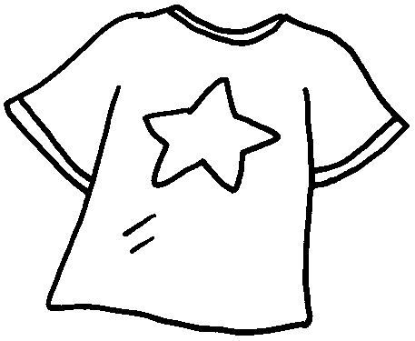 | 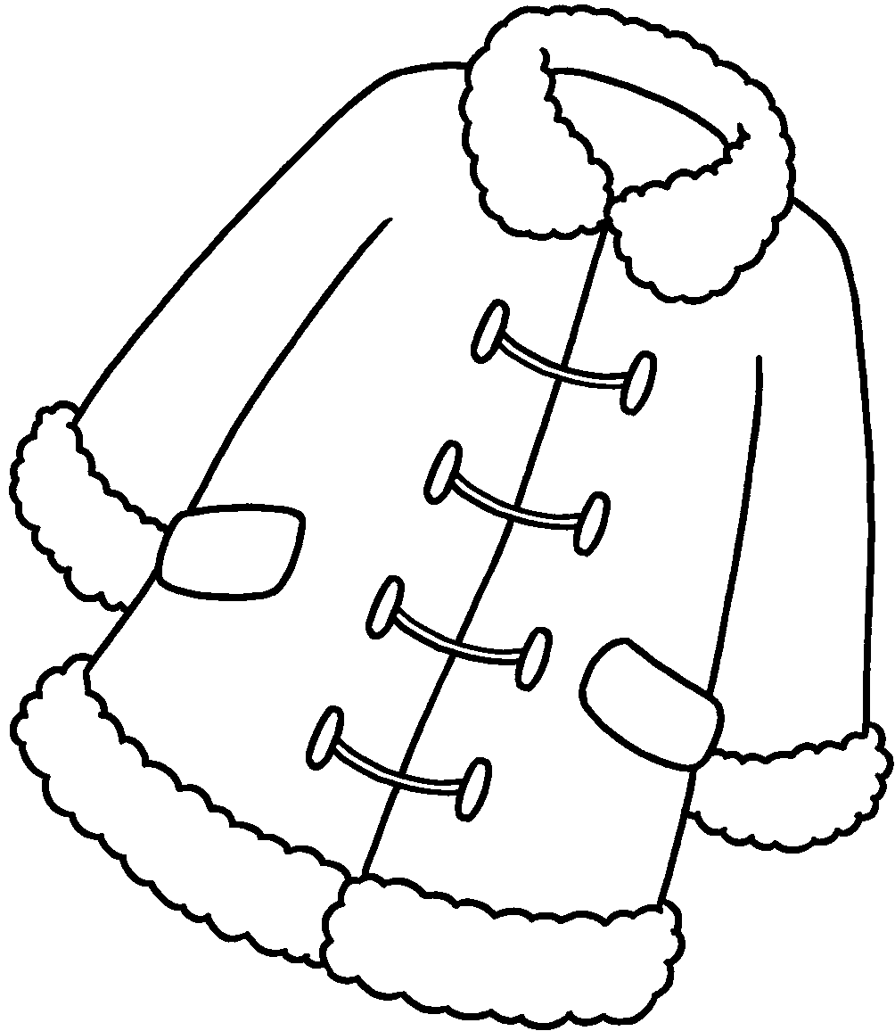 | 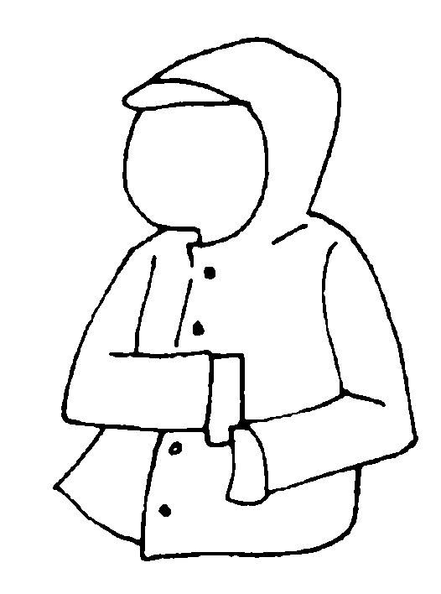

1 | a s | 2 | a
3 |  | 4

5  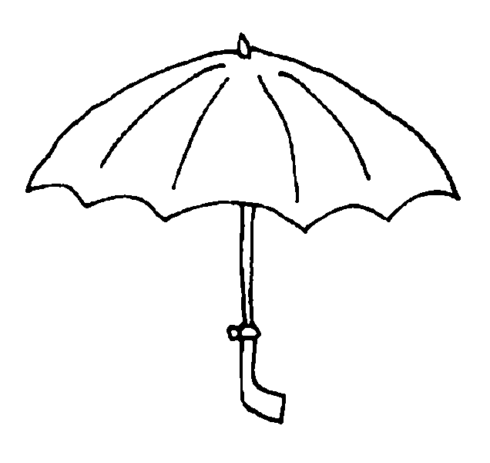  1 | 6  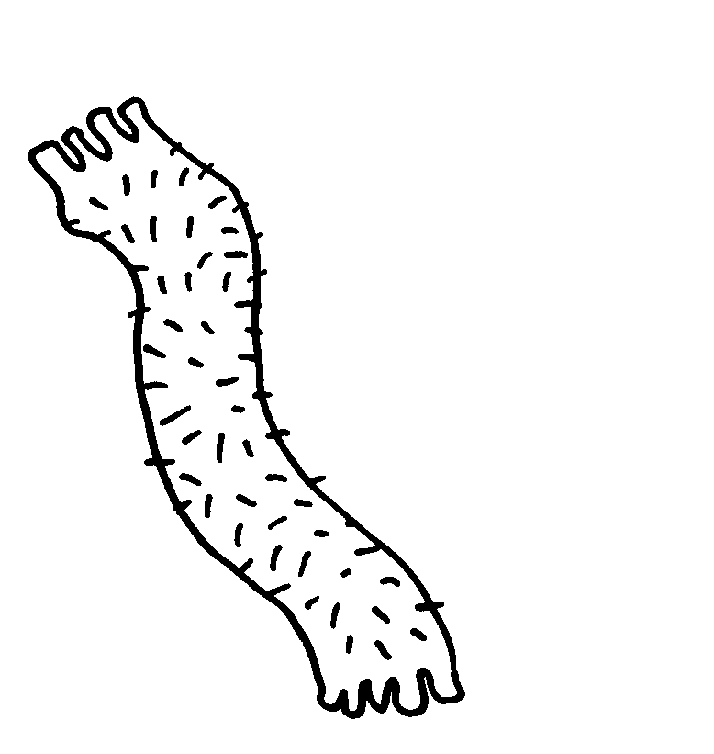 | 7  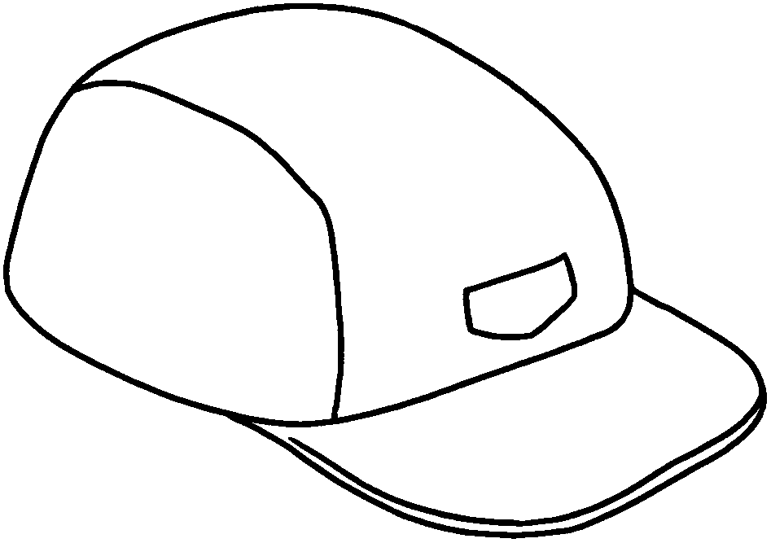
8  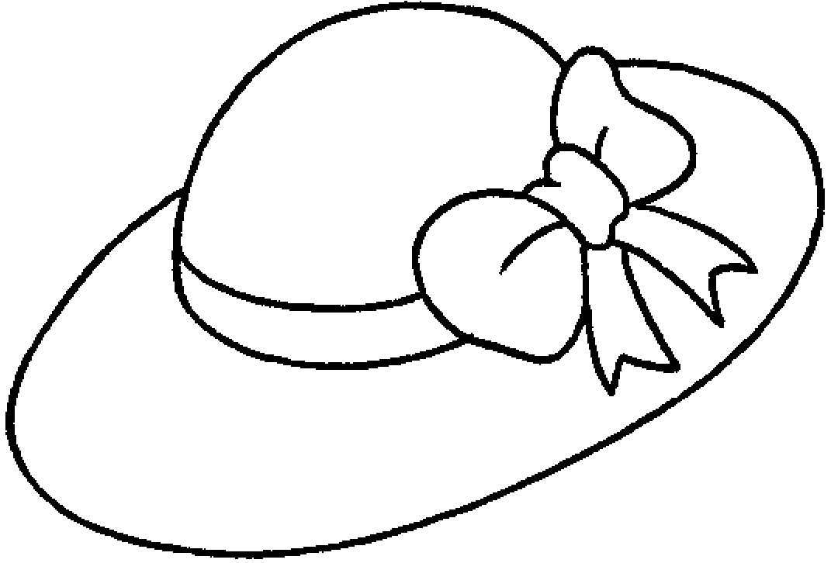  1 | 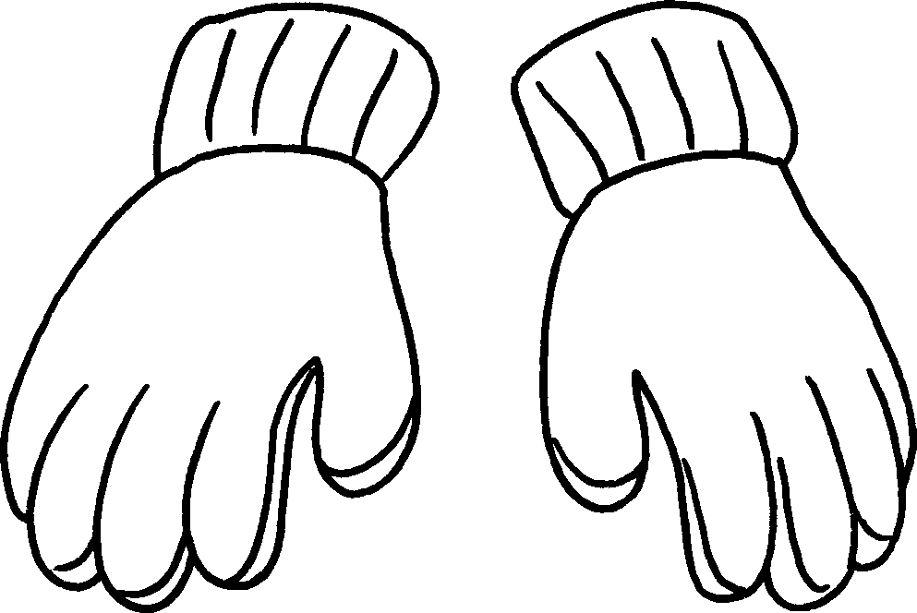  9 | 10  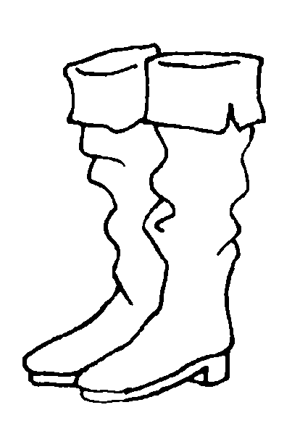

5 |  | 6
7 |  | 8
9 |  | 10

Book 2B Chapter 5 Graded Worksheets

Worksheet 1⬇⬇⬇
1 sweater 2 T-shirt
3 a coat 4 a raincoat
5 an umbrella 6 a scarf
7 a cap 8 a hat
9 gloves 10 boots

