Choose and write.

usually | in | spring | summer | autumn | winter

1 | 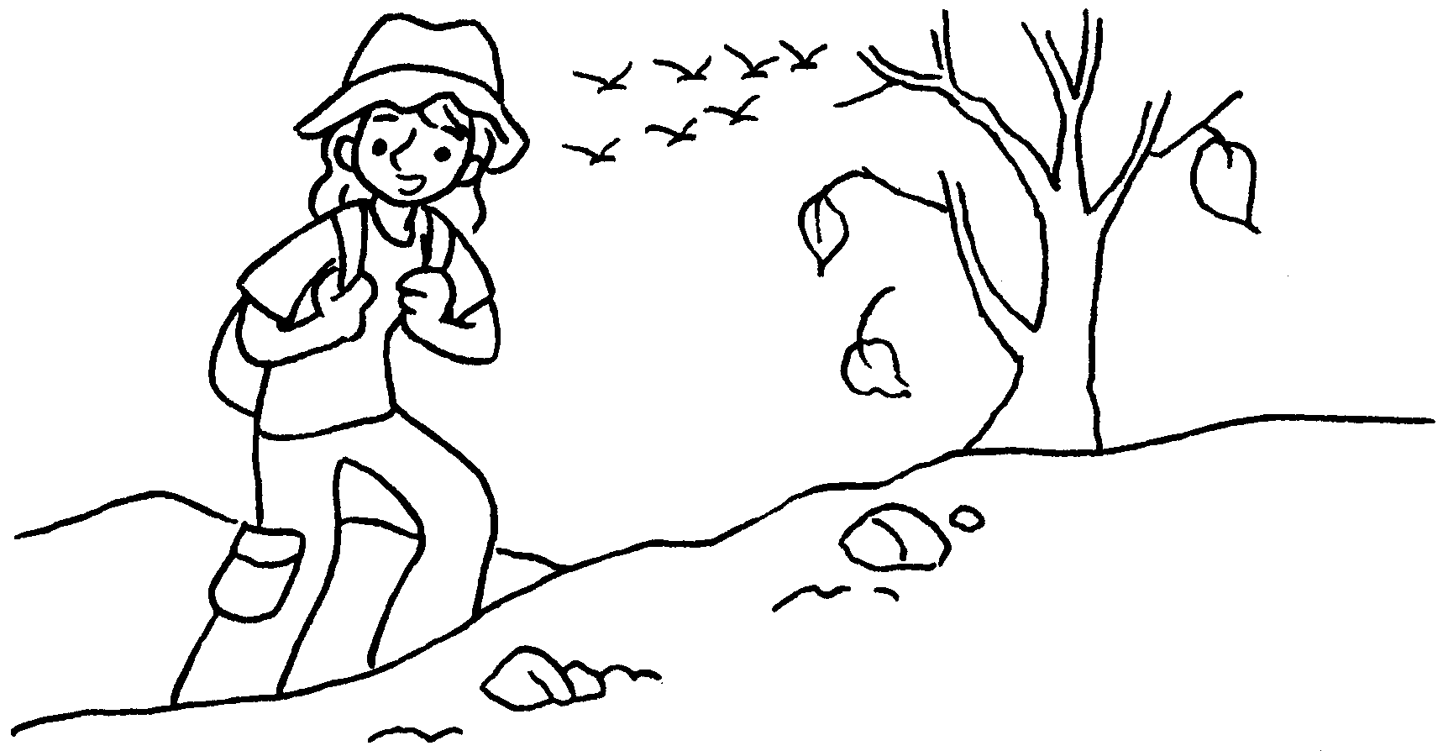  …  …  …  … |  | I usually go hiking in  .
2 | 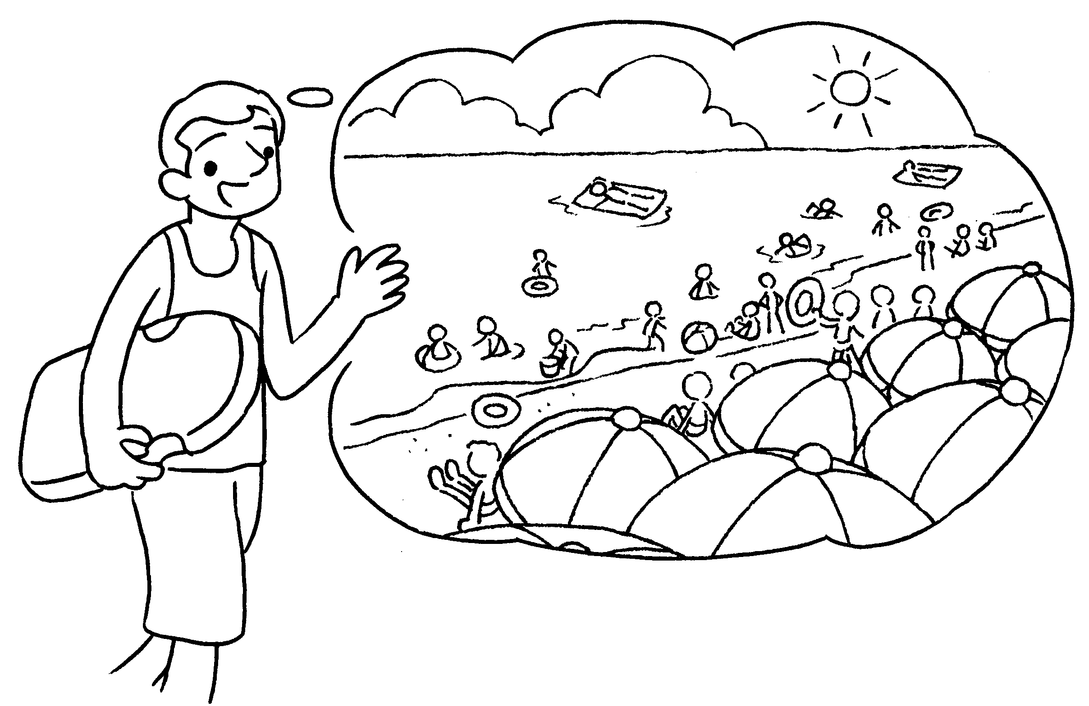 |  | I go to the beach in summer.
3 | 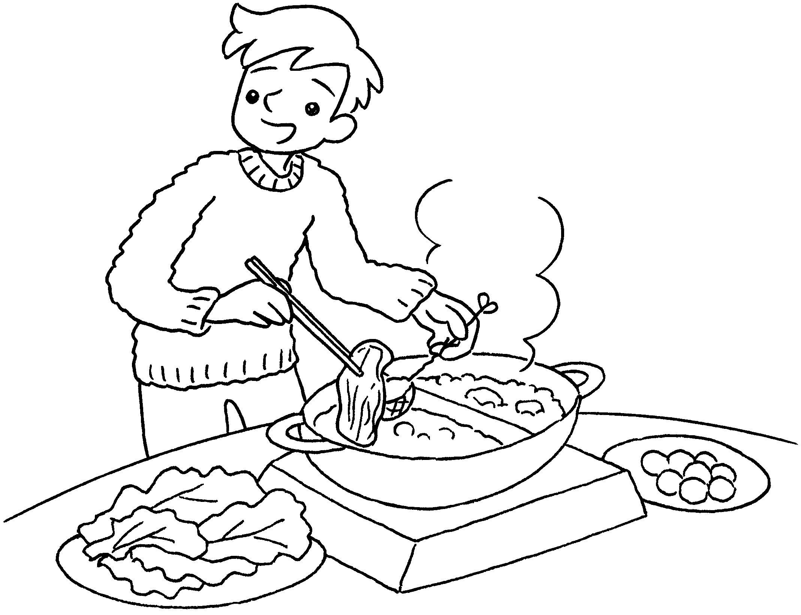 |  | I usually eat hotpot  .
4 | 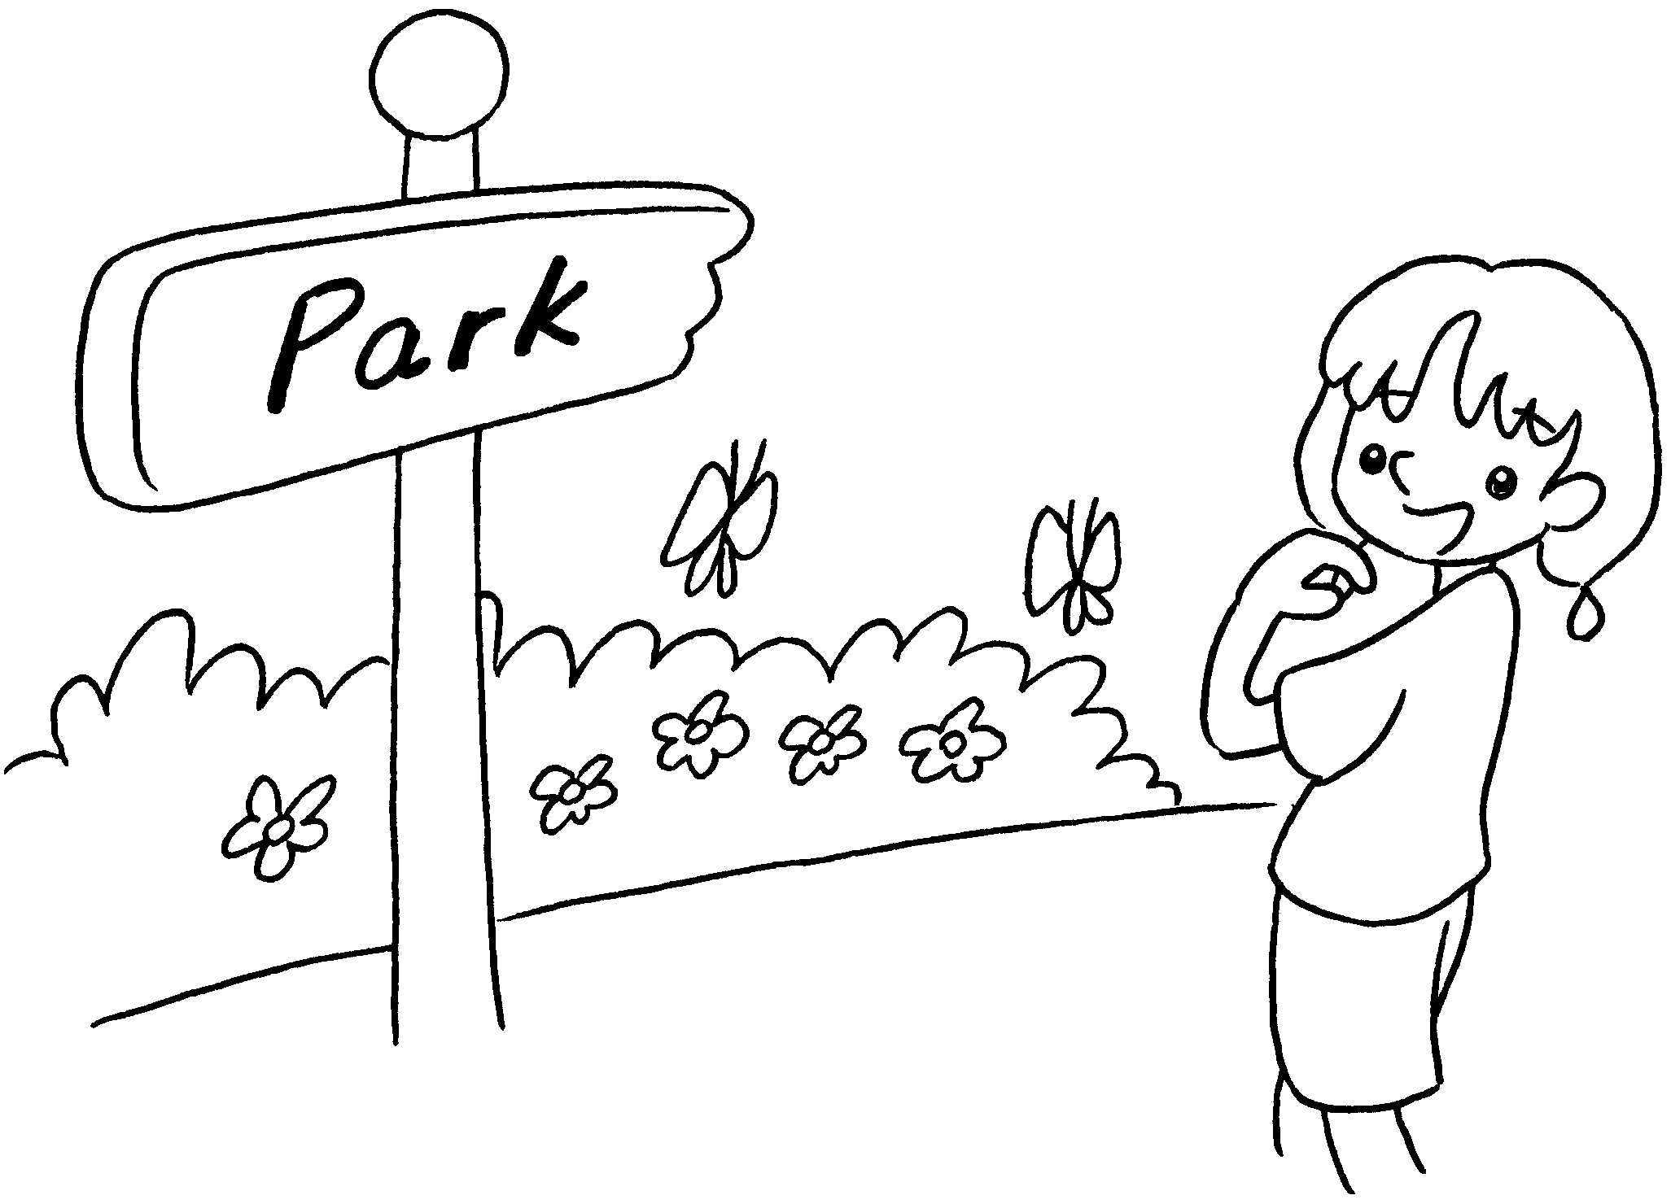 |  | I go to the park  .
5 | 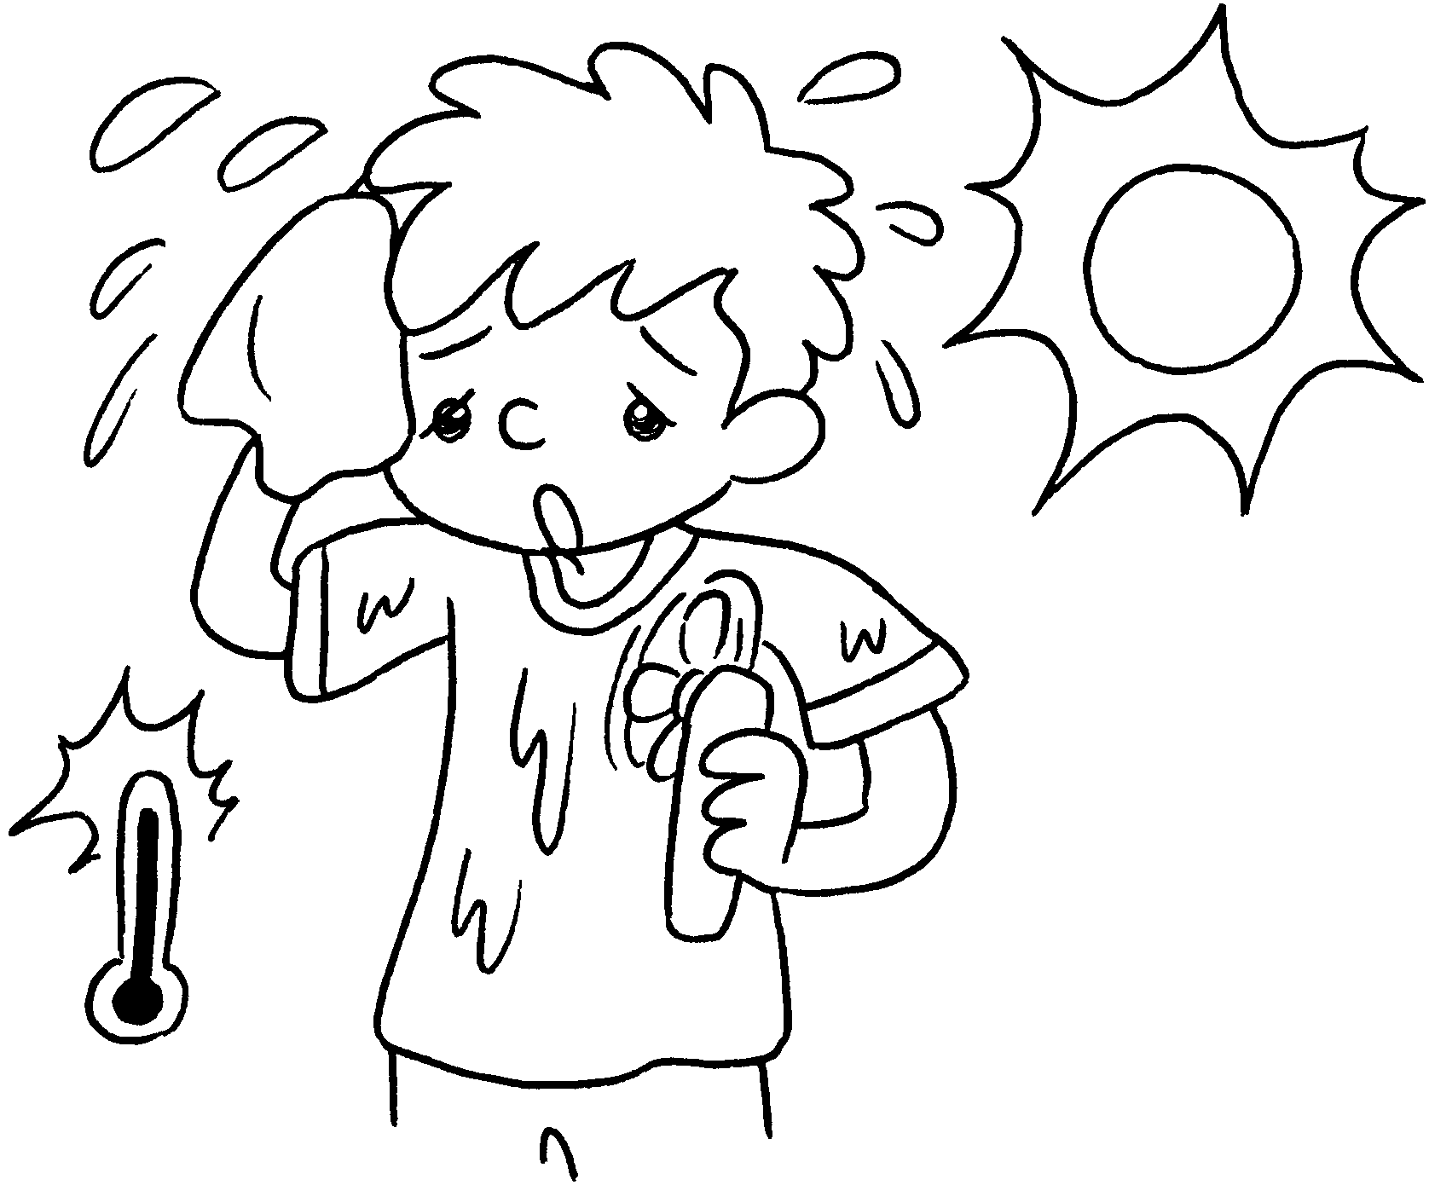 |  | I wear a T-shirt  .


Book 2B Chapter 5 Graded Worksheets
Worksheet 2⬇
- autumn
- usually
- in winter
- usually in spring
- usually in summer

