What do the people usually do in different seasons? Write.

usually | in

1 | 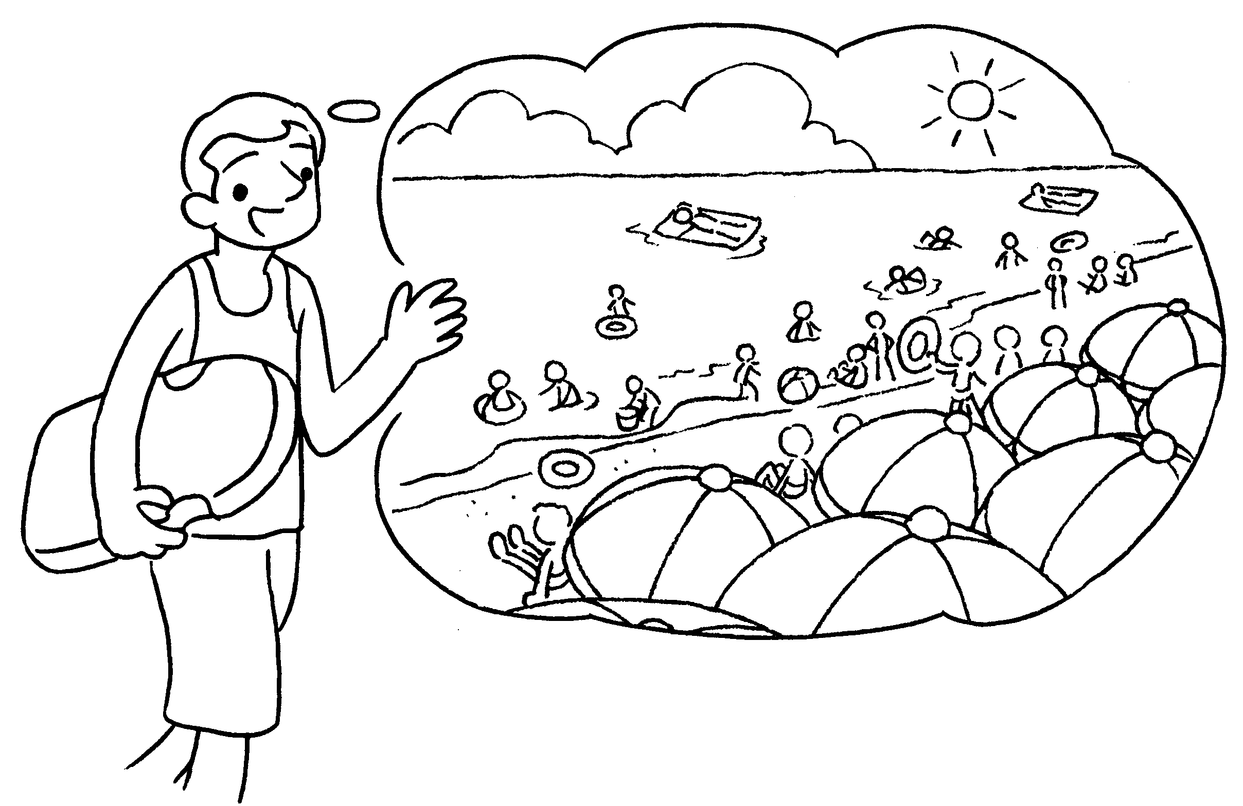 |  | I go to the beach in summer.
2 | 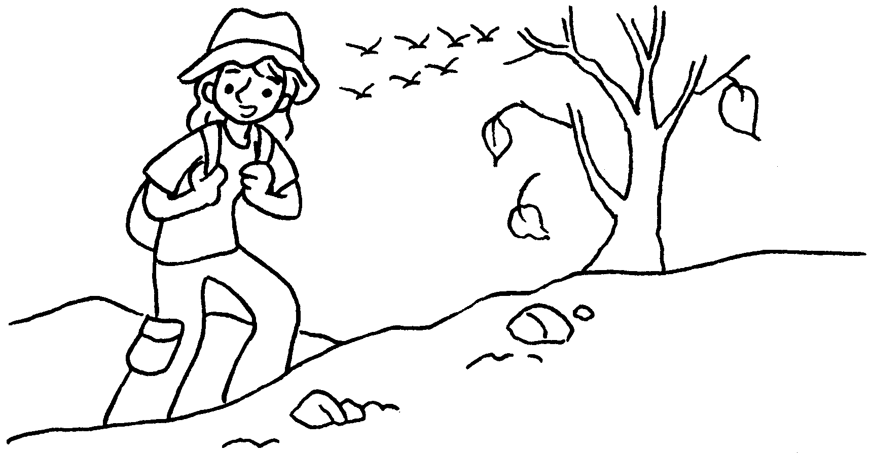  …  …  … |  | I usually go hiking  .
3 | 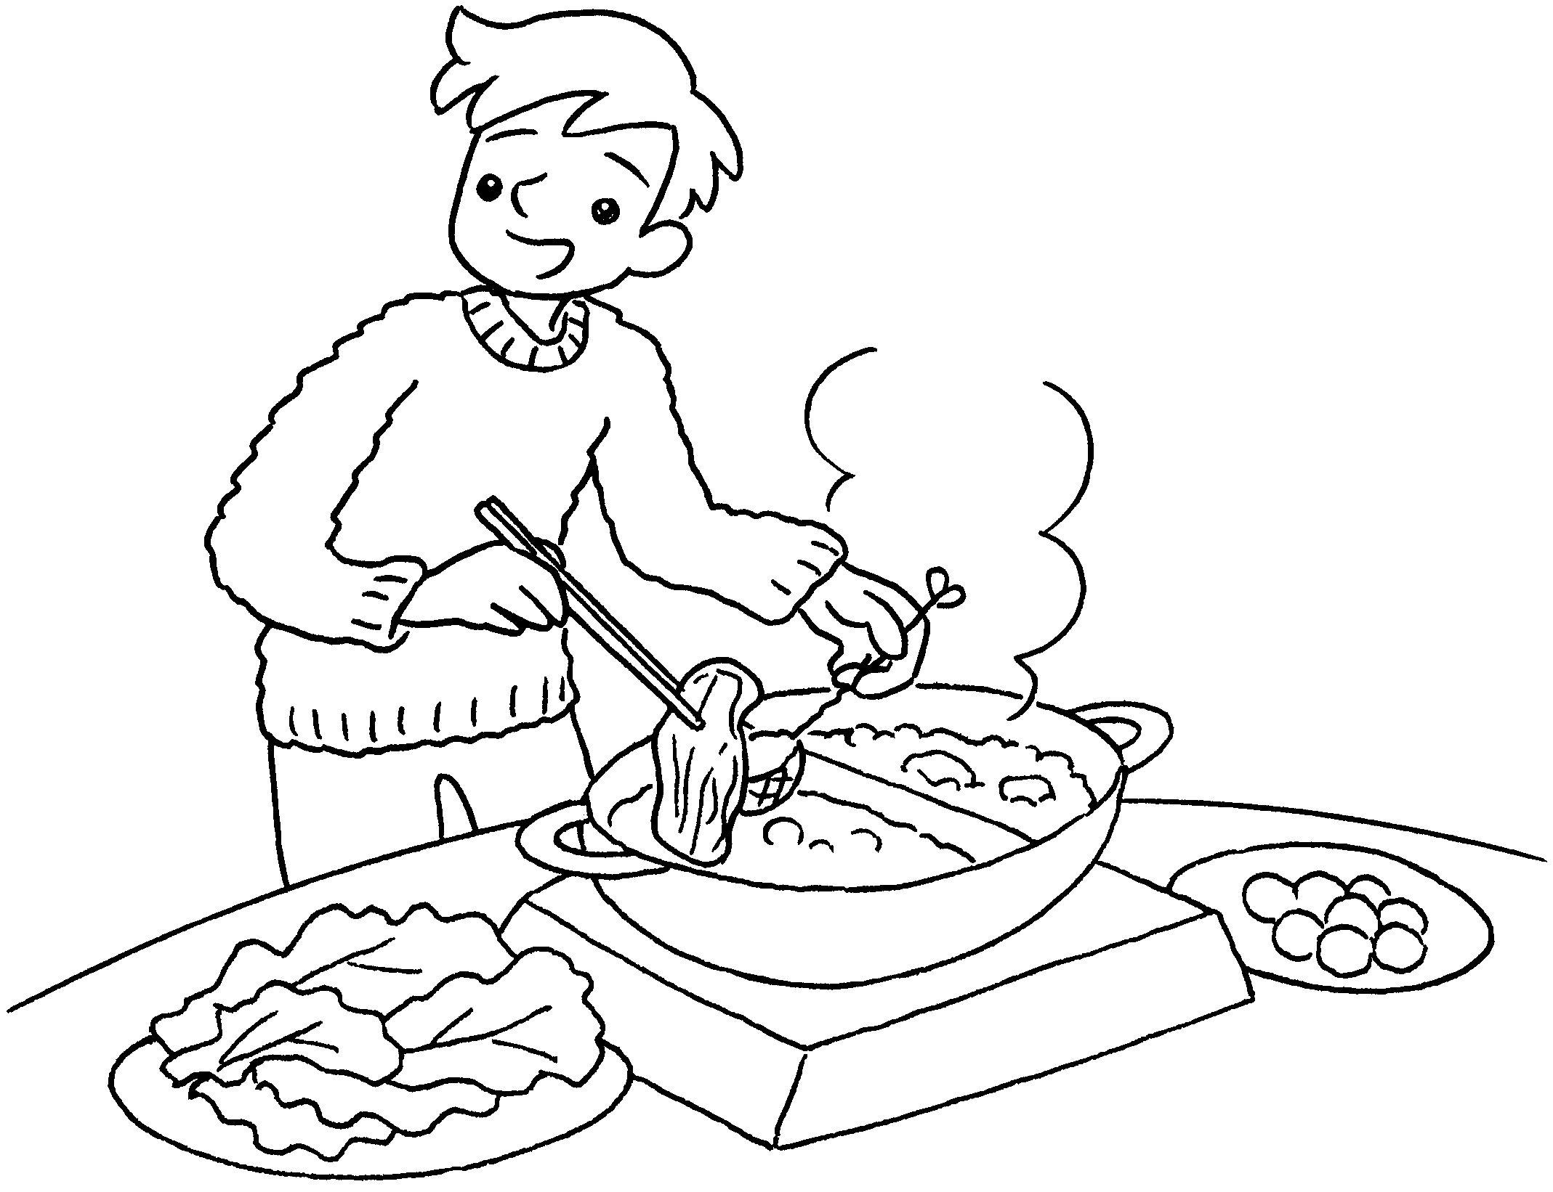 |  | I eat hotpot  .
4 | 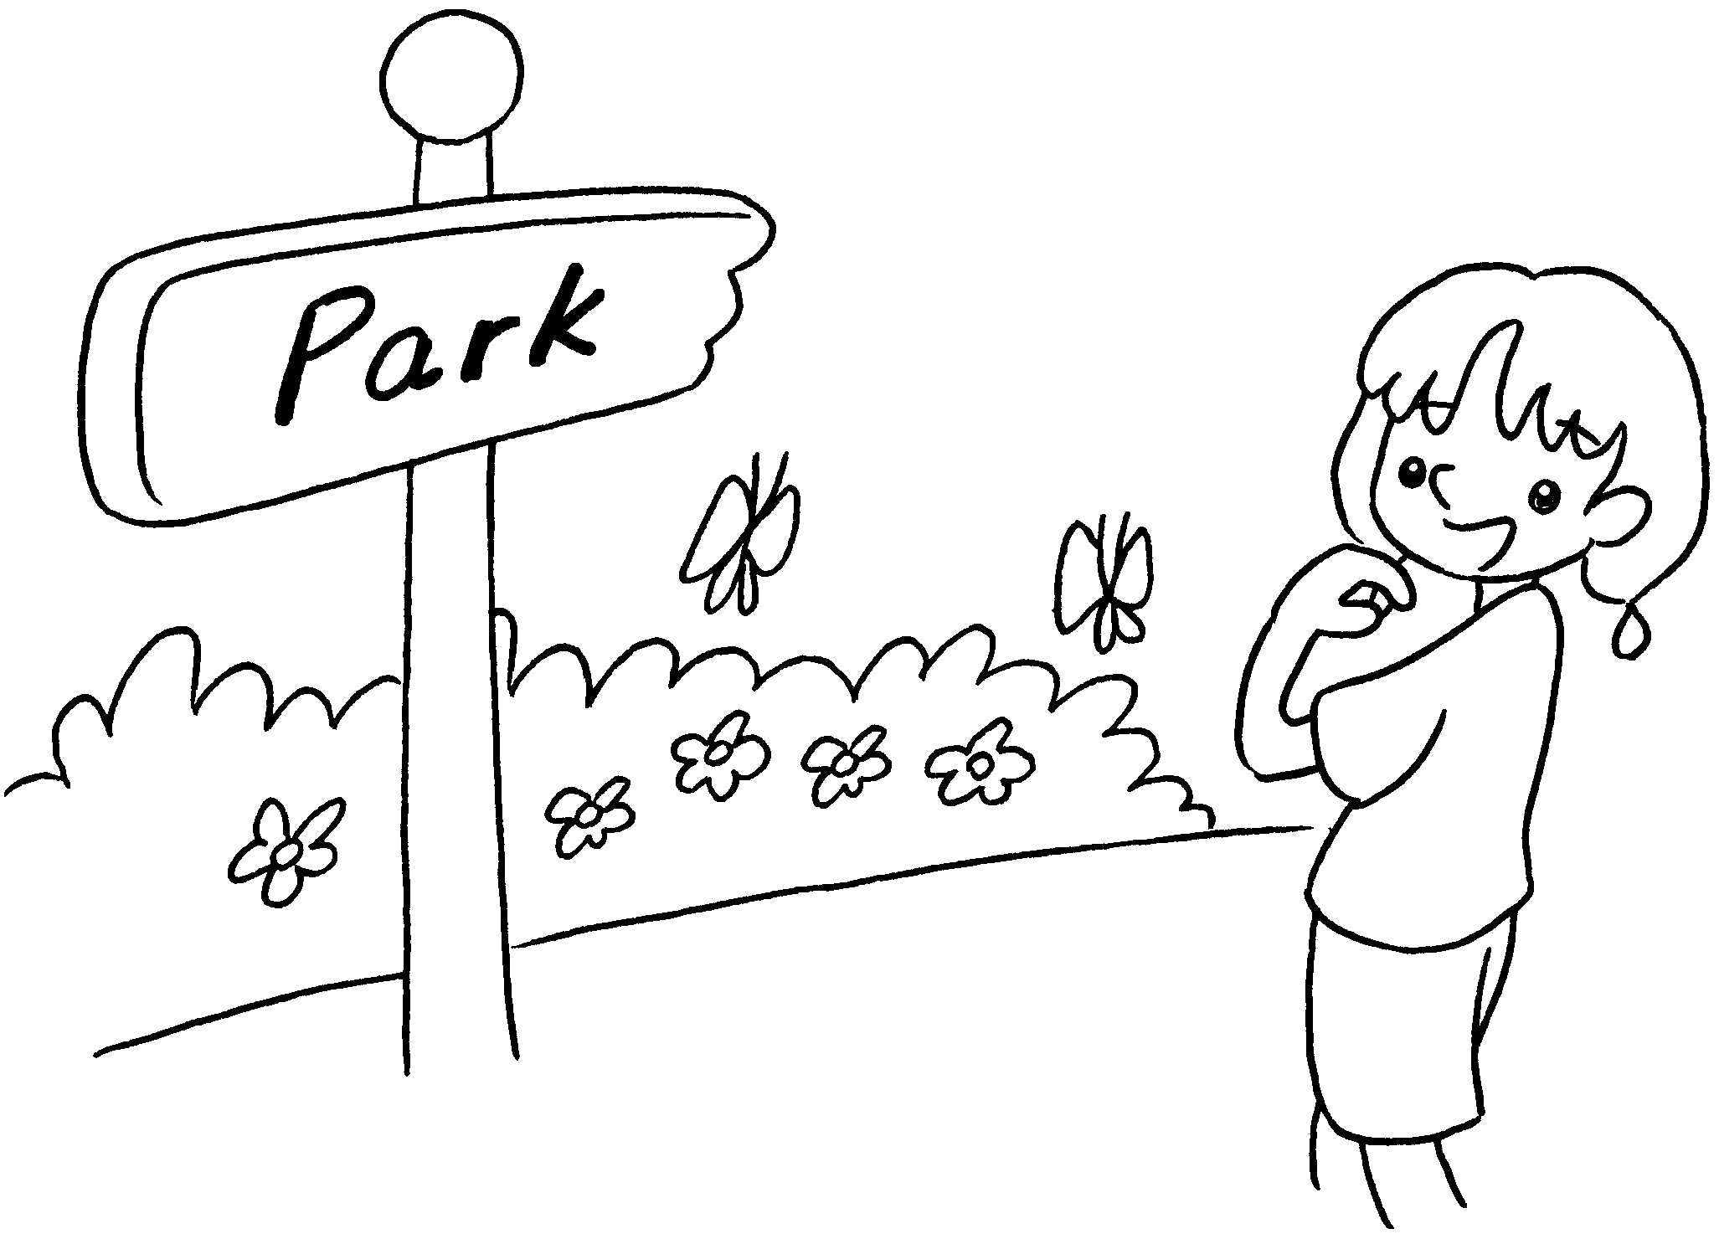 |  | I go to the park  .
5 | 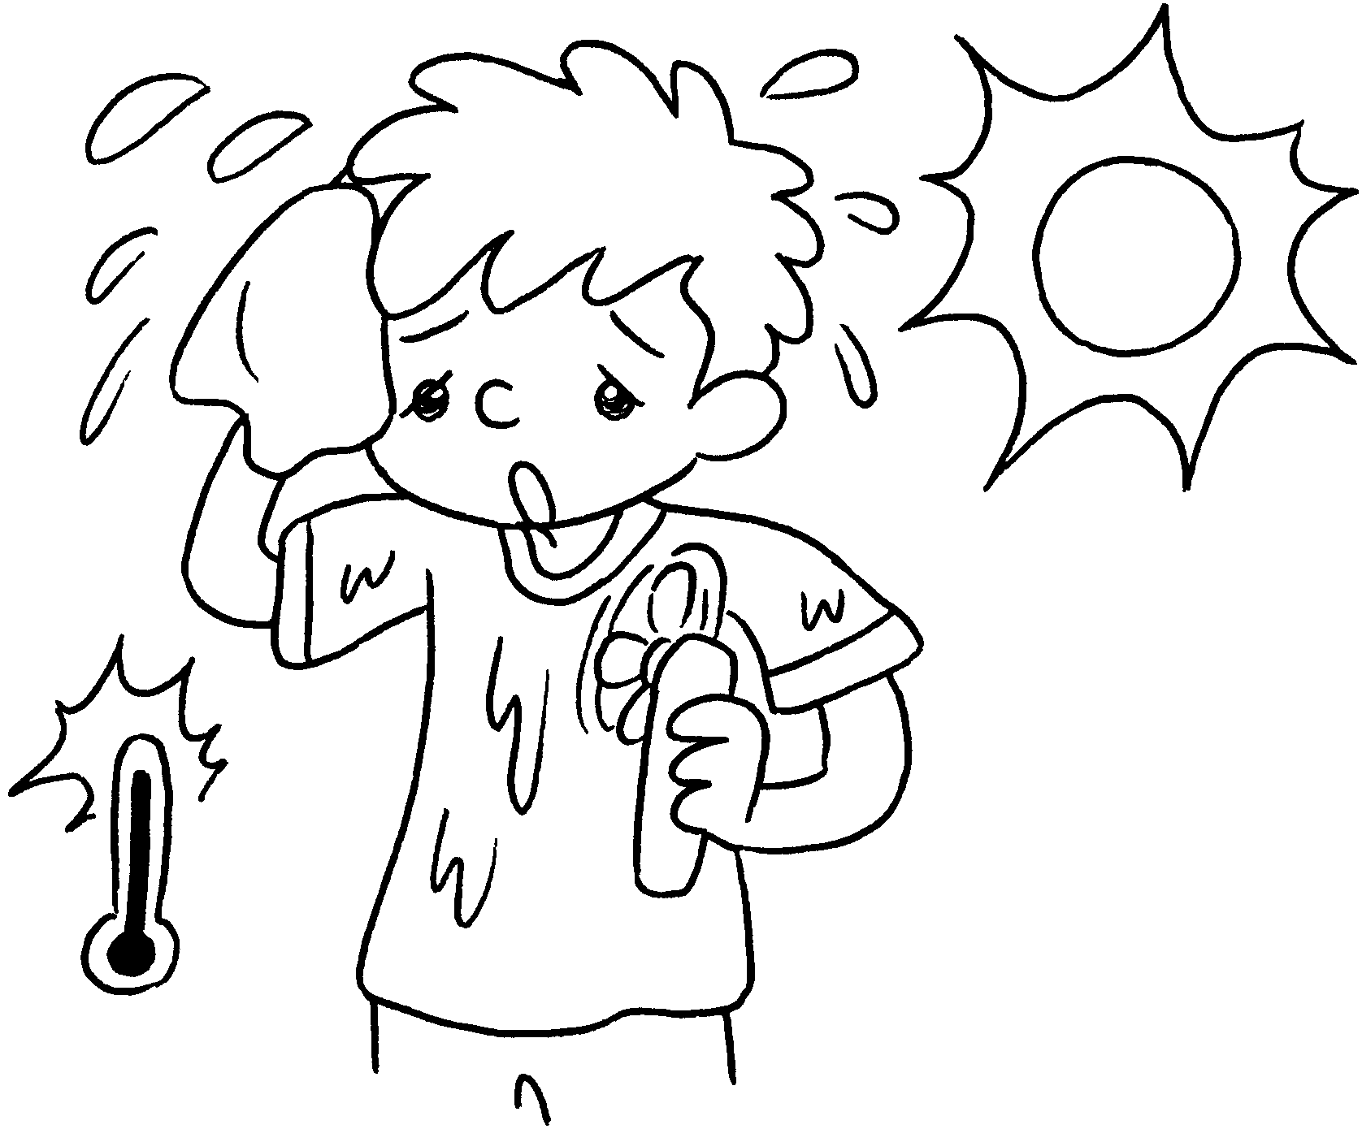 |  | I wear a T-shirt  .


Book 2B Chapter 5 Graded Worksheets
Worksheet 2⬇⬇
- usually
- in autumn
- usually in winter
- usually in spring
- usually in summer

