What do the people usually do in different seasons? Write.

wear a T-shirt eat hotpot go to the park

1 | 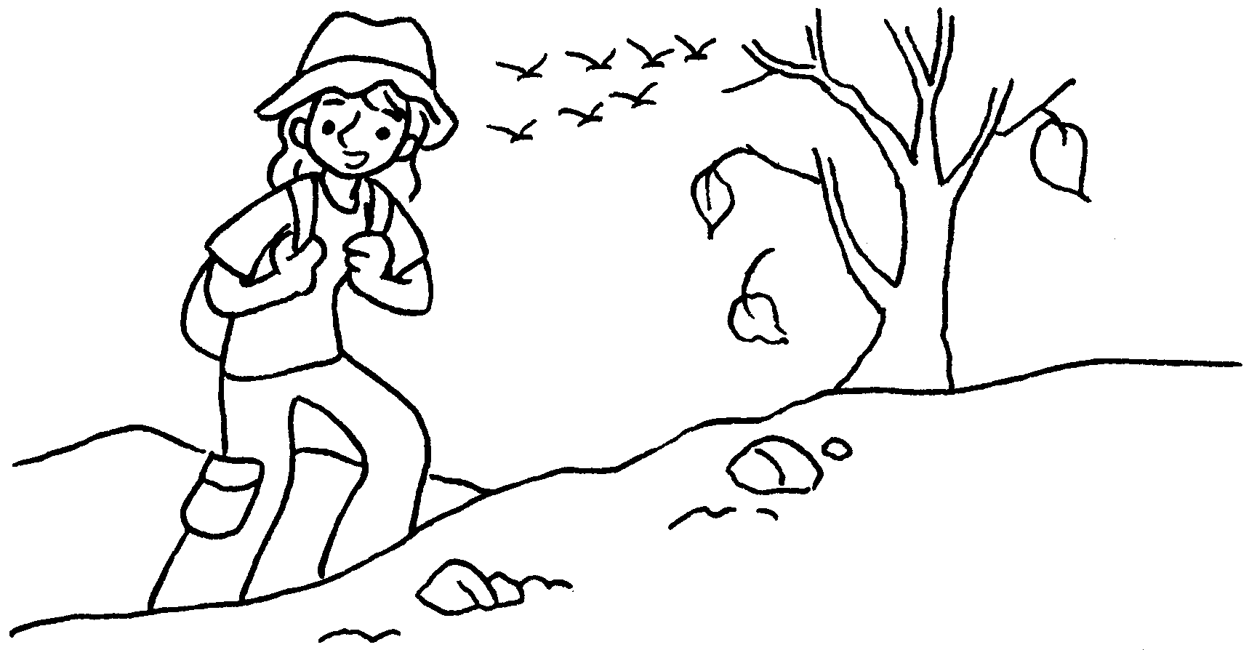  …  …  …  … |  | I usually go hiking in  .
2 | 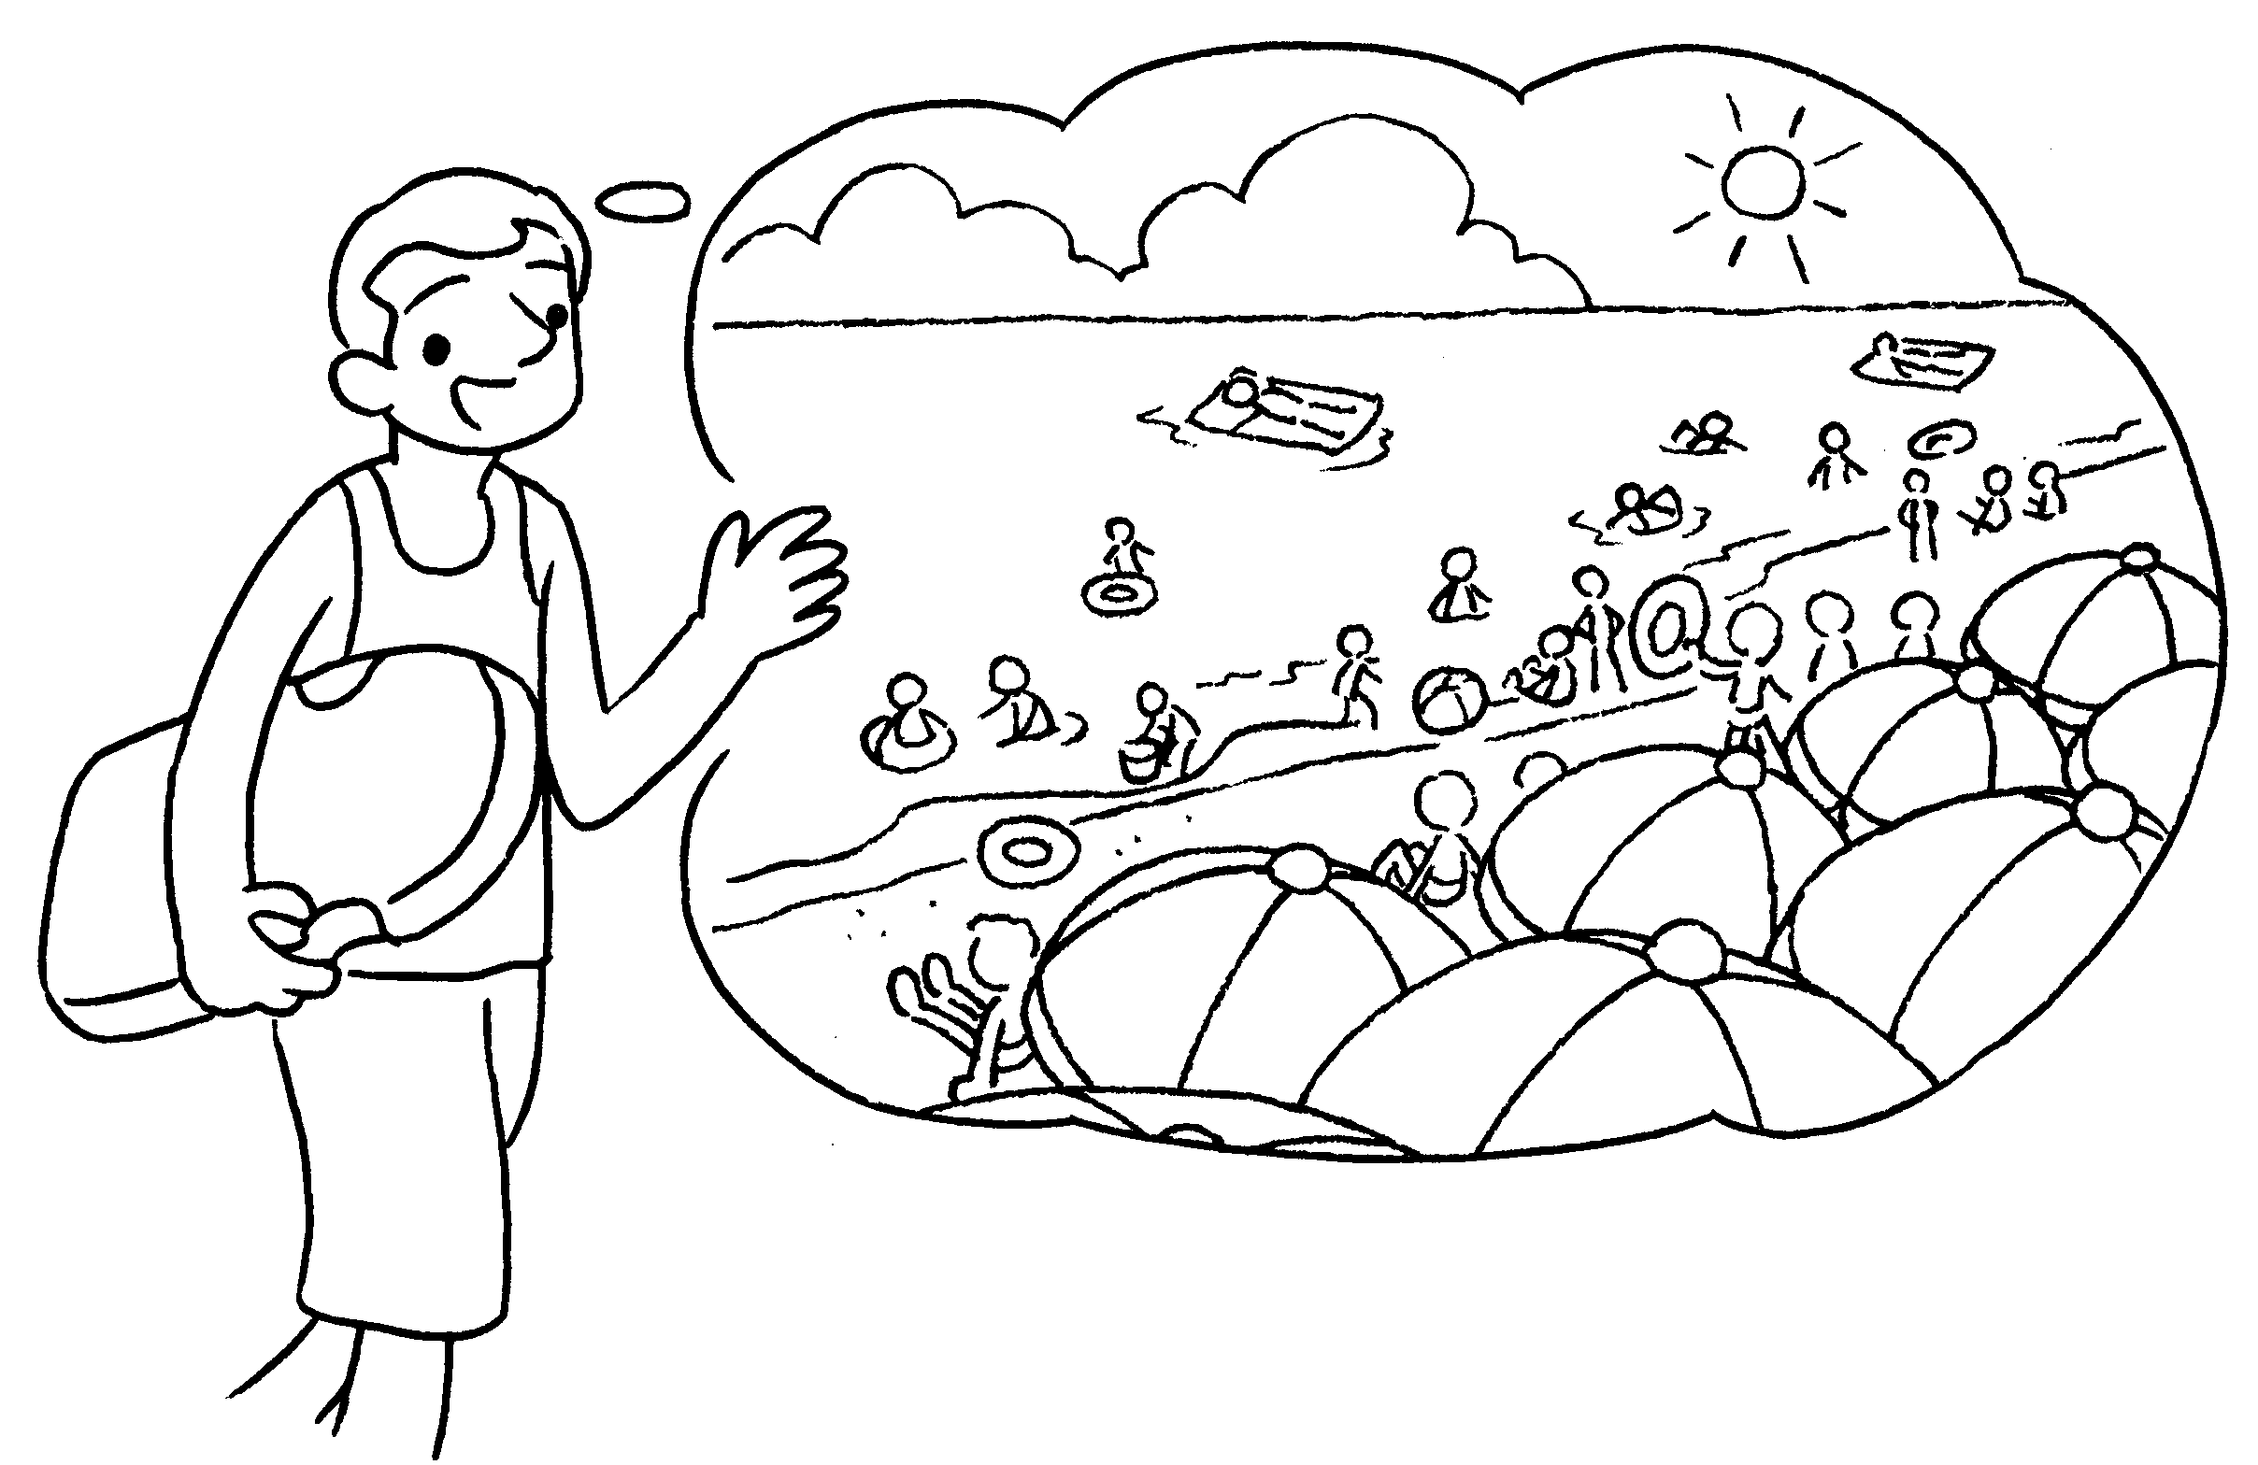 |  | I go to the beach summer.
3 | 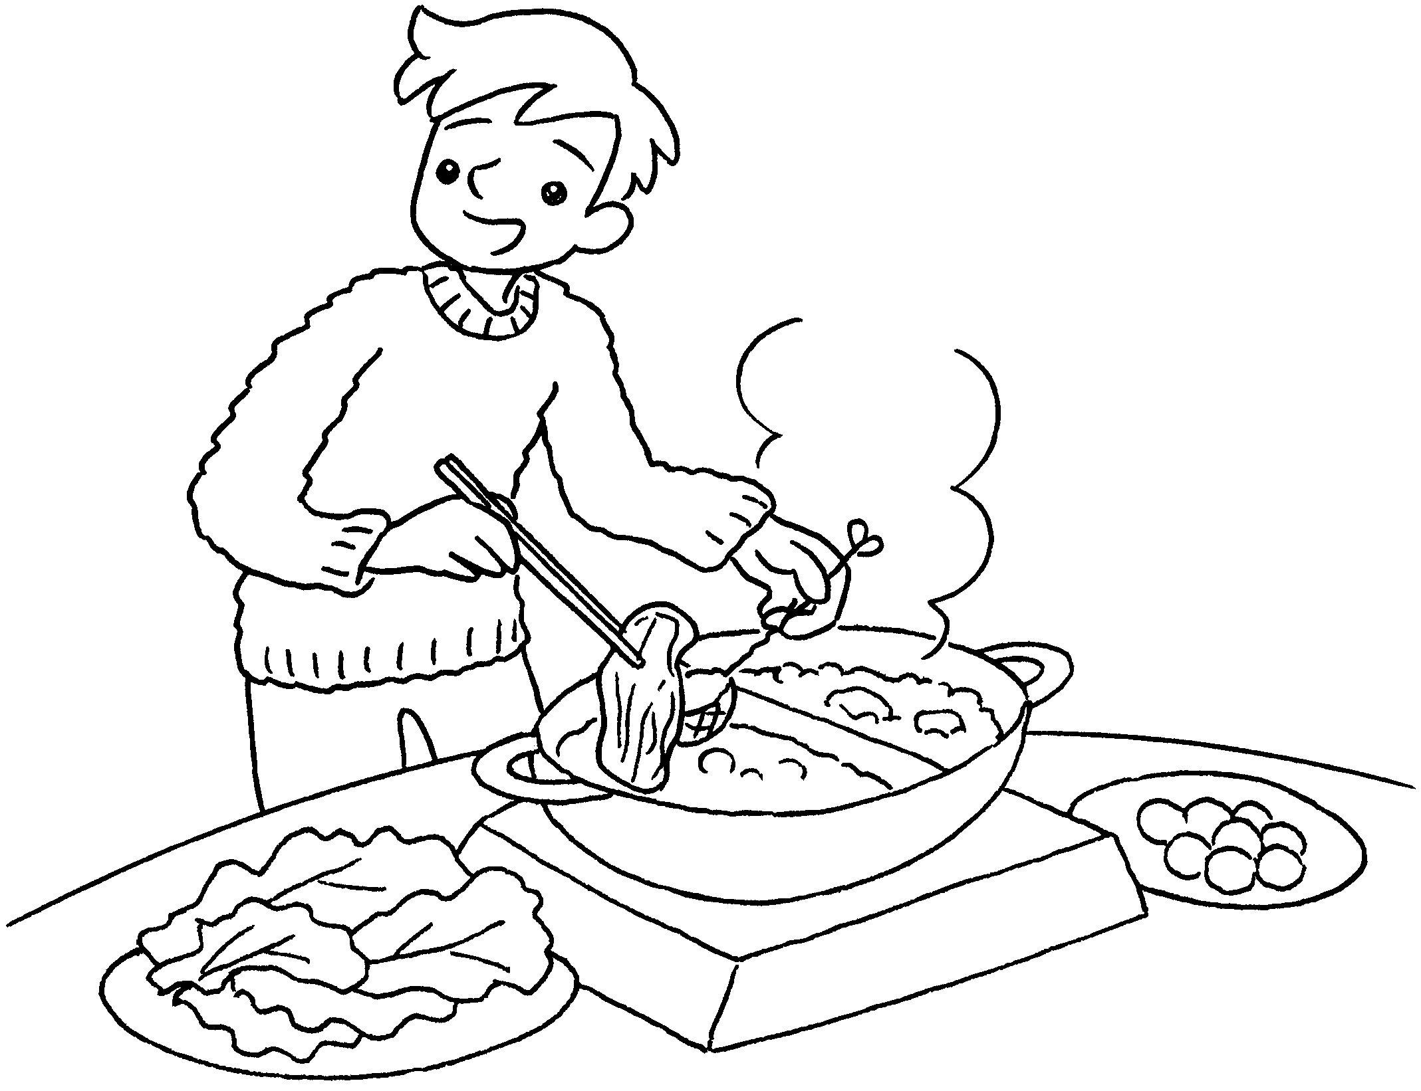 |  | I usually  .
4 | 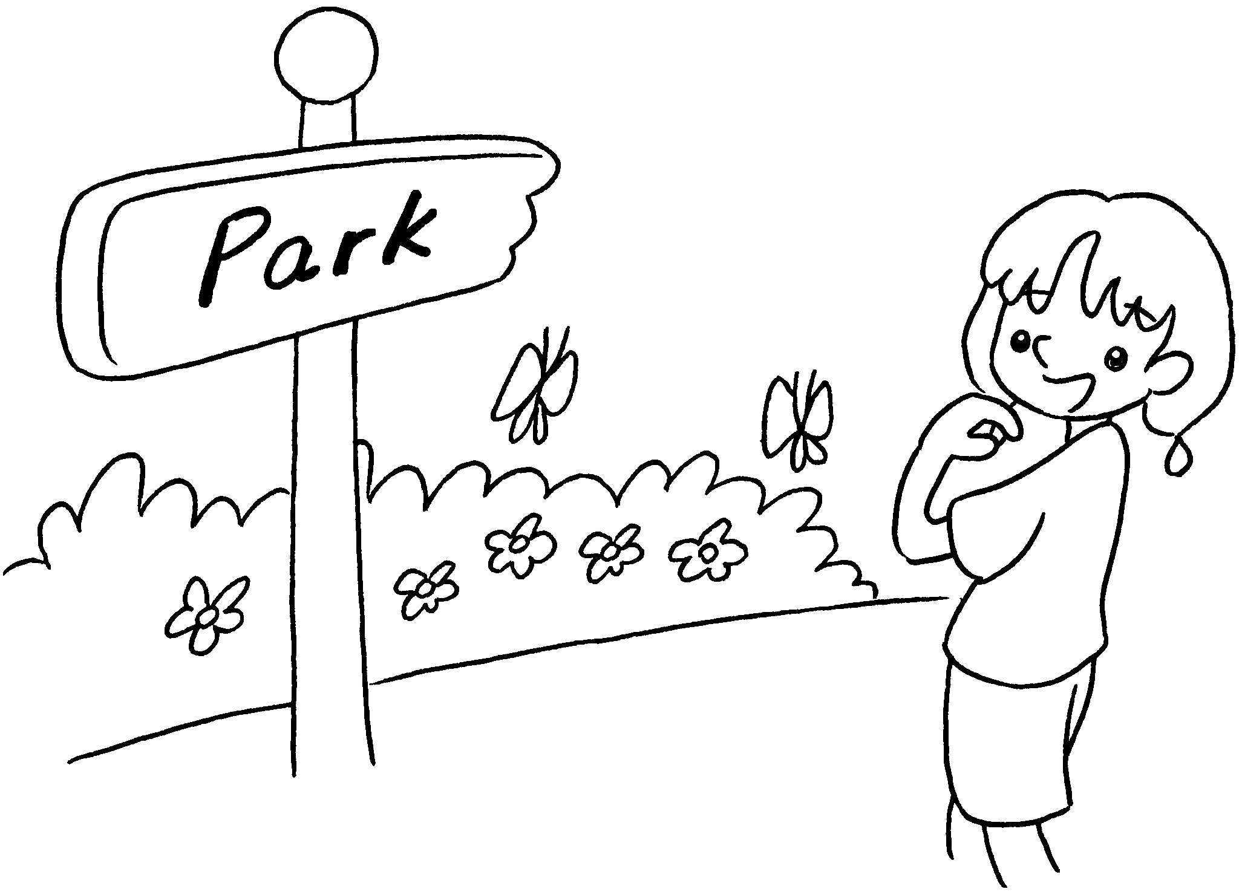 |  | I  .
5 | 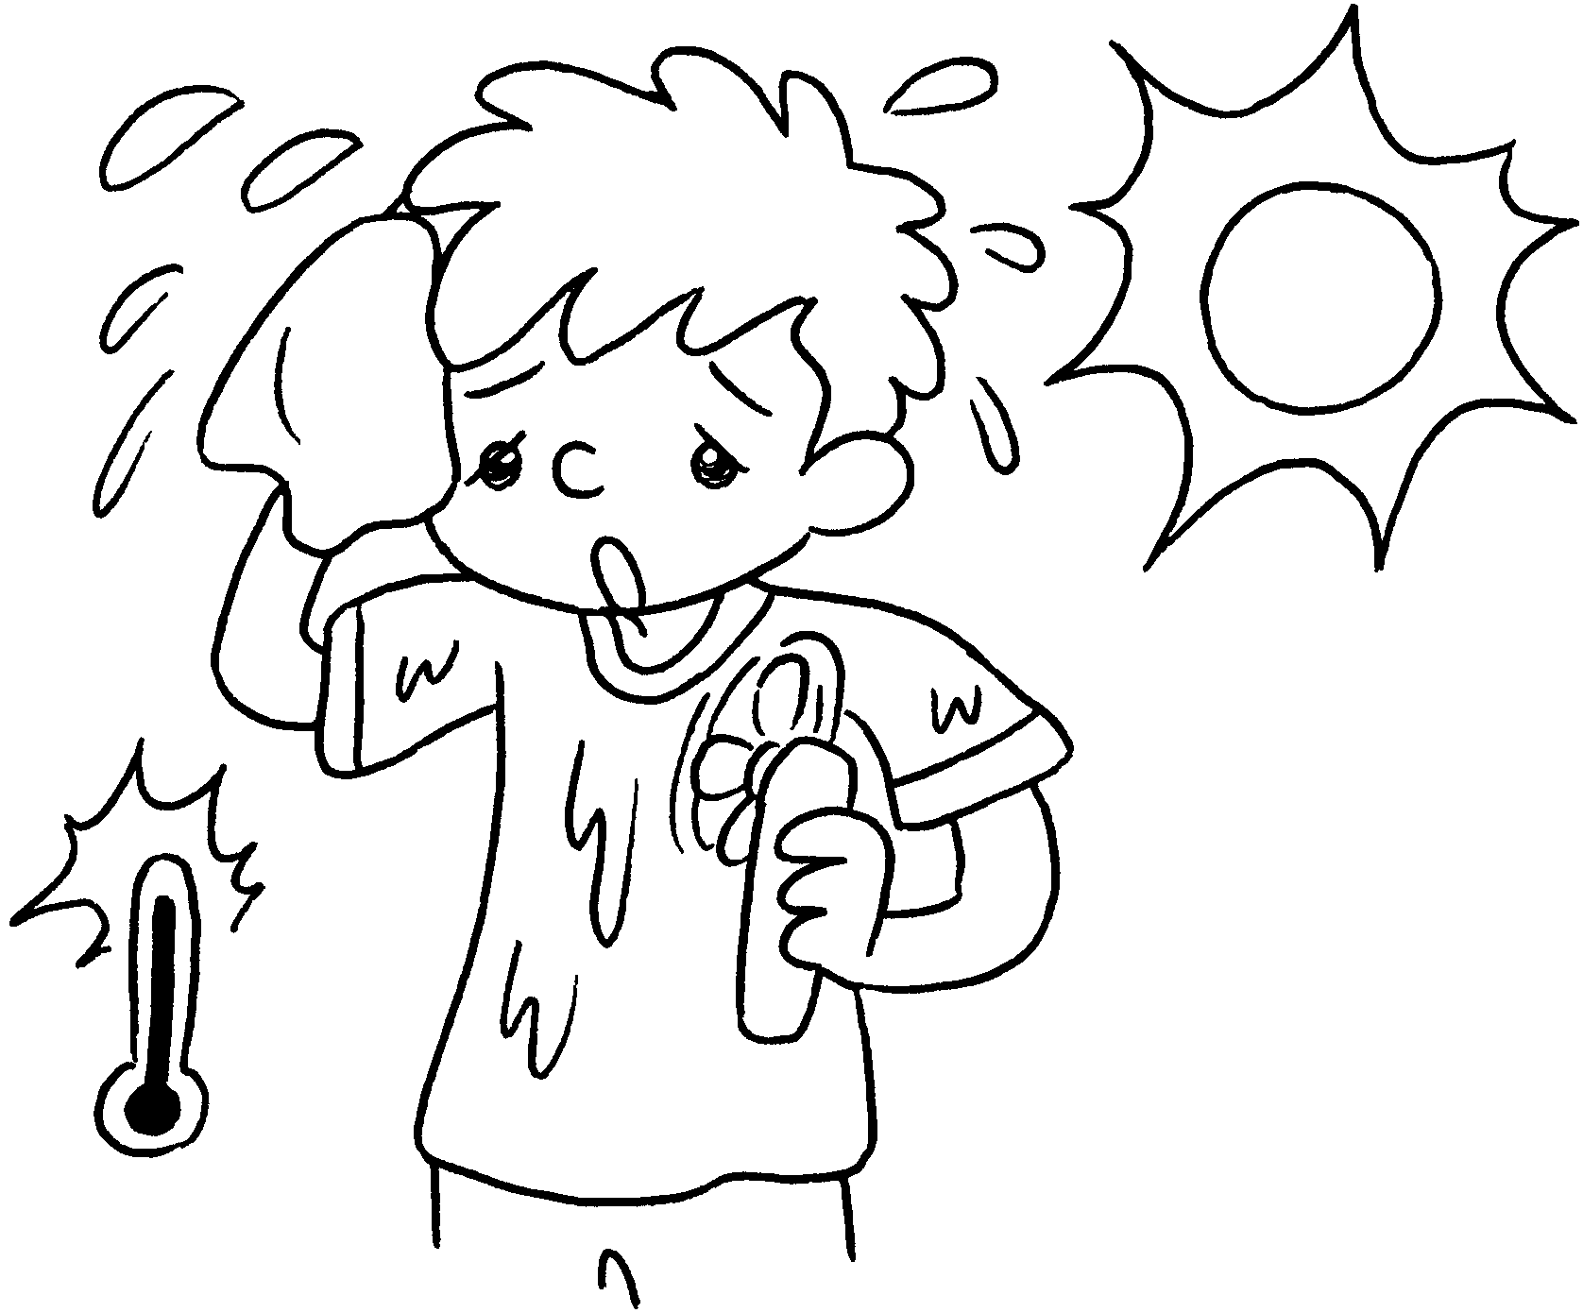


Book 2B Chapter 5 Graded Worksheets
Worksheet 2⬇⬇⬇
- autumn
- usually in
- eat hotpot in winter
- usually go to the park in spring
- I usually wear a T-shirt in summer.

