Choose and write.
Which | best | like | cool | hot | warm
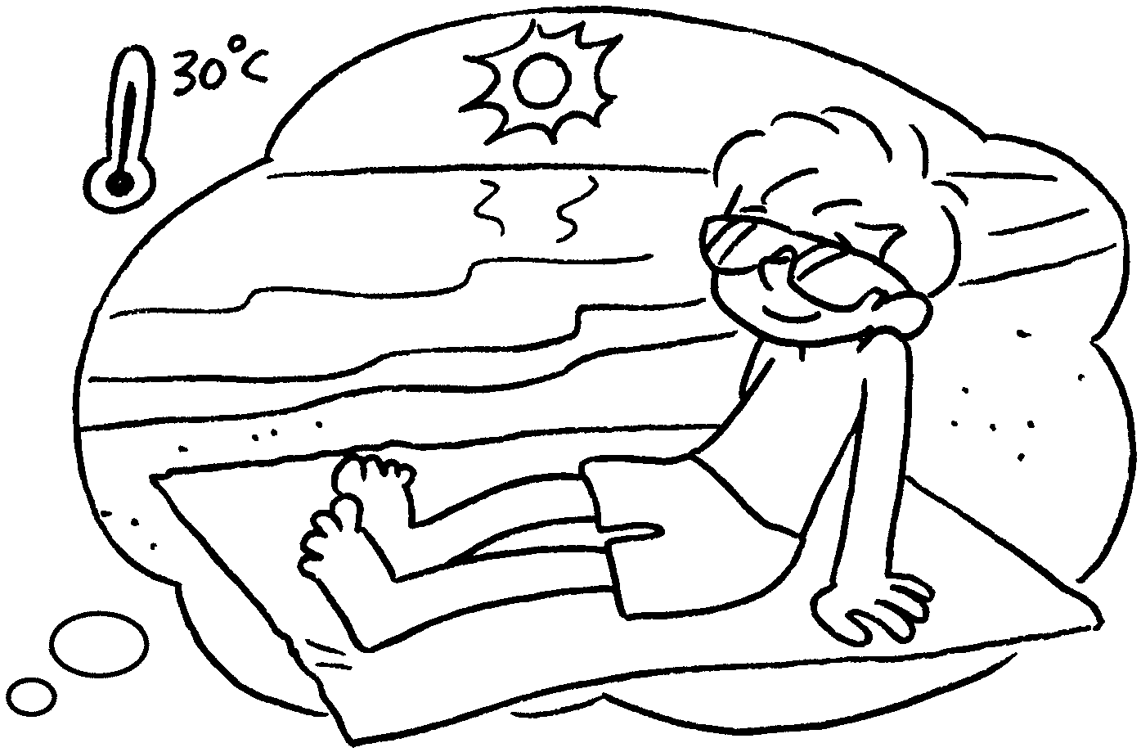
1  A  B  A  B  A  B | 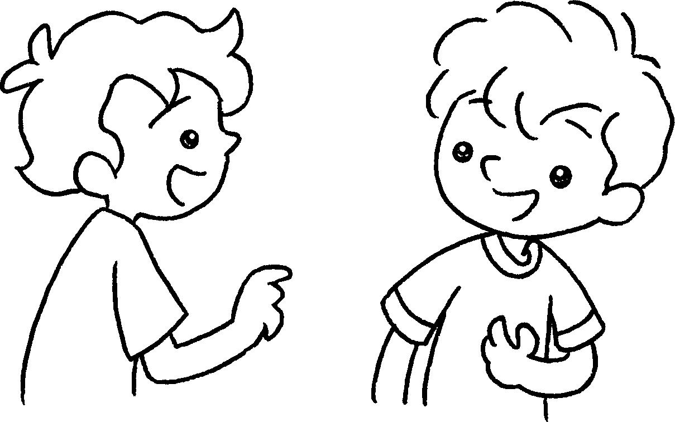 | A : season do you  like best?  B : I like summer best.  It’s .
2 | 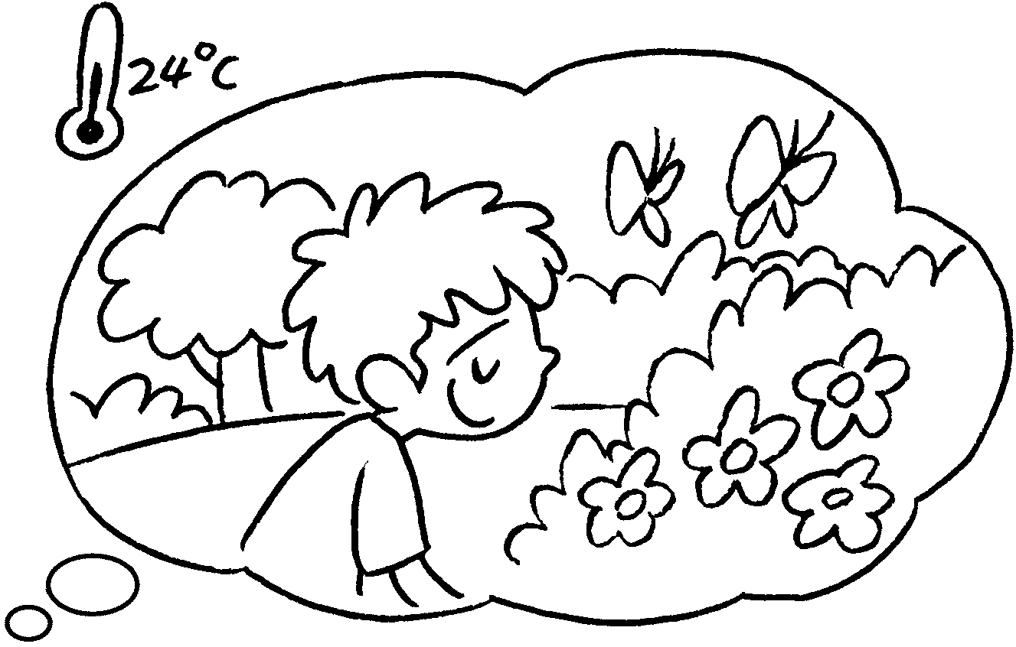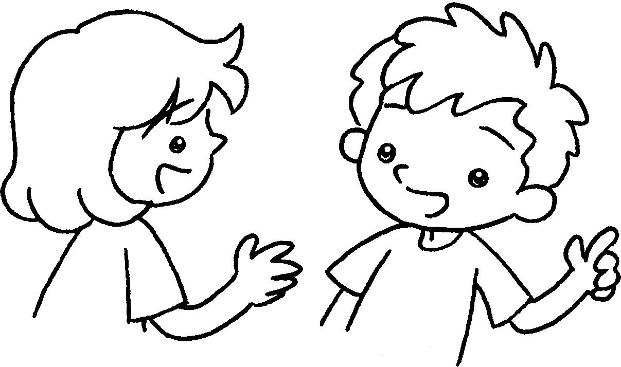 | A : season do you  like ?  B : I like spring .  It’s .
3 | 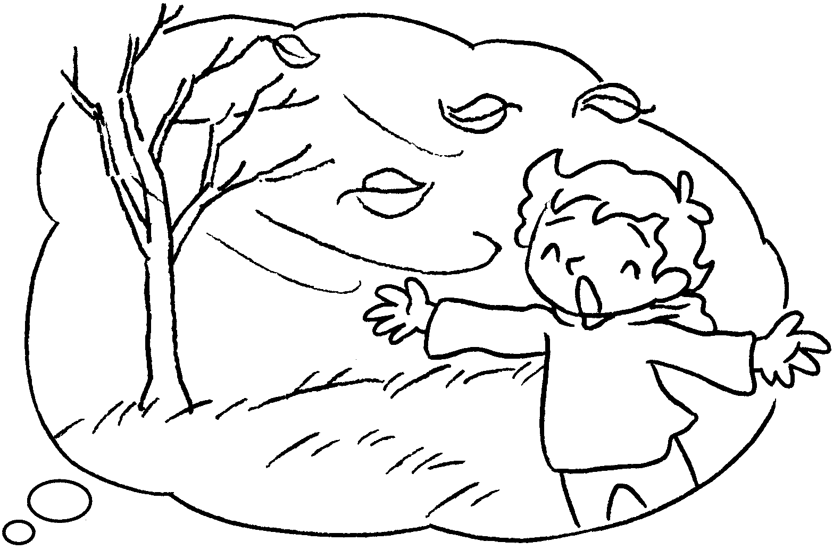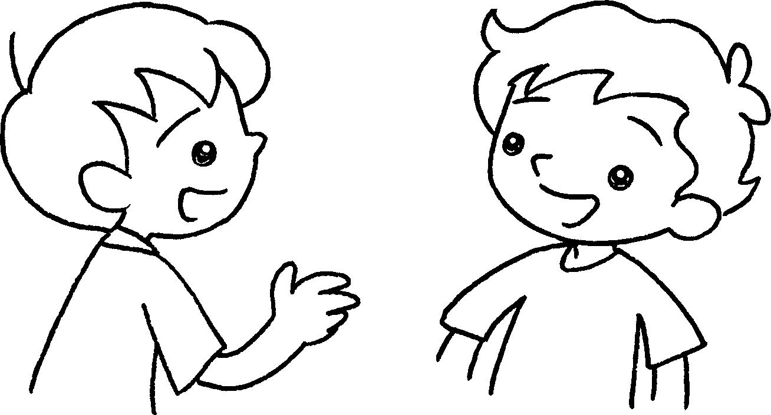 | A : season do you  ?  B : I autumn  . It’s .
4  A  B  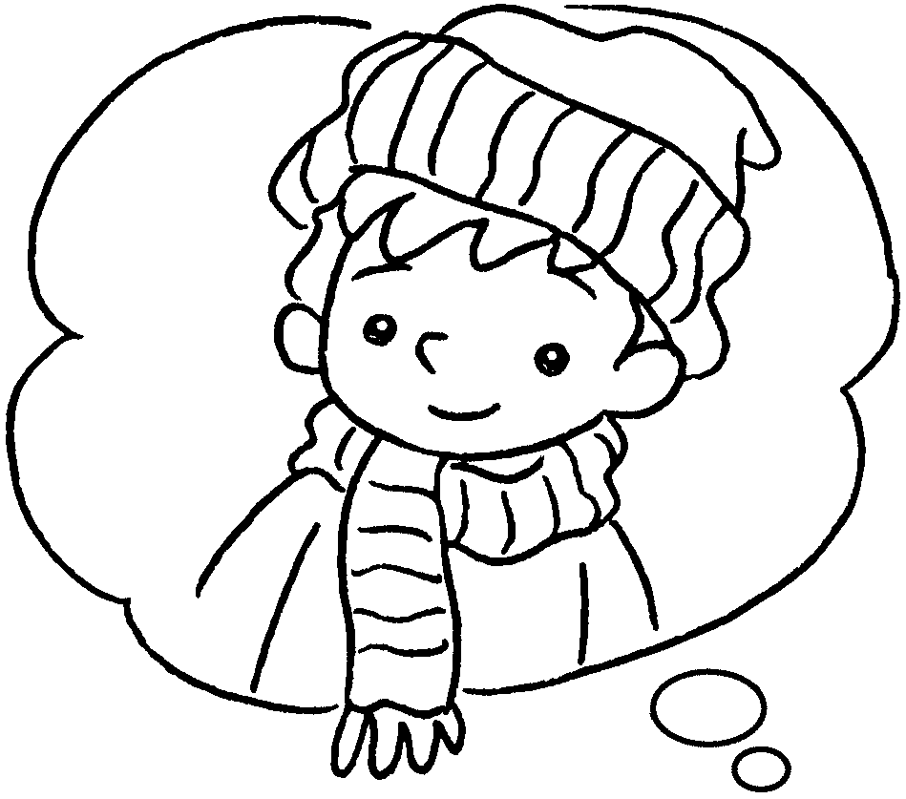  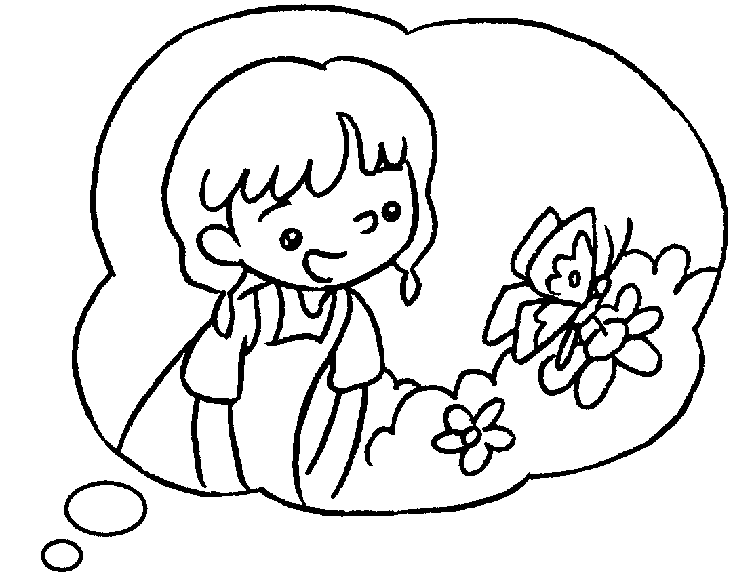 | 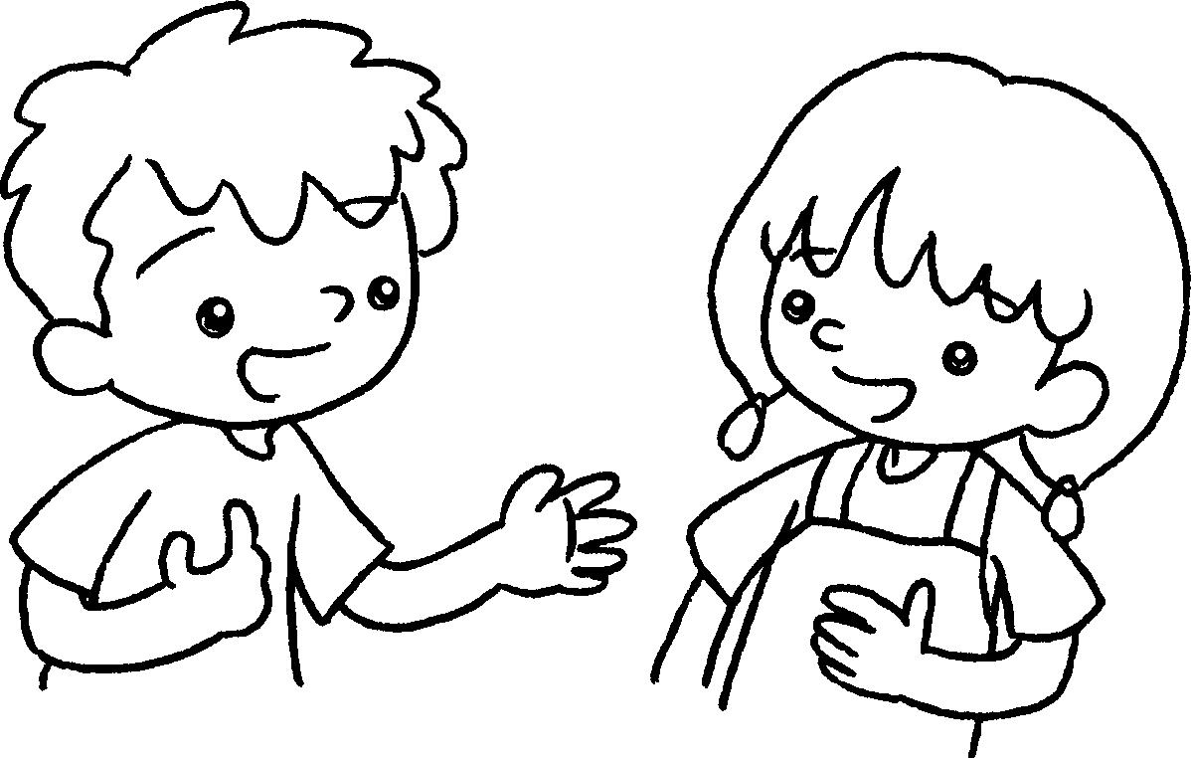 | A : I like winter .  season do you  ?  B : I spring .


Book 2B Chapter 5 Graded Worksheets
Worksheet 3⬇
- Which
hot
2 Which best
best warm
3 Which like best
like best cool
4 best Which like best
like best

