Which season do the children like best? Finish what they say.
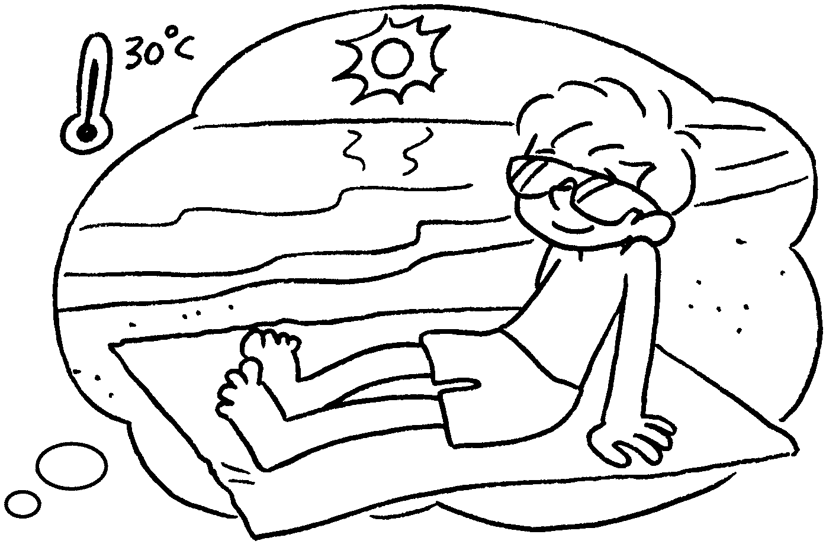
1  A  B  A  B  A  B | 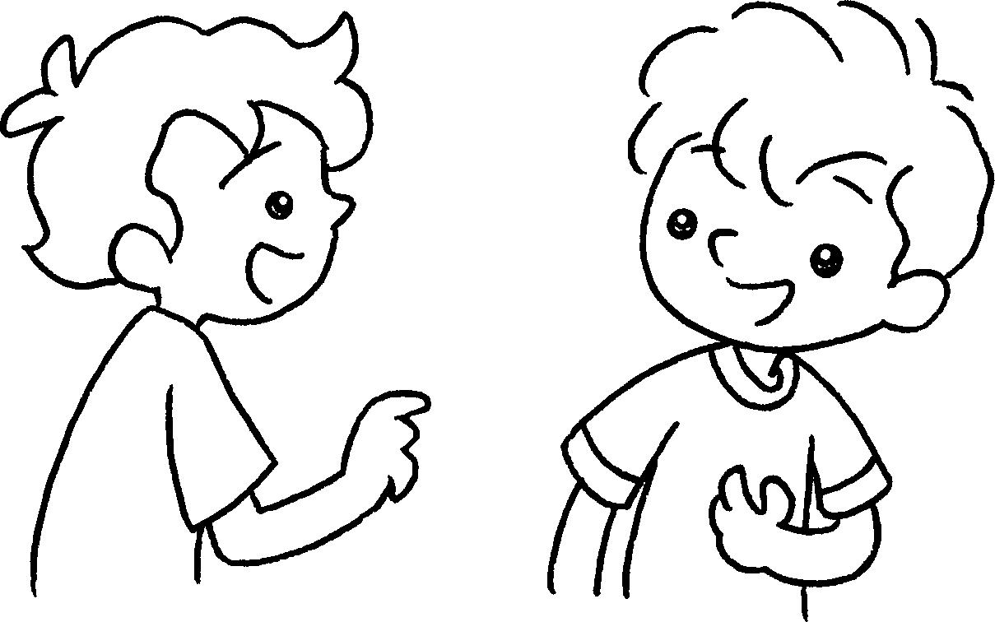 | Which  A : season do you  like best?  B : I like summer best.  It’s h .
2 | 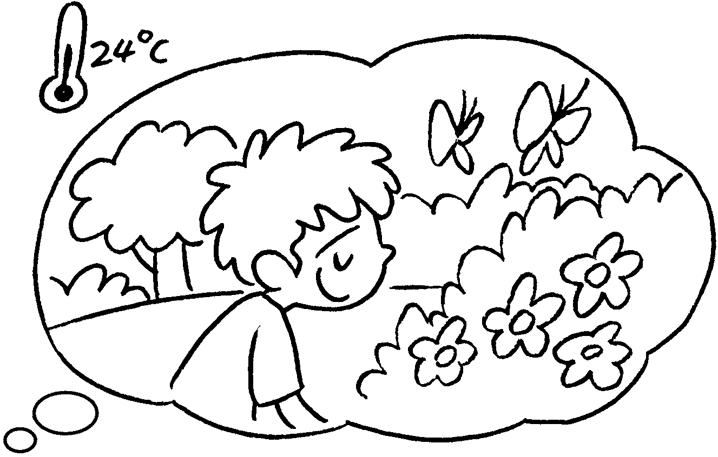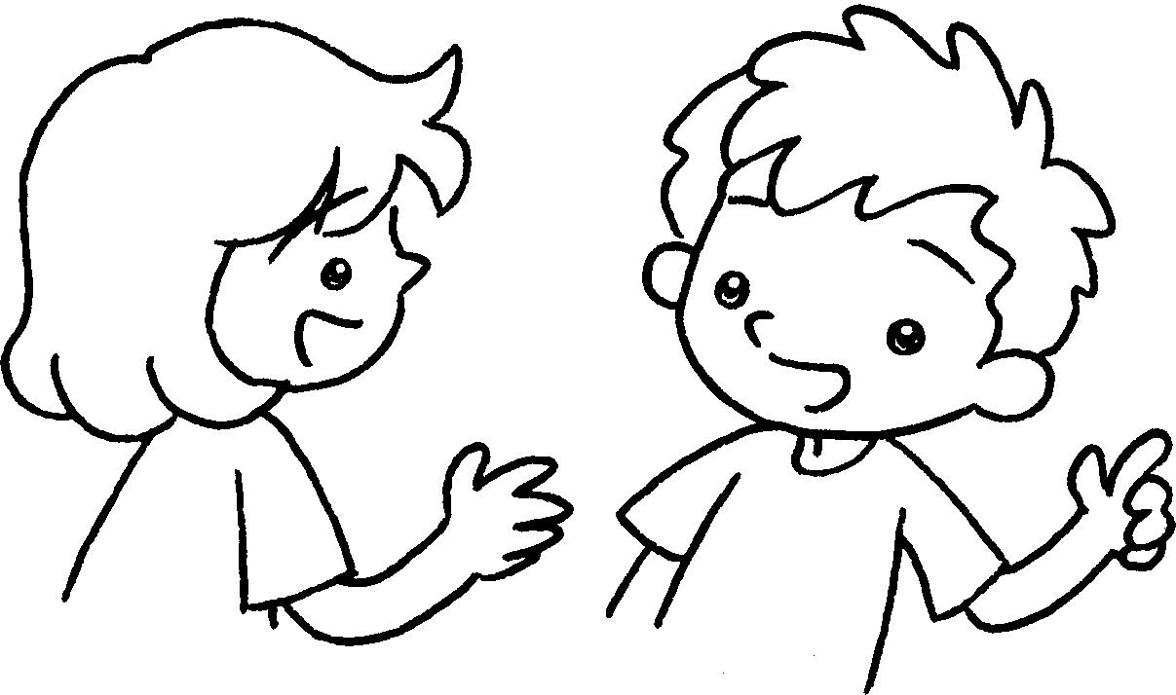 | A : season do you  like best?  B : I like spring .  It’s w .
3 | 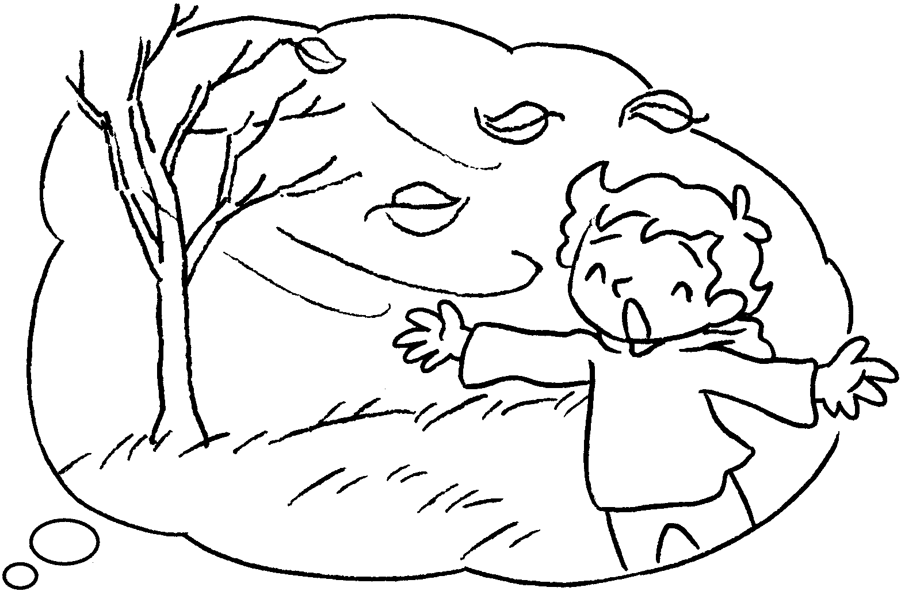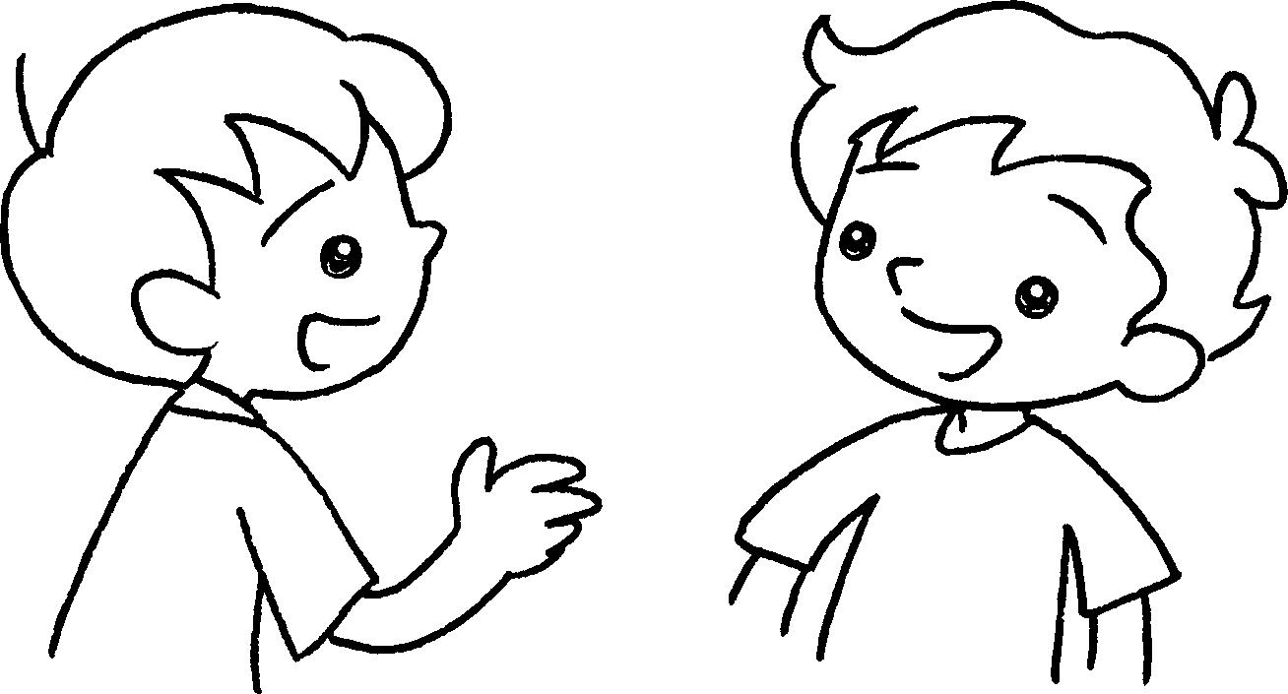 | A : season do you  ?  B : I autumn  . It’s c .
4  A  B  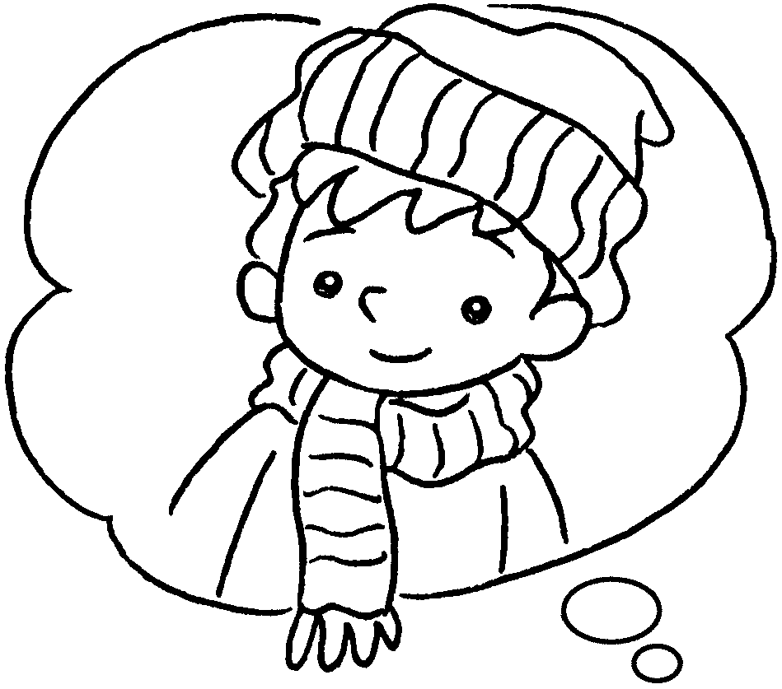  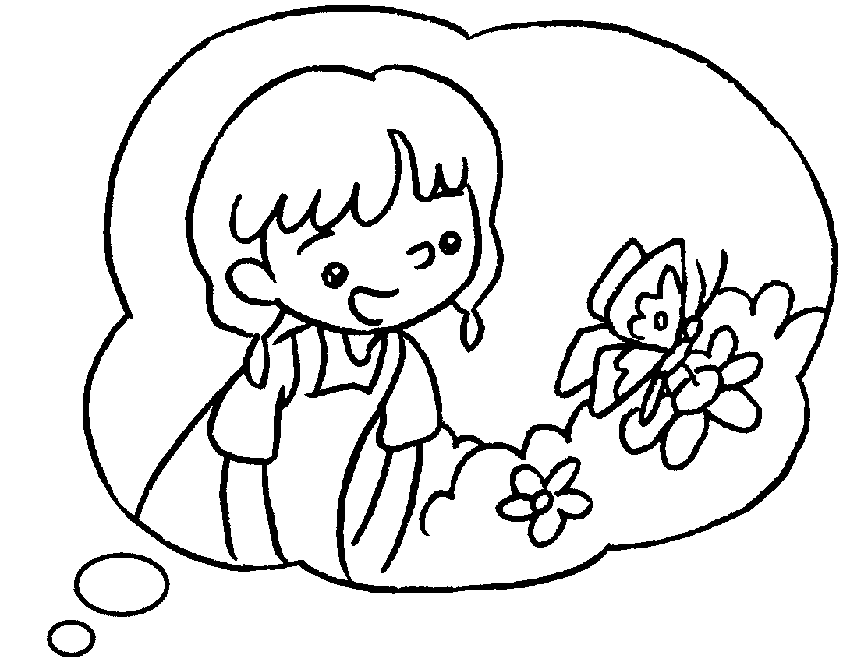 | 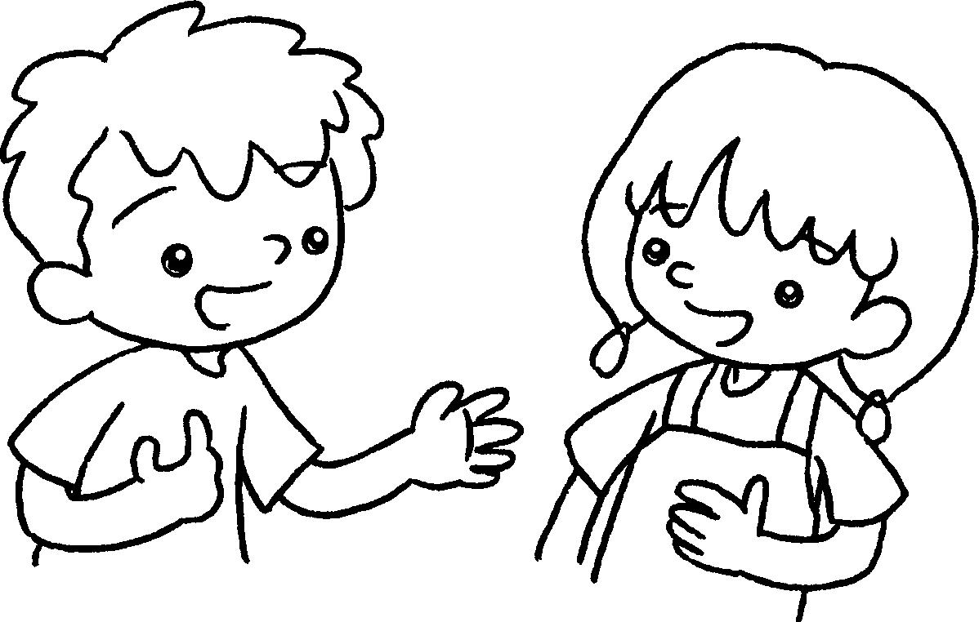 | A : I like winter .  season ?  B : I spring .


Book 2B Chapter 5 Graded Worksheets
Worksheet 3⬇⬇
1 hot
2 Which
best warm
3 Which like best
like best cool
4 best Which do you like best
like best

