Which season do the children like best? Finish what they say.
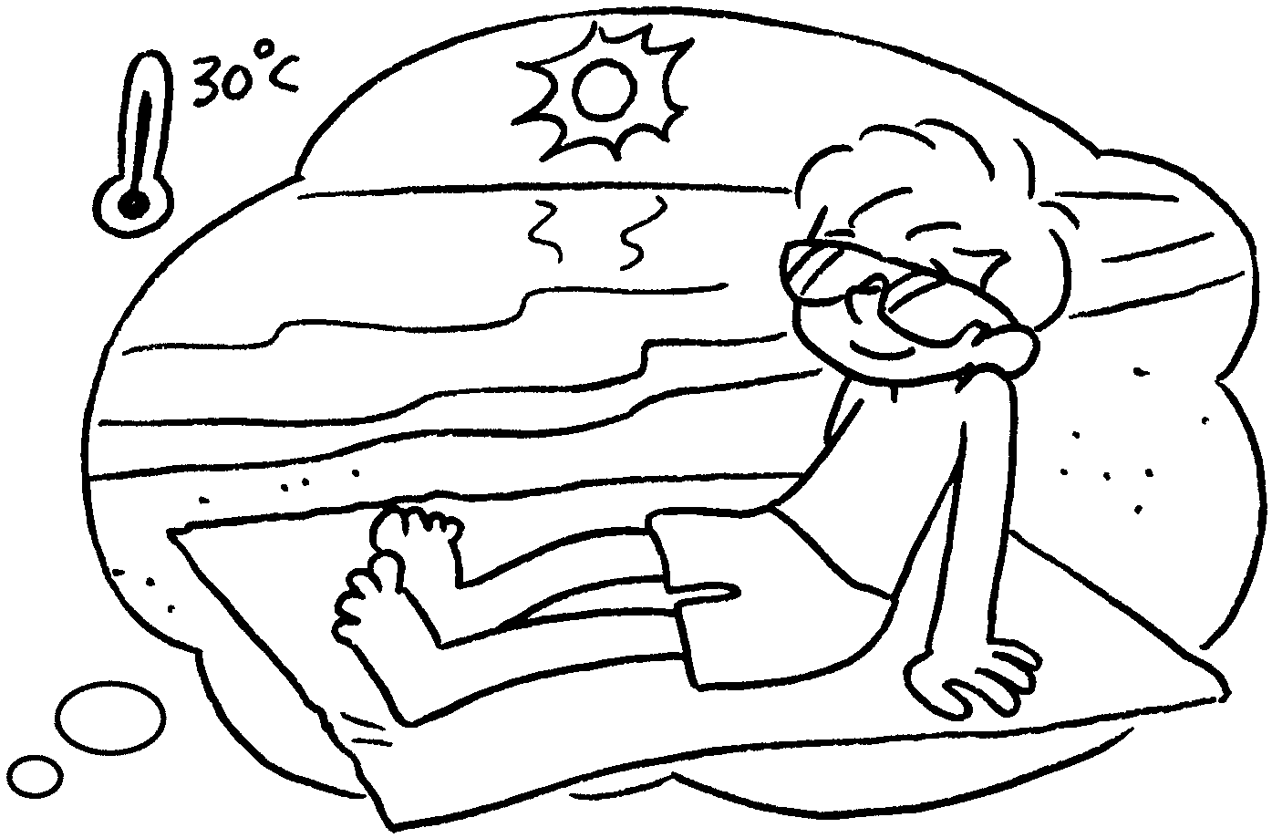
1  A  B  A  B  A  B | 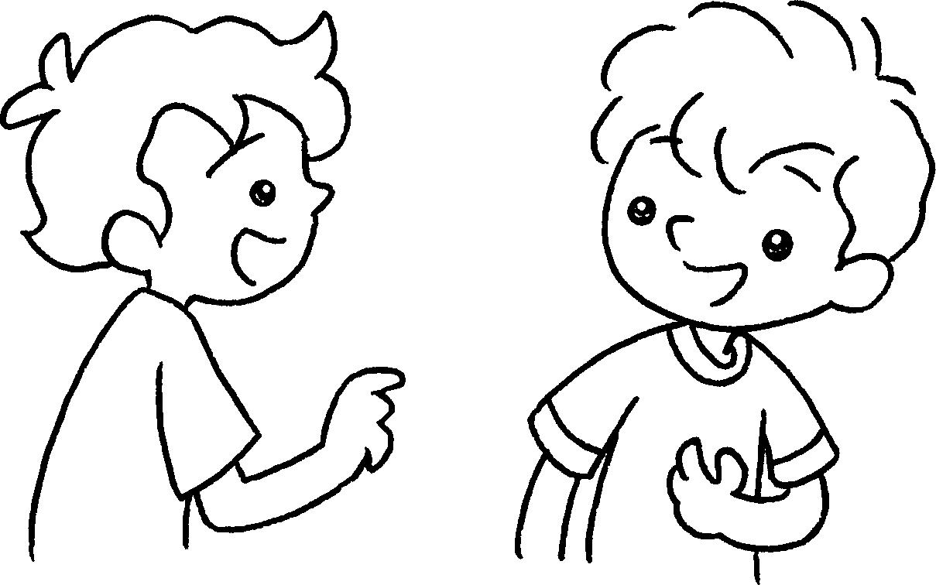 | Which  A : season do you  like best?  B : I like s best.  It’s h .
2 | 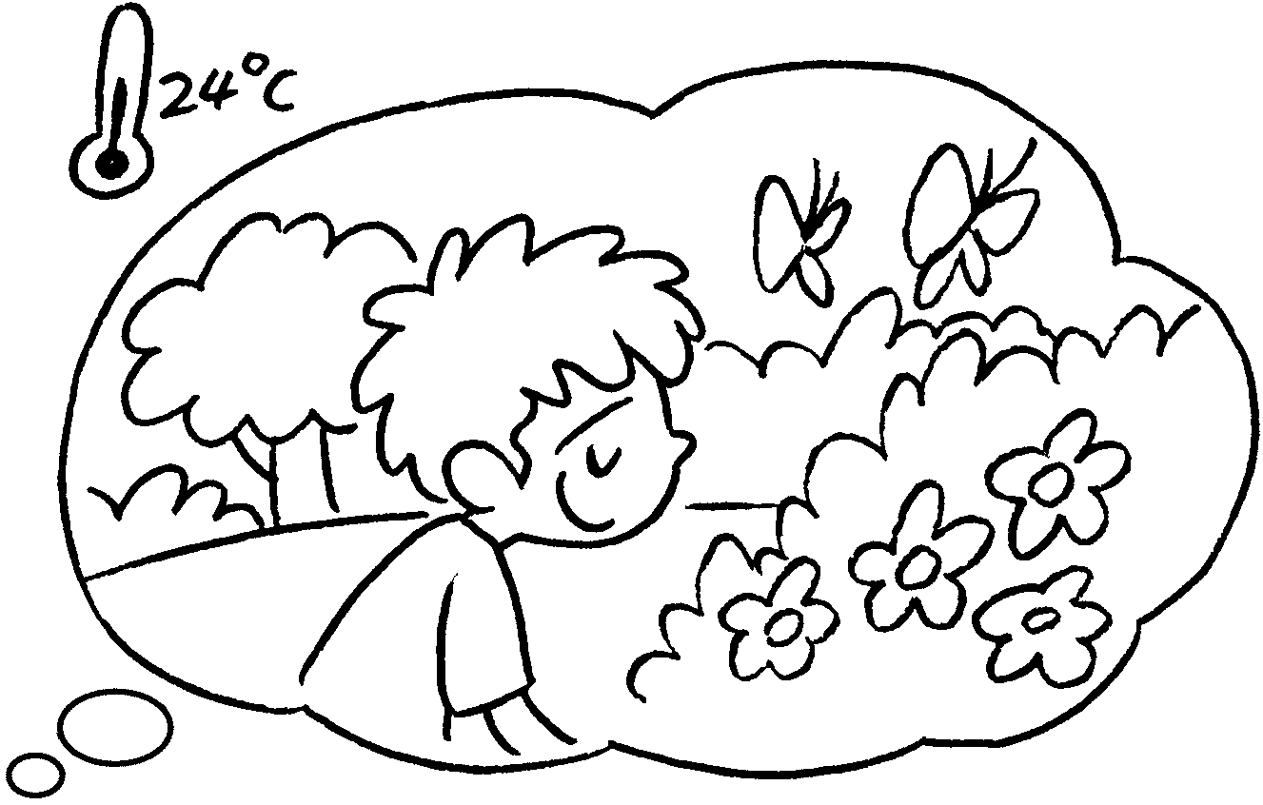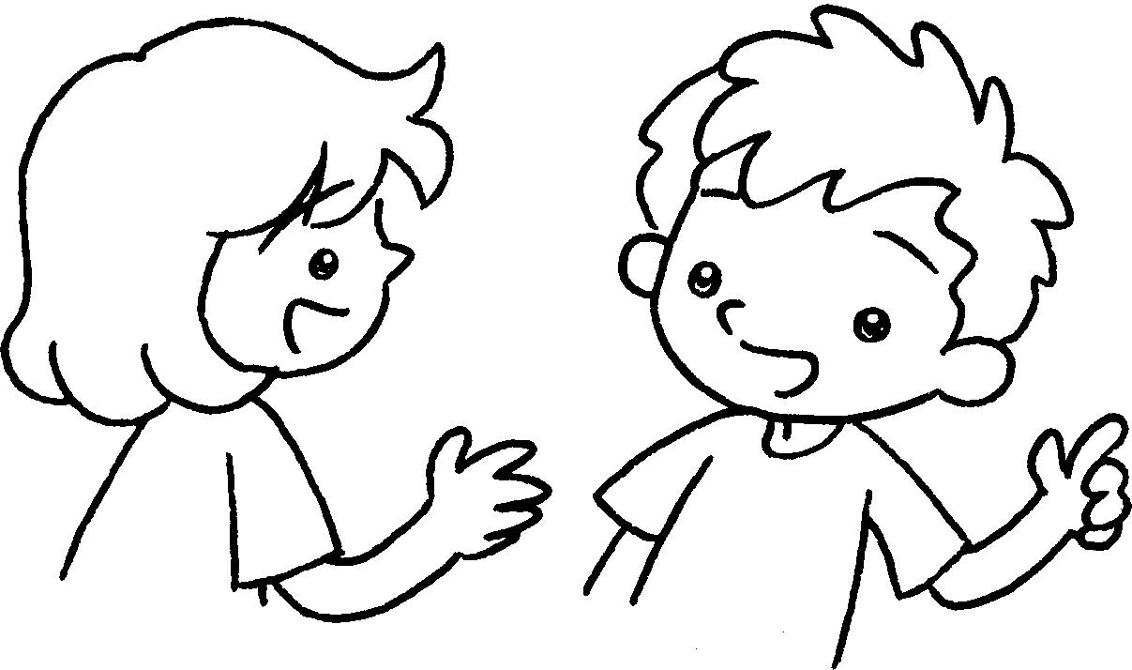 | A : season do you  like best?  B : I like .  It’s w .
3 | 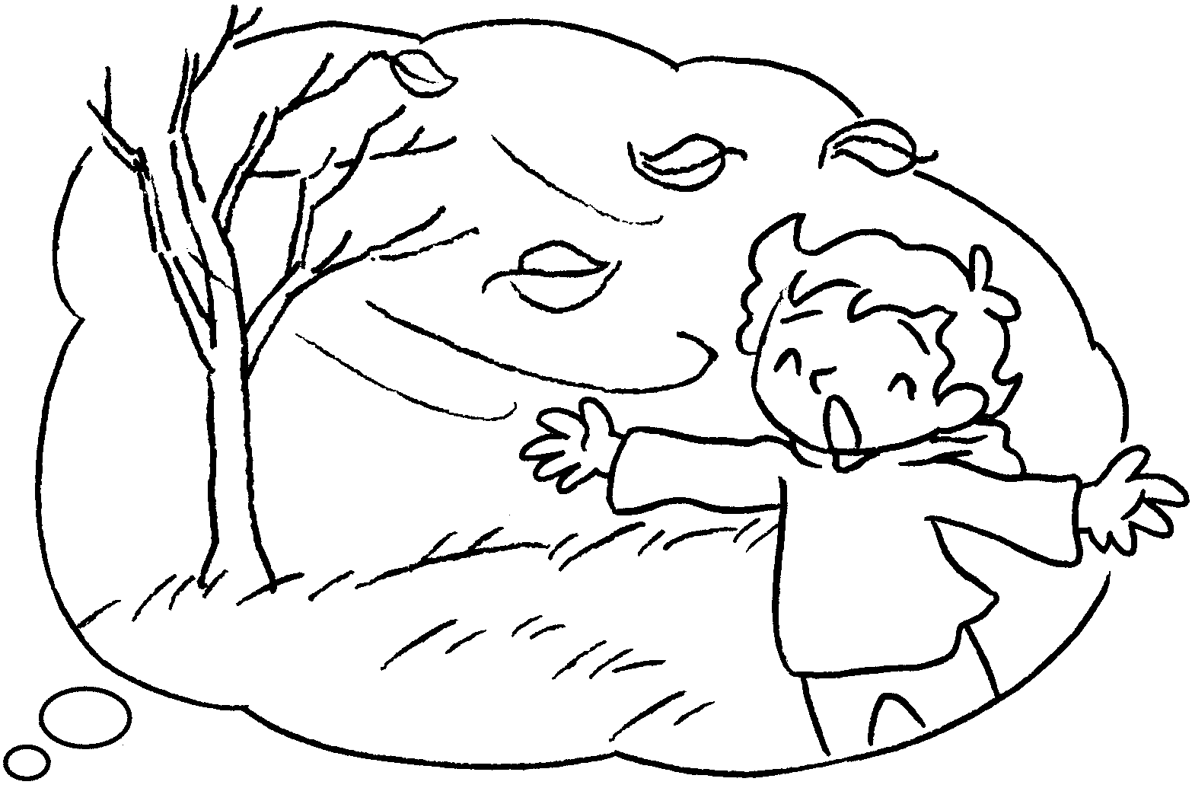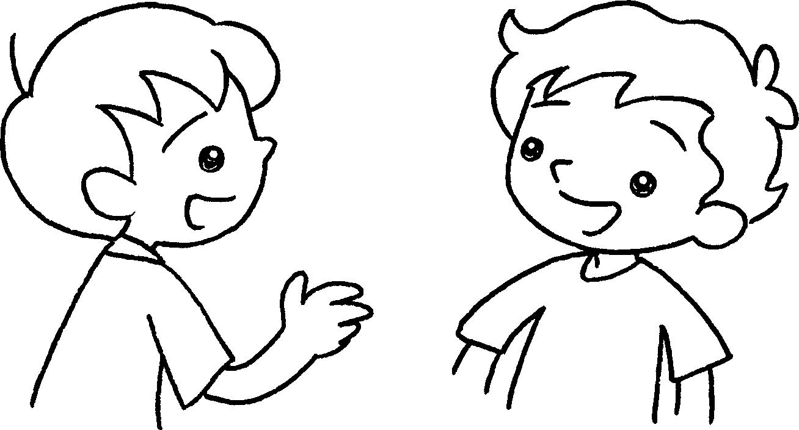 | A : season do you  ?  B : I  . It’s c .
4  A  B  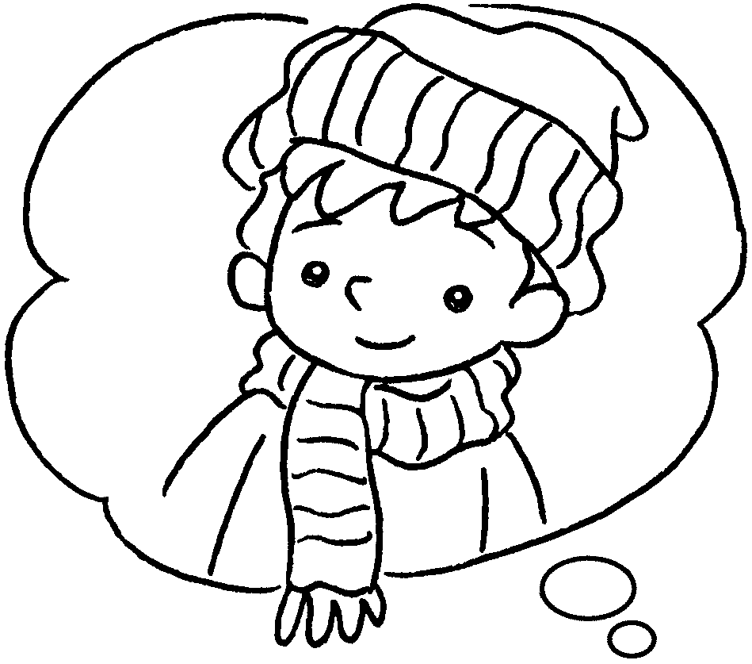  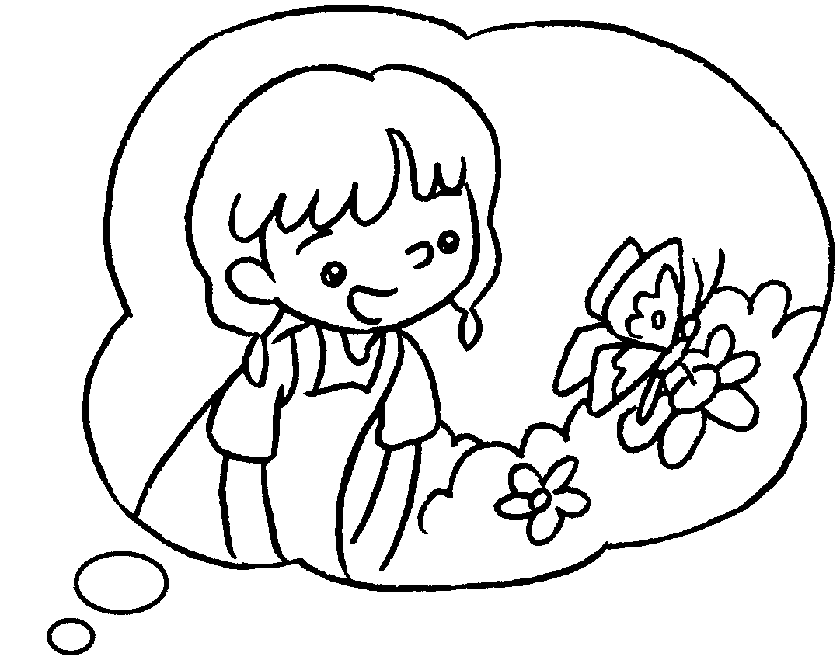 | 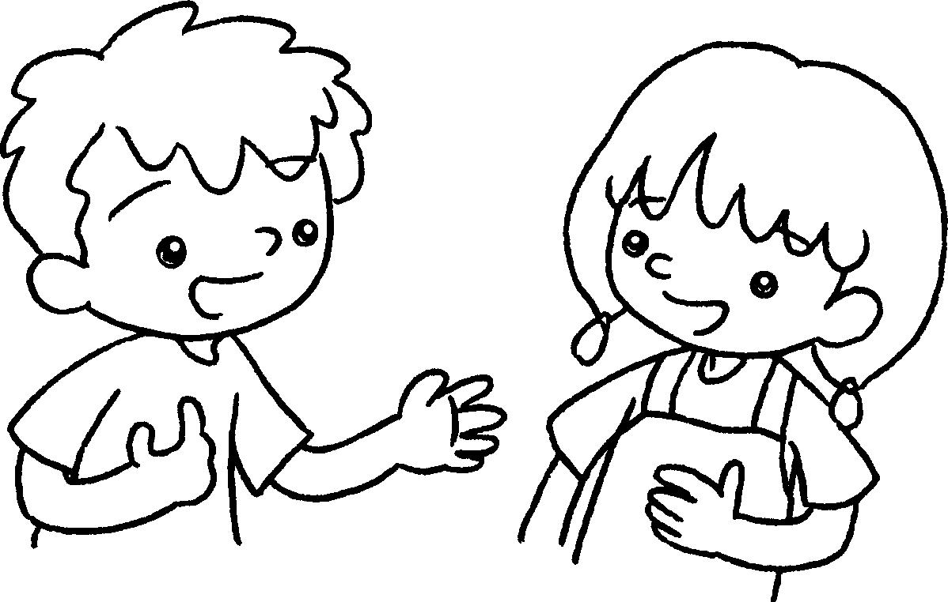 | A : I like .  season ?  B : I .


Book 2B Chapter 5 Graded Worksheets
Worksheet 3⬇⬇⬇
1 summer hot
2 Which
spring best warm
3 Which like best
like autumn best cool
4 winter best Which do you like best
like spring best

