Fill in the missing letters.

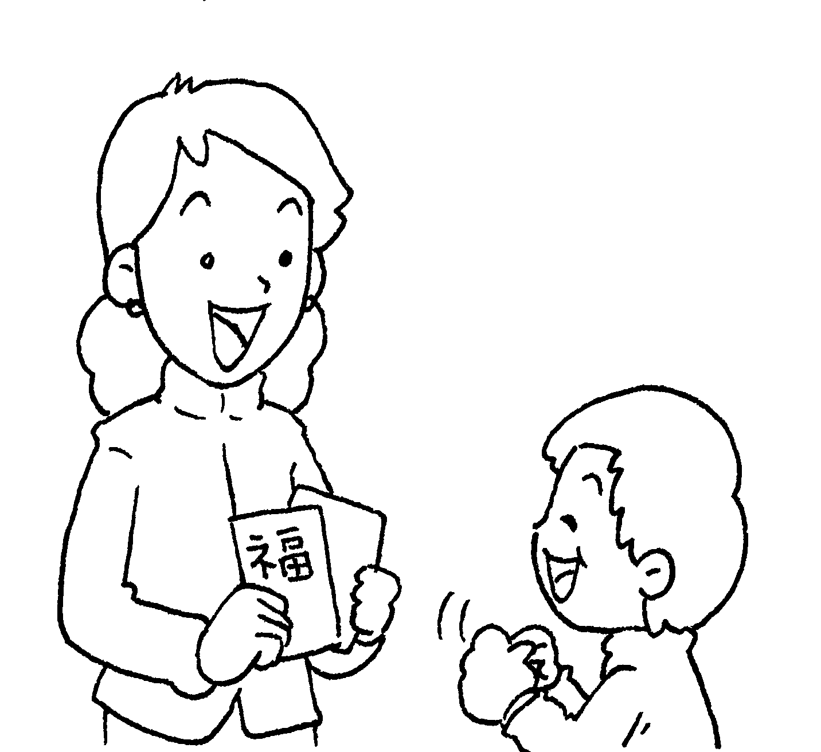  1  2  3  8  9  4  5  6  7 | 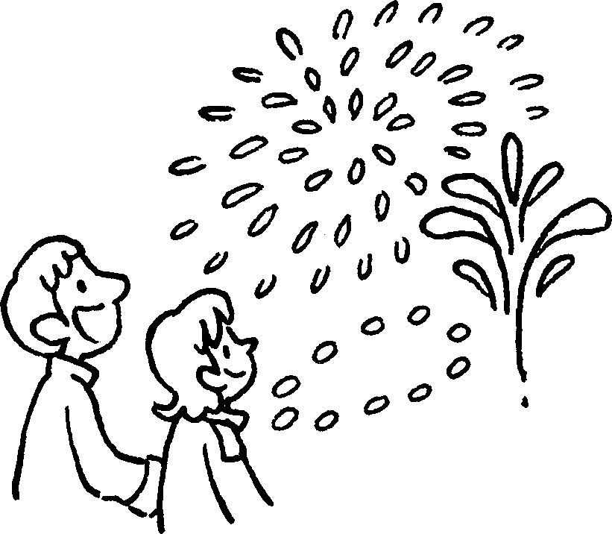 | 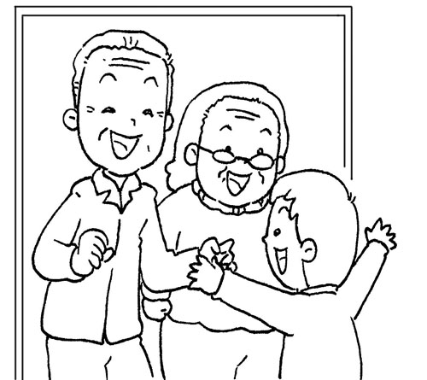
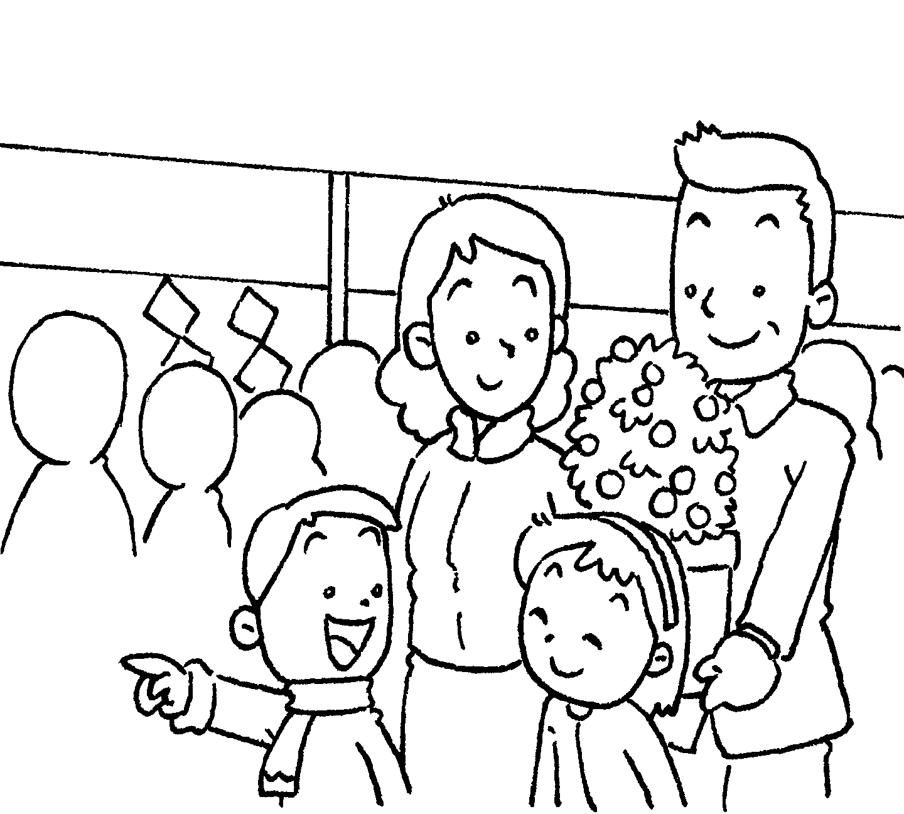 | 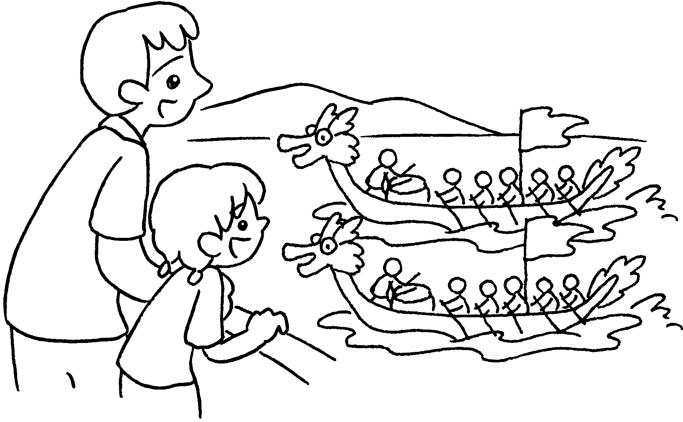 | 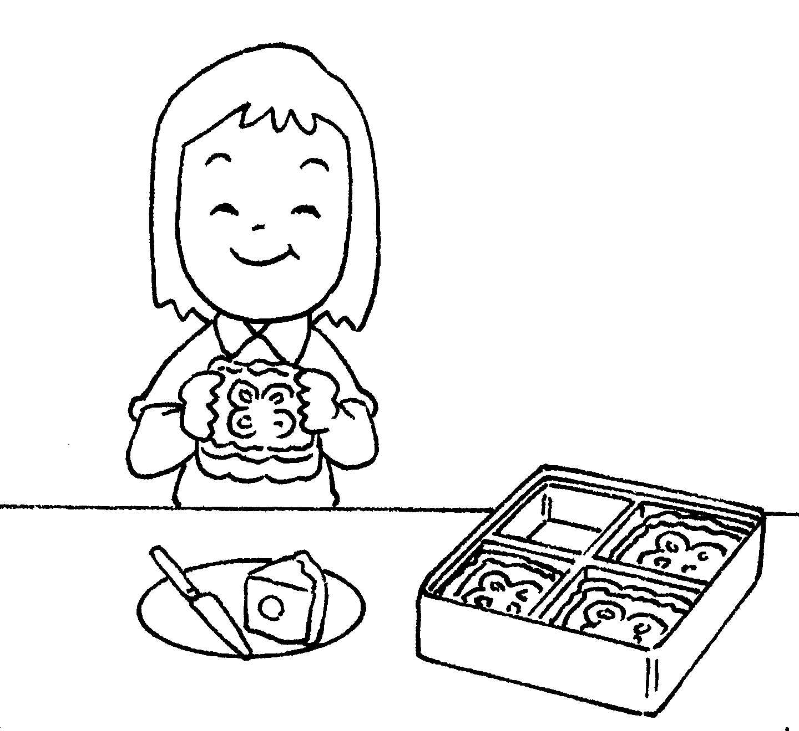
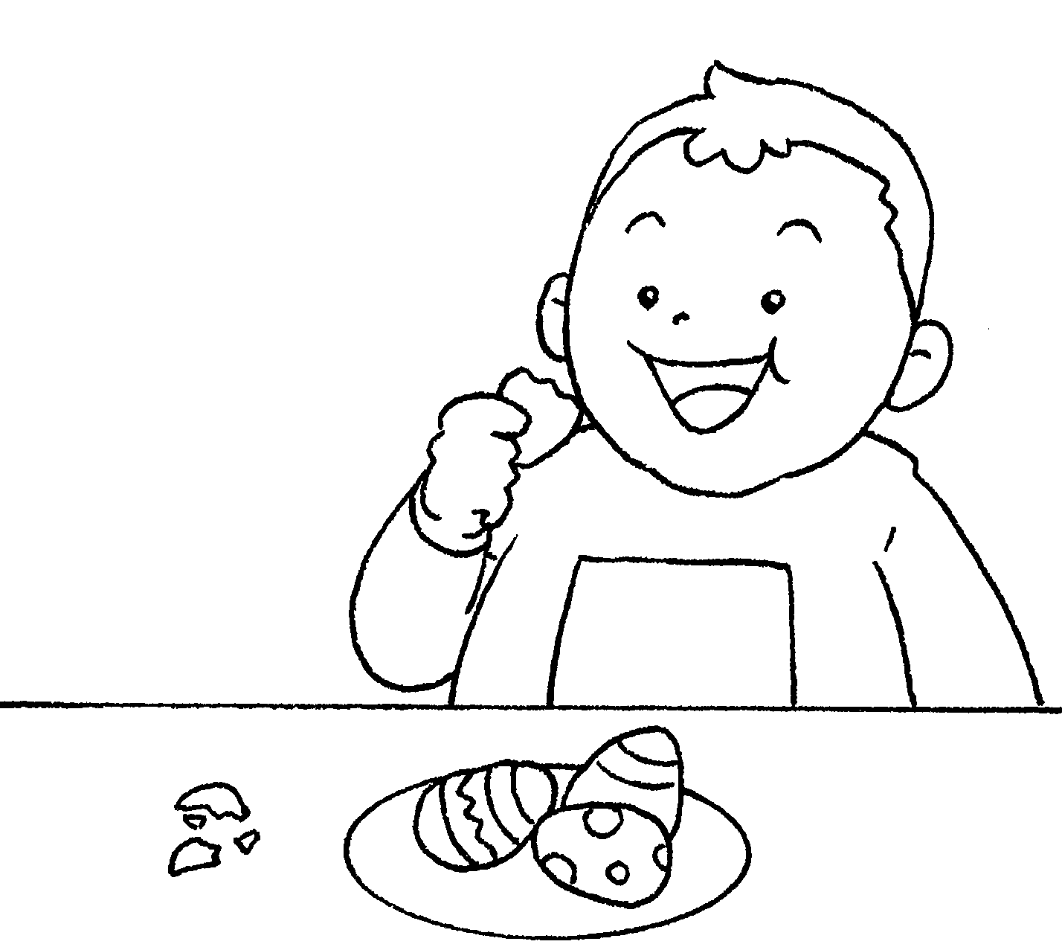 | 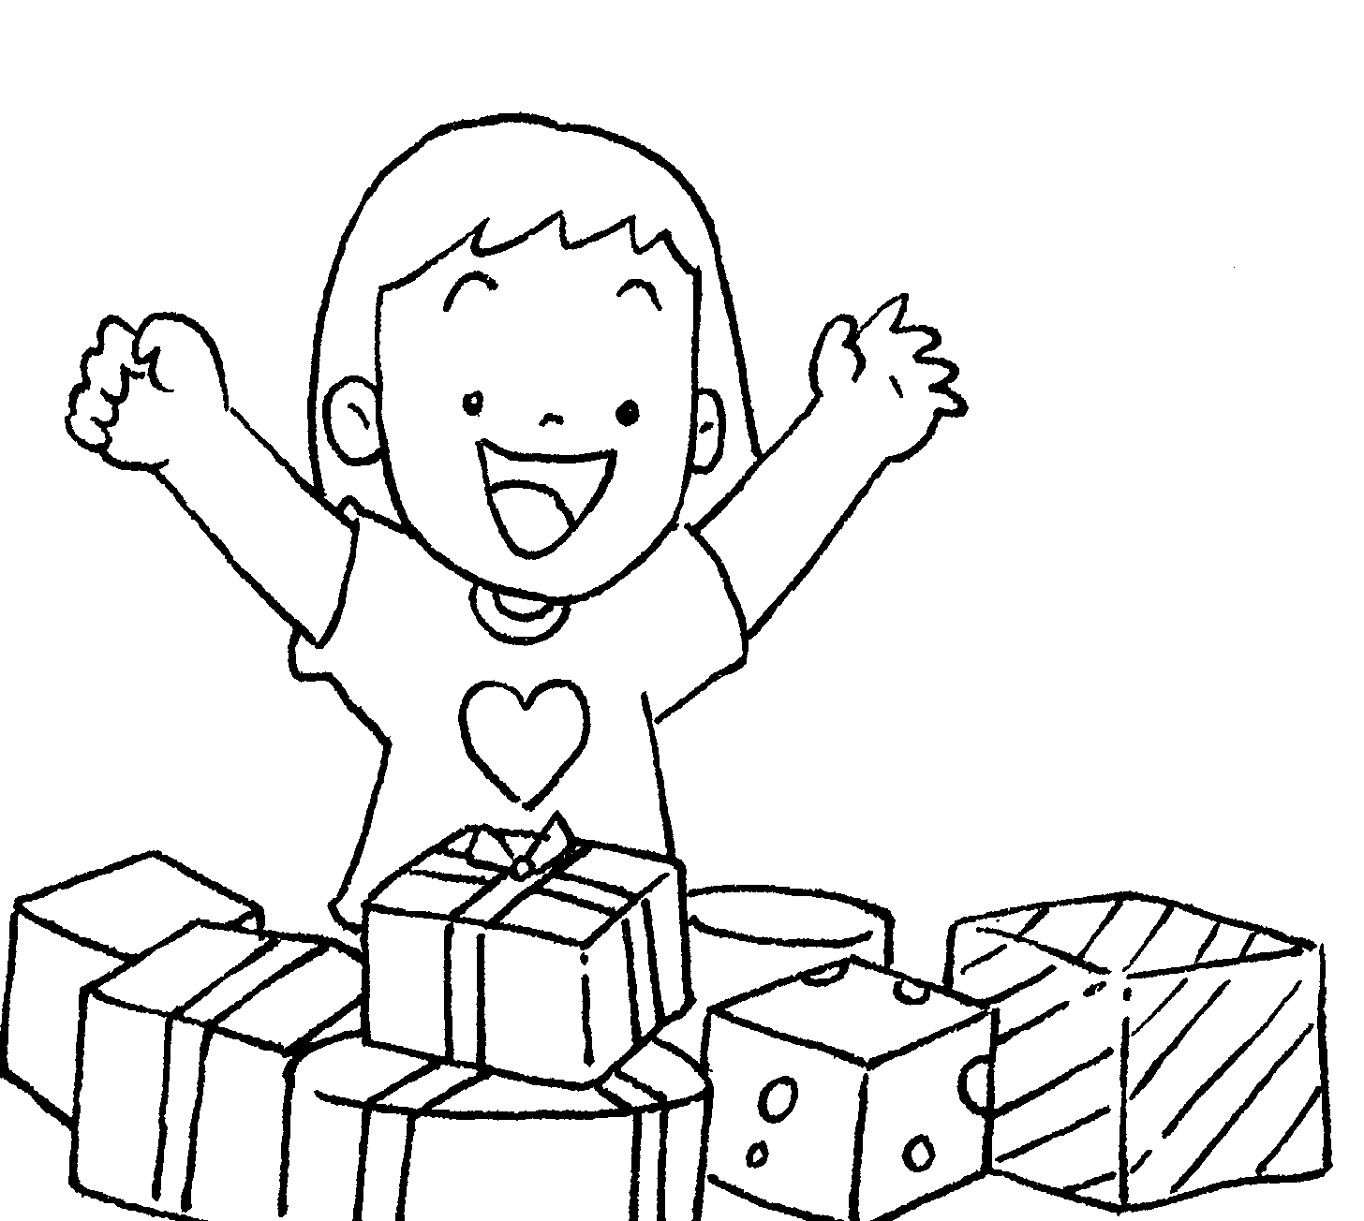 | 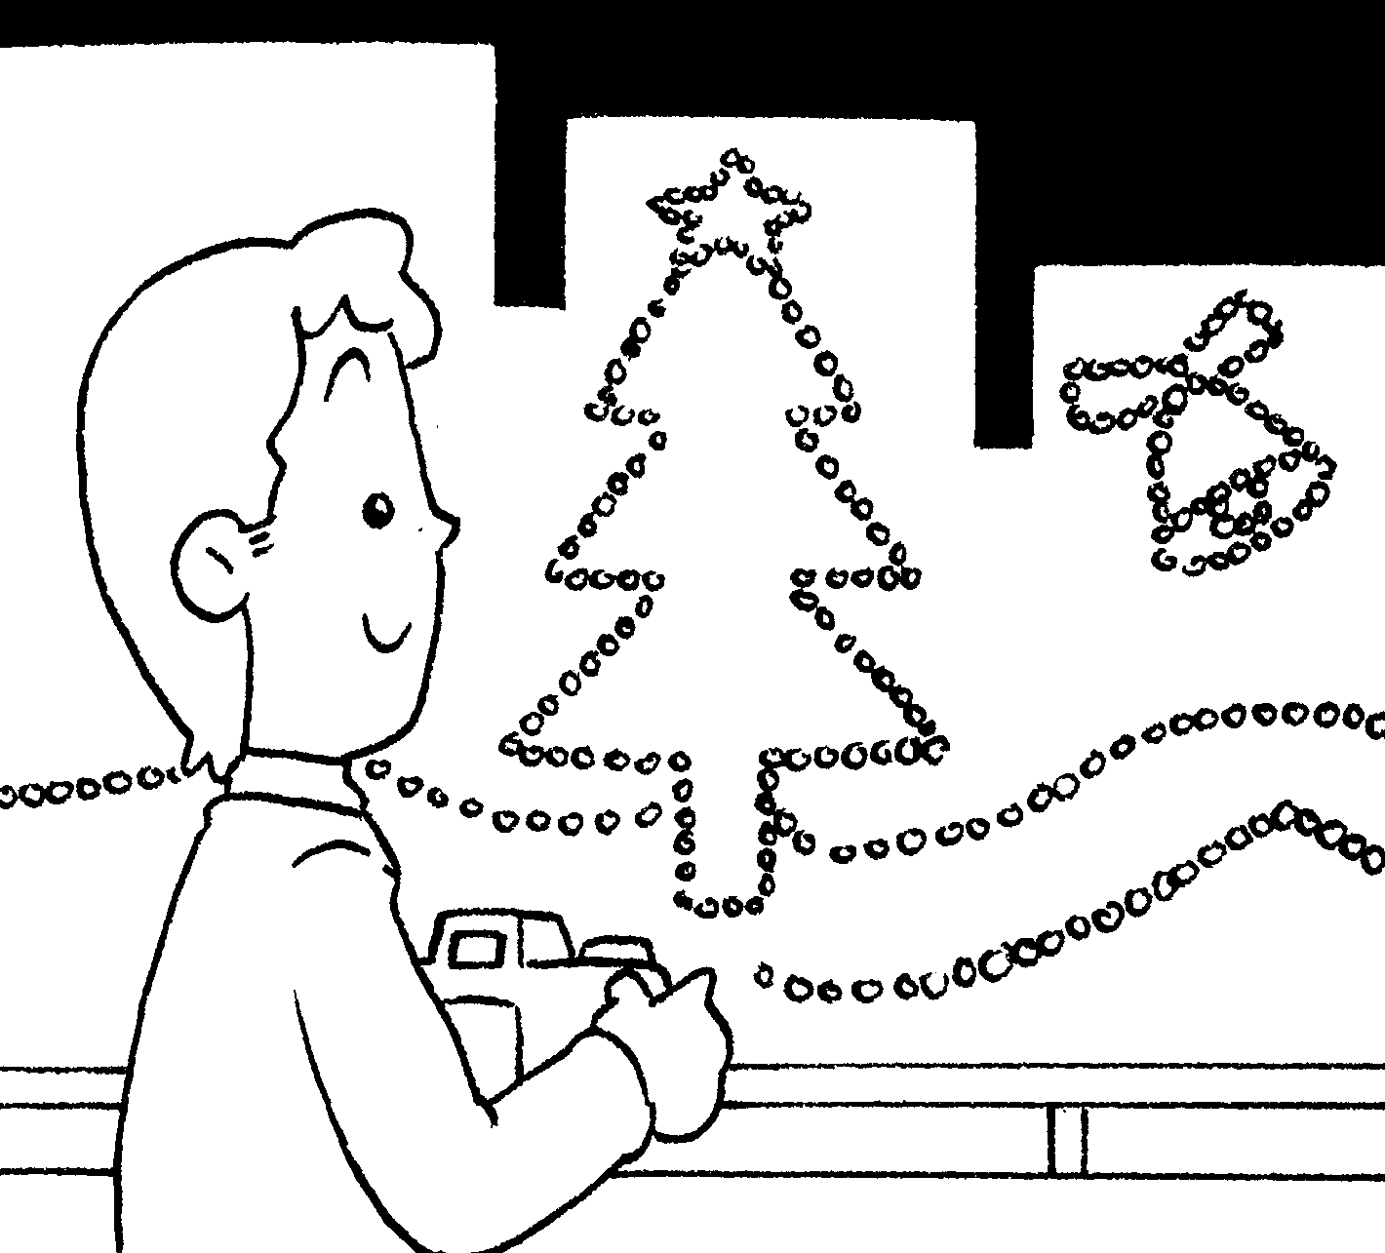
Chinese New Year Mid-Autumn Festival
1 get red p __ __ __ __ __ __ 6 eat m __ __ __ cakes
2 watch f __ __ __ __ __ __ __ __ Easter
3 visit r __ __ __ __ __ __ __ __ 7 eat cho __ __ __ __ te
4 go to the f __ __ __ __ __ e __ __ __
m __ __ __ __ __ Christmas
Dragon Boat Festival 8 get p __ __ __ __ __ __ s
5 watch d __ __ __ __ __ 9 look at the
b __ __ __ r __ __ __ s Ch __ __ __ __ __ __ __
l __ __ __ __ __



Book 2B Chapter 6 Graded Worksheets
Worksheet 1⬇⬇

p a c k e t s
- f i r e w o r k s
- r e l a t i v e s
- f l o w e r m a r k e t
- d r a g o n b o a t r a c e s
- m o o n
- cho c o l a te e g g s
- p r e s e n t s
- Ch r i s t m a s l i g h t s

